Supplementary materials
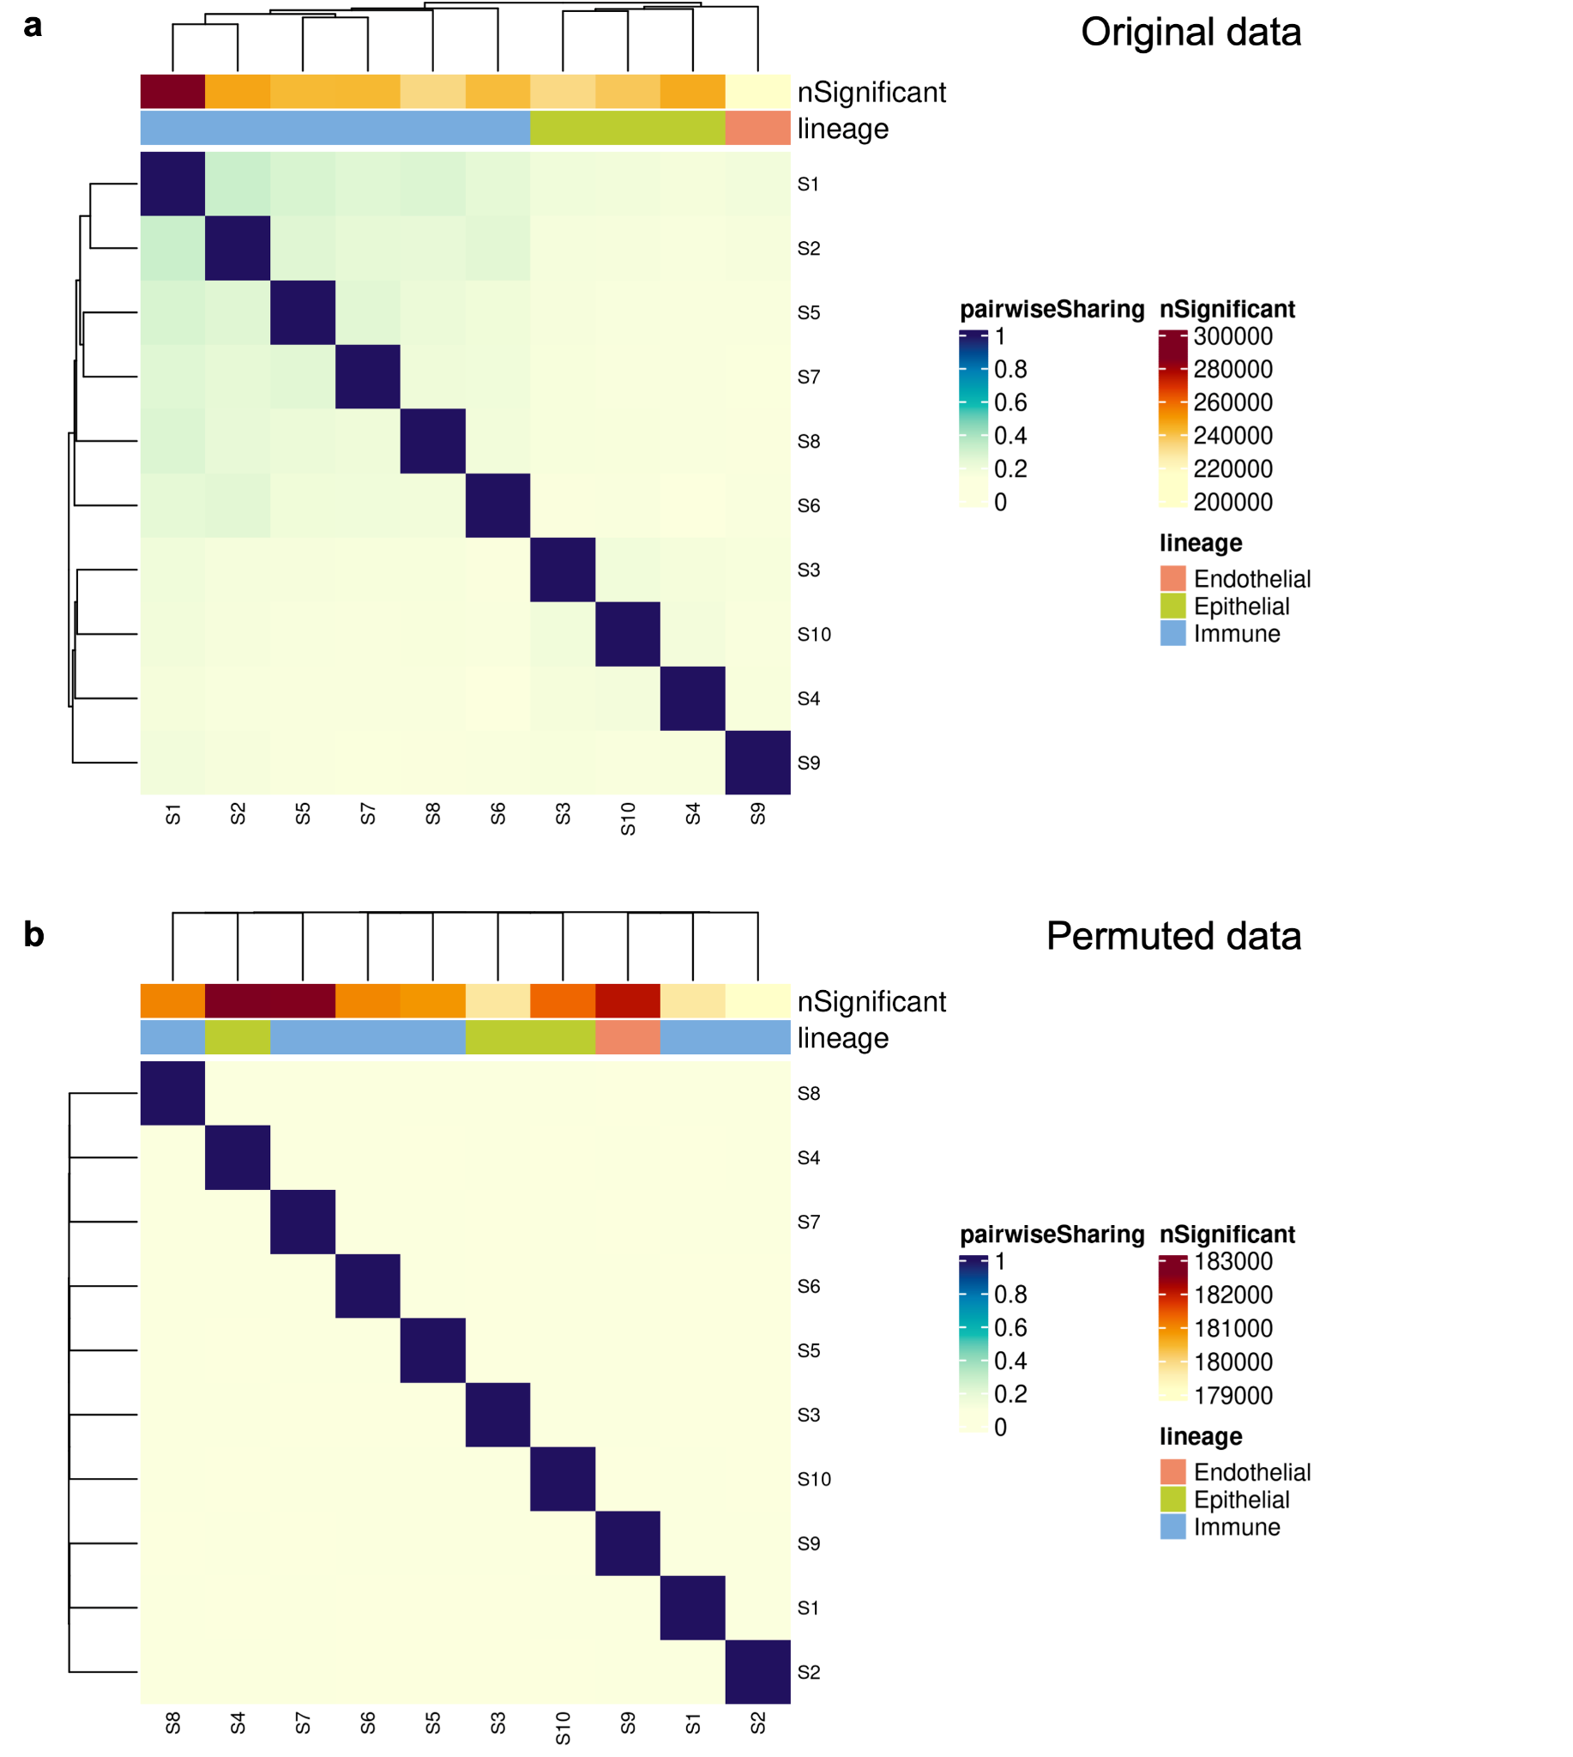
Supplementary Fig. 1. Comparison between pairwise sharing plot for the original data (a) and the empirical null data (b). Sharing is determined using p-values prior to multi-tissue integration.
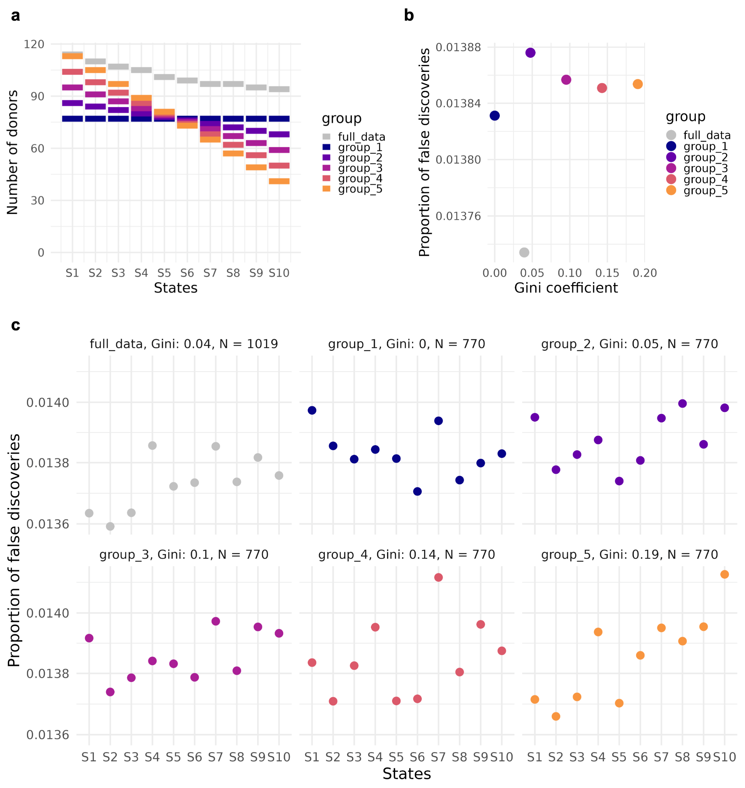
Supplementary Fig. 2. Simulation of FDR control under uneven sample sizes when calling significance using p-values. (a) Sample sizes for each experimental group (groups 1 through 5) as well as the sample sizes in the original data (grey). (b) Proportion of false discoveries for each group plotted against the Gini coefficient for that group, where a Gini coefficient of 0 indicates no inequality. (c) Proportion of false discoveries for each state and group.
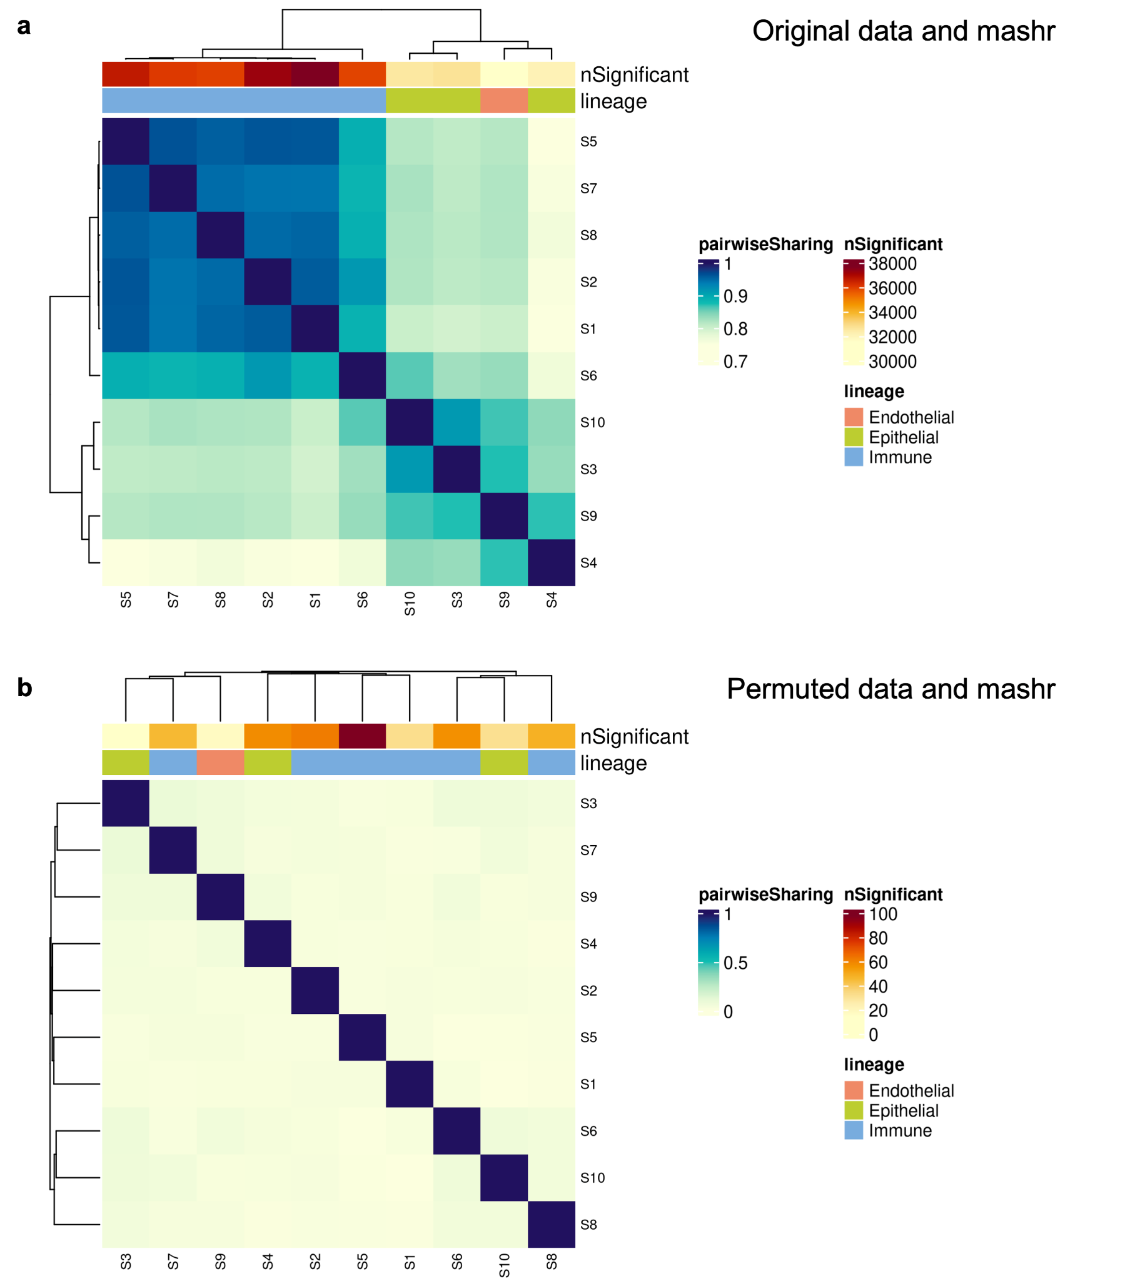
Supplementary Fig. 3. Comparison between pairwise sharing plot for the original data (a) and the empirical null data (b). Sharing is determined using the LFSRs obtained from mashr.
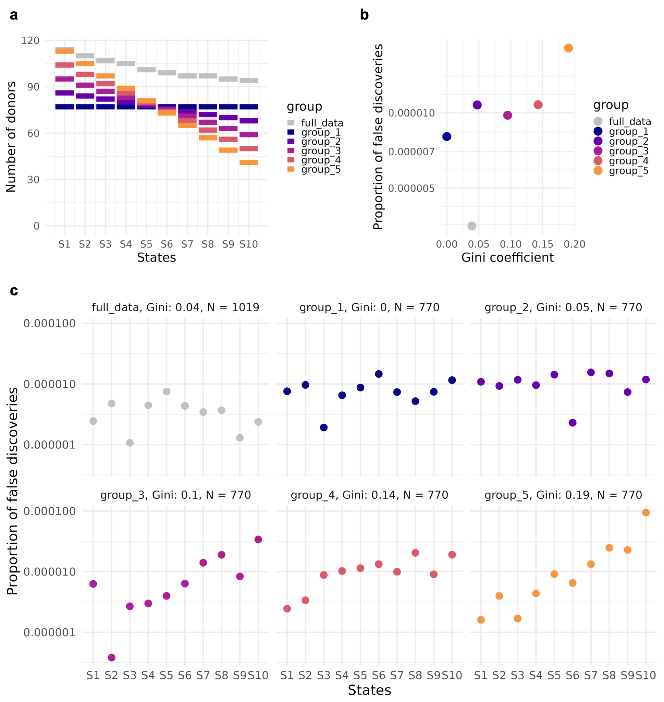
Supplementary Fig. 4. Simulation of FDR control under uneven sample sizes when calling significance using LFSRs from mashr. (a) Sample sizes for each experimental group (groups 1 through 5) as well as the sample sizes in the original data (grey). (b) Proportion of false discoveries for each group plotted against the Gini coefficient for that group, where a Gini coefficient of 0 indicates no inequality. (c) Proportion of false discoveries for each state and group.
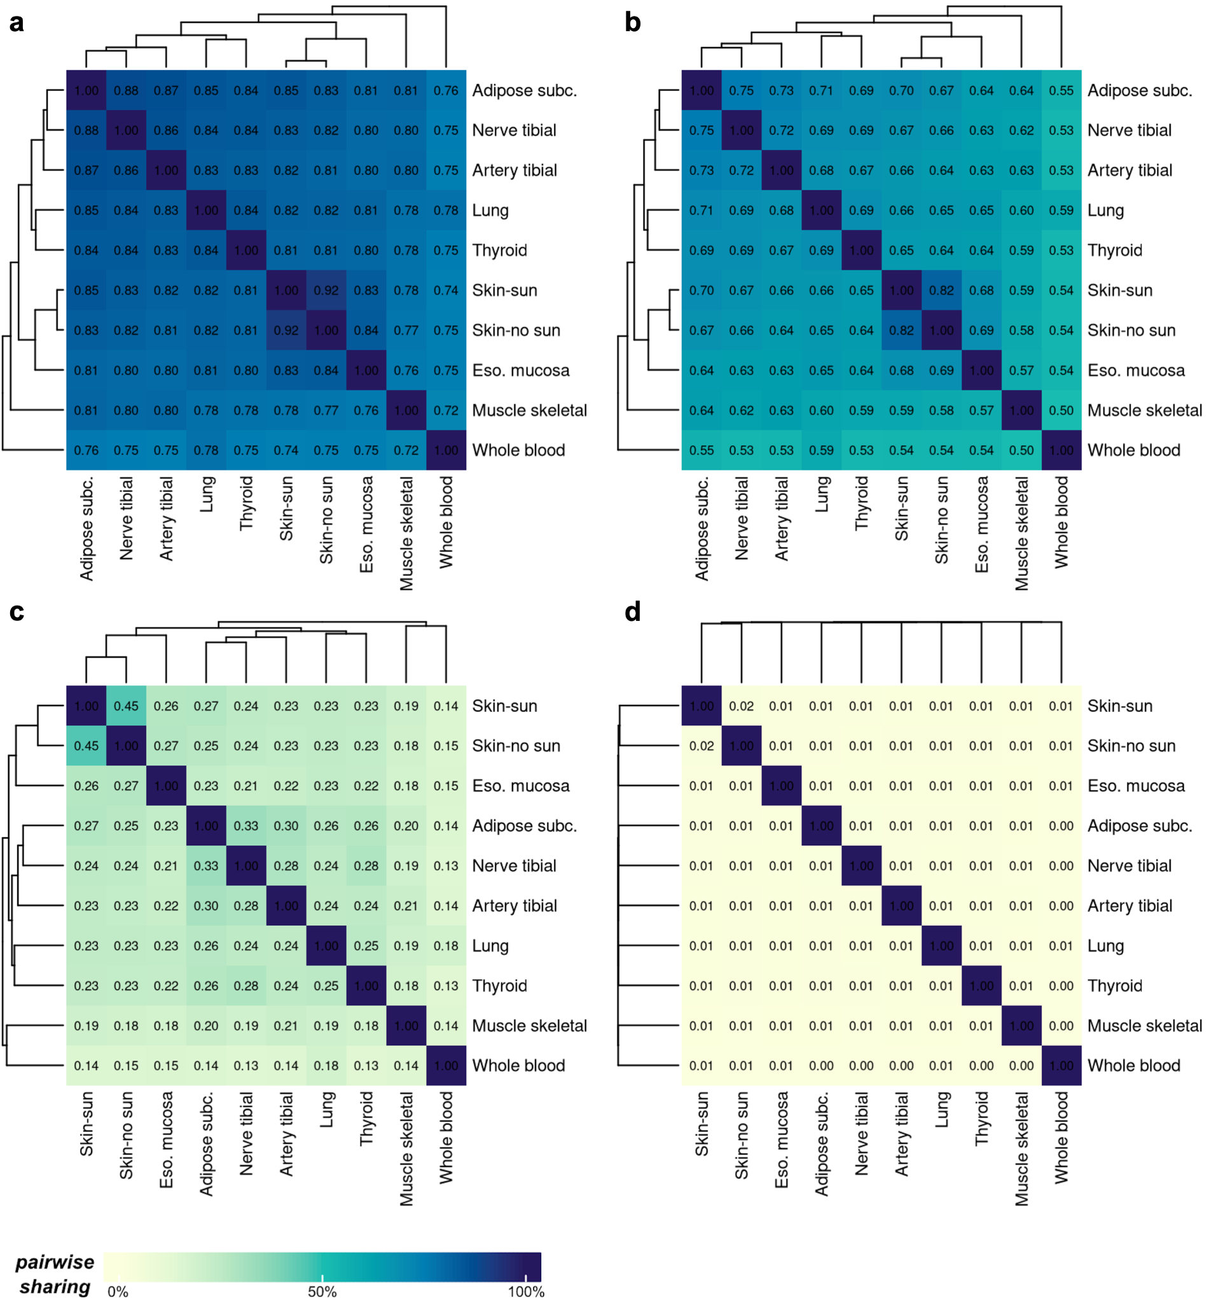
Supplementary Fig. 5. Comparison between choices for the factor parameter in runPairwiseSharing(). (a) factor = 0. (b) factor = 0.25. (c) factor = 0.75. (d) factor = 0.99. This represents a very strict threshold for the beta value, while acknowledging that the effect sizes will never be completely identical across states.
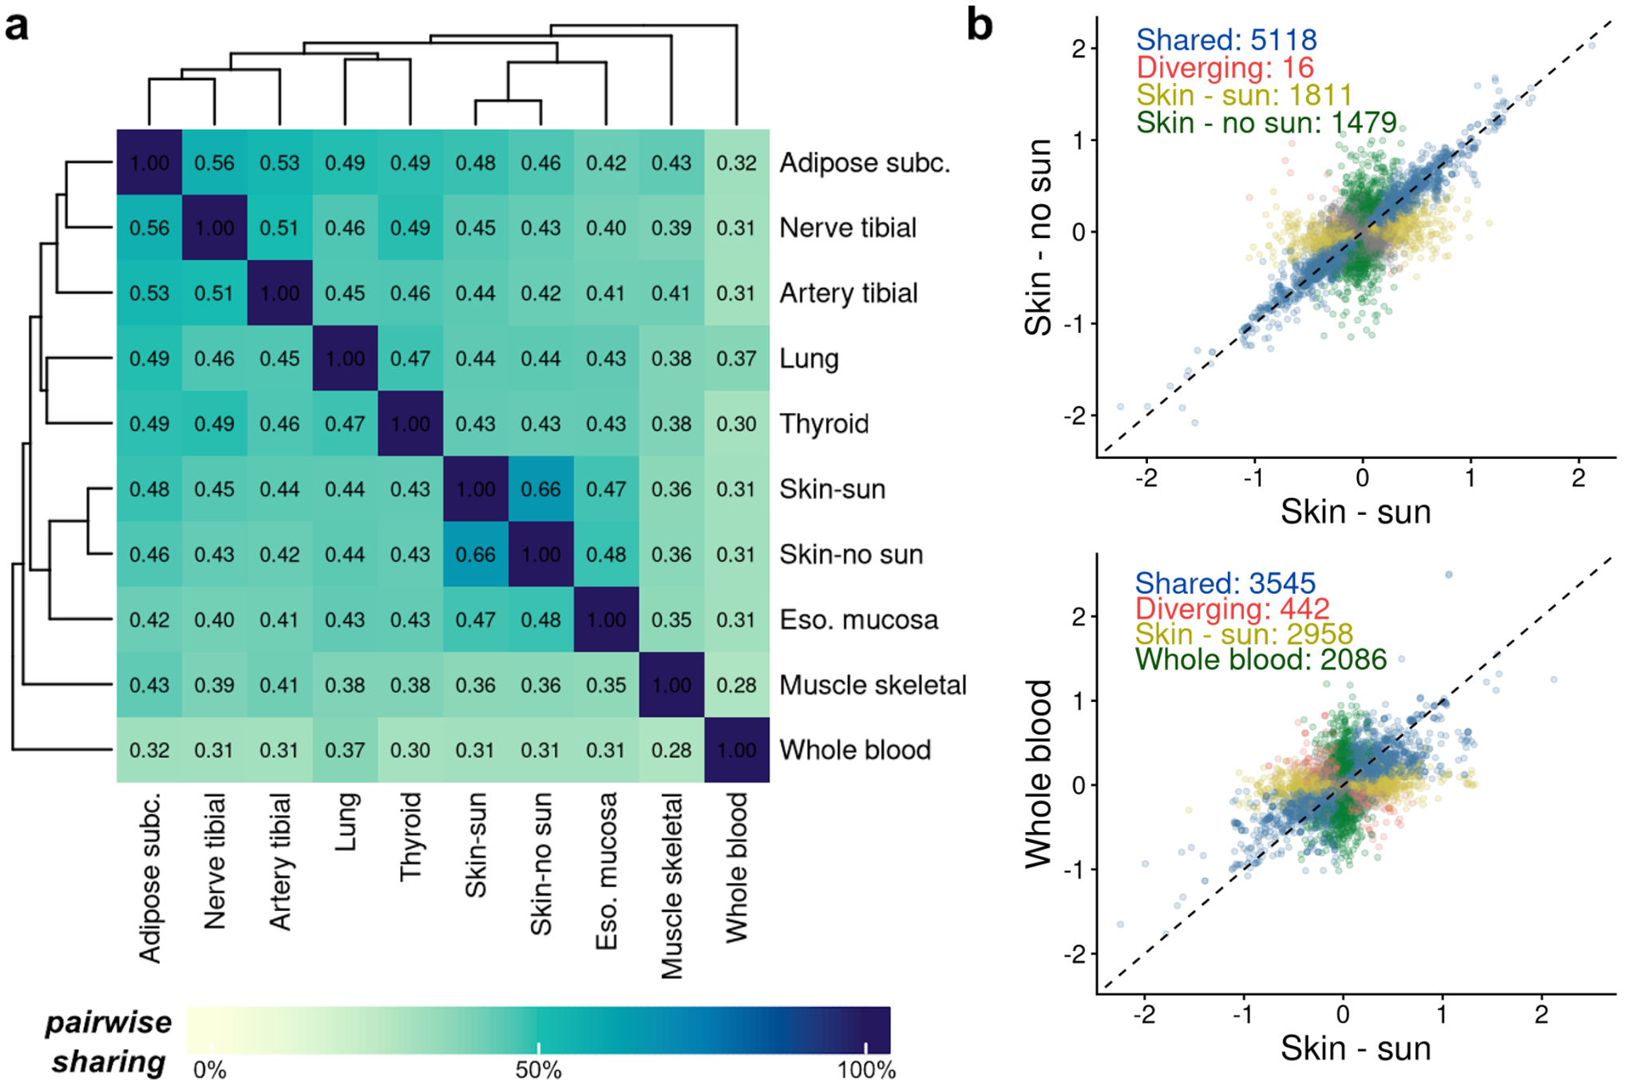
Supplementary Fig. 6. Global summary of GTEx chromosome 1 multi-tissue eQTL. (a) Pairwise sharing of eQTL across tissues, tissues are sorted by hierarchical clustering. (b) Comparison of estimated eQTL effect sizes between two tissues of interest. eQTL that are shared between tissues are shown in blue, those with diverging effects are in red, those only significant in the tissue on the x-axis are in yellow, and those only significant in the tissue on the y-axis are in green.
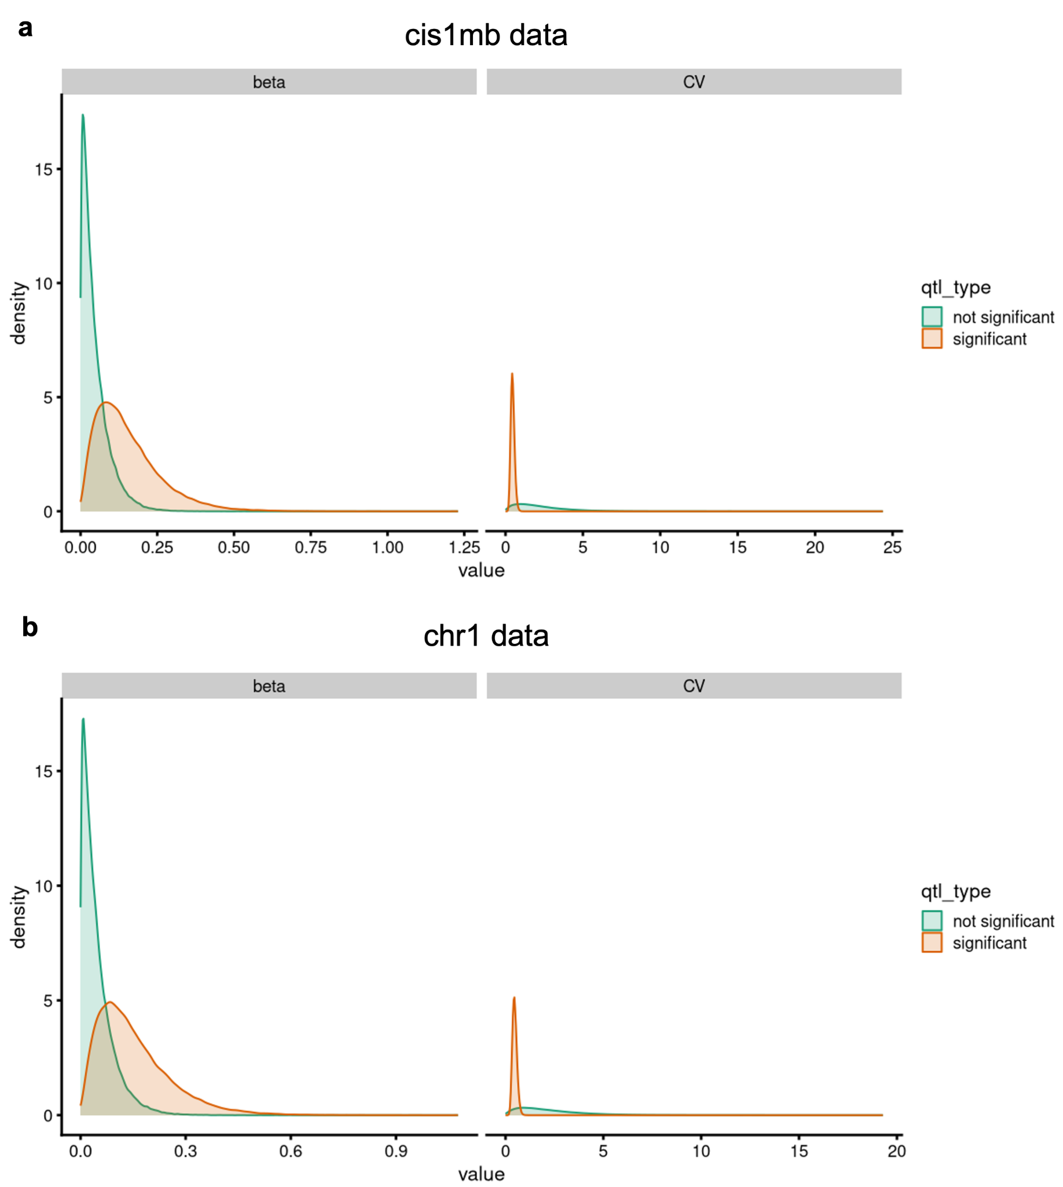
Supplementary Fig. 7. Gamma distributions defined by the multi-state QTL parameters estimated from the GTEx data. (a) Parameters estimated for the whole-genome cis-eQTL data. (b) Parameters estimated from the chromosome 1 data.
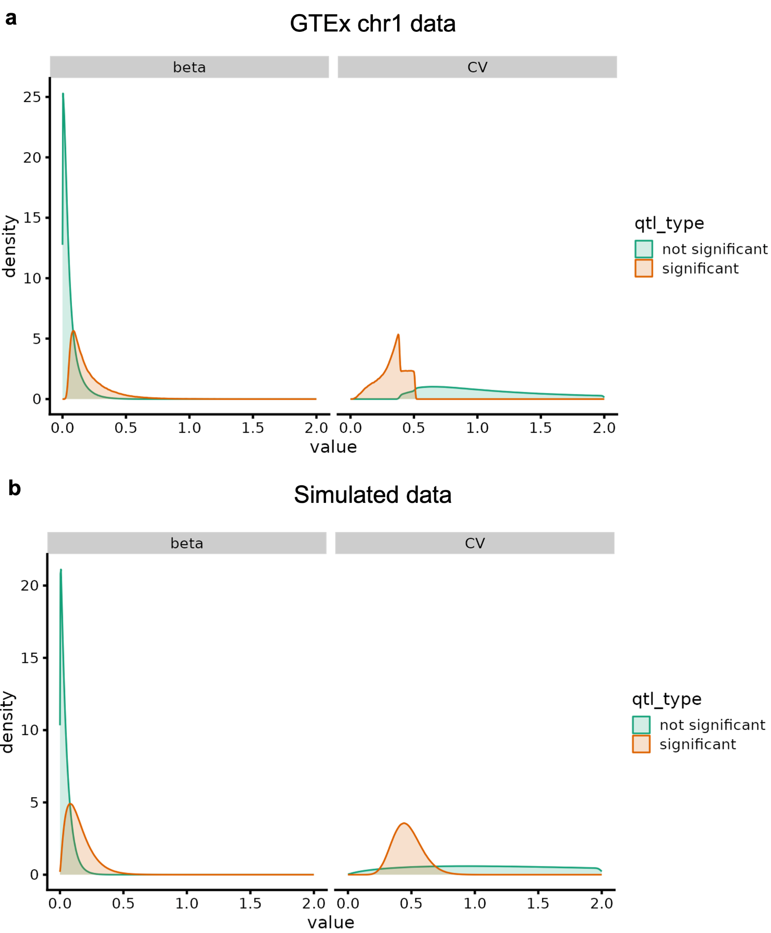Supplementary Fig. 8. Comparison between real and simulated multi-state QTL data. (a) Smoothed histogram of the beta values (effect sizes) and the coefficient of variation (CV) of effect sizes from the GTEx chromosome 1 data. (b) Distribution of simulated data where the parameters were obtained from the GTEx chromosome 1 data.
Parameters | Whole-genome | Chromosome 1
cv.sig.shape | 15.03969 | 16.68406
cv.sig.rate | 32.41345 | 35.53079
cv.null.shape | 1.71592 | 1.70729
cv.null.rate | 0.76937 | 0.76290
betas.sig.shape | 2.13552 | 2.15090
betas.sig.rate | 13.89004 | 14.19910
betas.null.shape | 1.05561 | 1.05646
betas.null.rate | 22.91329 | 22.63795

Supplementary Table 1. Comparison of estimated parameters from qtleEstimate() between the whole genome cis-eQTLs and the chromosome 1 data.

