Supplementary Information

Supplementary Results

Sequence-grouped validation
Random cross-validation was used as an interpolation benchmark within the sampled ChR design space. To assess transfer across sequence-defined groups, sequence-grouped cross-validation was performed as a supplementary stress test. For the energy-minimized molecular-field models, Pearson correlations were 0.407, 0.602, and 0.211 for max peak, green norm, and off-kinetics, respectively. The corresponding correlations for the sequence-based Gaussian-process models were 0.723, 0.848, and 0.232. Performance was lower than under random cross-validation, particularly for off-kinetics. Accordingly, the predictive results were interpreted within the sampled ChR design space, and generalization to sequence-distant variants has not been established. The molecular-field models did not outperform the sequence-based models. The sequence-distance matrices, complete-linkage clustering, and complete prediction panels are shown in Supplementary Fig. S1. Sequence-cluster assignments, train–test relatedness, and variant-level out-of-fold predictions are provided in Supplementary Table S2.
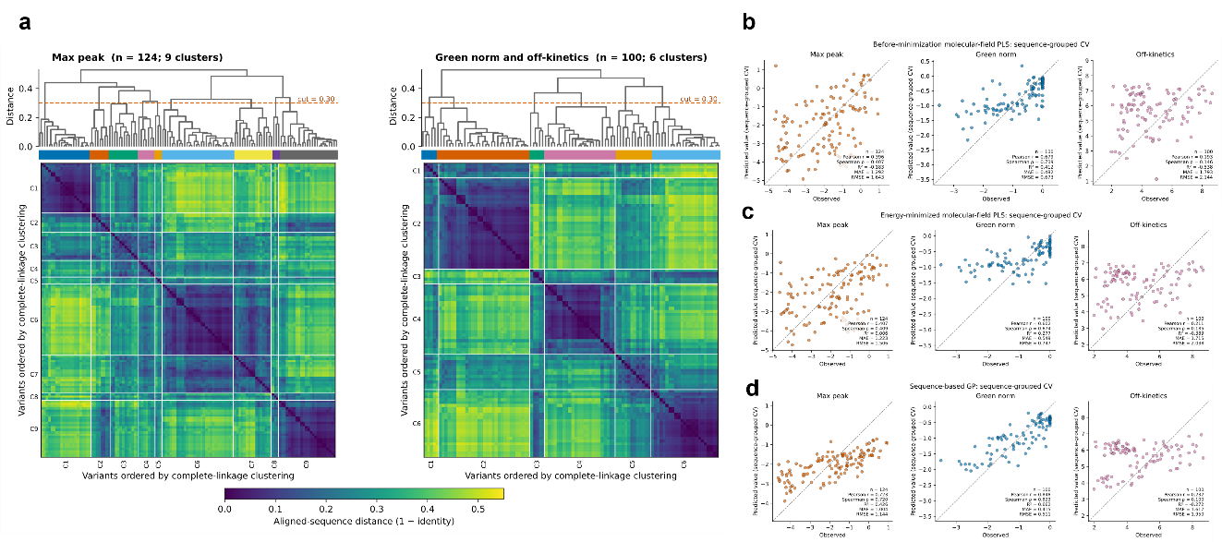
Supplementary Figure S1. Sequence clustering and sequence-grouped cross-validation stress test. a Complete-linkage dendrograms and pairwise aligned-sequence distance matrices (distance = 1 − identity) for the variants included in the max-peak analysis (n = 124) and in the green-norm and off-kinetics analyses (n = 100). The dashed line indicates the clustering cut at a distance of 0.30; the colored strips and white matrix boundaries show the resulting nine and six clusters, respectively. b–d Observed versus out-of-fold predicted values under sequence-grouped cross-validation for molecular-field models based on structures before (b) and after (c) energy minimization and for the sequence-based Gaussian-process baseline (d).

Model specification and preprocessing sensitivity
To examine variation in model specification across the 20 random cross-validation folds, the retained feature counts and selected PLS component counts were summarized for each endpoint. For the energy-minimized structures, the number of retained combined-field features ranged from 21,615 to 22,223 for max peak and from 24,445 to 25,189 for green norm and off-kinetics. The selected numbers of PLS components ranged from 4 to 15, 4 to 9, and 4 to 17 for max peak, green norm, and off-kinetics, respectively. Fold-specific feature and component counts, together with the numbers of van der Waals, Coulomb, and total features retained in every fold within each analysis, are provided in Supplementary Table S5.
To assess the sensitivity of predictive performance to molecular-field preprocessing, we evaluated 150 combinations of van der Waals clipping limits, SD thresholds, and absolute-skewness thresholds. For the energy-minimized models, Pearson correlations ranged from 0.540 to 0.655 for max peak, 0.821 to 0.854 for green norm, and 0.642 to 0.741 for off-kinetics. Models based on structures before energy minimization showed similar patterns. Predictive performance was generally stable across the tested preprocessing thresholds, with some variation among the three endpoints (Supplementary Fig. S2 and Supplementary Table S3).

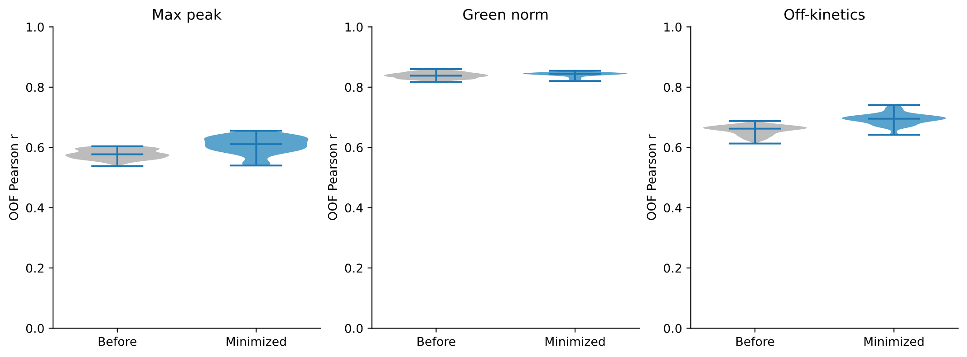
Supplementary Figure S2. Sensitivity to preprocessing thresholds. Prediction performance, measured using Pearson correlation coefficients, under different van der Waals clipping, standard-deviation (SD), and absolute-skewness thresholds for max peak, green norm, and off-kinetics.

Fold-to-fold consistency of important coefficient locations
To evaluate the fold-to-fold consistency of strongly weighted molecular-field locations, the original van der Waals PLS-coefficient grid points selected using the 99th- and 1st-percentile thresholds were compared before contour generation. This avoided dependence on the interpolation and spatial clustering used to render the contours. For max peak, the observed mean pairwise symmetric nearest-neighbor distances were 2.421 Å and 2.395 Å for the positive- and negative-coefficient locations, respectively. The corresponding distances were 1.975 Å and 1.756 Å for green norm and 1.688 Å and 1.911 Å for off-kinetics. No statistic from 10,000 within-fold permutations was as small as its observed counterpart (left-tailed empirical P = 1/10,001 for each comparison). These results describe spatial consistency relative to within-fold coordinate randomization across overlapping random cross-validation training sets and do not establish reproducibility across independent datasets. Fold-specific maps and complete permutation results are provided in Supplementary Fig. S3 and Supplementary Table S7.

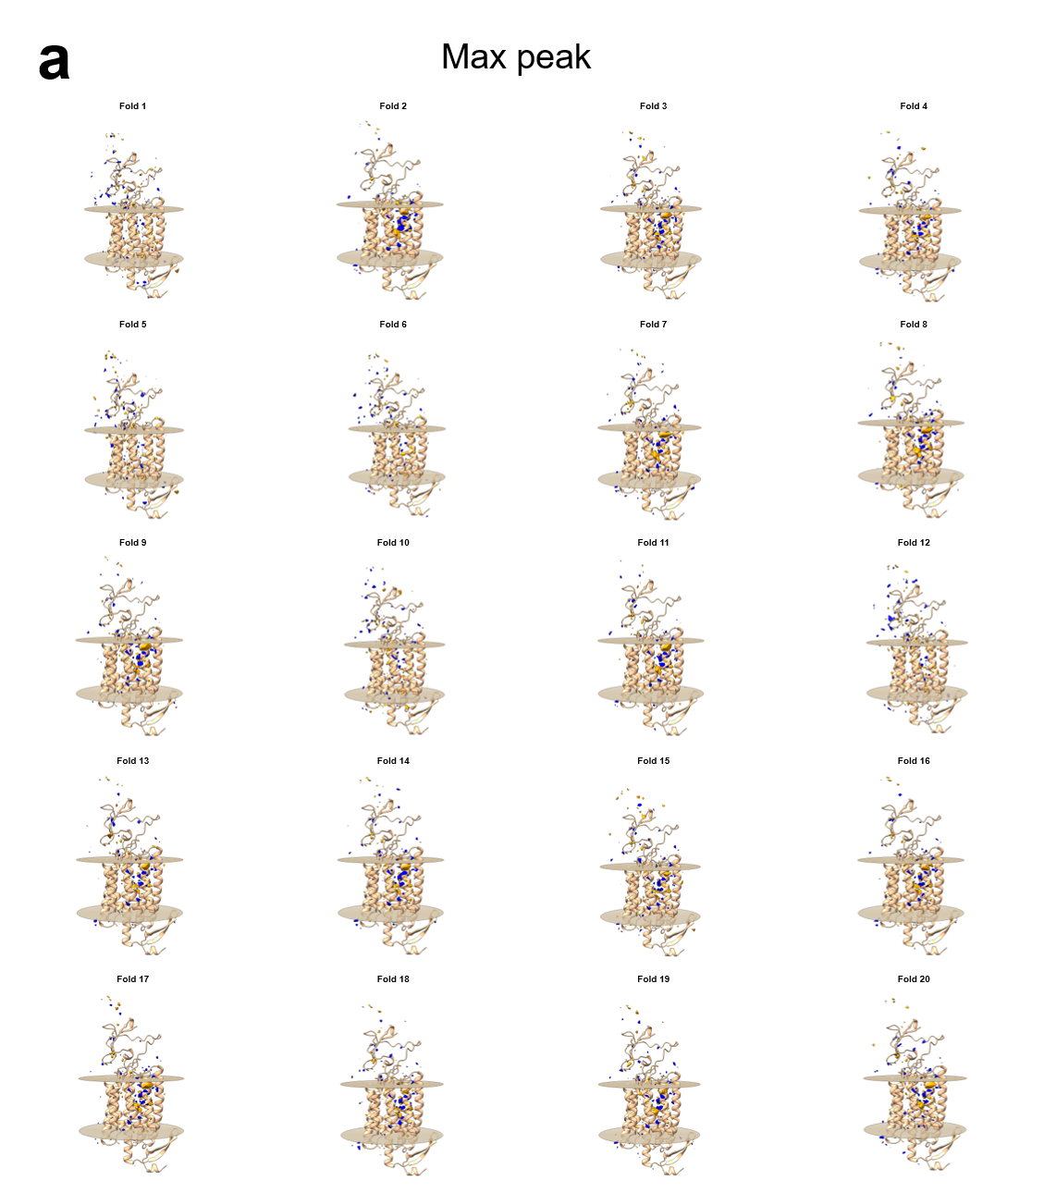
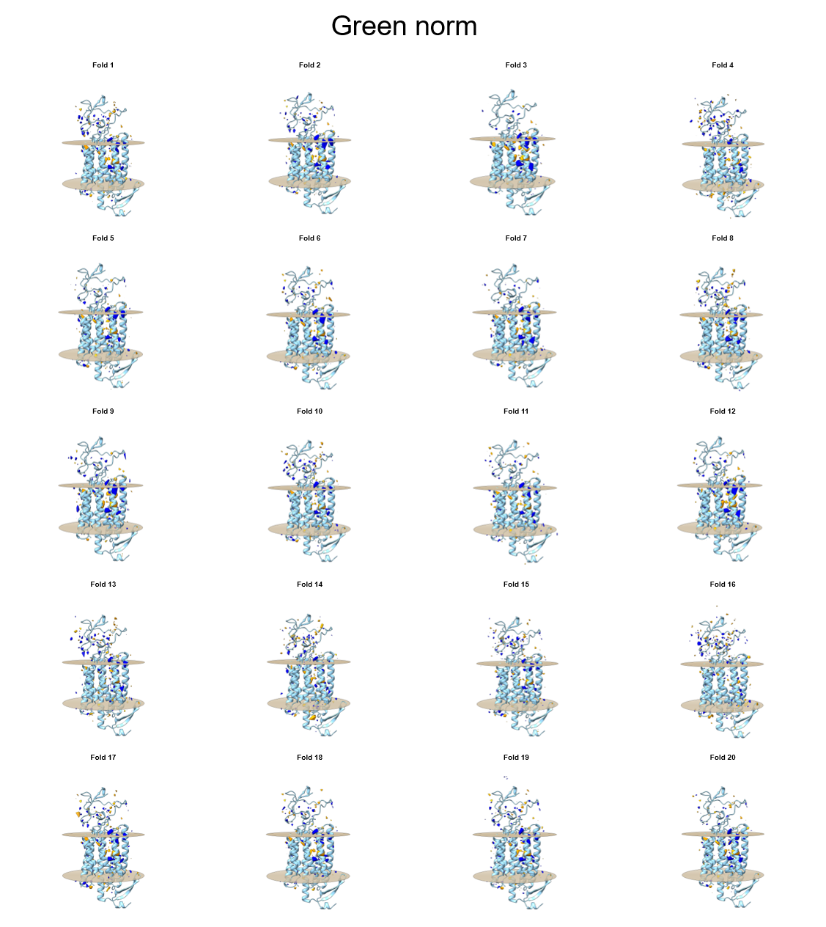
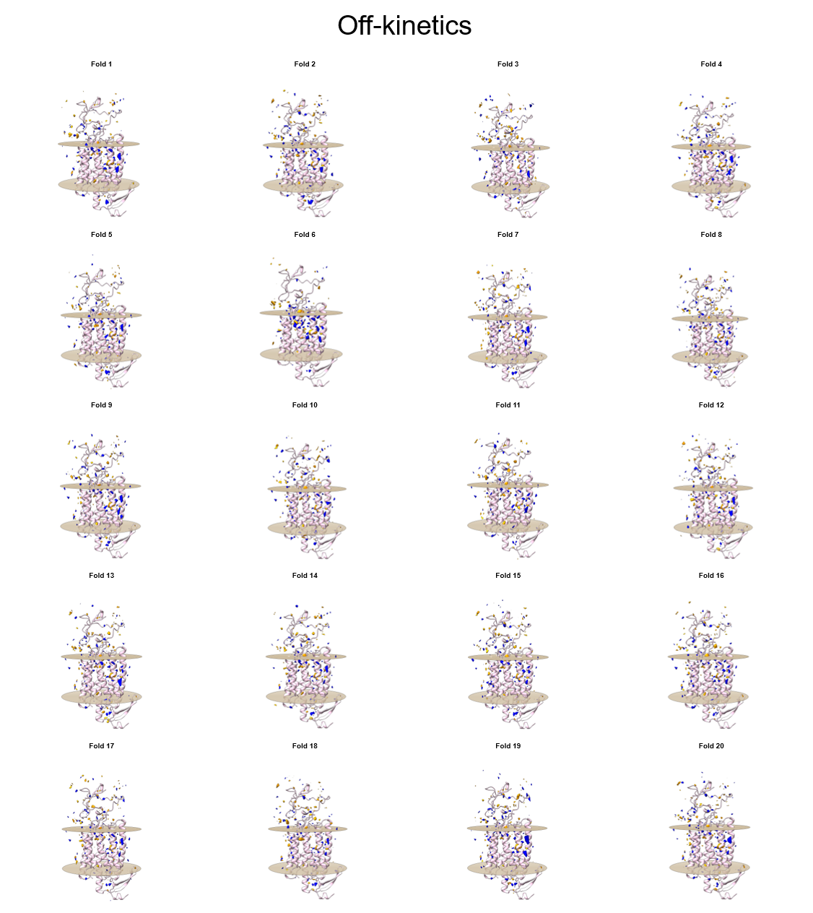
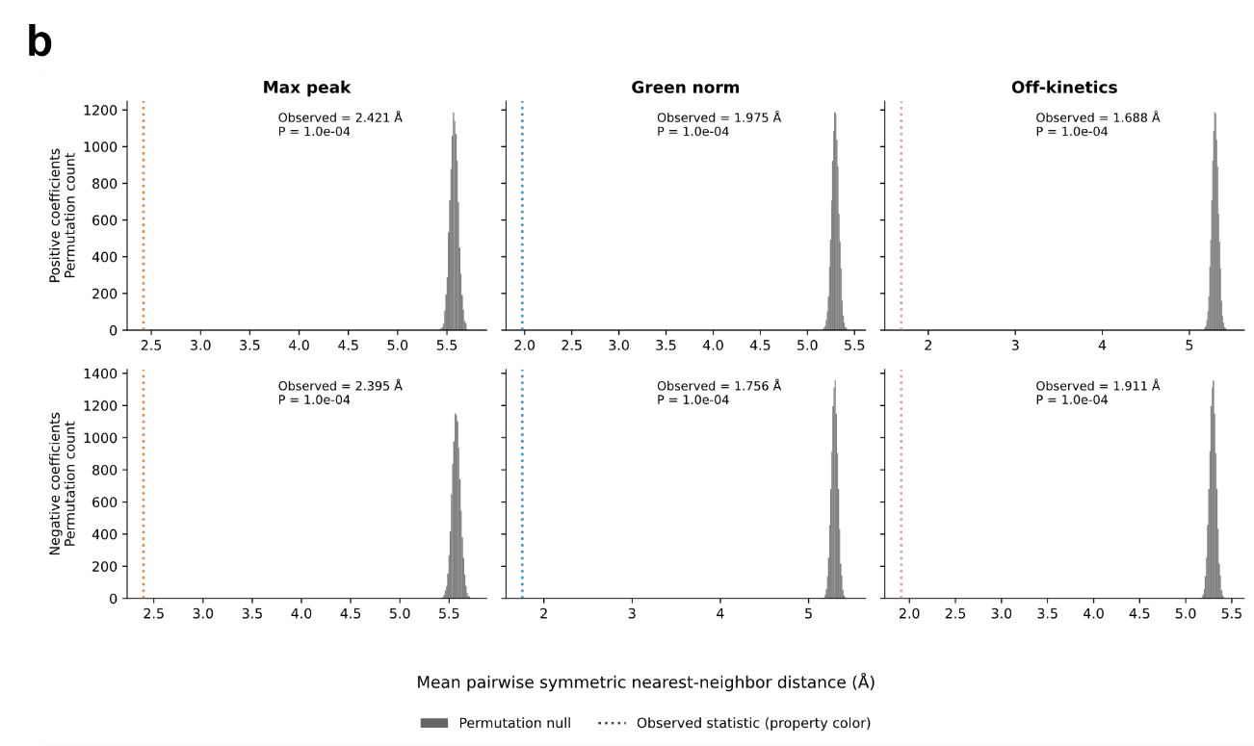
Supplementary Figure S3. Fold-specific coefficient maps and spatial consistency. a Fold-specific contour maps of candidate structural regions associated with max peak, green norm, and off-kinetics, obtained from the 20 folds of random cross-validation. Orange and blue contours indicate regions associated with positive and negative PLS coefficients of van der Waals features, respectively. The maps are overlaid on the energy-minimized C1C2 reference structure, and pale tan surfaces indicate predicted membrane boundaries. b Permutation tests of spatial consistency across folds for regions associated with positive and negative PLS coefficients. Histograms show null distributions of the mean pairwise symmetric nearest-neighbor distance obtained from 10,000 within-fold permutations, and dotted vertical lines indicate the observed distances. Smaller distances indicate greater spatial consistency across folds.

Structural confidence and biological context
To provide structural context for the highlighted molecular-field regions, residue-wise pLDDT is displayed together with the van der Waals coefficient contours in Supplementary Fig. S4. The relationship of the highlighted regions to 13 established functional and structural residues representing the internal gate, conserved hydrophobic retinal-binding pocket, extracellular vestibule, and retinal-binding Lys296 is shown in Fig. 5e. Using the van der Waals PLS-coefficient grid points selected by the 99th- and 1st-percentile thresholds, 10 of 13 landmarks for max peak, 9 of 13 for green norm, and 11 of 13 for off-kinetics were located within 5 Å. The corresponding one-sided empirical P values were 0.0192, 0.2087, and 0.0337, respectively. Using polygon centroids from the final contour representation, the corresponding counts were 11 of 13, 10 of 13, and 11 of 13, with one-sided empirical P values of 0.0092, 0.2012, and 0.0522, respectively. Thus, the direct coefficient-grid-point and final contour representations yielded similar proximity summaries (Supplementary Table S8).

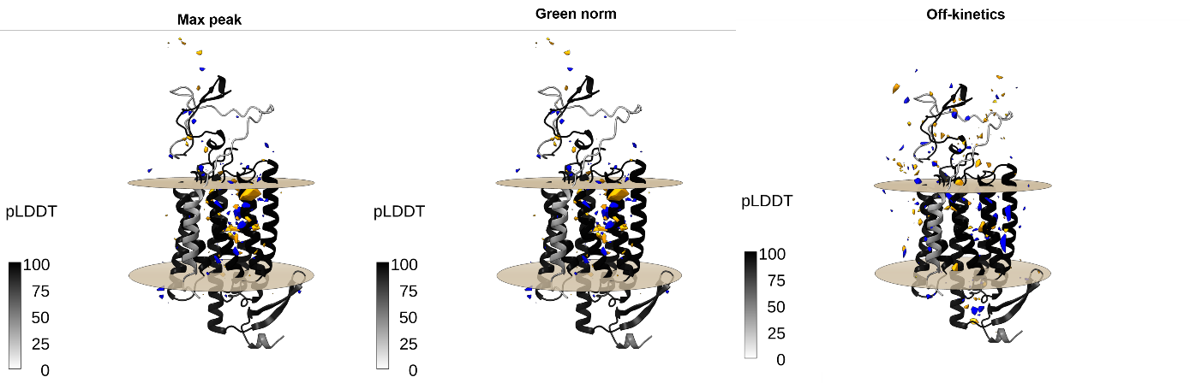
Supplementary Figure S4. Van der Waals PLS-coefficient contours and residue-wise AlphaFold2 confidence. The energy-minimized C1C2 reference structure was colored on a grayscale according to residue-wise pLDDT values and overlaid with van der Waals PLS-coefficient contours. Positive and negative contours are shown in orange and blue, respectively. Pale-tan transparent surfaces indicate the predicted membrane boundaries.

Supplementary Methods

Sequence-grouped cross-validation
To construct sequence-defined groups, aligned-sequence identity between variants was calculated as the proportion of identical characters across all aligned positions, and sequence distance was defined as 1 minus identity. Complete-linkage hierarchical clustering was applied to the pairwise distance matrix, and clusters were cut at a distance threshold of 0.30. One cluster at a time was used as the outer test set, with all remaining clusters used for training. This yielded nine folds for max peak and six folds for green norm and off-kinetics. Identical grouped folds were used for the molecular-field models before and after energy minimization and for the sequence-based Gaussian-process baseline.

Preprocessing-threshold sensitivity analysis
To assess preprocessing sensitivity, all combinations of van der Waals clipping limits of 10, 25, 50, 100, 200, and 400 kcal/mol; SD thresholds of 1.0, 1.5, 2.0, 2.5, and 3.0 kcal/mol; and absolute-skewness thresholds of 1.5, 2.0, 2.5, 3.0, and 3.5 were evaluated. This produced 150 preprocessing combinations for each endpoint and structure preparation. Predictive performance was evaluated using the same random outer-fold assignments as in the primary analysis.

Fold-to-fold consistency of important PLS-coefficient locations
To evaluate fold-to-fold consistency, the van der Waals PLS coefficients fitted in the 20 random cross-validation folds were analyzed directly before contour generation. For each fold and coefficient sign, grid coordinates at or above the 99th percentile or at or below the 1st percentile were selected. For each pair of folds, the mean nearest-neighbor distance was calculated in both directions and the two means were averaged. The test statistic was the mean of these symmetric nearest-neighbor distances across all fold pairs.
For the null model, PLS coefficients were randomly permuted over the retained grid coordinates independently within each fold. Thresholding and distance calculation were repeated 10,000 times. The left-tailed empirical P value was calculated as $(b+1)/(10,000+1)$, where $b$ was the number of null statistics no greater than the observed statistic.

Proximity to established ChR functional and structural residues
The reference set comprised the internal-gate residues S102, E129, and N297; the conserved hydrophobic retinal-binding-pocket residues W163, F217, W262, F265, and F269; the conserved extracellular-vestibule residues R159, Y160, E274, and S284; and the retinal-binding Lys296, using residue numbering from the C1C2 crystal structure (PDB ID: 3UG9). The corresponding positions in the full-length AlphaFold2-predicted C1C2 reference structure were obtained by adding 13 to each 3UG9 residue number.
For the direct coefficient-grid-point representation, grid points with van der Waals PLS coefficients at or above the 99th percentile or at or below the 1st percentile were pooled. The percentile thresholds were used as a fixed rule for identifying the most strongly weighted coefficient locations and were not selected on the basis of landmark proximity. For each reference residue, the distance from its Cα atom to the nearest selected grid point was calculated.
For the final contour representation, each triangular polygon in the positive and negative BILD contour files was represented by the centroid of its three vertices. For each reference residue, the distance from its Cα atom to the nearest polygon centroid was calculated. Supplementary Table S8 reports the number of the 13 residues within 5 Å and the median nearest distance for both representations.
To place the within-5-Å counts in a random-residue reference, 13 residues were sampled without replacement from the 361 Cα positions in the full-length C1C2 reference structure. For each random set, the number of residues within 5 Å of the nearest selected direct coefficient-grid point or final contour polygon centroid was calculated. Sampling was repeated 10,000 times using a random seed of 0. For each representation and endpoint, the one-sided empirical P value was calculated as $(b+1)/(10,000+1)$, where $b$ was the number of random sets with a within-5-Å count greater than or equal to the observed count. P values were not adjusted for multiple comparisons. Median nearest distances were reported descriptively and were not subjected to statistical testing.

Application of the fixed molecular-field representation to new sequences
For a new ChR sequence, a prepared structure can be aligned to the C1C2 reference structure, and its molecular fields can be calculated at the predefined grid coordinates. The resulting fields can then be processed using the fixed preprocessing parameters and evaluated with the fitted model, without redefining the representation using the original cohort. The reference structure and grid coordinates are available in Figshare at https://doi.org/10.6084/m9.figshare.29614910.

Supplementary Table Descriptions
Supplementary Tables S1–S7 are provided as separate electronic table files. Supplementary Table S8 is shown below and is also provided as a CSV file.

Supplementary Table S1
Supplementary Table S1. One variant-level random-CV table containing identifiers, aligned and PDB-derived sequences, PDB-derived protein lengths, selected AlphaFold2 structure information, pLDDT, endpoint-specific inclusion flags and fold assignments, observed values on the natural-log modeling scale, and out-of-fold predictions from the before-minimization molecular-field PLS, energy-minimized molecular-field PLS, and sequence-based GP models.

Supplementary Table S2
Supplementary Table S2. One variant-level sequence-grouped-CV table containing identifiers, aligned and PDB-derived sequences, PDB-derived protein lengths, selected AlphaFold2 structure information, pLDDT, endpoint-specific inclusion flags, sequence-cluster identifiers and sizes, grouped-fold assignments, maximum aligned-sequence identity between each test variant and its corresponding training set, observed values on the natural-log modeling scale, and out-of-fold predictions from the before-minimization molecular-field PLS, energy-minimized molecular-field PLS, and sequence-based GP models.

Supplementary Table S3
Supplementary Table S3. Preprocessing-sensitivity results over clipping, SD, and skewness thresholds.

Supplementary Table S4
Supplementary Table S4. Van der Waals-only, electrostatic-only, and combined-field ablation results.

Supplementary Table S5
Supplementary Table S5. Fold-specific van der Waals, Coulomb, and total retained-feature counts and selected PLS component counts. The table also reports, for each cross-validation scheme, endpoint, and structure preparation, the numbers of van der Waals, Coulomb, and total features retained in every fold.

Supplementary Table S6
Supplementary Table S6. Paired bootstrap comparison of structures before and after energy minimization.

Supplementary Table S7
Supplementary Table S7. Fold-to-fold spatial consistency of van der Waals PLS-coefficient locations selected using the 99th- and 1st-percentile thresholds.

Supplementary Table S8
Supplementary Table S8. Proximity of established ChR functional and structural residues to van der Waals PLS-coefficient regions and comparison of within-5-Å counts with random 13-residue sets.
Endpoint | Direct PLS-coefficient points within 5 Å | Direct count empirical P | Direct median distance (Å) | Contour polygon centroids within 5 Å | Contour count empirical P | Contour median distance (Å)
Max peak | 10/13 | 0.0192 | 3.92 | 11/13 | 0.0092 | 3.74
Green norm | 9/13 | 0.2087 | 4.23 | 10/13 | 0.2012 | 4.10
Off-kinetics | 11/13 | 0.0337 | 4.61 | 11/13 | 0.0522 | 4.13
The same 13 established functional and structural residues were evaluated for all endpoints. Direct distances were calculated from each landmark Cα atom to the nearest van der Waals PLS-coefficient grid point selected using the 99th- and 1st-percentile thresholds. For the final contour representation, distances were calculated to the nearest centroid of a triangular polygon in the positive or negative contours. Counts indicate residues located within 5 Å; medians were calculated across all 13 residues. Empirical P values apply only to the within-5-Å counts. For each endpoint and representation, 13 of the 361 Cα positions were sampled without replacement 10,000 times. P values are one-sided and unadjusted. Median distances are descriptive and were not subjected to statistical testing.

