Additional File 1
Amino-acid sequences and Cα coordinates were extracted from the retrieved PDB structures. Chains of 60 residues or fewer were excluded, and chains lacking a retained experimentally supported GO annotation were removed. The resulting dataset contained 7,534 Viridiplantae chains. Dataset-construction counts are summarized in Table S1.
No GO-term frequency filter was applied. All propagated non-root GO terms observed in the retained chains were included. Aspect-specific chain and vocabulary counts are summarized in Table S2.

Table S1 Dataset-construction summary exclusively consisting of experimentally determined structure files acquired from Protein Data Bank (PDB). Only a subset of the experimentally determined structure was used constrained by the Gene Ontology annotation and sequence length
Processing stage | Count
Candidate polymer entities | 17,886
Successfully parsed files | 8,795
Viridiplantae author-assigned chain instances | 33,753
Chains longer than 60 residues | 31,077
Chains with at least one retained experimental GO annotation | 7,534

Table S2 Gene Ontology (GO) annotation composition for the base terms of Biological Process (BP), Cellular Component (CC), and Molecular Function (MF). Only the terms that are annotated for more than 50 chains were included in the train, test and validation dataset
GO aspect | Annotated chains | Retained terms | Terms supported by fewer than 50 chains
Molecular function | 6,435 | 1,052 | 892
Biological process | 4,619 | 2,193 | 1,686
Cellular component | 5,313 | 318 | 190

Note: Ontology-specific chain counts are not mutually exclusive because an individual chain may carry annotations from more than one GO aspect.

Sequence-similarity aware partitioning
The 7,534 retained chains were clustered with MMseqs2 using: cluster --min-seq-id 0.30 -c 0.80 --cov-mode 0 --cluster-mode 1
Chains were joined into the same cluster when they shared an identical sequence, originating from the same PDB entry, or belonged to the same MMseqs2 cluster. The resulting 471 clusters were assigned intact to the training, validation, and test partitions using greedy bin-packing with split seed 42 and target proportions of 80%, 10%, and 10%, respectively.
An independent BLASTP search was used to assess residual test-to-training similarity because the MMseqs2 clustering threshold was treated as a nominal partitioning criterion rather than a strict pairwise identity bound. Test sequences were searched against the training sequences using an E-value threshold of $1×{10}^{-3}$and a maximum of one high-scoring segment pair per query-subject pair. Partition and audit results are summarized in Table S3.

Table S3 Summary of partition and residual similarity between test and training datasets. The MMseqs2 generated clusters were assigned either to train or the test fold to minimize the homology leakage between the splits
Quantity | Value
Clusters | 471
Training chains | 6,026
Validation chains | 754
Test chains | 754
Test chains with any BLASTP hit | 142
Test chains with ≥30% identity and ≥80% audit coverage | 116 (15.4%)
Test chains with ≥60% identity | 31 (4.1%)
Mean maximum test-to-training identity | 8.9%
Maximum test-to-training identity | 99.5%
Maximum custom audit coverage | 1.08

Table S4 Model specifications and parameter settings for protein language model embeddings, residue-level node features, and spatial contact graph construction
Component | Implementation
Protein language model | Rostlab/prot_bert_bfd (ProtBERT-BFD; ProtTrans)
Embedding extraction | last_hidden_state; one vector per residue; special tokens removed
Maximum processed sequence length | 1,022 residues
Language-model training status | Frozen; evaluation mode under torch.no_grad()
Cached residue embedding | 1,024 dimensions
Additional residue descriptors | Kyte-Doolittle hydrophobicity; binary polarity; formal charge (−1, 0, +1)
Final node-feature width | 1,027
Structural contact rule | Euclidean Cα-Cα distance ≤10 Å
Stored graph | Undirected contacts stored in both directions; diagonal removed

Table S5 Hyperparameter search space, candidate sampling distributions, and random search protocol settings
Hyperparameter | Search space
Learning rate | Log-uniform: 1 × 10⁻⁵ to 3 × 10⁻³
Weight decay | Log-uniform: 1 × 10⁻⁷ to 1 × 10⁻²
Dropout | {0.0, 0.1, 0.2, 0.4}
Hidden width | {128, 256, 512}
Batch size | {16, 32, 64}
Gradient clipping | {0.5, 1.0, 5.0}
Early-stopping patience | {8, 9, 10}
Loss | {weighted BCE, weighted focal}
Focal γ | {1, 2, 3} when focal loss was sampled
Search design | 40 unique random trials per aspect; search seed 20260714

Table S6 Final selected model architectures and training hyperparameter settings per Gene Ontology domain (MF, BP, CC)
Ontology | Trial | Learning rate | Weight decay | Dropout | h | Batch | Clip | Patience | Loss
MF | 011 | 3.377×10⁻⁴ | 8.267×10⁻⁶ | 0.4 | 512 | 16 | 1.0 | 8 | BCE
BP | 014 | 5.462×10⁻⁵ | 1.033×10⁻⁷ | 0.2 | 512 | 32 | 5.0 | 10 | Focal, γ=1
CC | 033 | 2.771×10⁻³ | 4.596×10⁻⁷ | 0.2 | 128 | 64 | 0.5 | 9 | Focal, γ=3

The realized 40-trial search contained 19 BCE and 21 focal configurations. Configurations were ranked by validation macro-Fmax; within each run, checkpoint selection and early stopping used validation micro-Fmax.
For GO term $j$, the positive-class weight was calculated from the training labels as
$$w_{j}=\operatorname{clip}\left(\frac{N_{train}-n_{j}}{n_{j}},1,1000\right), n_{j}>0$$
where $N_{train}$is the number of training proteins and $n_{j}$is the number annotated with term $j$. When $n_{j}=0$, $w_{j}$ was set to 1. The weighted BCE objective used $w$as the positive-class weight vector.
For focal loss, let $B_{ij}$ denote the unreduced BCE-with-logits loss for protein $i$ and GO term $j$. The focal probability and class-weighting terms were defined as
$$p_{t,ij}=exp⁡\left(-B_{ij}\right), \\ c_{ij}=1+y_{ij}\left(w_{j}-1\right),$$
and the final focal-loss objective was $L_{focal}=\frac{1}{MK_{GO}}\sum_{i=1}^{M}{\sum_{j=1}^{K_{GO}}{{\left(1-p_{t,ij}\right)}^{γ}}}B_{ij}c_{ij}$, where $M$is the minibatch size, $K_{GO}$ is the number of GO terms, and $y_{ij}∈ \{0, 1\}$ is the corresponding target label. Thus, $c_{ij}=w_{j}$ for positive labels and $c_{ij}=1$ for negative labels, so the class weight was applied only to positive examples.

Table S7 Hardware infrastructure specifications, reproducibility configurations, and multi-seed convergence results
Item | Setting
Independent seeds | 1103, 2207, 3301, 4409, 5501
Benchmark prediction | Element-wise mean of the five probability matrices
cuDNN | deterministic=True; benchmark=False
Hardware per job | 1 NVIDIA L40S GPU; 4 CPU cores; 32 GB RAM
Maximum epochs | 200 with early stopping
Observed convergence ranges | MF 28–39; BP 37–55; CC 18–28 epochs

Table S8 Architectural variants, input feature ablation protocols, and experimental evaluation settings across Gene Ontology domains
Factor | Levels or implementation
Model ablation | MLP, GCN, GAT, Hybrid (GCNConv and GATv2Conv), Hybrid with jump connections
Input ablation | Full; sequence-only (self-loops replace structural graph); structure-only (node features zeroed)
Seeds | Five per architecture × input × aspect
Total held out runs | 225
Ablation checkpoint metric | Validation macro-Fmax
Ablation maximum epochs | 100

Table S9 Ablation Micro Fmax for each ontology across sequence and structure inputs, along with only sequence and only structure. The ablation was carried out across the architectures evaluated in the study
Input | Architecture | MF | BP | CC
Full sequence + structure | MLP | 0.279 ± 0.028 | 0.135 ± 0.004 | 0.172 ± 0.003
Full sequence + structure | GCN | 0.301 ± 0.034 | 0.108 ± 0.009 | 0.188 ± 0.016
Full sequence + structure | GAT | 0.071 ± 0.022 | 0.054 ± 0.009 | 0.135 ± 0.009
Full sequence + structure | Hybrid | 0.447 ± 0.041 | 0.203 ± 0.027 | 0.347 ± 0.034
Full sequence + structure | Hybrid-JK | 0.458 ± 0.021 | 0.214 ± 0.023 | 0.342 ± 0.066
Sequence only | MLP | 0.300 ± 0.039 | 0.147 ± 0.023 | 0.172 ± 0.003
Sequence only | GCN | 0.235 ± 0.038 | 0.108 ± 0.013 | 0.237 ± 0.049
Sequence only | GAT | 0.102 ± 0.093 | 0.066 ± 0.018 | 0.172 ± 0.075
Sequence only | Hybrid | 0.447 ± 0.038 | 0.222 ± 0.014 | 0.360 ± 0.033
Sequence only | Hybrid-JK | 0.472 ± 0.037 | 0.210 ± 0.018 | 0.366 ± 0.061
Structure only | MLP | 0.038 ± 0.007 | 0.079 ± 0.014 | 0.115 ± 0.012
Structure only | GCN | 0.104 ± 0.059 | 0.083 ± 0.029 | 0.199 ± 0.073
Structure only | GAT | 0.155 ± 0.036 | 0.079 ± 0.020 | 0.224 ± 0.098
Structure only | Hybrid | 0.026 ± 0.007 | 0.026 ± 0.006 | 0.083 ± 0.012
Structure only | Hybrid-JK | 0.015 ± 0.003 | 0.023 ± 0.006 | 0.089 ± 0.030

Table S10 Ablation Macro Fmax for each ontology across sequence and structure inputs, along with only sequence and only structure. The ablation was carried out across the architectures evaluated in the study
Input | Architecture | MF | BP | CC
Full sequence + structure | MLP | 0.300 ± 0.007 | 0.258 ± 0.002 | 0.231 ± 0.005
Full sequence + structure | GCN | 0.329 ± 0.014 | 0.263 ± 0.004 | 0.245 ± 0.012
Full sequence + structure | GAT | 0.160 ± 0.010 | 0.193 ± 0.010 | 0.199 ± 0.020
Full sequence + structure | Hybrid | 0.351 ± 0.017 | 0.216 ± 0.008 | 0.314 ± 0.017
Full sequence + structure | Hybrid-JK | 0.356 ± 0.013 | 0.229 ± 0.010 | 0.339 ± 0.038
Sequence only | MLP | 0.307 ± 0.013 | 0.257 ± 0.005 | 0.230 ± 0.006
Sequence only | GCN | 0.307 ± 0.020 | 0.265 ± 0.003 | 0.285 ± 0.035
Sequence only | GAT | 0.169 ± 0.027 | 0.189 ± 0.018 | 0.232 ± 0.074
Sequence only | Hybrid | 0.351 ± 0.015 | 0.252 ± 0.019 | 0.330 ± 0.021
Sequence only | Hybrid-JK | 0.353 ± 0.021 | 0.235 ± 0.018 | 0.335 ± 0.024
Structure only | MLP | 0.052 ± 0.000 | 0.052 ± 0.001 | 0.130 ± 0.000
Structure only | GCN | 0.082 ± 0.002 | 0.086 ± 0.001 | 0.162 ± 0.002
Structure only | GAT | 0.076 ± 0.004 | 0.073 ± 0.001 | 0.167 ± 0.002
Structure only | Hybrid | 0.086 ± 0.005 | 0.089 ± 0.003 | 0.156 ± 0.007
Structure only | Hybrid-JK | 0.080 ± 0.007 | 0.074 ± 0.005 | 0.153 ± 0.007

Table S11 Ablation Micro AUPRC for each ontology across sequence and structure along with only sequence and only structure. The ablation was carried out across the architectures evaluated in the study
Input | Architecture | MF | BP | CC
Full sequence + structure | MLP | 0.200 ± 0.016 | 0.067 ± 0.005 | 0.085 ± 0.002
Full sequence + structure | GCN | 0.218 ± 0.030 | 0.049 ± 0.003 | 0.093 ± 0.006
Full sequence + structure | GAT | 0.022 ± 0.005 | 0.021 ± 0.004 | 0.068 ± 0.010
Full sequence + structure | Hybrid | 0.331 ± 0.038 | 0.119 ± 0.020 | 0.272 ± 0.039
Full sequence + structure | Hybrid-JK | 0.350 ± 0.021 | 0.128 ± 0.023 | 0.269 ± 0.087
Sequence only | MLP | 0.210 ± 0.021 | 0.076 ± 0.015 | 0.085 ± 0.002
Sequence only | GCN | 0.159 ± 0.032 | 0.049 ± 0.005 | 0.120 ± 0.029
Sequence only | GAT | 0.055 ± 0.082 | 0.026 ± 0.008 | 0.092 ± 0.049
Sequence only | Hybrid | 0.325 ± 0.014 | 0.131 ± 0.020 | 0.309 ± 0.043
Sequence only | Hybrid-JK | 0.347 ± 0.044 | 0.115 ± 0.016 | 0.301 ± 0.087
Structure only | MLP | 0.013 ± 0.001 | 0.026 ± 0.005 | 0.051 ± 0.005
Structure only | GCN | 0.037 ± 0.021 | 0.037 ± 0.016 | 0.099 ± 0.062
Structure only | GAT | 0.053 ± 0.011 | 0.030 ± 0.008 | 0.105 ± 0.066
Structure only | Hybrid | 0.084 ± 0.068 | 0.070 ± 0.039 | 0.096 ± 0.063
Structure only | Hybrid-JK | 0.099 ± 0.072 | 0.091 ± 0.042 | 0.093 ± 0.029

Table S12 Ablation Macro AUPRC for each ontology across sequence and structure along with only sequence and only structure. The ablation was carried out across the architectures evaluated in the study
Input | Architecture | MF | BP | CC
Full sequence + structure | MLP | 0.204 ± 0.006 | 0.169 ± 0.003 | 0.152 ± 0.004
Full sequence + structure | GCN | 0.230 ± 0.013 | 0.162 ± 0.007 | 0.160 ± 0.008
Full sequence + structure | GAT | 0.078 ± 0.018 | 0.100 ± 0.007 | 0.127 ± 0.018
Full sequence + structure | Hybrid | 0.281 ± 0.019 | 0.149 ± 0.010 | 0.238 ± 0.016
Full sequence + structure | Hybrid-JK | 0.289 ± 0.009 | 0.161 ± 0.010 | 0.255 ± 0.033
Sequence only | MLP | 0.211 ± 0.013 | 0.168 ± 0.007 | 0.151 ± 0.005
Sequence only | GCN | 0.205 ± 0.022 | 0.167 ± 0.002 | 0.199 ± 0.034
Sequence only | GAT | 0.086 ± 0.031 | 0.097 ± 0.012 | 0.153 ± 0.059
Sequence only | Hybrid | 0.275 ± 0.016 | 0.175 ± 0.020 | 0.242 ± 0.020
Sequence only | Hybrid-JK | 0.278 ± 0.024 | 0.158 ± 0.013 | 0.251 ± 0.023
Structure only | MLP | 0.515 ± 0.000 | 0.487 ± 0.003 | 0.542 ± 0.000
Structure only | GCN | 0.032 ± 0.001 | 0.036 ± 0.001 | 0.103 ± 0.001
Structure only | GAT | 0.042 ± 0.004 | 0.038 ± 0.002 | 0.092 ± 0.002
Structure only | Hybrid | 0.147 ± 0.046 | 0.130 ± 0.044 | 0.197 ± 0.024
Structure only | Hybrid-JK | 0.219 ± 0.066 | 0.162 ± 0.050 | 0.246 ± 0.079

Table S13 Ablation Micro AUROC for each ontology across sequence and structure along with only sequence and only structure. The ablation was carried out across the architectures evaluated in the study
Input | Architecture | MF | BP | CC
Full sequence + structure | MLP | 0.899 ± 0.007 | 0.820 ± 0.006 | 0.721 ± 0.004
Full sequence + structure | GCN | 0.908 ± 0.009 | 0.803 ± 0.004 | 0.734 ± 0.009
Full sequence + structure | GAT | 0.758 ± 0.009 | 0.683 ± 0.015 | 0.654 ± 0.026
Full sequence + structure | Hybrid | 0.802 ± 0.038 | 0.723 ± 0.024 | 0.731 ± 0.025
Full sequence + structure | Hybrid-JK | 0.839 ± 0.007 | 0.715 ± 0.016 | 0.759 ± 0.070
Sequence only | MLP | 0.902 ± 0.009 | 0.825 ± 0.013 | 0.720 ± 0.005
Sequence only | GCN | 0.883 ± 0.009 | 0.798 ± 0.006 | 0.758 ± 0.026
Sequence only | GAT | 0.767 ± 0.061 | 0.712 ± 0.022 | 0.689 ± 0.072
Sequence only | Hybrid | 0.829 ± 0.017 | 0.748 ± 0.017 | 0.768 ± 0.025
Sequence only | Hybrid-JK | 0.839 ± 0.021 | 0.739 ± 0.019 | 0.759 ± 0.058
Structure only | MLP | 0.696 ± 0.009 | 0.709 ± 0.018 | 0.636 ± 0.024
Structure only | GCN | 0.782 ± 0.046 | 0.722 ± 0.017 | 0.710 ± 0.047
Structure only | GAT | 0.805 ± 0.004 | 0.727 ± 0.014 | 0.700 ± 0.061
Structure only | Hybrid | 0.580 ± 0.057 | 0.591 ± 0.057 | 0.515 ± 0.102
Structure only | Hybrid-JK | 0.503 ± 0.041 | 0.552 ± 0.051 | 0.534 ± 0.092

Table S14 Ablation Macro AUROC for each ontology across sequence and structure along with only sequence and only structure. The ablation was carried out across the architectures evaluated in the study
Input | Architecture | MF | BP | CC
Full sequence + structure | MLP | 0.752 ± 0.006 | 0.721 ± 0.004 | 0.576 ± 0.004
Full sequence + structure | GCN | 0.780 ± 0.004 | 0.711 ± 0.002 | 0.587 ± 0.014
Full sequence + structure | GAT | 0.614 ± 0.006 | 0.659 ± 0.012 | 0.502 ± 0.040
Full sequence + structure | Hybrid | 0.703 ± 0.020 | 0.617 ± 0.017 | 0.643 ± 0.015
Full sequence + structure | Hybrid-JK | 0.729 ± 0.009 | 0.631 ± 0.018 | 0.663 ± 0.046
Sequence only | MLP | 0.755 ± 0.008 | 0.723 ± 0.005 | 0.575 ± 0.007
Sequence only | GCN | 0.764 ± 0.010 | 0.717 ± 0.004 | 0.606 ± 0.017
Sequence only | GAT | 0.618 ± 0.030 | 0.656 ± 0.023 | 0.541 ± 0.102
Sequence only | Hybrid | 0.722 ± 0.023 | 0.640 ± 0.026 | 0.654 ± 0.026
Sequence only | Hybrid-JK | 0.721 ± 0.041 | 0.637 ± 0.018 | 0.635 ± 0.016
Structure only | MLP | 0.500 ± 0.000 | 0.499 ± 0.003 | 0.500 ± 0.000
Structure only | GCN | 0.531 ± 0.008 | 0.563 ± 0.006 | 0.513 ± 0.012
Structure only | GAT | 0.506 ± 0.015 | 0.498 ± 0.006 | 0.503 ± 0.012
Structure only | Hybrid | 0.571 ± 0.013 | 0.567 ± 0.016 | 0.504 ± 0.028
Structure only | Hybrid-JK | 0.534 ± 0.005 | 0.506 ± 0.012 | 0.518 ± 0.005

Table S15 Ablation Frequency weighted Smin for each ontology across sequence and structure along with only sequence and only structure. The ablation was carried out across the architectures evaluated in the study
Input | Architecture | MF | BP | CC
Full sequence + structure | MLP | 24.45 ± 0.27 | 99.05 ± 0.45 | 29.66 ± 0.16
Full sequence + structure | GCN | 23.49 ± 1.08 | 99.69 ± 0.26 | 29.73 ± 0.13
Full sequence + structure | GAT | 26.78 ± 0.00 | 101.01 ± 0.06 | 29.71 ± 0.27
Full sequence + structure | Hybrid | 17.90 ± 0.83 | 90.84 ± 1.10 | 25.29 ± 1.74
Full sequence + structure | Hybrid-JK | 17.31 ± 0.43 | 91.25 ± 3.69 | 26.01 ± 2.19
Sequence only | MLP | 24.65 ± 0.55 | 97.94 ± 1.89 | 29.66 ± 0.17
Sequence only | GCN | 25.18 ± 0.58 | 99.90 ± 0.22 | 29.66 ± 0.20
Sequence only | GAT | 26.15 ± 1.41 | 100.79 ± 0.63 | 29.46 ± 0.66
Sequence only | Hybrid | 18.40 ± 1.05 | 90.49 ± 1.51 | 24.34 ± 0.98
Sequence only | Hybrid-JK | 17.82 ± 1.25 | 91.12 ± 1.18 | 24.99 ± 2.23
Structure only | MLP | 26.78 ± 0.00 | 101.04 ± 0.04 | 29.93 ± 0.00
Structure only | GCN | 26.78 ± 0.00 | 100.86 ± 0.28 | 29.93 ± 0.00
Structure only | GAT | 26.78 ± 0.00 | 101.06 ± 0.00 | 29.76 ± 0.36
Structure only | Hybrid | 1580.52 ± 1088.29 | 3855.20 ± 1754.02 | 824.84 ± 171.84
Structure only | Hybrid-JK | 2608.56 ± 1477.05 | 4670.61 ± 2042.59 | 531.06 ± 277.92

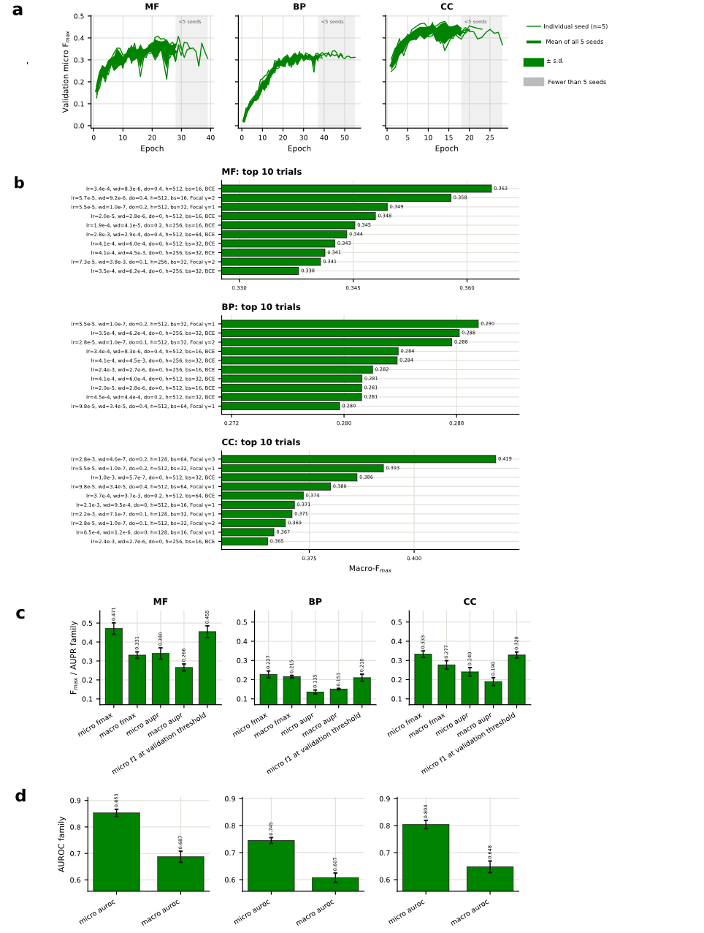

Fig. S1 (a) Validation micro-$F_{max}$ trajectories for the selected MF, BP and CC configurations across five independent training seeds. (b) Ten highest-ranked random-search configurations for each GO aspect, ordered by validation macro-$F_{max}$. (c–d) Mean test-set $F_{max}$, AUPRC, validation-threshold $F_{1}$, and AUROC metrics across the five independently trained models; error bars indicate standard deviation.

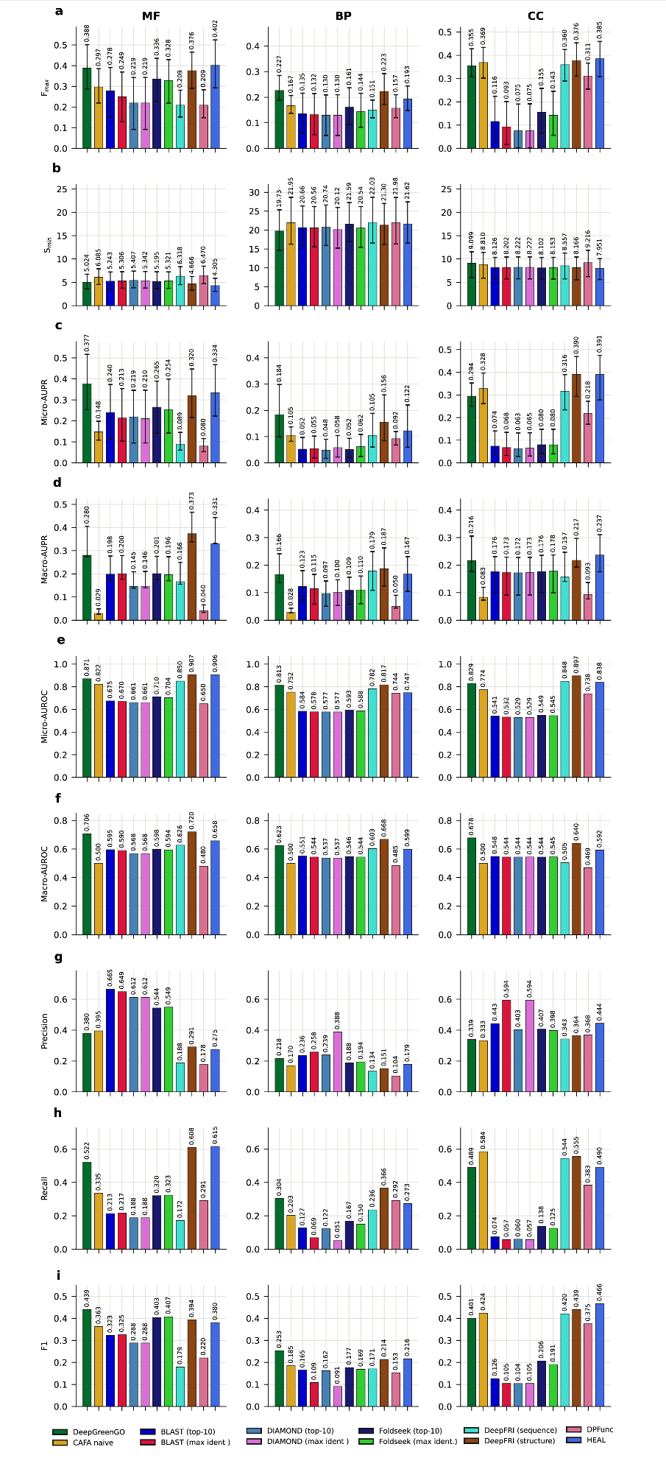
Fig. S2 Comparative performance analysis across Gene Ontology domains. Performance evaluation of various predictive models evaluated across three primary Gene Ontology (GO) domains: Molecular Function (MF, left), Biological Process (BP, center), and Cellular Component (CC, right). Rows (A–I) represent individual evaluation metrics plotted along the y-axes. Colored bars correspond to different model architectures and baselines as detailed in the legend (bottom).

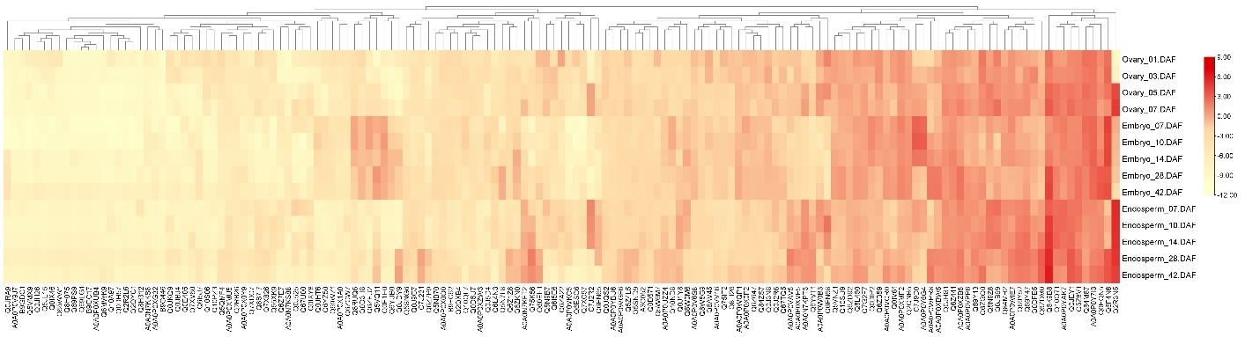
Fig. S3 Expression profiles of predicted seed development proteins across rice seed tissues and developmental stages for unreviewed sequences. The selected samples include ovary (1, 3, 5, and 7 DAF), embryo (7, 10, 14, 28, and 42 DAF), and endosperm (7, 10, 14, 28, and 42 DAF). Positive values (red) indicate higher expression, while negative values (yellow to white) indicate lower expression relative to the sample median.

