Supplementary information

Supplementary Table 1. Comparative overview of computational methods for perturbation response and regulatory interpretation.

Category | Method examples | Primary input | Primary output | Perturbation-aware | Quantitative expression output | Generalization to unseen perturbations | Sequence-level interpretability | Element–gene linking | Upstream TF prioritization
Sequence-based perturbation interpretation (this study) | GenPerturb | DNA sequence + target RNA-only Perturb-seq | Fitted expression outputs + differential attribution | ○ | ○ | × | ○ | ○ | ○
Sequence-to-expression (bulk) | Enformer, Borzoi, AlphaGenome | DNA sequence | Expression / epigenome | × | ○ | × | ○ | ○ | ○
Sequence-to-expression (single-cell) | GET, scooby, Decima | DNA sequence + single-cell ATAC and/or RNA | Cell-type- / state-specific expression / epigenome | × | ○ | × | ○ | ○ | ○
Perturb-seq analysis | MIMOSCA, scMAGeCK-LR | scRNA + gRNA | DEG / effect sizes | ○ | ○ | × | × | × | △
gLM | HyenaDNA, Evo2, Nucleotide Transformer | DNA sequence | DNA functional annotation after fine-tuning | × | × | × | ○ | × | ×
Base-resolution regulatory profile models | BPNet, ChromBPNet | DNA sequence + ATAC-seq or ChIP-seq profiles/peaks | TF binding / chromatin accessibility profiles + attribution | × | × | × | ○ | × | ○
ATAC-seq motif activity | chromVAR, ArchR, Signac | scATAC / peaks | Motif deviation / TF activity | △ | × | × | △ | × | ○
Regulon / TF-activity inference | SCENIC, SCENIC+, DoRothEA, VIPER | scRNA (+ scATAC) | Regulons / TF activity scores | △ | △ | × | △ | △ | ○
Enhancer–gene linking | ABC, rE2G | BED + cell-type-specific epigenomic annotations | Enhancer–gene scores | △ | × | × | × | ○ | ×
Motif analysis | TOMTOM, MEME, gimme motifs | BED (genomic regions) | Motif discovery / matching | △ | × | × | ○ | × | ○
Perturbation response prediction | GEARS, scGPT, CPA | Gene embeddings + perturbation labels | Expression prediction | ○ | ○ | ○ | × | × | ×
Sequence-conditioned perturbation prediction | STRAND | DNA sequence (around perturbed locus) + scRNA (control cells) | Single-cell expression distribution after perturbation | ○ | ○ | ○ | × | × | ×

Supplementary Table 1 summarizes major computational methods for analysing, modelling, and interpreting transcriptional responses to genetic perturbations, across multiple aspects including input, output, perturbation awareness, quantitative expression output, generalization to unseen perturbations, sequence-level interpretability, element–gene linking, and upstream transcription factor (TF) prioritization.

• ○: Provided as a native or primary function.
• △: Available only partially, indirectly, or through common downstream combination with additional resources.
• ×: Not provided by the method for the relevant comparison axis.

In the element–gene linking and upstream TF prioritization columns, ○ denotes a native output with an evidential basis specific to the method. ABC and rE2G score enhancer–gene links from cell-type-specific chromatin measurements. GenPerturb and other sequence models use attribution to rank intervals and motif instances within a gene window. Attribution-derived rankings are computational hypotheses for experimental testing of enhancer or TF activity, while ABC and rE2G scores are computational predictions of enhancer–gene relationships and accessibility- or regulon-based methods estimate TF activity from measured chromatin or expression data. The symbols describe functional scope, with experimental validation needed to establish regulatory function.
Below, we describe the roles and limitations of each category in the order of the comparison (Supplementary Table 1).

1. Sequence-based perturbation interpretation (GenPerturb)
GenPerturb fits observed RNA-only Perturb-seq responses using pretrained sequence features. For each fitted condition contrast, control-subtracted attribution ranks candidate intervals and motif instances at the same gene locus, prioritizing sequence-grounded hypotheses about cis-regulatory elements and upstream TF families associated with the response.

2. Sequence-to-expression models (bulk: Enformer, Borzoi, AlphaGenome) [1–3]
These models predict bulk gene expression and epigenomic signals from DNA sequence, integrating long-range cis context. Attribution analysis enables quantification of contributions from individual sequence elements and can support enhancer–gene linking. However, these attributions primarily reflect steady-state regulatory landscapes and do not directly capture perturbation-induced regulatory changes.

3. Sequence-to-expression models (single-cell: GET, scooby, Decima) [4–6]
GET integrates chromatin accessibility and sequence information to predict gene expression across many human cell types, while scooby extends pretrained sequence representations with cell-specific decoders to predict single-cell RNA and ATAC signals. Decima predicts cell-type- and state-resolved expression directly from sequence (RNA-only, after Borzoi-based training on large single-cell atlases) and can interpret cis-regulatory differences between observational states such as healthy versus disease. These models resolve cell-type- and state-specific regulation, but they condition expression on observational cell-type or disease covariates rather than fitting the transcriptional response to a defined genetic or chemical perturbation. Consequently, they do not produce the control-subtracted differential attribution that GenPerturb uses to prioritize perturbation-induced cis-regulatory changes on the same gene locus.

4. Perturb-seq analysis methods (MIMOSCA, scMAGeCK-LR) [7,8]
These methods estimate perturbation effect sizes via regression models using gRNA assignments while controlling for covariates. They are effective for statistical detection and quantification of perturbation effects but attribute expression changes directly to perturbation labels, without modelling upstream cis-regulatory mechanisms.

5. Genomic language models (gLMs: HyenaDNA, Evo2, Nucleotide Transformer) [9–11]
These models learn general-purpose sequence representations through self-supervised training on large DNA corpora. While adaptable to diverse downstream tasks via fine-tuning, they do not directly predict expression or perturbation responses and require task-specific training for regulatory interpretation.

6. Base-resolution regulatory profile models (BPNet, ChromBPNet) [12,13]
BPNet and ChromBPNet are models that learn base-resolution regulatory profiles from DNA sequences using experimental data such as ChIP-seq (for transcription factor binding) or ATAC-seq (for chromatin accessibility). They can also be used to identify important sequence features, such as regulatory motifs. However, these models predict assay-specific signals rather than gene expression changes, and they require corresponding ChIP-seq or ATAC-seq data for training or application.

7. ATAC-seq motif activity estimation (chromVAR, ArchR, Signac) [14–16]
chromVAR estimates transcription factor activity based on motif enrichment in accessible chromatin regions. Integrated frameworks such as ArchR and Signac extend this to multiomic analyses. While powerful, they require ATAC-seq data and depend on predefined peaks and known motif databases, rather than deriving regulatory contributions directly from sequence alone.

8. Regulon and TF-activity inference (SCENIC, SCENIC+, DoRothEA, VIPER) [17–20]
SCENIC infers regulons based on co-expression and motif enrichment, but it cannot directly connect transcription factors to specific cis-regulatory elements. SCENIC+ partially addresses this by incorporating chromatin accessibility information, but this requires additional ATAC-seq data. DoRothEA and VIPER estimate TF activity from gene expression using curated or inferred regulons, but they depend on predefined regulon resources and do not link activity to specific cis-regulatory sequence elements.

9. Enhancer–gene linking (ABC, rE2G) [21,22]
These methods estimate enhancer–gene interactions using chromatin contact and epigenomic data. While effective for mapping regulatory relationships in steady-state conditions, they rely on predefined regions and annotations and are not designed to detect perturbation-induced regulatory changes from RNA-only data. Public resource coverage is also cell-type dependent: the ABC prediction resource used in this study is distributed for 131 cell types and tissues, whereas rE2G extended genome-wide prediction resources are available for two cell lines, K562 and GM12878. Standard ENCODE-rE2G can be applied to additional biosamples with bulk ATAC-seq or DNase-seq, and optionally H3K27ac and Hi-C, but this still requires cell-type-matched epigenomic input or processing. Therefore, ABC and rE2G scores are valuable when appropriate annotations exist for the relevant cell type or a close proxy, but they are not uniformly available for arbitrary RNA-only Perturb-seq cell states.

10. Motif analysis (TOMTOM, MEME, GimmeMotifs) [23,24]
These methods perform motif discovery or matching within given genomic regions. Although perturbation-specific motif changes can be assessed by comparing region sets, results depend heavily on region selection. They do not directly provide element–gene linking or quantitative expression prediction.

11. Perturbation response prediction models (GEARS, scGPT, CPA) [25–27]
These models perform conditional prediction of gene expression in response to perturbations in a learned embedding space. By generalizing relationships between genes and perturbations, they can predict responses to unseen or combinatorial perturbations. However, since predictions are confined to expression space, they lack a mechanism to attribute responses to specific sequence elements such as motifs or regulatory regions.

12. Sequence-conditioned perturbation prediction models (STRAND) [28]
STRAND uses DNA sequence information as a feature to represent perturbations, enabling generalization to unseen perturbations with similar sequence context. However, this sequence information is not used to predict gene expression for each target gene. As a result, it cannot link gene expression changes to specific cis-regulatory elements that drive those responses.
Positioning of GenPerturb
GenPerturb provides a complementary interpretation layer between perturbation response prediction models, sequence-to-expression models, and regulatory inference methods. Whereas unseen-perturbation prediction models emphasize generalization in expression space, GenPerturb focuses on interpreting observed perturbation responses at the level of motifs and candidate cis-regulatory elements. This enables sequence-grounded regulatory hypothesis prioritization from RNA-only Perturb-seq datasets without requiring matched chromatin or multiome measurements in the target experiment.
Note on scope. Supplementary Table 1 maps where GenPerturb sits among related method families, organized by input, output, perturbation awareness, and interpretation target rather than by performance on a shared task. The listed methods differ in their required inputs—for example curated regulons (DoRothEA, VIPER), matched chromatin (SCENIC+, ABC, rE2G), or gene embeddings (GEARS, scGPT, CPA)—and in their primary outputs, so they are not all addressed to the same question on the same data. The comparison here is therefore positional rather than quantitative, with the columns intended to convey differences in scope rather than a ranking among methods.

Supplementary Table 2. Dataset metadata used for training.

Perturbation | Cell type | Paper | Num. genes | Num. perturbations
CRISPRa | K562 | Norman et al. Science 2019 [29] | 12,105 | 220
CRISPRi (gwps) | K562 | Replogle et al. Cell 2022 [30] | 8,078 | 1,545
CRISPRi (essential gene) | K562 | Replogle et al. Cell 2022 [30] | 8,386 | 638
CRISPRi | RPE1 | Replogle et al. Cell 2022 [30] | 8,600 | 409
Compound | Myeloid | Jiang et al. Cell 2026 [31] | 12,319 | 496
Compound | CD8T | Jiang et al. Cell 2026 [31] | 13,502 | 620
Compound | CD4T | Jiang et al. Cell 2026 [31] | 12,839 | 537
Compound | B cell | Jiang et al. Cell 2026 [31] | 14,095 | 290
Compound | A549 | Srivatsan et al. Science 2020 [32] | 27,927 | 703
Compound | K562 | Srivatsan et al. Science 2020 [32] | 27,991 | 683
Compound | MCF7 | Srivatsan et al. Science 2020 [32] | 23,224 | 740
CRISPR KO | Erythroid | Martin et al. Science 2025 [33] | 11,971 | 14

Note: "Num. perturbations" counts the total number of fitted output conditions, including the non-targeting control. The Martin et al. value of 14 corresponds to 13 perturbations plus the non-targeting control; 12 TF-targeted perturbations form the motif-recovery benchmark (Fig. 4e).

Supplementary Table 3. Mixscape and pseudobulk filtering summary for genetic-perturbation datasets.
a, Mixscape filtering. Cell counts include the non-targeting control; target-perturbation counts exclude it. A target was considered retained immediately after Mixscape if at least one targeting cell remained.

Dataset | Mixscape execution unit | Cells before Mixscape | NP cells removed | Cells retained after Mixscape | Targets before Mixscape | Targets eliminated by Mixscape | Targets retained after Mixscape
Norman K562 CRISPRa | One call for the dataset object | 111,445 | 25,192 | 86,253 | 236 | 3 | 233
Replogle K562 essential CRISPRi | One call for the dataset object | 310,385 | 131,924 | 178,461 | 2,057 | 502 | 1,555
Replogle K562 genome-wide CRISPRi† | Six stored chunks; one call per chunk | 1,989,578 | 1,548,789 | 440,789 | 9,866 | 6,545 | 3,321
Replogle RPE1 CRISPRi | One call for the dataset object | 247,914 | 81,687 | 166,227 | 2,393 | 399 | 1,994
Martin erythroid CRISPR knockout | One call for the dataset object | 137,604 | 84,775 | 52,829 | 19 | 6 | 13

Cells assigned mixscape_class_global = 'NP' at posterior perturbation probability ≤ 0.5 were removed. Mixscape was called jointly on the target labels within each dataset object, while marker selection and mixture classification were performed separately for each target. The Replogle genome-wide screen was processed as six stored objects.
b, Subsequent pseudobulk minimum-cell gate. Conditions represented by 100 cells or fewer after NP removal were excluded before pseudobulk aggregation. This gate was applied separately from Mixscape classification.

Dataset | Cells after Mixscape | Targets after Mixscape | Cells after >100-cell gate | Targets after >100-cell gate
Norman K562 CRISPRa | 86,253 | 233 | 84,491 | 219
Replogle K562 essential CRISPRi | 178,461 | 1,555 | 121,872 | 637
Replogle K562 genome-wide CRISPRi† | 440,789 | 3,321 | 335,185 | 1,544
Replogle RPE1 CRISPRi | 166,227 | 1,994 | 87,517 | 408
Martin erythroid CRISPR knockout | 52,829 | 13 | 52,829 | 13

† The six genome-wide objects contain the same 75,328 non-targeting control cells; these cells were counted once in the dataset-level totals. The post-gate target counts agree with the adopted fitted matrices.

Supplementary Table 4. Expression agreement by dataset and expression quintile.
The table summarises per-gene Pearson correlations between observed and fitted log2(CPM + 1) values across conditions, including control, by dataset and expression quintile. Quintiles are assigned from mean observed expression across conditions before restriction to test loci. For each dataset and quintile, the table reports the median and interquartile range of the correlation, the number of conditions and test loci, and the counts of loci with valid or undefined correlations. Pearson correlation is undefined when either the observed or fitted values are constant across conditions, because the variance is zero. The dataset- and quintile-level records (Fig. 2c) are provided in the accompanying spreadsheet Supplementary_tables.xlsx (worksheet "Supplementary Table 4").

Supplementary Table 5. Datasets considered for accessibility-based region ranking and motif evaluation.

Dataset | Modality | Cell type | Perturbation type | Perturbation modality | Motif evaluation | Accessibility-based region ranking
Martin et al. (Perturb-multiome) | Multiome (RNA + ATAC) | Erythroid lineage cells | TF perturbations | CRISPR KO | Yes (motif recovery and in silico motif mutation) | Yes (AUPRC, distance-stratified)
Norman et al. (Perturb-seq) | Single-cell RNA-seq | K562 cells | TF / other perturbations | CRISPRa | Yes (motif recovery and in silico motif mutation) | No
PRJNA1128171 / Metzner et al. (Multiome Perturb-seq) | Multiome (RNA + ATAC) | RPE-1 cells | Chromatin regulators | CRISPRi | No (not used for TF evaluation) | No (too few perturbations with sufficient accessibility overlaps at responsive gene loci)
GSE277747 / Yan et al. (MultiPerturb-seq) | Multiome (RNA + ATAC) | BT16 cells with NIH3T3 spike-in | Chromatin regulators | CRISPRi | No (not used for TF evaluation) | No (only one eligible perturbation after preprocessing, including Mixscape filtering)
GSE288996 / Shevade, Yang et al. (CAT-ATAC) | Multiome (RNA + ATAC) | iPSC and K562 cells | Chromatin regulators | CRISPRi | No (not used for TF evaluation) | No (per-cell sgRNA assignments unavailable in the public data)

Note: The Martin et al. erythroid Perturb-multiome dataset [33] was used for accessibility-based region ranking, motif recovery, and in silico motif mutation; the Norman et al. K562 Perturb-seq dataset [29] was used for motif recovery and in silico mutation. PRJNA1128171 [34], GSE277747 [35], and GSE288996 [36] were screened as additional perturbation-multiome resources.
Accessibility-based evaluation requires identifiable perturbations and sufficient positive intervals per perturbation and distance stratum. In the Martin benchmark, candidate gene–interval pairs lie within the TSS-centred model window of a perturbation-responsive gene and are labelled positive when they overlap an accessibility interval responsive to the same perturbation. AUPRC therefore measures agreement with co-occurring RNA and accessibility responses within a gene window; establishing functional enhancer–gene relationships requires direct experimental testing.
PRJNA1128171 was processed successfully, but few perturbations had sufficient accessibility overlaps at responsive gene loci for perturbation-level AUPRC comparisons, despite substantial ATAC changes following chromatin-remodeler and histone-related perturbations.
For GSE277747, only one perturbation met downstream eligibility criteria after the same preprocessing workflow used for the other datasets, including Mixscape filtering. This provided insufficient perturbation-level variation for model fitting and regulatory evaluation.
For GSE288996, the public same-cell RNA and ATAC resource provided only aggregated sgRNA counts. Per-cell sgRNA assignments were needed to match accessibility and expression responses to individual perturbations.
The present accessibility-based region-ranking results cover a single cellular context, the Martin erythroid lineage. Broader assessment of regulatory interpretation requires eligible perturbation-multiome datasets from additional cellular contexts.

Supplementary Table 6. Perturbation-level motif recovery in the Martin TF-knockout conditions.
Motif-match status for each of the 12 analysed Martin TF-knockout conditions under every evaluated method: TF-MoDISco applied to differential attribution, and GimmeMotifs applied to GenPerturb, rE2G extended, rE2G, ABC, TSS ± 1 kb, and shuffled GenPerturb regions. A gene-level match denotes recovery of the perturbed TF's own motif and a cluster-level match recovery of its JASPAR motif-family cluster, each called at q ≤ 0.05. The perturbation-level records supporting the recovery frequencies (Fig. 4e) are provided in the accompanying spreadsheet Supplementary_tables.xlsx (worksheet "Supplementary Table 6").

Supplementary Table 7. Perturbation-level motif recovery in the Norman CRISPRa conditions.
Motif-match status for the 14 single-TF Norman CRISPRa conditions included in this analysis, using the same reporting criteria and set of methods as the Martin analysis (Supplementary Table 6). The perturbation-level records supporting the recovery frequencies (Fig. S9a) are provided in the accompanying spreadsheet Supplementary_tables.xlsx (worksheet "Supplementary Table 7").

Supplementary Table 8. Candidate composition, eligibility, and per-perturbation AUPRC for the region-ranking evaluation.
The table reports region-ranking results on a common candidate universe defined from rE2G extended, rE2G, ABC, and TSS-proximal annotations, independently of GenPerturb peak boundaries. For each Martin perturbation and distance stratum, it lists the total, positive, and negative gene–interval pair counts, positive prevalence, and eligibility decision. AUPRC is reported for GenPerturb differential attribution, rE2G extended, rE2G, ABC, and TSS distance. All methods share the same candidate counts and prevalence within each perturbation and distance stratum. The number and fraction of candidates with an available source score are also reported for each method. For rE2G extended, rE2G, and ABC, availability denotes an overlapping annotation record linked to the same gene; for GenPerturb, it denotes an available raw differential-attribution score; and TSS distance is available for every candidate. Entries failing the eligibility criteria include an exclusion reason and AUPRC of NA. The corresponding values (Fig. 4d; Fig. S8) are provided in the accompanying spreadsheet Supplementary_tables.xlsx (worksheet "Supplementary Table 8").

Supplementary Table 9. Screening of compound conditions for the corticosteroid comparison.
The table lists all screened Jiang CD8 T-cell compound conditions, with their pharmacological group assignment, the supporting PubChem annotation evidence, and NR3C1 motif rank. Each condition has an inclusion decision and, where applicable, an exclusion reason. The exploratory comparison included 319 eligible single-compound conditions: 22 corticosteroid and 297 other conditions. Excluded entries were controls, combinations, or compound conditions that dropped out during dataset preparation, where per-condition cell-number filtering left too few cells for pseudobulk aggregation and the downstream motif analysis. Group assignment used the PubChem-derived annotation alone, and both group assignment and eligibility were independent of NR3C1 ranks. The condition-level records (Fig. 6a) are provided in the accompanying spreadsheet Supplementary_tables.xlsx (worksheet "Supplementary Table 9").

Supplementary Figures

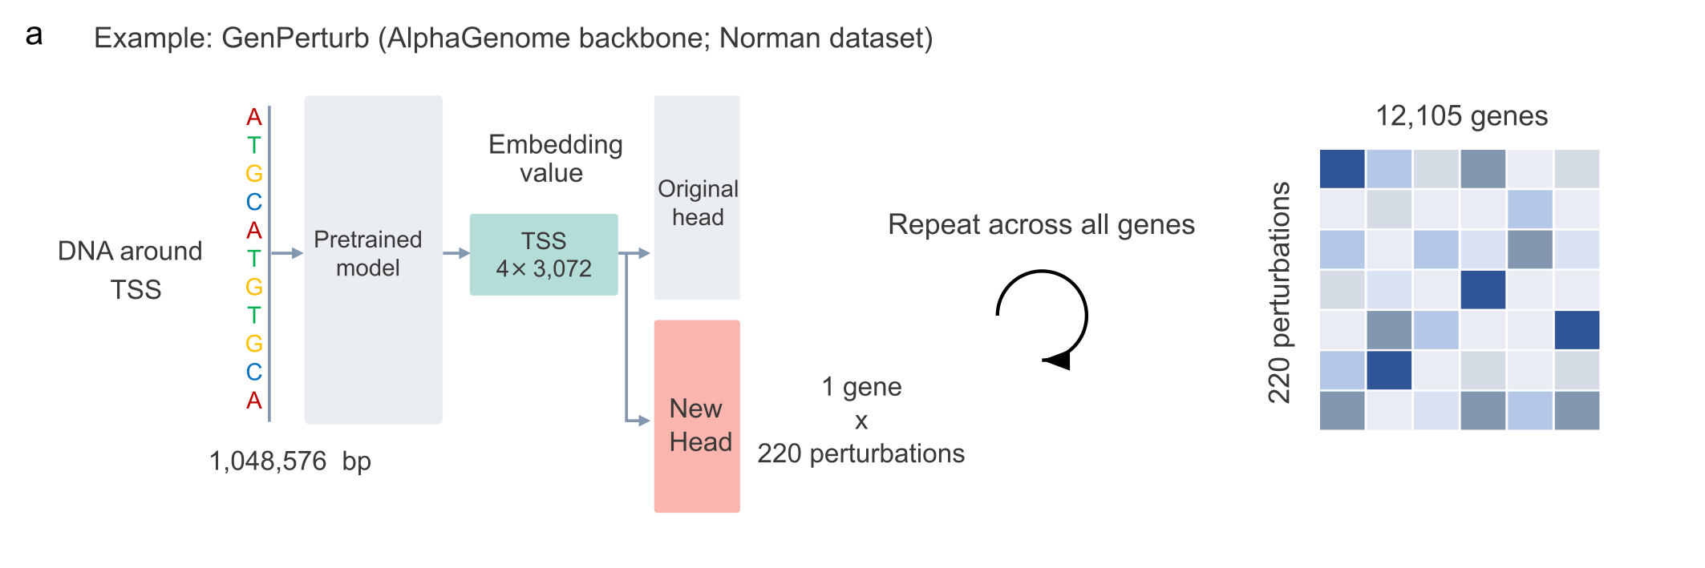
Supplementary Figure S1. Sequence-embedding and prediction-head architecture used for GenPerturb transfer learning.
Schematic of the GenPerturb architecture, shown here as an example using the Norman dataset and an AlphaGenome backbone. The same multi-output prediction-head design is used with the other pretrained backbones and across transfer-learning strategies; backbone updating differs among feature extraction, LoRA, and full fine-tuning. For each gene, a 1,048,576-bp genomic sequence window centred on a representative transcription start site (TSS) is passed through the pretrained AlphaGenome backbone. The activations immediately preceding the original prediction head are retained for the four 128-bp bins surrounding the transcription start site, yielding a per-gene embedding of shape (4, 3,072), i.e. 12,288 dimensions. This embedding feeds two heads in parallel: the original pretrained prediction head, which reproduces the non-perturbed AlphaGenome output, and a newly fitted multi-output linear head followed by a ReLU activation, which is trained on the target Perturb-seq data. Each output channel of the new head corresponds to the non-targeting control or one observed perturbation condition in the target dataset and represents fitted per-gene log2(CPM + 1) expression. Applying the model gene by gene assembles a gene-by-perturbation expression matrix (12,105 genes across all data splits × 220 perturbation conditions in the depicted Norman example). In feature extraction, the sequence representation is fixed and dataset-specific adaptation occurs only in the new readout. The original pretrained output is used for comparison and is not an additional loss target in this fitting procedure.

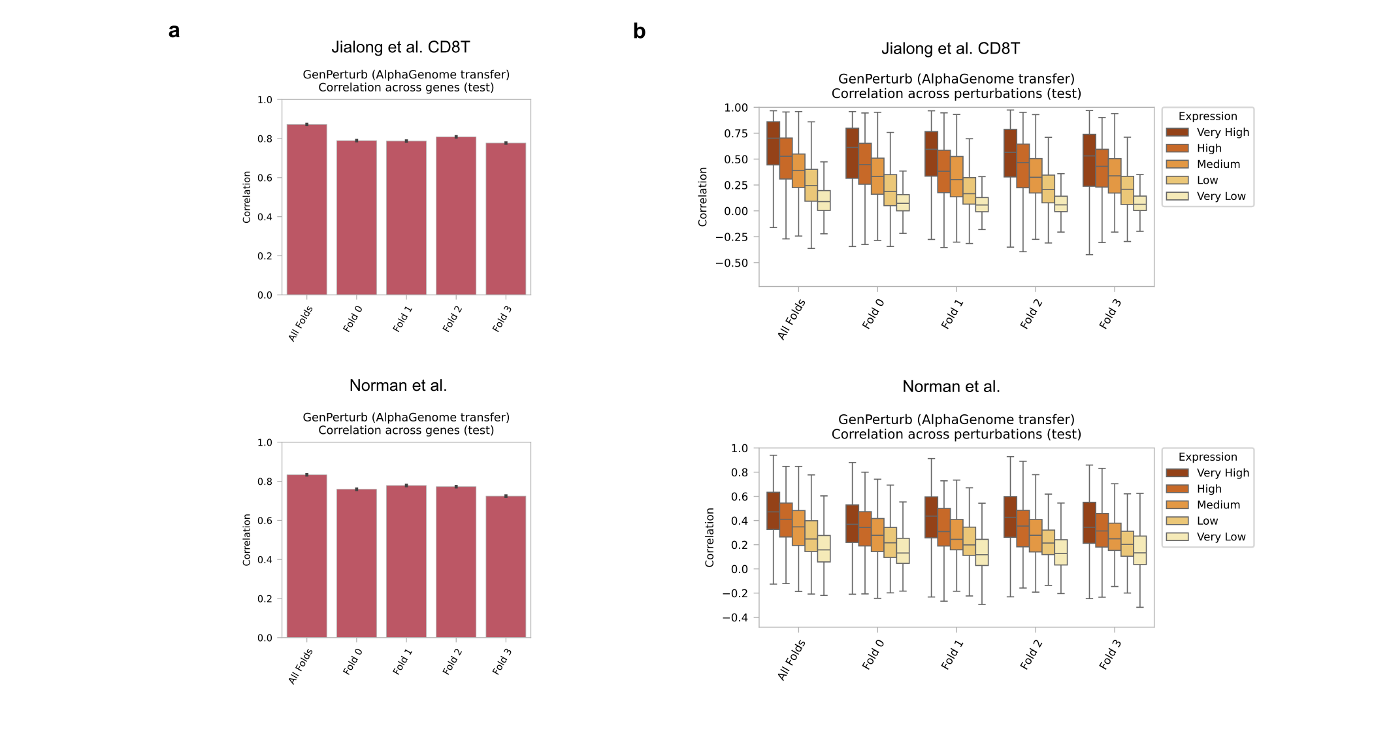
Supplementary Figure S2. Fold-specific versus all-fold AlphaGenome checkpoints using matched genomic partitions.
Multifold evaluation of AlphaGenome-based GenPerturb fitting using fold-specific pretrained AlphaGenome checkpoints and matched train/validation/test splits derived from the original AlphaGenome release. The all-fold comparator used the all-fold pretrained checkpoint and the same downstream prediction-head split as fold_0. Fold 0 therefore evaluates the same test loci as the all-fold comparator, whereas folds 1–3 contain their own test-locus sets and are shown as additional sensitivity analyses.
a, Across-gene agreement for fold-specific genomic partitions and the corresponding all-fold-checkpoint comparator (Pearson r across genes, computed per perturbation).
b, Across-perturbation agreement for fold-specific genomic partitions and the corresponding all-fold-checkpoint comparator (Pearson r across perturbations, computed per gene; expression quintiles).
Across all expression quintiles in the fold_0 test loci, median per-gene across-condition correlations (IQR) for all-fold and fold-specific embeddings were 0.325 (0.167–0.491) and 0.266 (0.114–0.417), respectively, in Norman K562, and 0.342 (0.137–0.601) and 0.280 (0.082–0.532), respectively, in Jiang CD8 T cells. Relative to the all-fold comparator, fold-specific checkpoints lowered the median by about 0.06 in both datasets, corresponding to roughly 18%. These results provide a sequence-split sensitivity check in the two evaluated datasets, Norman K562 and Jiang CD8 T cells. The Norman K562 dataset contains 220 conditions; its fold 0–3 test sets contain 1,879, 1,397, 1,733, and 1,405 loci, respectively. The Jiang CD8 T-cell dataset contains 620 conditions; its corresponding test sets contain 2,073, 1,515, 1,873, and 1,590 loci.

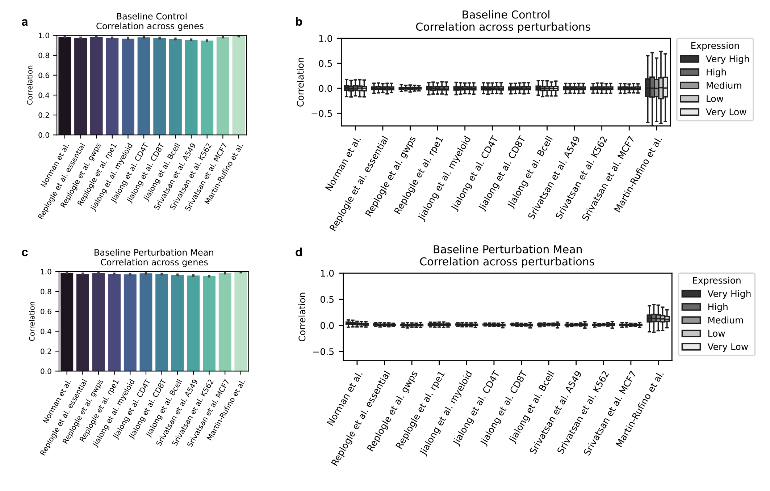
Supplementary Figure S3. Simple expression baselines do not reproduce perturbation-dependent gene-wise variation.
a, Across-gene agreement for the control-copy baseline, in which the non-perturbed expression profile is used in place of condition-specific fitted outputs (Pearson r across genes, computed per perturbation).
b, Across-perturbation agreement for the control-copy baseline (Pearson r across perturbations, computed per gene; expression quintiles).
c, Across-gene agreement for the perturbation-mean baseline, in which the average expression profile across perturbations is used in place of condition-specific fitted outputs (Pearson r across genes, computed per perturbation).
d, Across-perturbation agreement for the perturbation-mean baseline (Pearson r across perturbations, computed per gene; expression quintiles).
Although both baselines achieve high across-gene agreement, this agreement largely reflects stable basal expression structure shared across perturbations. Neither baseline reproduces perturbation-dependent variation across genes, indicating that the across-perturbation signal retained by the fitted GenPerturb outputs contains perturbation-specific transcriptional information beyond shared baseline or average response patterns.

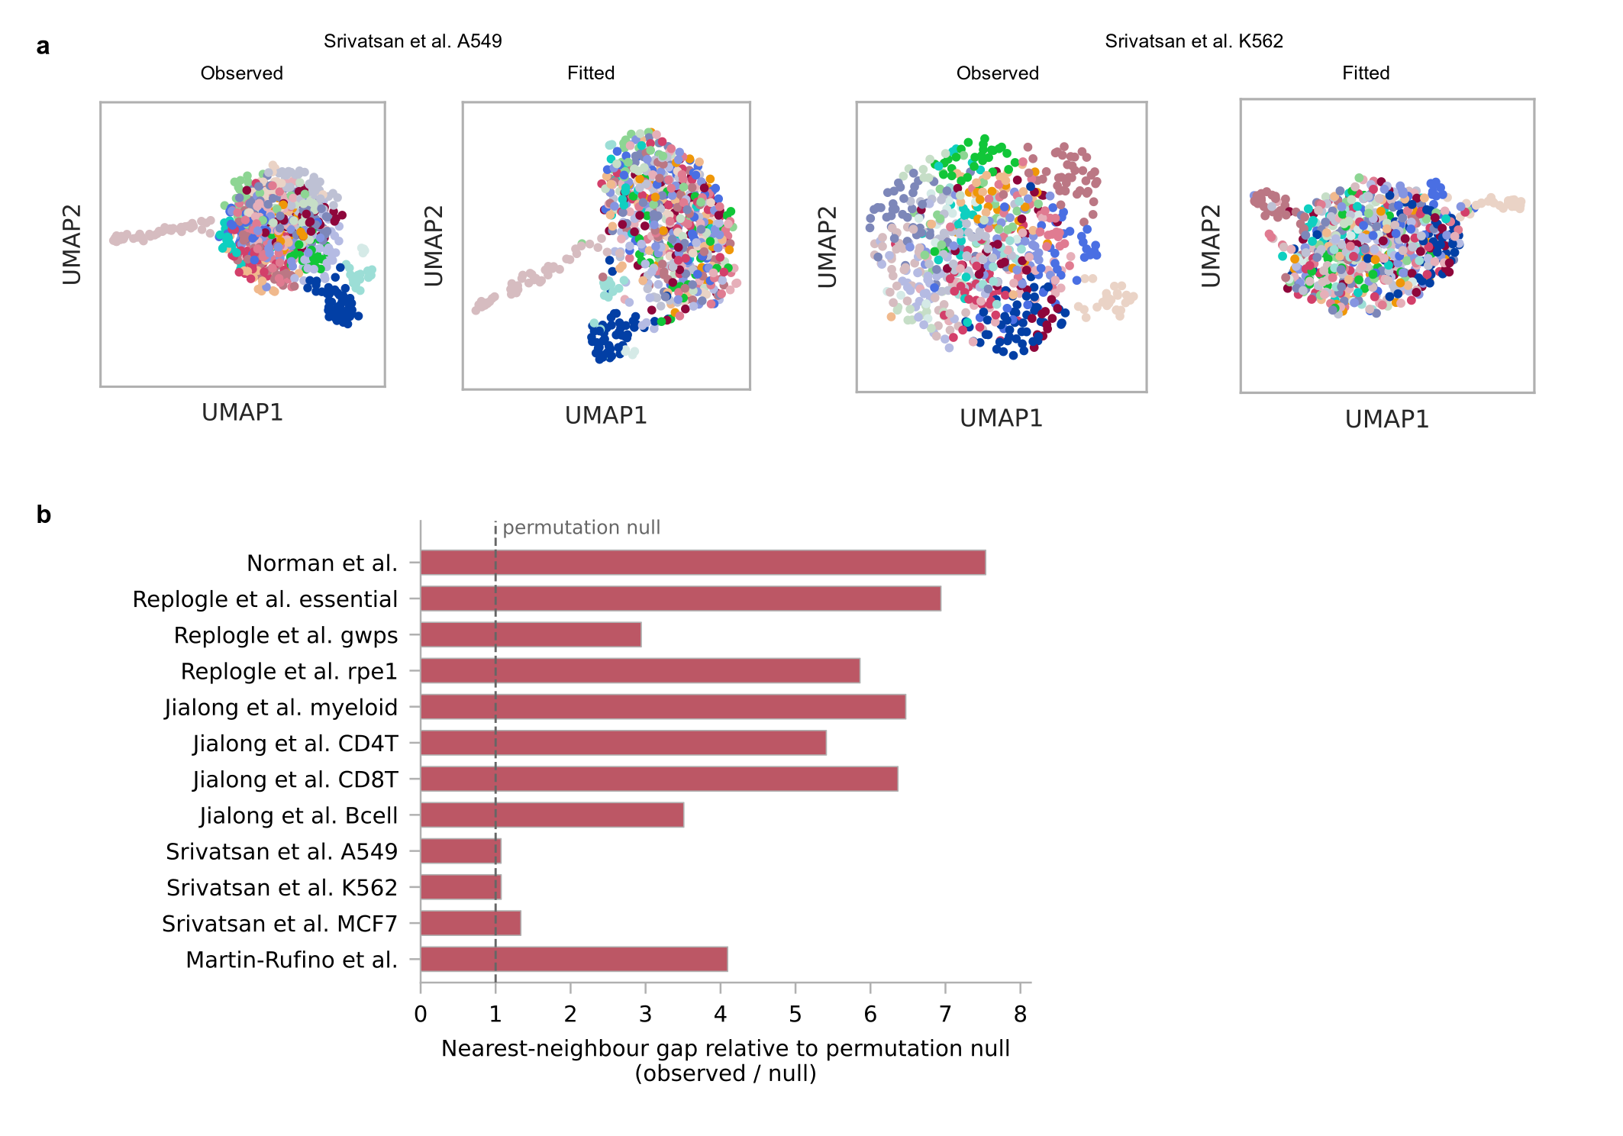
Supplementary Figure S4. Diffuse perturbation structure in compound perturbation datasets and its quantification in the observed data.
a, Low-dimensional organization of observed and fitted expression profiles for compound perturbation datasets with more diffuse perturbation structure in the observed space (Srivatsan et al. A549 and K562). Dots in both observed and fitted UMAPs are coloured by Leiden clusters computed from the observed expression space, and the same observed-cluster colours are projected onto the fitted UMAPs. Similar diffuseness in the fitted UMAPs is consistent with the weaker local organization of the observed responses, while correspondence between the two spaces also depends on fitting quality.
b, Separation of perturbation responses in the observed data across the twelve datasets, computed without clustering or fitted outputs. Control-subtracted response profiles were correlated between perturbations using the 2,000 most variable genes, and each perturbation was summarized by the gap between its highest correlation with another perturbation and its median correlation with all others. Bars show the median gap normalized by a perturbation-count-matched null generated by independently shuffling gene identities within each perturbation profile (20 repeats); a ratio of 1 indicates that the observed median gap matches the null expectation. The three Srivatsan datasets lie closest to the null, indicating weak local organization in their observed responses. This result provides data-side context for their low cluster concordance (Fig. 2e), whose magnitude also depends on fitting quality.

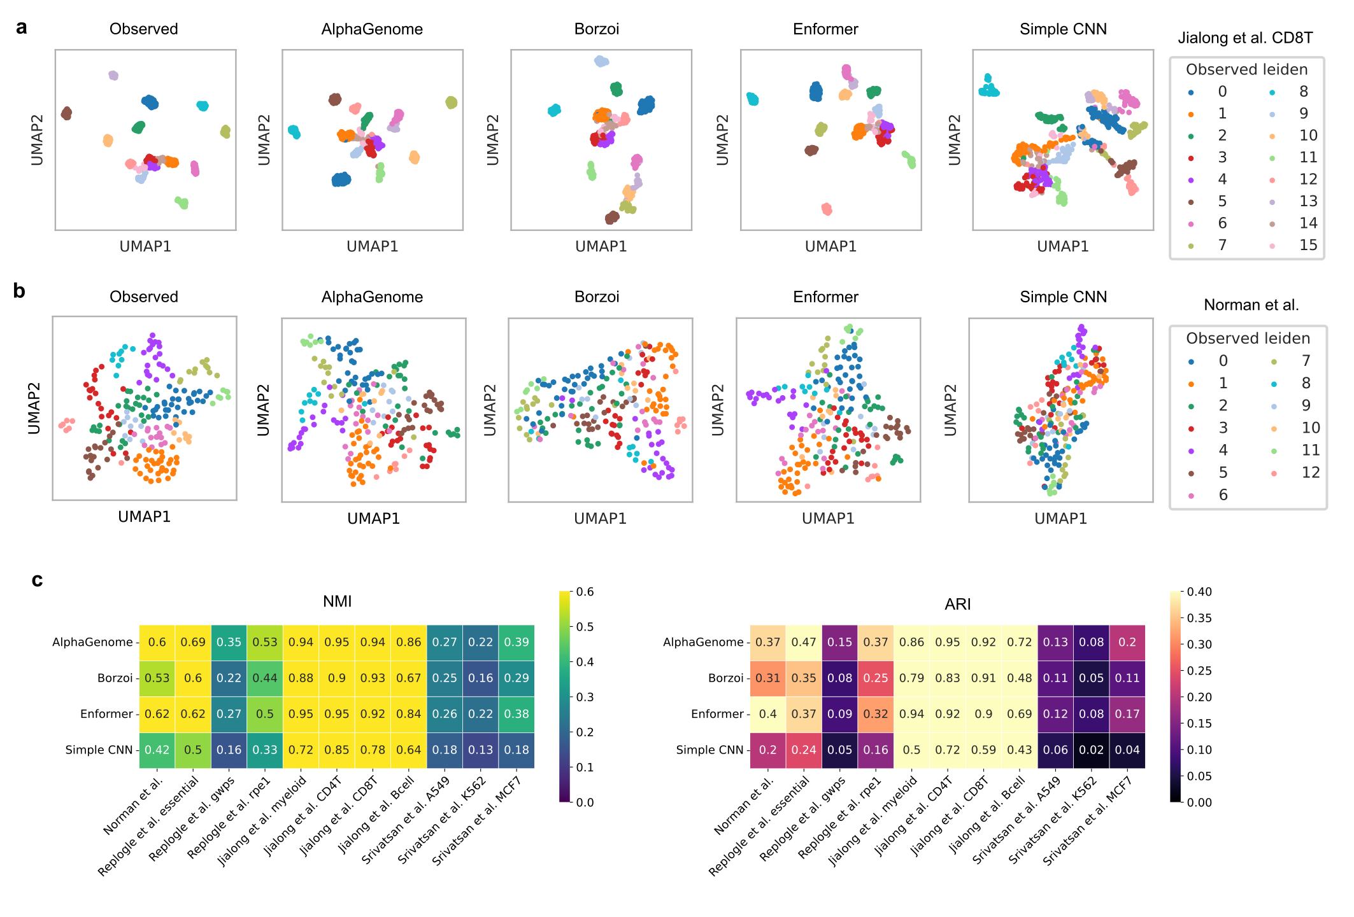
Supplementary Figure S5. Comparison of sequence representation models in low-dimensional perturbation space.
a, Low-dimensional organization of observed and fitted expression profiles for Jiang et al. CD8 T cells using transfer learning with AlphaGenome, Borzoi, Enformer, and a Simple CNN trained from scratch without large-scale regulatory pretraining. Observed Leiden cluster colours are projected onto the fitted UMAPs for each model (held-out downstream test split).
b, Low-dimensional organization of observed and fitted expression profiles for Norman K562 perturbations using the same model set. Observed Leiden cluster colours are projected onto the fitted UMAPs for each model (held-out downstream test split).
c, Cluster concordance between observed and fitted expression spaces across models and datasets (ARI, NMI; observed vs fitted Leiden partitions; held-out downstream test split). AlphaGenome-derived representations more effectively preserve perturbation-state geometry and fitted cluster structure than alternative pretrained representations or the non-pretrained Simple CNN baseline.

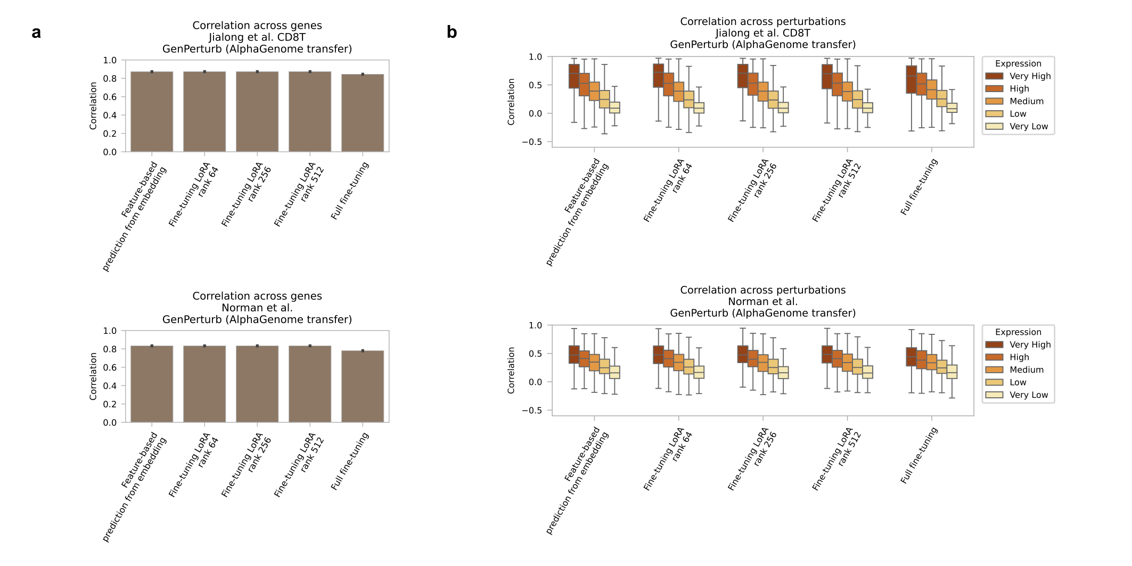
Supplementary Figure S6. Comparison of transfer-learning strategies for pretrained sequence representations.
Comparison of full fine-tuning, LoRA-based tuning, and feature extraction using AlphaGenome-derived representations.
a, Across-gene agreement for each fitting strategy (Pearson r across genes, computed per perturbation).
b, Across-perturbation agreement for each fitting strategy (Pearson r across perturbations, computed per gene; expression quintiles).
The transfer-learning strategies yielded broadly comparable agreement across datasets. Feature extraction was therefore used in subsequent analyses because it retained perturbation-dependent expression structure while substantially reducing computational cost. On a single NVIDIA H200 GPU, feature extraction required approximately one day for one-time precomputation of pretrained sequence embeddings followed by approximately 20 minutes for fitting the prediction head, whereas LoRA and full fine-tuning each required approximately one week per run.

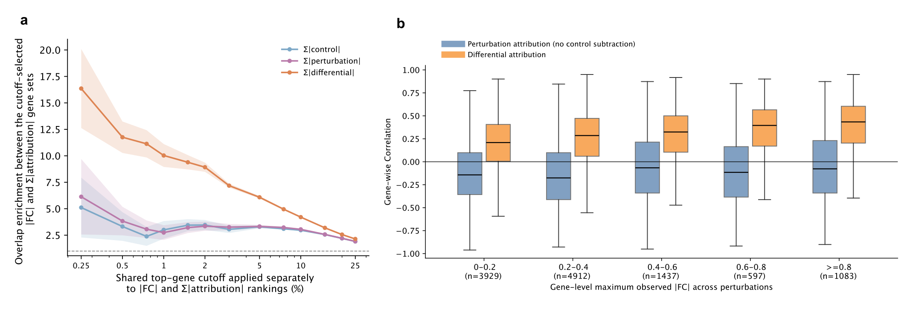
Supplementary Figure S7. Gene-level attribution–fold-change concordance analysis supporting control-subtracted differential attribution.
GenPerturb was fitted to the Martin et al. erythroid Perturb-multiome dataset, and gene-level attribution summaries were computed from genome-wide attribution profiles prior to enhancer benchmark evaluation.
a, Top-k overlap enrichment between genes ranked by observed absolute log fold change and genes ranked by summed absolute attribution magnitude. Rankings were computed separately for control-output attribution, perturbation-output attribution, and control-subtracted differential attribution within each perturbation, and enrichment was summarized across top-gene cutoffs. Lines show the mean across perturbations and shaded bands show the standard error.
b, Gene-wise Spearman correlation between observed absolute log fold change and attribution magnitude across perturbations, stratified by each gene's maximum observed absolute fold change. Perturbation-output attribution without control subtraction is compared with control-subtracted differential attribution. Box plots summarize the distribution across genes in each response-magnitude bin; sample sizes indicate the number of genes in each bin.

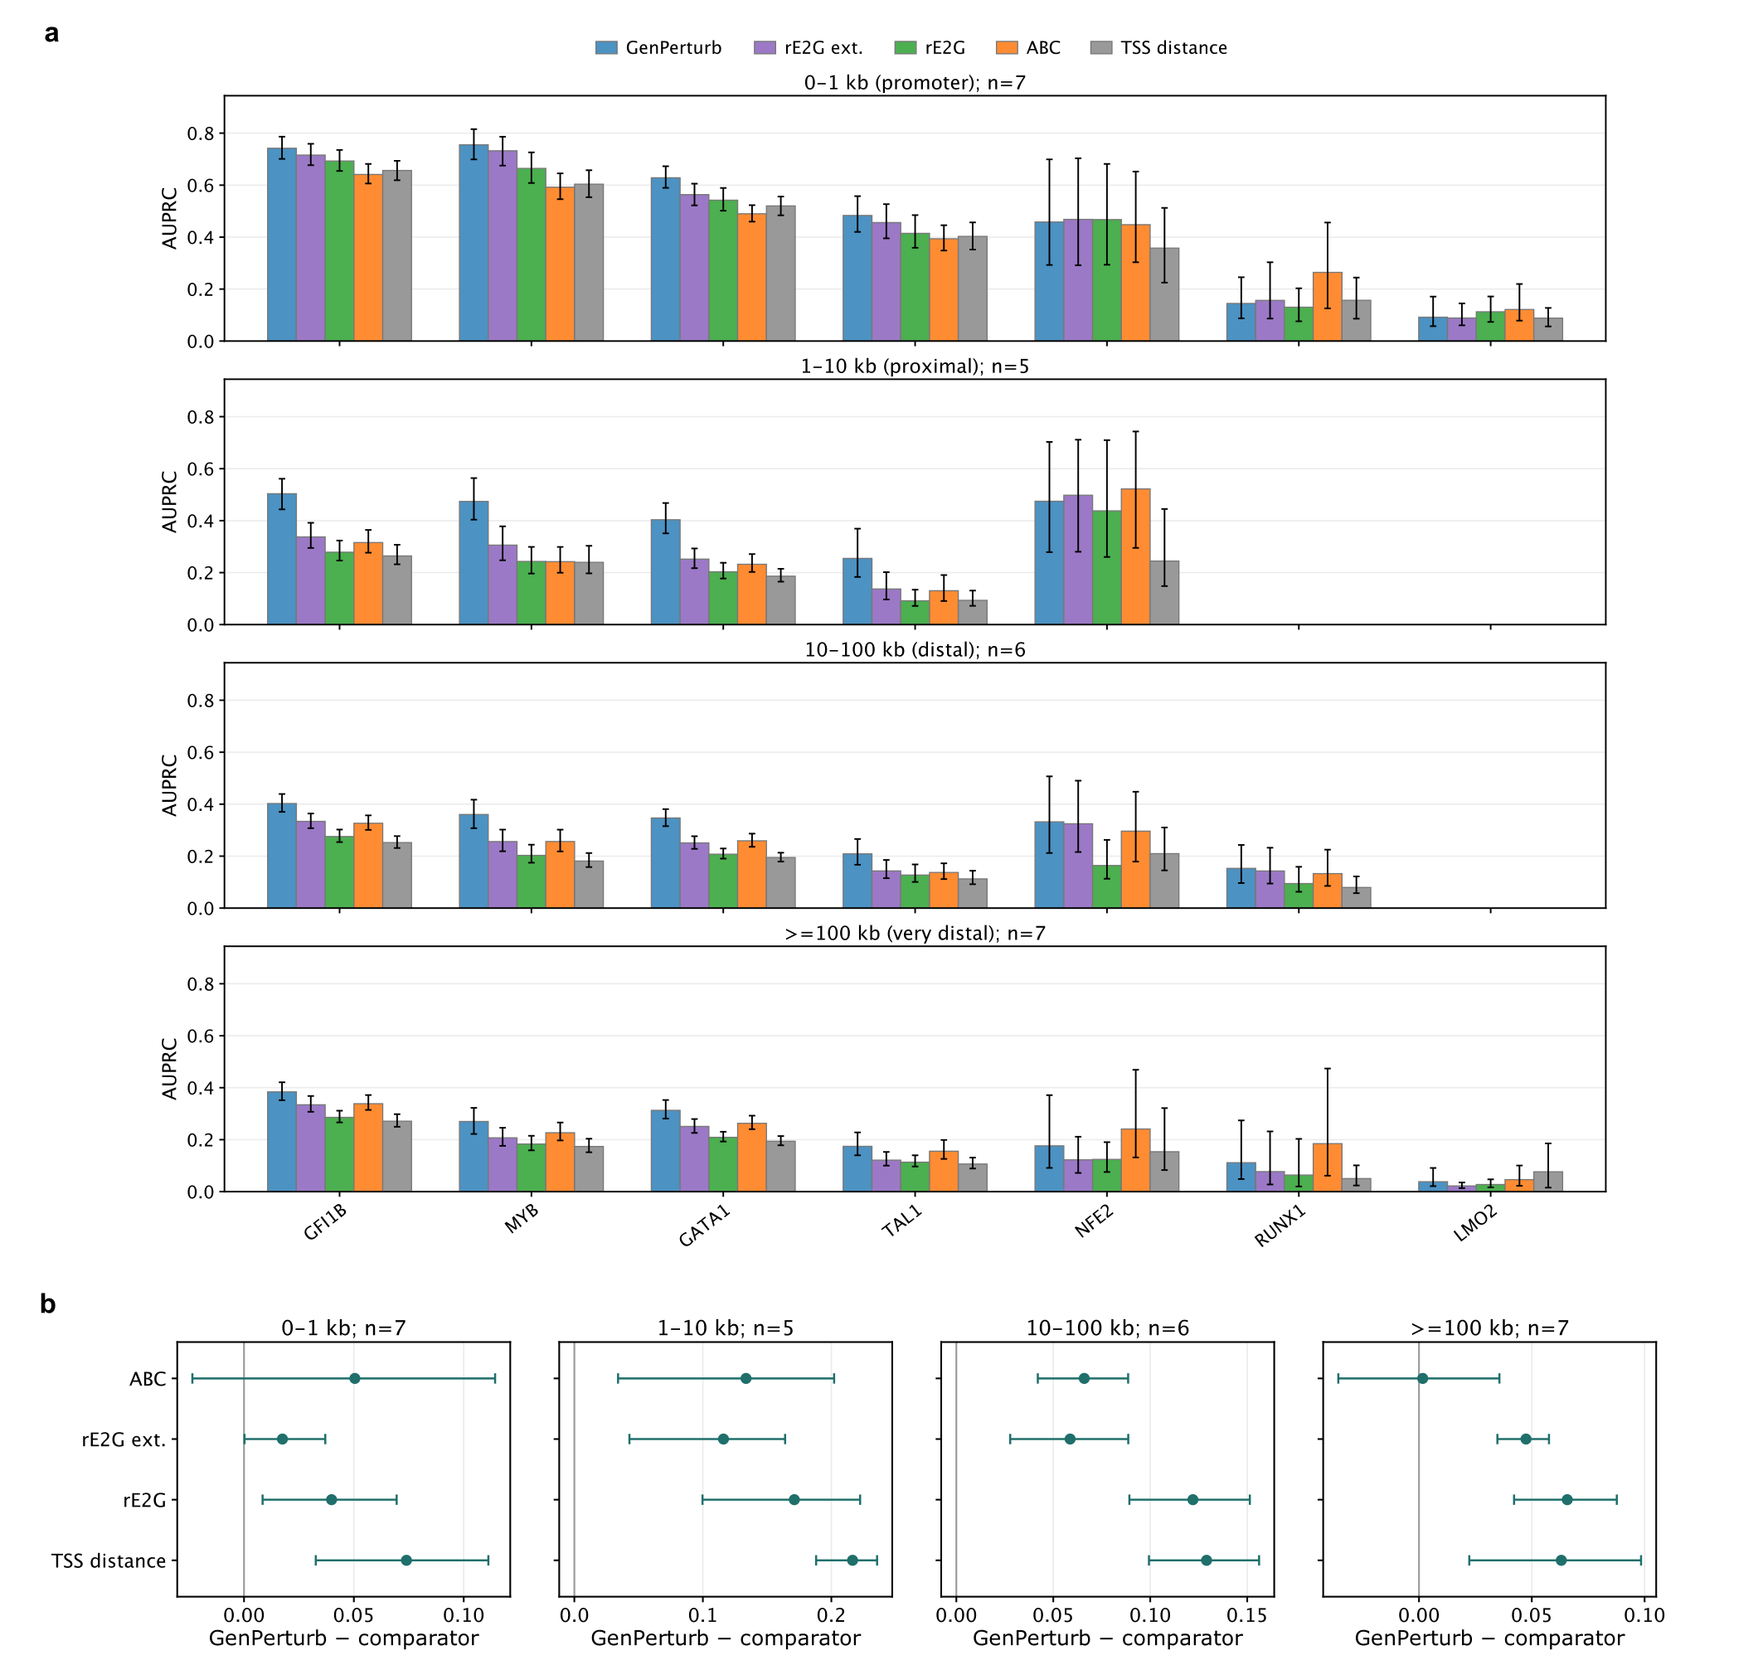
Supplementary Figure S8. Perturbation-level results from the method-independent region-ranking benchmark.
Positive labels denote accessibility responses within the model window of a responsive gene; enhancer–gene relationships require direct functional validation.
a, Per-perturbation AUPRC values in the annotation-defined candidate universe (Fig. 4d). Bars show AUPRC for each score within each eligible Martin perturbation and distance stratum; whiskers show 95% percentile-bootstrap confidence intervals from 1,000 resamples of candidate intervals within that perturbation and are not confidence intervals for differences between scores. A perturbation–stratum is eligible when it contains at least ten positive and one negative candidate gene–interval pair after restricting associated genes to |log2FC| ≥ 0.5. Blank positions denote ineligible perturbation–strata rather than zero AUPRC. The total, positive, and negative candidate gene–interval pair counts and positive prevalence for each perturbation–stratum are tabulated separately (Supplementary Table 8).
b, Paired AUPRC differences on the same candidate universe, computed within perturbations as GenPerturb minus each comparator. Points show mean differences and whiskers show 95% percentile-bootstrap confidence intervals from 10,000 resamples of whole perturbations (seed 42). The four strata contain seven, five, six, and seven eligible perturbations, respectively. Fourteen of the 16 intervals exclude zero in favour of GenPerturb. The comparisons with ABC at <1 kb (0.050; −0.024 to 0.114) and ≥100 kb (0.002; −0.036 to 0.036) span zero, leaving both a difference and equivalence unresolved.

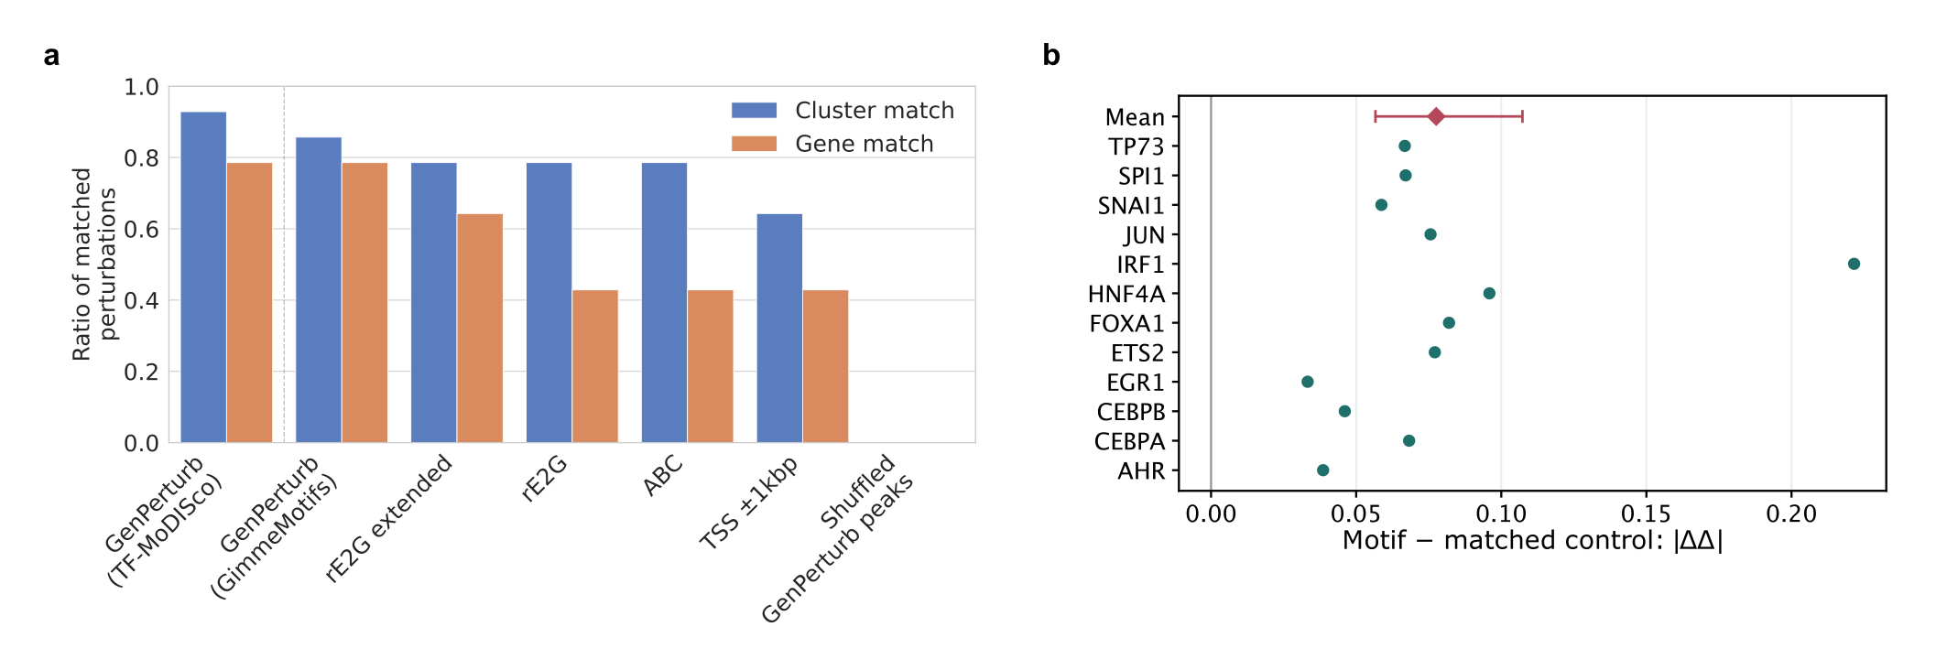
Supplementary Figure S9. Motif recovery and model-internal mutation analysis in a separate CRISPRa dataset.
GenPerturb was fitted to the Norman CRISPRa Perturb-seq dataset to examine motif recovery and fitted sequence sensitivity in a second perturbation modality.
a, Motif recovery among the 14 single-TF CRISPRa conditions included in this analysis, evaluated as in the Martin comparison (Fig. 4e). Blue and orange bars show cluster- and gene-level recovery, respectively. TF-MoDISco recovered 13 cluster and 11 gene matches, and GimmeMotifs on attribution-derived regions recovered 12 cluster and 11 gene matches, whereas rE2G extended, rE2G, and ABC regions each gave 11 cluster matches, TSS-proximal regions 9, and the shuffled-peak control 0. Supplementary Table 7 reports the perturbation-level results for these same 14 conditions.
b, Perturbation-aggregated in silico mutation analysis using the same procedure as the Martin analysis (Fig. 4f). Circles show the gene-aggregated within-perturbation difference between motif |ΔΔ| and matched-control |ΔΔ| across twelve eligible source perturbations. The mean motif and matched-control magnitudes were 0.084 and 0.0059, respectively, and perturbation-specific ratios ranged from 7.6 to 21.8. The diamond and whiskers show the mean paired difference and 95% percentile-bootstrap confidence interval from perturbation-level resamples: 0.078 (0.057–0.107; two-sided exact sign p = 0.00049). The displayed high-attribution subset contains 742 genes, 2,771 unique motif sites, and 2,788 site–source-perturbation pairs. This panel evaluates sensitivity within the fitted model.

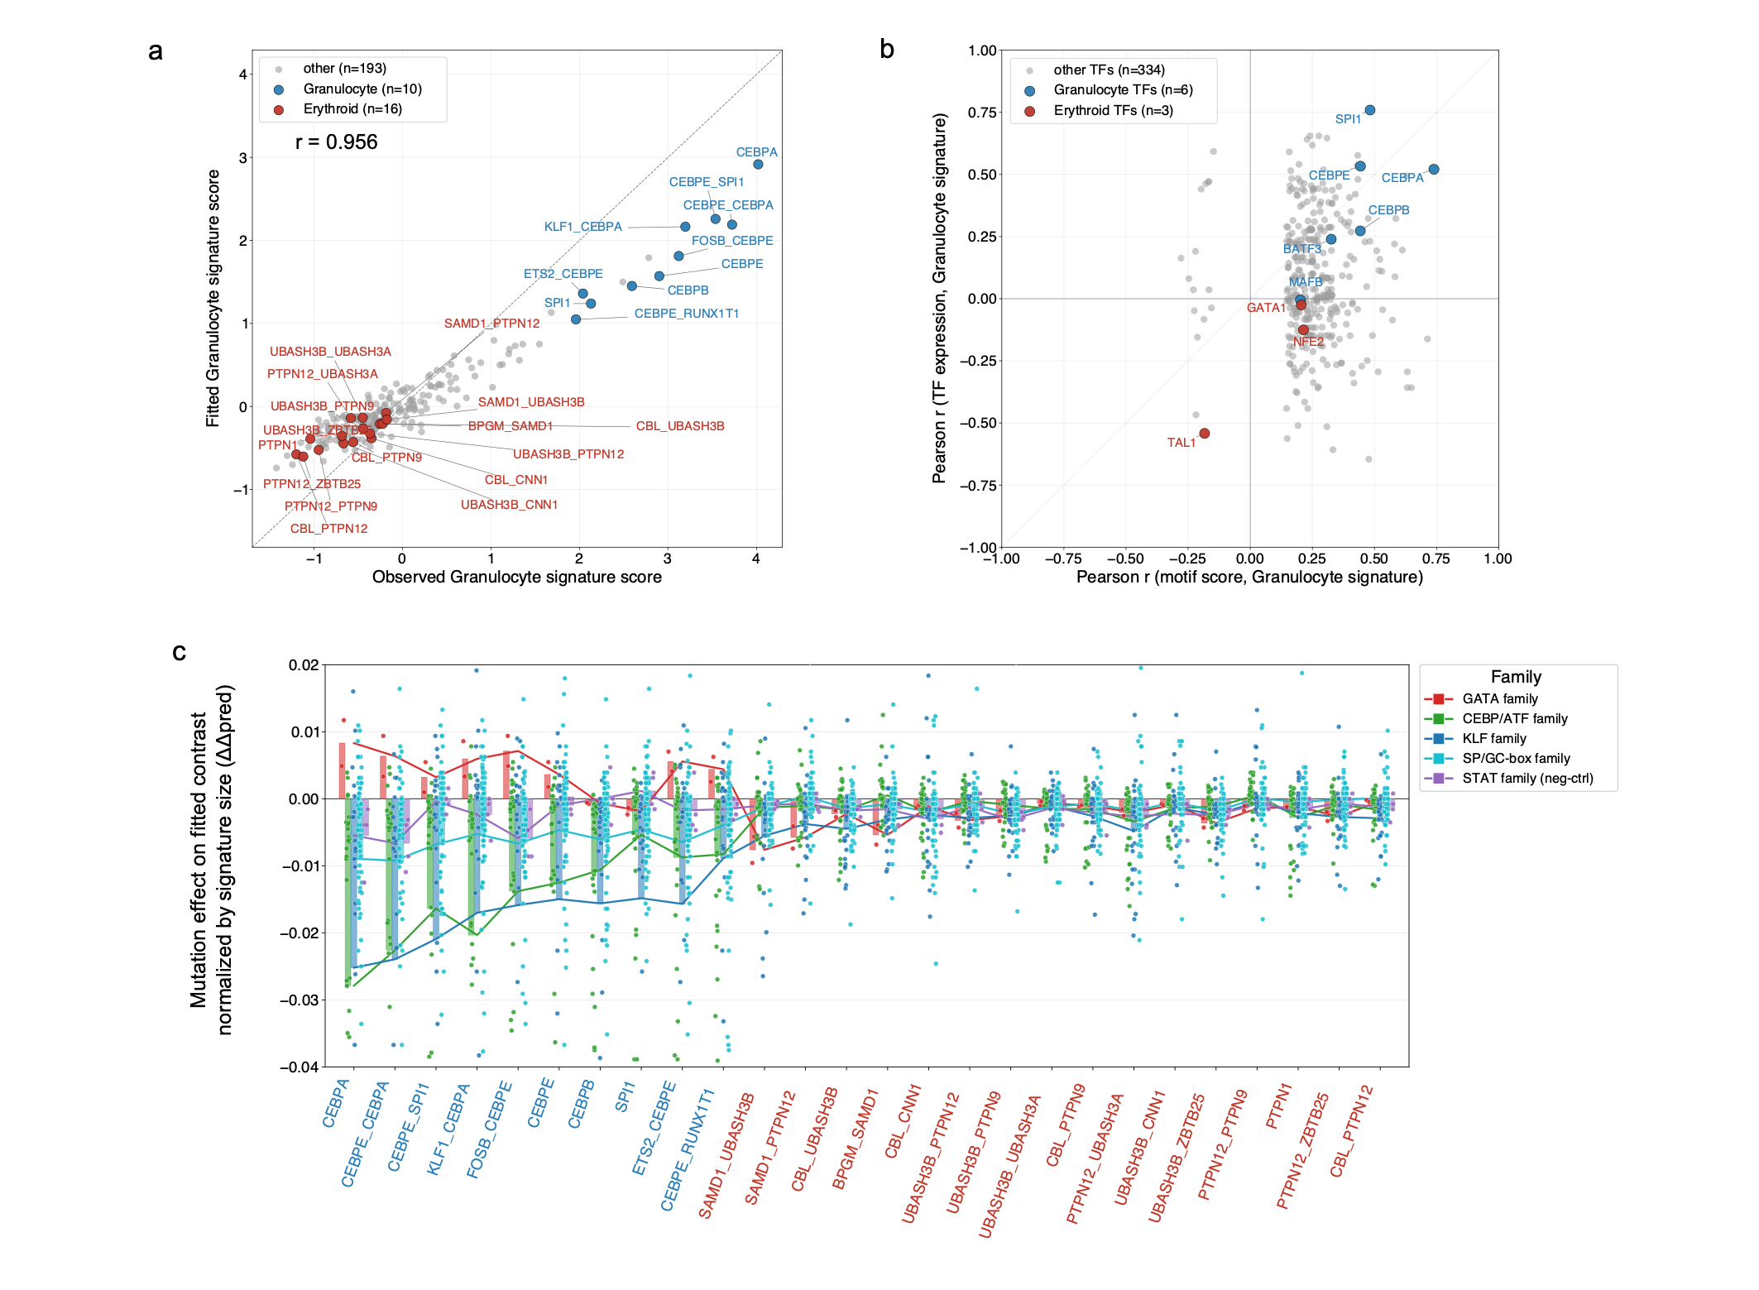
Supplementary Figure S10. Prior-informed granulocyte differentiation-axis analysis in the Norman dataset.
The granulocyte signature and highlighted TF families were defined from the original study and established lineage biology, providing an analysis corresponding to the erythroid axis (Fig. 5).
a, Observed and fitted granulocyte signature scores for 219 non-control conditions, using four signature genes from the original Norman study. Scores are computed from all-gene matrices, so r = 0.96 is interpreted as a fit check. Red points mark 16 erythroid-program perturbations, blue points mark ten granulocyte-program perturbations, and grey points mark 193 other perturbations.
b, Exploratory comparison of motif–signature and TF mRNA–signature correlations for 310 plotted motif–TF summaries passing motif–signature Benjamini–Hochberg FDR < 0.05 after accounting for selection between eligible positive- and negative-pattern correlations within each motif. Both axes use the observed granulocyte signature: x is its correlation with the motif significance score, defined as −log10(q), and y is its correlation with TF mRNA. Positive- and negative-pattern motif scores are evaluated separately, and the signed correlation with larger absolute magnitude is retained. The corresponding erythroid-axis analysis uses the same approach (Fig. 5c).
c, In silico mutation of TF-MoDISco motif instances at three available granulocyte marker genes across 26 lineage-labelled perturbations (3,640 seqlet–perturbation pairs), with mutation effects averaged across five mononucleotide-preserving shuffles per instance. The y-axis shows the site-level change in fitted perturbation-minus-control expression after mutation, divided by the four-gene granulocyte signature size. Negative values indicate a lower marker-gene contrast. X-axis labels are sorted by observed granulocyte signature score and coloured using the original Norman program annotations. Bars and lines show mean effects within each motif family and perturbation. Dots are seqlet–perturbation pairs from this model-internal sequence-sensitivity analysis and are treated as repeated measurements rather than as independent biological replicates.

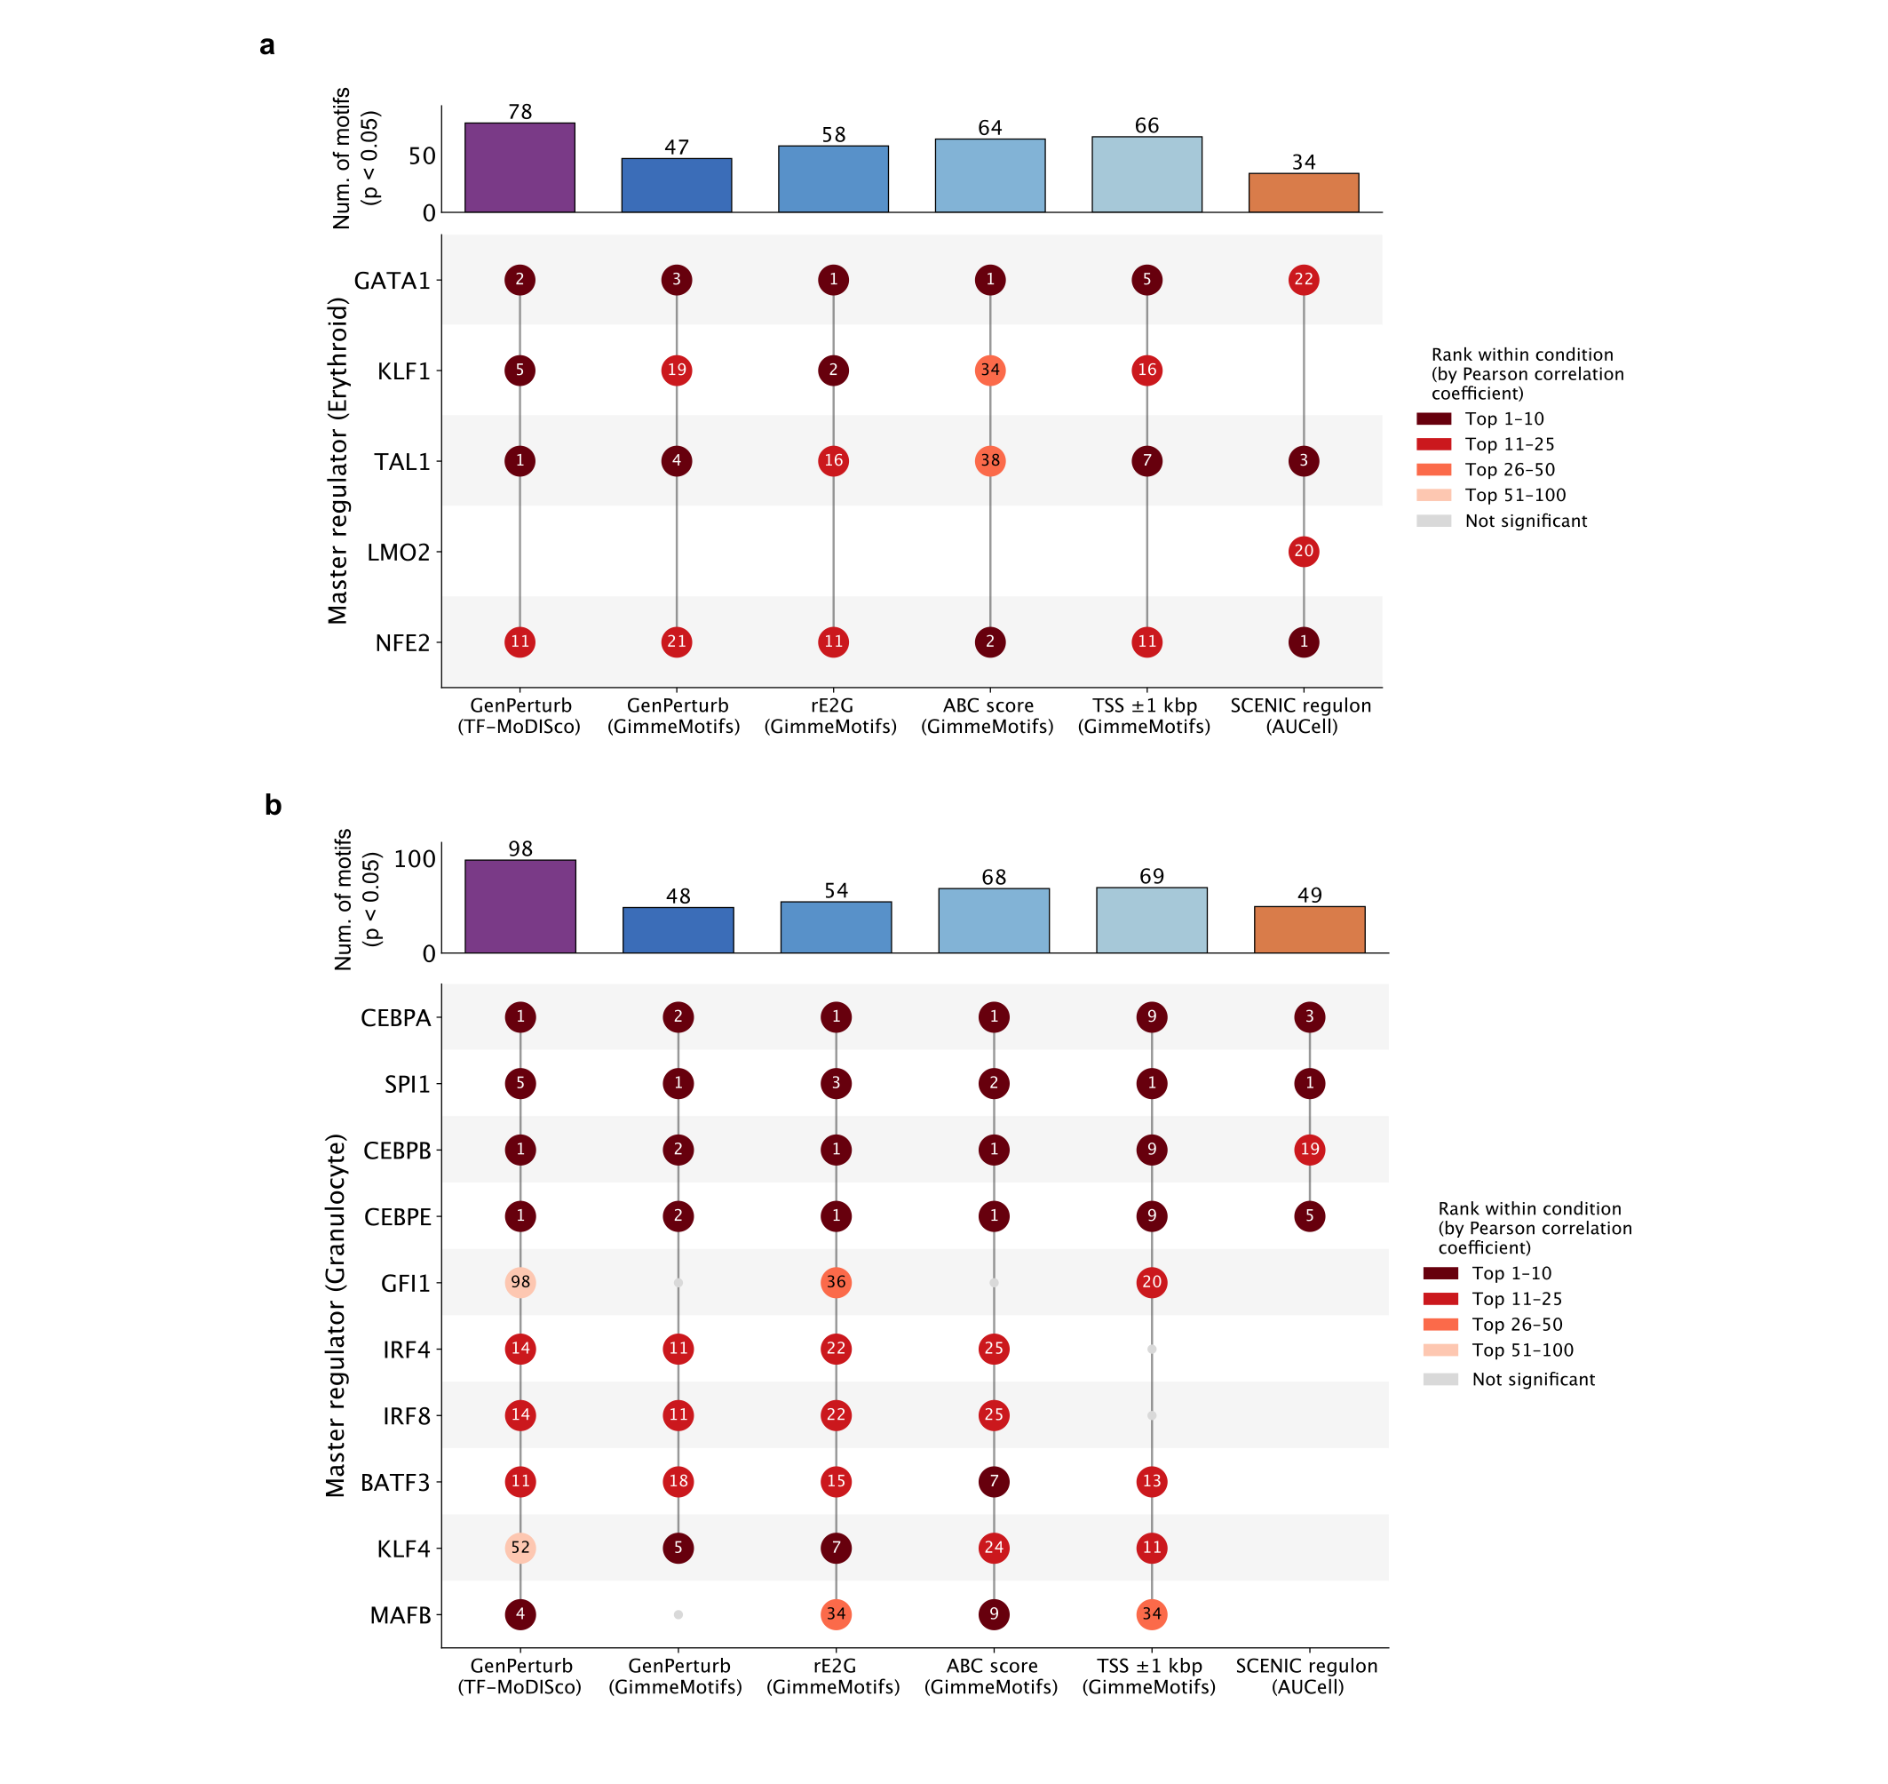
Supplementary Figure S11. Comparison of lineage regulator ranking across attribution, enhancer-link, and regulon evidence.
Comparison of candidate lineage regulators identified by GenPerturb attribution, motif enrichment over GenPerturb-derived regions, rE2G, ABC, TSS-proximal annotations, and SCENIC regulon activity. Regulator ranking was based on the absolute Pearson correlation coefficient between lineage signature scores and regulator-associated signals within each method. Numbers indicate regulator rank within each source. Top panels show the number of significant motif associations detected in each method (nominal p < 0.05).
a, Erythroid regulator ranking comparison. LMO2 was detected only by SCENIC because no corresponding LMO2 motif was included in the JASPAR database used for the motif-based analyses.
b, Granulocyte regulator ranking comparison.
Different methods showed partially overlapping regulator rankings, reflecting differences in attribution strategy, enhancer-link annotation, motif enrichment, and regulon inference. These approaches provide complementary evidence layers for interpreting lineage-associated regulatory programs.

References

1. Avsec Z, Agarwal V, Visentin D, et al. Effective gene expression prediction from sequence by integrating long-range interactions. Nat Methods. 2021;18:1196-1203. doi:10.1038/s41592-021-01252-x.
2. Linder J, Srivastava D, Yuan H, Agarwal V, Kelley DR. Predicting RNA-seq coverage from DNA sequence as a unifying model of gene regulation. Nat Genet. 2025;57:949-961. doi:10.1038/s41588-024-02053-6.
3. Avsec Z, Latysheva N, Cheng J, et al. Advancing regulatory variant effect prediction with AlphaGenome. Nature. 2026;649:1206-1218. doi:10.1038/s41586-025-10014-0.
4. Fu X, Mo S, Buendia A, et al. A foundation model of transcription across human cell types. Nature. 2025;637:965-973. doi:10.1038/s41586-024-08391-z.
5. Hingerl JC, Martens LD, Karollus A, et al. scooby: modeling multimodal genomic profiles from DNA sequence at single-cell resolution. Nat Methods. 2025;22:2275-2285. doi:10.1038/s41592-025-02854-5.
6. Lal A, Karollus A, Gunsalus L, et al. Decoding sequence determinants of gene expression in diverse cellular and disease states. Nat Methods. 2026. doi:10.1038/s41592-026-03102-0.
7. Dixit A, Parnas O, Li B, et al. Perturb-Seq: dissecting molecular circuits with scalable single-cell RNA profiling of pooled genetic screens. Cell. 2016;167:1853-1866.e17. doi:10.1016/j.cell.2016.11.038.
8. Yang L, Zhu Y, Yu H, et al. scMAGeCK links genotypes with multiple phenotypes in single-cell CRISPR screens. Genome Biol. 2020;21:19. doi:10.1186/s13059-020-1928-4.
9. Nguyen E, Poli M, et al. HyenaDNA: long-range genomic sequence modeling at single nucleotide resolution. arXiv. 2023. doi:10.48550/arXiv.2306.15794.
10. Brixi G, et al. Genome modelling and design across all domains of life with Evo 2. Nature. 2026. doi:10.1038/s41586-026-10176-5.
11. Dalla-Torre H, Gonzalez L, Mendoza-Revilla J, et al. Nucleotide Transformer: building and evaluating robust foundation models for human genomics. Nat Methods. 2025. doi:10.1038/s41592-024-02523-z.
12. Avsec Z, Weilert M, Shrikumar A, et al. Base-resolution models of transcription-factor binding reveal soft motif syntax. Nat Genet. 2021;53:354-366. doi:10.1038/s41588-021-00782-6.
13. Pampari A, et al. ChromBPNet: bias factorized, base-resolution deep learning models of chromatin accessibility reveal cis-regulatory sequence syntax, transcription factor footprints and regulatory variants. bioRxiv. 2025. doi:10.1101/2024.12.25.630221.
14. Schep AN, Wu B, Buenrostro JD, Greenleaf WJ. chromVAR: inferring transcription-factor-associated accessibility from single-cell epigenomic data. Nat Methods. 2017;14:975-978. doi:10.1038/nmeth.4401.
15. Granja JM, Corces MR, Pierce SE, et al. ArchR is a scalable software package for integrative single-cell chromatin accessibility analysis. Nat Genet. 2021;53:403-411. doi:10.1038/s41588-021-00790-6.
16. Stuart T, Srivastava A, Madad S, Lareau CA, Satija R. Single-cell chromatin state analysis with Signac. Nat Methods. 2021;18:1333-1341. doi:10.1038/s41592-021-01282-5.
17. Aibar S, Gonzalez-Blas CB, Moerman T, et al. SCENIC: single-cell regulatory network inference and clustering. Nat Methods. 2017;14:1083-1086. doi:10.1038/nmeth.4463.
18. Bravo Gonzalez-Blas C, De Winter S, Hulselmans G, et al. SCENIC+: single-cell multiomic inference of enhancers and gene regulatory networks. Nat Methods. 2023;20:1355-1367. doi:10.1038/s41592-023-01938-4.
19. Garcia-Alonso L, Holland CH, Ibrahim MM, Türei D, Saez-Rodriguez J. Benchmark and integration of resources for the estimation of human transcription factor activities. Genome Res. 2019;29:1363-1375. doi:10.1101/gr.240663.118.
20. Alvarez MJ, Shen Y, Giorgi FM, et al. Functional characterization of somatic mutations in cancer using network-based inference of protein activity. Nat Genet. 2016;48:838-847. doi:10.1038/ng.3593.
21. Fulco CP, Nasser J, Jones TR, et al. Activity-by-contact model of enhancer-promoter regulation from thousands of CRISPR perturbations. Nat Genet. 2019;51:1664-1669. doi:10.1038/s41588-019-0538-0.
22. Gschwind AR, Mualim KS, Karbalayghareh A, et al. An encyclopedia of enhancer-gene regulatory interactions in the human genome. bioRxiv. 2023. doi:10.1101/2023.11.09.563812.
23. Bailey TL, Johnson J, Grant CE, Noble WS. The MEME Suite. Nucleic Acids Res. 2015;43:W39-W49. doi:10.1093/nar/gkv416.
24. Bruse N, van Heeringen SJ. GimmeMotifs: an analysis framework for transcription factor motif analysis. bioRxiv. 2018. doi:10.1101/474403.
25. Roohani Y, Huang K, Leskovec J. Predicting transcriptional outcomes of novel multigene perturbations with GEARS. Nat Biotechnol. 2024;42:927-935. doi:10.1038/s41587-023-01905-6.
26. Cui H, Wang C, Maan H, et al. scGPT: toward building a foundation model for single-cell multi-omics using generative AI. Nat Methods. 2024;21:1470-1480. doi:10.1038/s41592-024-02201-0.
27. Lotfollahi M, Susmelj AK, De Donno C, et al. Predicting cellular responses to complex perturbations in high-throughput screens. Mol Syst Biol. 2023;19:e11517. doi:10.15252/msb.202211517.
28. Fu B, Dasoulas G, Gabbita S, et al. STRAND: sequence-conditioned transport for single-cell perturbations. arXiv. 2026. doi:10.48550/arXiv.2602.10156.
29. Norman TM, Horlbeck MA, Replogle JM, et al. Exploring genetic interaction manifolds constructed from rich single-cell phenotypes. Science. 2019;365:786-793. doi:10.1126/science.aax4438.
30. Replogle JM, Saunders RA, Pogson AN, et al. Mapping information-rich genotype-phenotype landscapes with genome-scale Perturb-seq. Cell. 2022;185:2559-2575.e28. doi:10.1016/j.cell.2022.05.013.
31. Jiang J, Chen S, Tsou T, et al. D-SPIN constructs regulatory network models from scRNA-seq that reveal organizing principles of perturbation response. Cell. 2026. doi:10.1016/j.cell.2026.04.028.
32. Srivatsan SR, McFaline-Figueroa JL, Ramani V, et al. Massively multiplex chemical transcriptomics at single-cell resolution. Science. 2020;367:45-51. doi:10.1126/science.aax6234.
33. Martin-Rufino JD, Caulier A, Lee S, et al. Transcription factor networks disproportionately enrich for heritability of blood cell phenotypes. Science. 2025;388:52-59. doi:10.1126/science.ads7951.
34. Metzner F, Southard KM, Norman TM. Multiome Perturb-seq unlocks scalable discovery of integrated perturbation effects on the transcriptome and epigenome. Cell Syst. 2025;16:101161. doi:10.1016/j.cels.2024.12.002.
35. Yan RE, Corman A, Katgara L, et al. Pooled CRISPR screens with joint single-nucleus chromatin accessibility and transcriptome profiling. Nat Biotechnol. 2025;43:1628-1634. doi:10.1038/s41587-024-02475-x.
36. Shevade K, Yang YA, Feng K, et al. Simultaneous capture of single cell RNA-seq, ATAC-seq, and CRISPR perturbation enables multiomic screens to identify gene regulatory relationships. Cell Rep Methods. 2025;5:101222. doi:10.1016/j.crmeth.2025.101222.

