Contents
Supplementary figures 3
Figure S1. Total number of SNVs present in the reporter lists which were absent and detected in the baseline sample. 3
Figure S2. Overview of MNVista performance for the ‘baseline’ (0.1% dilution) PhasED-Seq sample per patient using the PhasED-Seq reporter list as input 4
Figure S3 Overview of the largest (size 9) multi-nucleotide variant (MNV) called by MNVista in the dilution series analysis using both the de novo in-house SNV input and PhasED-Seq reporter list SNV input, stemming from the DLBCL084 patient 5
Figure S4. Overview of MNVista performance for the ‘baseline’ (0.1% dilution) PhasED-Seq sample per patient using the in-house SNVs as input. 6
Figure S5. Comparison of MNV calls and MNV span between MNVista and the PhasED-Seq reporter MNVs. 7
Figure S6. Overview of MNVista multi nucleotide variant (MNV) supporting reads and read depth per dilution sample using the reporter SNVs as input 8
Figure S7. Overview of Mutect2 (SNV mode) performance for the PhasED-Seq dilution series. 9
Figure S8. Overview of the synthetic benchmark spike-in SNV statistics. 10
Figure S9. Overview of false-positive analysis in the MNVista synthetic benchmark for each noise group. 10
Figure S10. Prior sensitivity analysis in a baseline setting for both priors (-P and -E) for three values (0.01, 0.1, 0.5) resulting in a grid space of 9 points per each noise group. 11
Figure S11. Stratification of recall fractions per sample and noise group per spike-in VAF level subgroup (A), inter-SNV span of MNVs (B), locus read depth (C) and number of supporting reads (D). 12
Supplementary tables 13
Table S1. Overview of all samples used in the analyses and their respective dataset 13
Table S2. Overview of the super enhancer region-focused panel used for benchmarking 13
Table S3. Overview of MNVista calls showing MNVs called using the reporter-list SNVs and in-house called SNVs as inputs, compared to the reporter-list MNVs. 14
Table S4. Overview of MNVista calls using in-house SNVs in the dilution-series ‘baseline’ sample and the overlap with matching reporter MNVs and SNVs. 15
Table S5. Description of analyses used for the public dilution series data 15
Table S6. Overview of the number of SNVs spiked-in the BAM files of the 5 DLBCL samples (with somatic and sequencing errors background) used for the synthetic benchmark. 15
Table S7. Overview of spike-in statistics in the synthetic benchmark for each DLBCL sample and noise group. 15

Supplementary figures
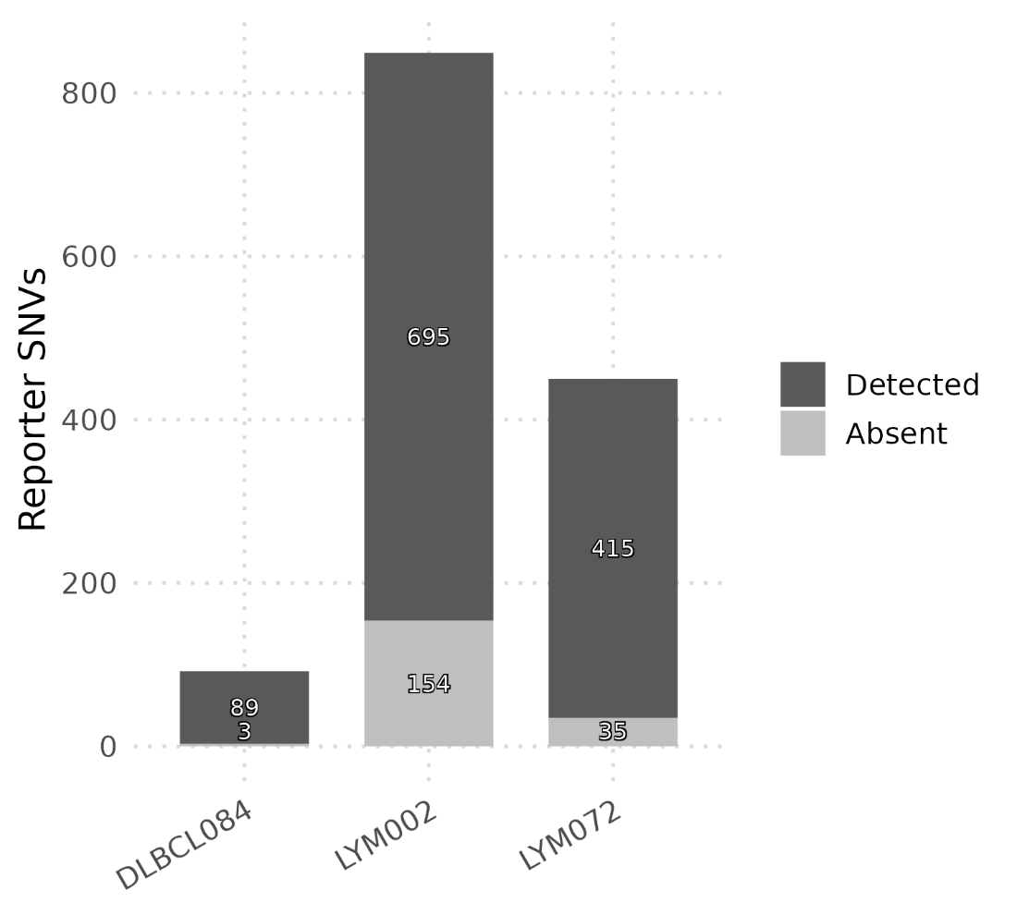
Figure S1. Total number of SNVs present in the reporter lists which were absent and detected in the baseline sample. Counts are shown per-patient for detected SNVs (dark) and absent SNVs (light)

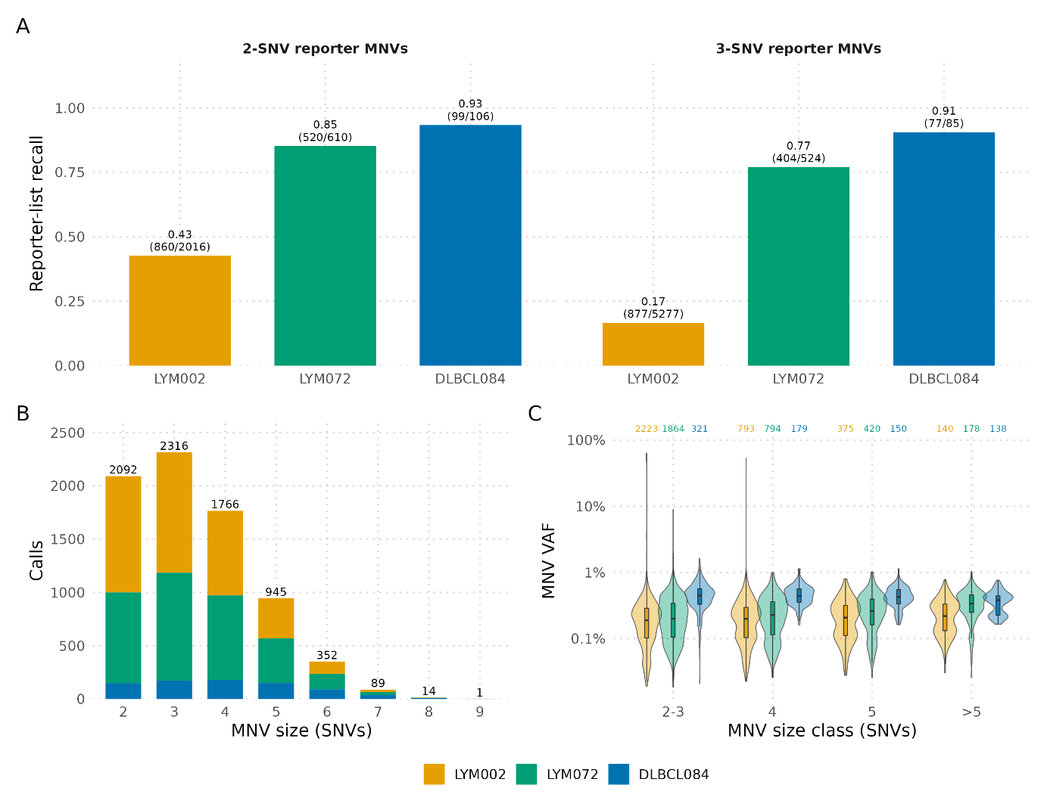
Figure S2. Overview of MNVista performance for the ‘baseline’ (0.1% dilution) PhasED-Seq sample per patient using the PhasED-Seq reporter list as input. Panel A: MNV recall is shown per patient for MNVs of size 2 (A, left bar graph) and size 3 (A, right bar graph). MNVista identified 7,584 MNVs in total, of which 2,837 (32.9%) matched reporter MNVs and 4,747 were novel. Per-patient recall was 92.1% (176/191) for DLBCL084, 23.8% (1,737/7,293) for LYM002, and 81.5% (924/1,134) for LYM072, with the lower overall recall driven primarily by LYM002. Panel B: stacked bar graphs of the number of MNVs called per patient and MNV size, with 2,316 three-SNV, 2,092 two-SNV, and 1,766 four-SNV MNVs comprising the most frequent size classes. Panel C: violin plots of MNV VAF distributions per MNV size class, with the total number of entries at the top, color-coded per patient. VAF variation decreased with increasing MNV size, consistent with the greater evidential constraint imposed by requiring all constituent SNVs to occur on the same read.

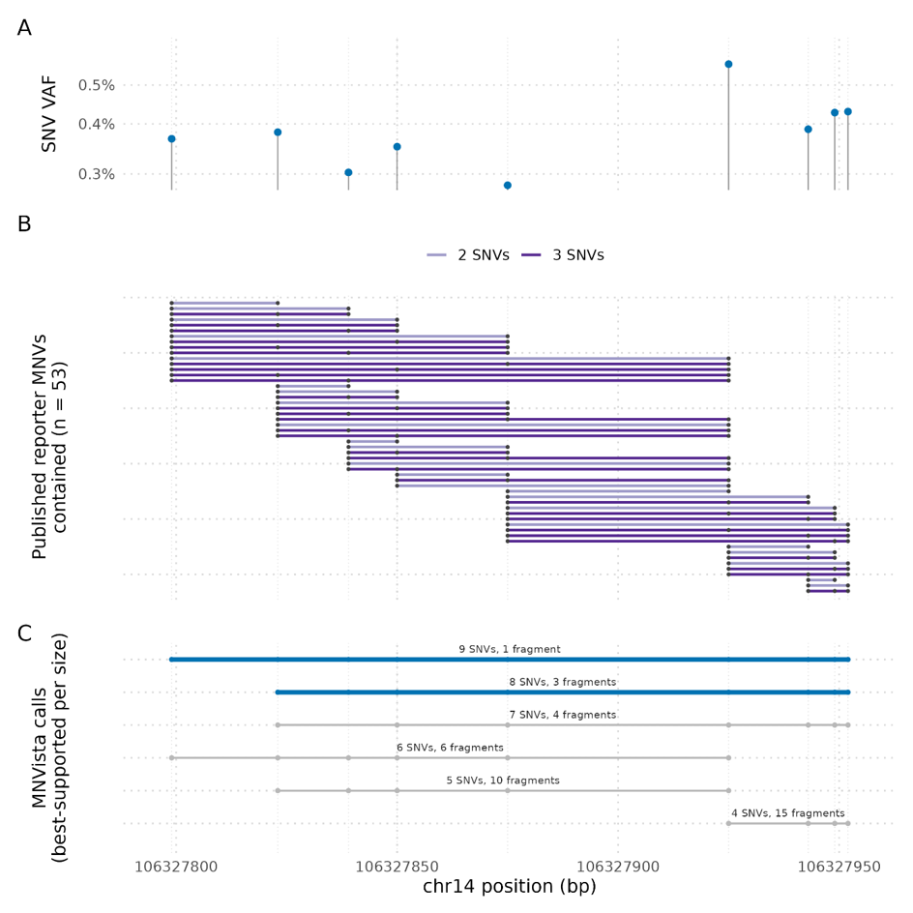
Figure S3 Overview of the largest (size 9) multi-nucleotide variant (MNV) called by MNVista in the dilution series analysis using both the de novo in-house SNV input and PhasED-Seq reporter list SNV input, stemming from the DLBCL084 patient. Panel A: the variant allele frequencies (VAF) of each individual SNV, clustering around 0.3 - 0.5%. Panel B: individual PhasED-Seq (n=53) 2- and 3-size MNVs (n=23, n=30 respectively) comprising the MNVista largest MNV. These MNVs are sorted top to bottom by start position in an ascending manner. Panel C: best-supported MNVista MNV calls up to a size 9 MNV that encompass the PhasED-Seq MNVs, along with the supporting number of reads for each MNV. Best-supported here means the MNVs with the highest number of supporting reads.

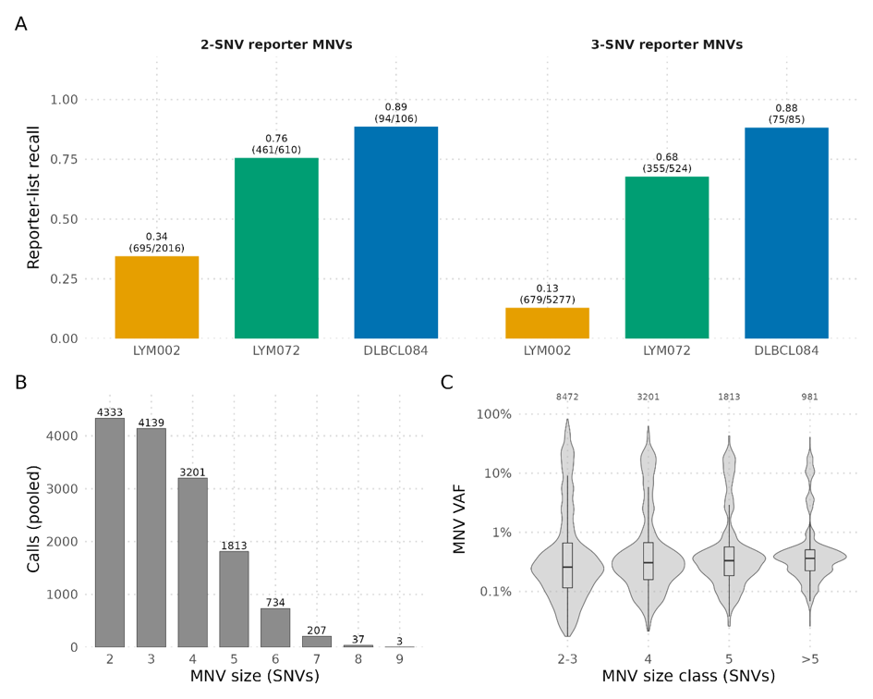
Figure S4. Overview of MNVista performance for the ‘baseline’ (0.1% dilution) PhasED-Seq sample per patient using the in-house SNVs as input. Panel A: Multi-nucleotide variant (MNV) recall is stratified per patient for MNVs of size 2 (A, left bar graph) and size 3 (A, right bar graph). MNVista called 14,467 MNVs in total, of which 2,359 (27.4%) matched reporter MNVs and 12,108 were novel. Per-patient recall was 88.5% (169/191) for DLBCL084, 18.8% (1,374/7,293) for LYM002, and 72.0% (816/1,134) for LYM072, again with lower recall for LYM002. Panel B: pooled stacked bar graphs and the corresponding total number of MNVs called per MNV size; the most frequent size classes were 2-SNV (n=4,333), 3-SNV (n=4,139), and 4-SNV (n=3,201) MNVs. Calls are shown pooled because novel MNVs could not be assigned to individual patients in the absence of patient-specific BAM files. Panel C: violin plots of MNV VAF distributions per MNV size class, with the total number of MNVs at the top. As in the reporter-SNV analysis, VAF variation decreased with increasing MNV size.

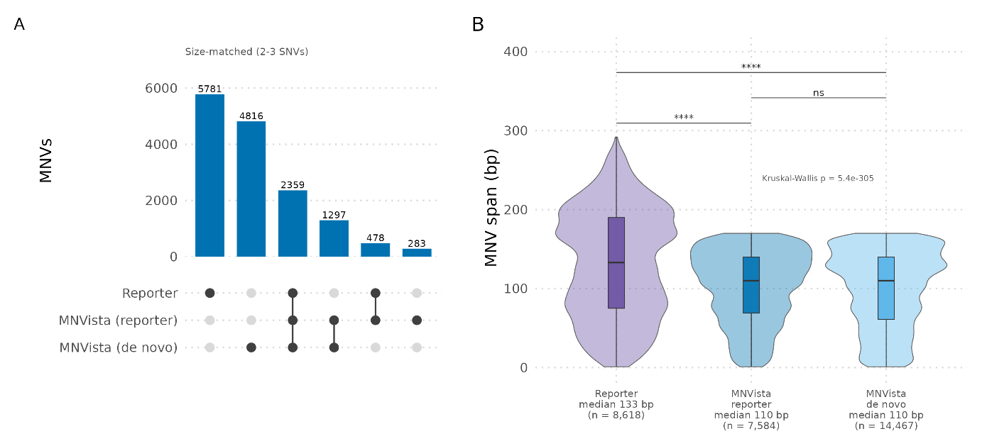
Figure S5. Comparison of MNV calls and MNV span between MNVista and the PhasED-Seq reporter MNVs. Panel A: UpSet plot showing the overlap between MNVs in the PhasED-Seq reporter list and MNVista calls using reporter SNVs or high-sensitivity in-house SNVs as input. The two MNVista approaches shared 3,656 MNVs, of which 2,359 were also present in the reporter list and 1,297 were novel. Of the 761 MNVs uniquely identified using reporter SNVs as input, 478 were reporter MNVs and 283 were novel, whereas all 4,816 MNVs uniquely identified using in-house SNVs were novel. Panel B: Boxplot showing MNV span, defined as the distance between the first and last constituent SNV positions, for the reporter MNVs and MNVista calls generated using reporter SNVs or in-house SNVs. Reporter MNVs generally spanned larger regions than MNVista calls (median 133 bp vs. 110 bp for both input strategies). MNV span distributions differed significantly between the three sources (Kruskal–Wallis), with significant pairwise differences between the reporter MNVs and both MNVista outputs, but not between the two MNVista input strategies. “****” = p < 0.0001; “ns” = not significant.

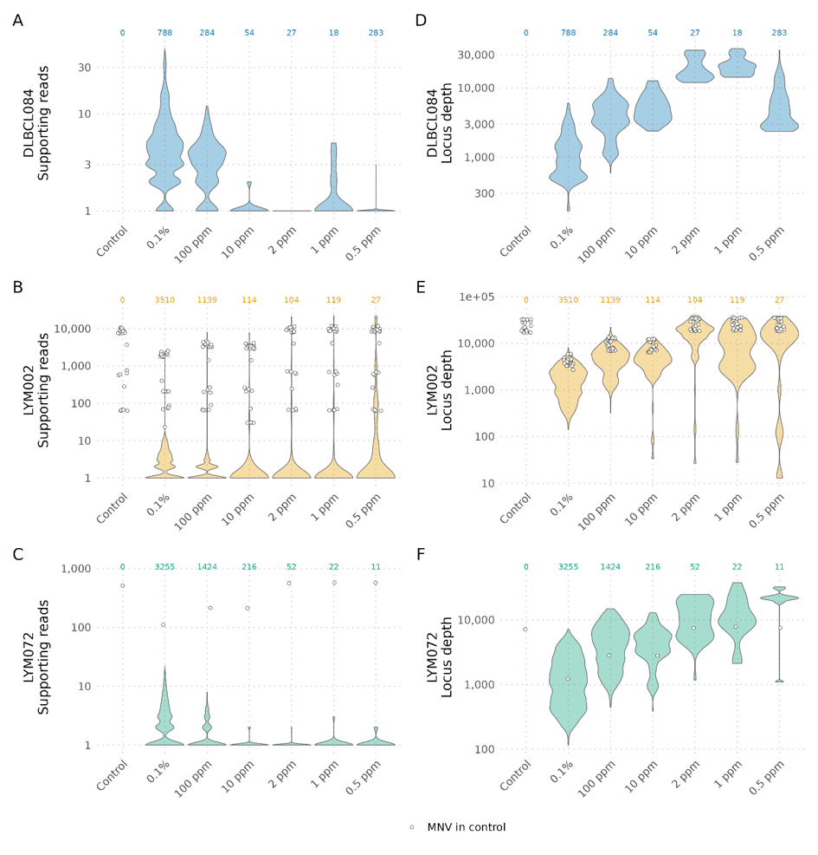
Figure S6. Overview of MNVista multi nucleotide variant (MNV) supporting reads and read depth per dilution sample using the reporter SNVs as input. Panels A-C show a violin plot depicting the number of supporting reads per dilution level (x-axis) per patient (y-axis), with the total number of MNV calls at the top of each violin. Panels D-F show the total read depth (locus depth) for the same MNVs in the same manner. Supporting reads largely decreases as dilution level increases, while the total read depth increases as the dilution level increases.

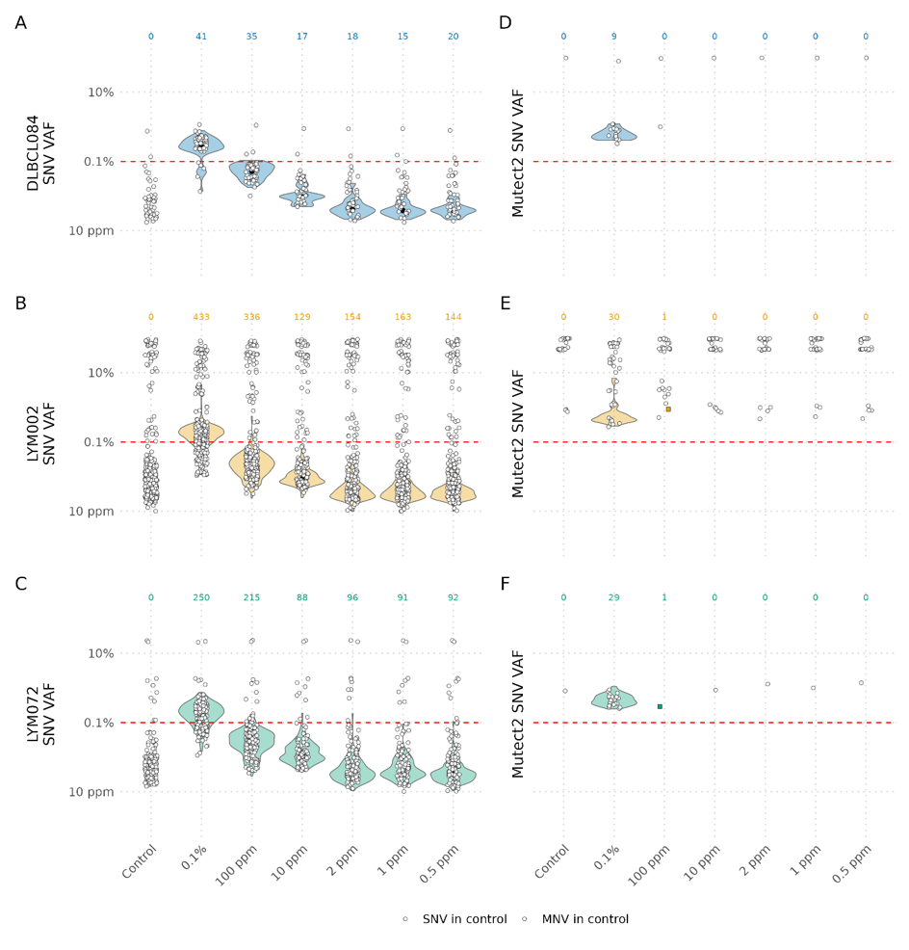
Figure S7. Overview of Mutect2 (SNV mode) performance for the PhasED-Seq dilution series. Panels A-C show violin plots of the reporter list SNV VAF and counts per patient and per dilution sample. SNVs present in the control sample are shown as dots. Panels D-F show Mutect2 SNV calls that match the reporter list SNVs per dilution sample. SNV counts are shown at the top of each panel, color-coded per patient. White dots indicate entries present in the control sample. Individual MNVs are shown as squares in samples with too few MNV counts to draw a violin.

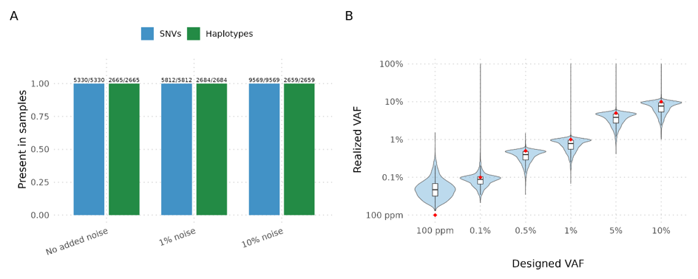
Figure S8. Overview of the synthetic benchmark spike-in SNV statistics. Panel A: fraction of spiked-in single nucleotide variants (SNV) and 2 SNV-haplotypes present in BAM files per noise group. All SNVs and corresponding MNV haplotypes were spiked in successfully. Panel B: a violin plot of the realized VAF vs the designed VAF of the spike-in SNVs, with the red dot representing the target designed VAF value. For the lowest spike-in group (100 ppm), the realized VAF is higher than the designed VAF, caused by insufficient read depth at this level to achieve the desired VAF, and this level clusters more closely around ~500 ppm.
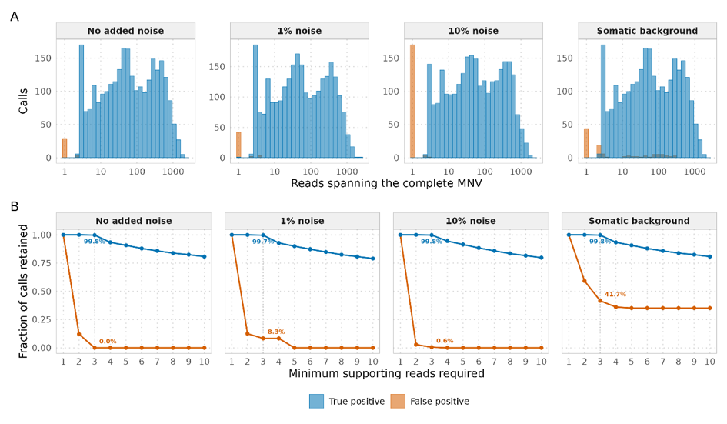
Figure S9. Overview of false-positive analysis in the MNVista synthetic benchmark for each noise group. Panel A: histograms of true positives (TP, blue) and false positives (FP, orange) per noise group. The number of MNV calls (y-axis) is shown for supporting read bins. FPs are mostly supported by only 1 read. Panel B: fraction of calls retained per threshold value for minimum supporting number of reads. The recall percentage of TPs is >99.7% even when applying a minimum criterion of 3 supporting reads, while FPs are reduced dramatically when increasing the threshold of at least 2 supporting reads.

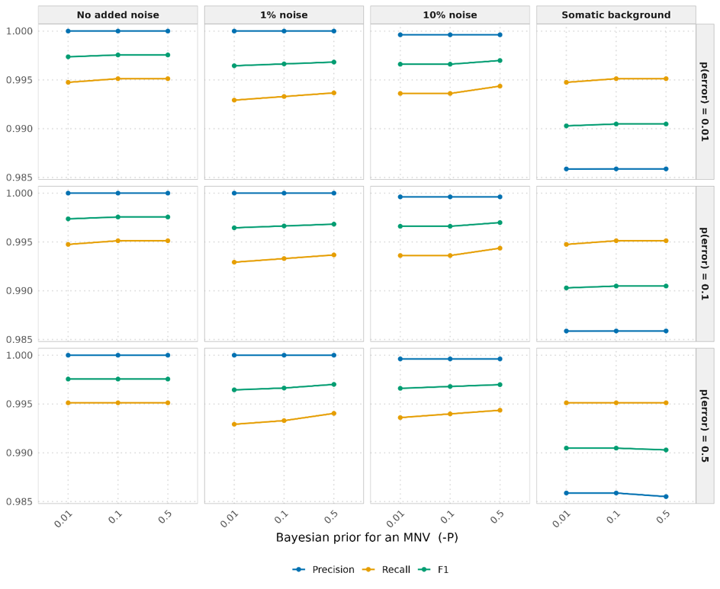
Figure S10. Prior sensitivity analysis in a baseline setting for both priors (-P and -E) for three values (0.01, 0.1, 0.5) resulting in a grid space of 9 points per each noise group. The prior -P is shown on the x-axis, while each row of sub-figures indicate an ascending -E value (top to bottom). The colored lines indicate the precision, recall, and F1 score. The choice of priors has minimal effect on the benchmark results.
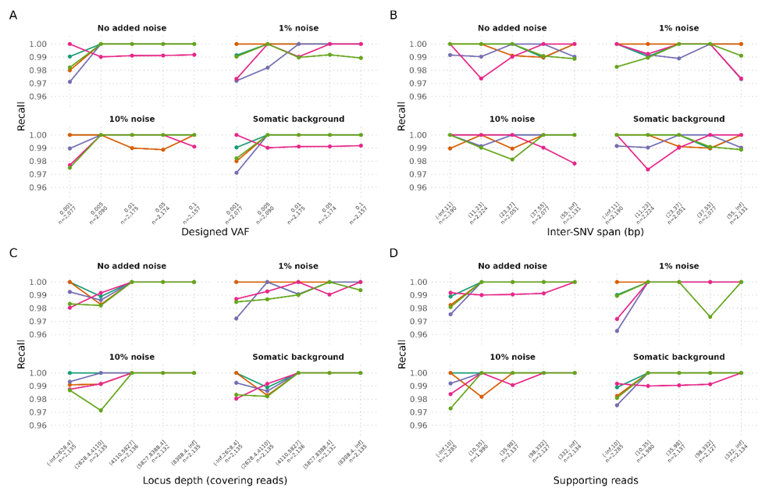
Figure S11. Stratification of recall fractions per sample and noise group per spike-in VAF level subgroup (A), inter-SNV span of MNVs (B), locus read depth (C) and number of supporting reads (D). For Panel B, C, and D, bins were evenly divided, with the group span and n denoted on the x-axis. No trend and minimal effect on the resulting recall is observed from the stratification for each noise group.

Supplementary tables

Table S1. Overview of all samples used in the analyses and their respective dataset
Sample | Dataset | Used for | Tumor fraction
S1* | In-house DLBCL cfDNA | Synthetic benchmark | Spiked, 100 ppm –10%
S2* | In-house DLBCL cfDNA | Synthetic benchmark | Spiked, 100 ppm –10%
S3* | In-house DLBCL cfDNA | Synthetic benchmark | Spiked, 100 ppm –10%
S4* | In-house DLBCL cfDNA | Synthetic benchmark | Spiked, 100 ppm –10%
S5* | In-house DLBCL cfDNA | Synthetic benchmark | Spiked, 100 ppm –10%
Control** | Public PhasED-Seq dilution series | Negative control | 0 (healthy donor)
PSP001** | Public PhasED-Seq dilution series | Baseline proxy | 0.10%
PSP002** | Public PhasED-Seq dilution series | Follow-up | 100 ppm (0.01%)
PSP003** | Public PhasED-Seq dilution series | Follow-up | 10 ppm (0.001%)
PSP004** | Public PhasED-Seq dilution series | Follow-up | 2 ppm (0.0002%)
PSP005** | Public PhasED-Seq dilution series | Follow-up | 1 ppm (0.0001%)
PSP006** | Public PhasED-Seq dilution series | Follow-up | 0.5 ppm (0.00005%)
* For each patient three BAM file were generated, one per noise arm (no added noise, 1% noise, 10% noise). The somatic-background arm re-uses the no-noise BAM and differs only in its candidate SNV VCF file.
** One dilution series spiked into a healthy-donor cfDNA background, carrying material from three lymphoma patients (DLBCL084, LYM002, LYM072) simultaneously. The resulting BAM files contain variants of each of the three patients. The per-patient split in the results is based on the published reporter lists. The PSP001 BAM file serves as a proxy for a ‘baseline’ sample due to unavailability of the BAM files of the patients specific baseline BAM files.

Table S2. Overview of the super enhancer region-focused panel used for benchmarking
Chromosome | Start | End | Gene
chr1 | 203304943 | 203305943 | BTG2_SE
chr2 | 136117168 | 136118168 | CXCR4_SE
chr3 | 31980498 | 31981498 | OSBPL10_SE
chr3 | 187742485 | 187743485 | BCL6_SE
chr5 | 159100361 | 159101361 | EBF1_SE
chr9 | 37024991 | 37025991 | PAX5_SE
chr12 | 92144670 | 92145670 | BTG1_SE
chr12 | 113056576 | 113057576 | DTX1_SE
chr16 | 10877103 | 10878103 | CIITA_SE
chr16 | 11254480 | 11255480 | SOCS1_SE

Table S3. Overview of MNVista calls showing MNVs called using the reporter-list SNVs and in-house called SNVs as inputs, compared to the reporter-list MNVs.
Metric | PhasED-Seq | MNVista calls using reporter-list SNVs (N=1,391) as input |  |  | MNVista calls using in-house called SNVs (N=17,500) as input*
Metric | PhasED-Seq | Recalled | Novel | Total | Recalled | Novel | Total
Combined total MNVs in published reporter lists from tumor tissue (original sample) (all patients) † | 8,618 | 2,837 | 4,747 | 7,584 | 2,359 | 12,108 | 14,467
Unique SNVs comprising the MNVs present in the combined reporter lists | 1,391 | N.A. | N.A. | N.A. | N.A. | N.A. | N.A.
Reporter-list SNVs detected in the 0.1% 'baseline' (n, % of 1391) | 1,199 (86.2%) | N.A. | N.A. | N.A. | N.A. | N.A. | N.A.
Size-matched MNVs (2-3 SNVs) | 8618 (100%) | 2,837 | 1,571 | 4,408 | 2,359 | 6,113 | 8,472
MNVs in DLBCL084 reporter list (n, % of 8,618) | 191 (2.2%) | 176 | 612 | 778 | 169 | N.A. ‡ | N.A. ‡
MNVs in LYM002 reporter list (n, % of 8,618) | 7,293 (84.6%) | 1,737 | 1,794 | 3,531 | 1,374 | N.A. ‡ | N.A. ‡
MNVs in LYM072 reporter list (n, % of 8,618) | 1,134 (13.2%) | 924 | 2,332 | 3,256 | 816 | N.A. ‡ | N.A. ‡
Size-matched MNVs, DLBCL084 (2-3 SNVs) | 191 | 176 | 145 | 321 | 169 | N.A. ‡ | N.A. ‡
Size-matched MNVs, LYM002 (2-3 SNVs) | 7,293 | 1,737 | 486 | 2,223 | 1,374 | N.A. ‡ | N.A. ‡
Size-matched MNVs, LYM072 (2-3 SNVs) | 1,134 | 924 | 940 | 1,864 | 816 | N.A. ‡ | N.A. ‡
* Total numbers of patient specific subsets are the same as the combined total because all variants are derived from SNVs called in one .BAM file. Multiple patient samples were spiked into one cfDNA study.
† Derived from Kurtz et al. Supp Table 7.
‡ Per-patient counts using in-house SNVs as input for MNVista are not reported because the BAMs include pooled spike-ins from three patients, preventing assignment of in-house SNVs to a single patient.

Table S4. Overview of MNVista calls using in-house SNVs in the dilution-series ‘baseline’ sample and the overlap with matching reporter MNVs and SNVs.
MNVista | Total calls | Reporter matched | Novel (all) | Novel (reporter MNVs)* | Novel (reporter SNVs)* | Novel (partially reporter SNVs)** | Novel (no reporter SNVs)
In-house SNVs | 14467 | 2359 | 12108 | 4048 | 3899 | 2127 | 6082
* The number of novel MNV calls (not on the reporter MNV list) that consisted entirely of either reporter MNVs or reporter SNVs.
** The number of novel MNV calls (not on the reporter MNV list) that consisted of partially reporter SNVs and in-house SNVs.

Table S5. Description of analyses used for the public dilution series data
Analysis | Tool | Input | Description
A | Pysam | Reporter SNVs | Quantify per-patient SNVs present in dilution series samples and calculate Variant allele frequencies (VAFs)of these SNVs.
B | MNVista | Reporter SNVs | Evaluate MNV positivity on the dilution series by detecting MNVs using only the SNVs present in the reporter lists. Any MNV (novel or overlapping with reporter MNVs) was also considered as positive, as the comprising SNVs were patient-specific.
C | MNVista | In-house SNVs (De novo) | Evaluate MNV positivity on the dilution series using in-house SNVs. MNV positivity was called only if a resulting MNV overlapped with the MNVs generated from Analysis B.
D | MNVista | In-house SNVs (De novo) | Same input strategy as Analysis C. MNV positivity was called only if a resulting MNV overlapped with the PhasED-Seq reporter MNVs.
E | Mutect2 | De novo | Evaluate MNV positivity on the dilution series by de novo calling of MNVs. MNV positivity was called only if a resulting MNV overlapped with the MNVs generated from Analysis B.
F | Mutect2 | De novo | Same input strategy as Analysis E. MNV positivity was called only if a resulting MNV overlapped with the PhasED-Seq reporter MNVs.

Table S6. Overview of the number of SNVs spiked-in the BAM files of the 5 DLBCL samples (with somatic and sequencing errors background) used for the synthetic benchmark.

Sample | Pre-spike-in SNVs | Median SNV VAF | Median SNV depth
S1 | 2,337 | 0.03% | 16,919x
S2 | 963 | 0.03% | 11,212x
S3 | 997 | 0.03% | 11,006x
S4 | 1,101 | 0.04% | 10,248x
S5 | 1,723 | 0.03% | 14,611x

Table S7. Overview of spike-in statistics in the synthetic benchmark for each DLBCL sample and noise group.
Sample | Group | Spiked SNVs | Spiked MNVs | Noise SNVs | Median  spike-in depth
S1 | No added noise | 1060 | 530 | 0 | 12550
S1 | 1% noise | 1178 | 544 | 90 | 12410
S1 | 10% noise | 1917 | 531 | 855 | 12543
S2 | No added noise | 1060 | 530 | 0 | 9890
S2 | 1% noise | 1163 | 537 | 89 | 9906
S2 | 10% noise | 1897 | 523 | 851 | 9726
S3 | No added noise | 1066 | 533 | 0 | 8183
S3 | 1% noise | 1158 | 535 | 88 | 8274
S3 | 10% noise | 1943 | 546 | 851 | 8559
S4 | No added noise | 1090 | 545 | 0 | 8107
S4 | 1% noise | 1164 | 536 | 92 | 7943
S4 | 10% noise | 1888 | 521 | 846 | 7817
S5 | No added noise | 1054 | 527 | 0 | 12815
S5 | 1% noise | 1149 | 532 | 85 | 12619
S5 | 10% noise | 1924 | 538 | 848 | 12299

