Supplementary Material
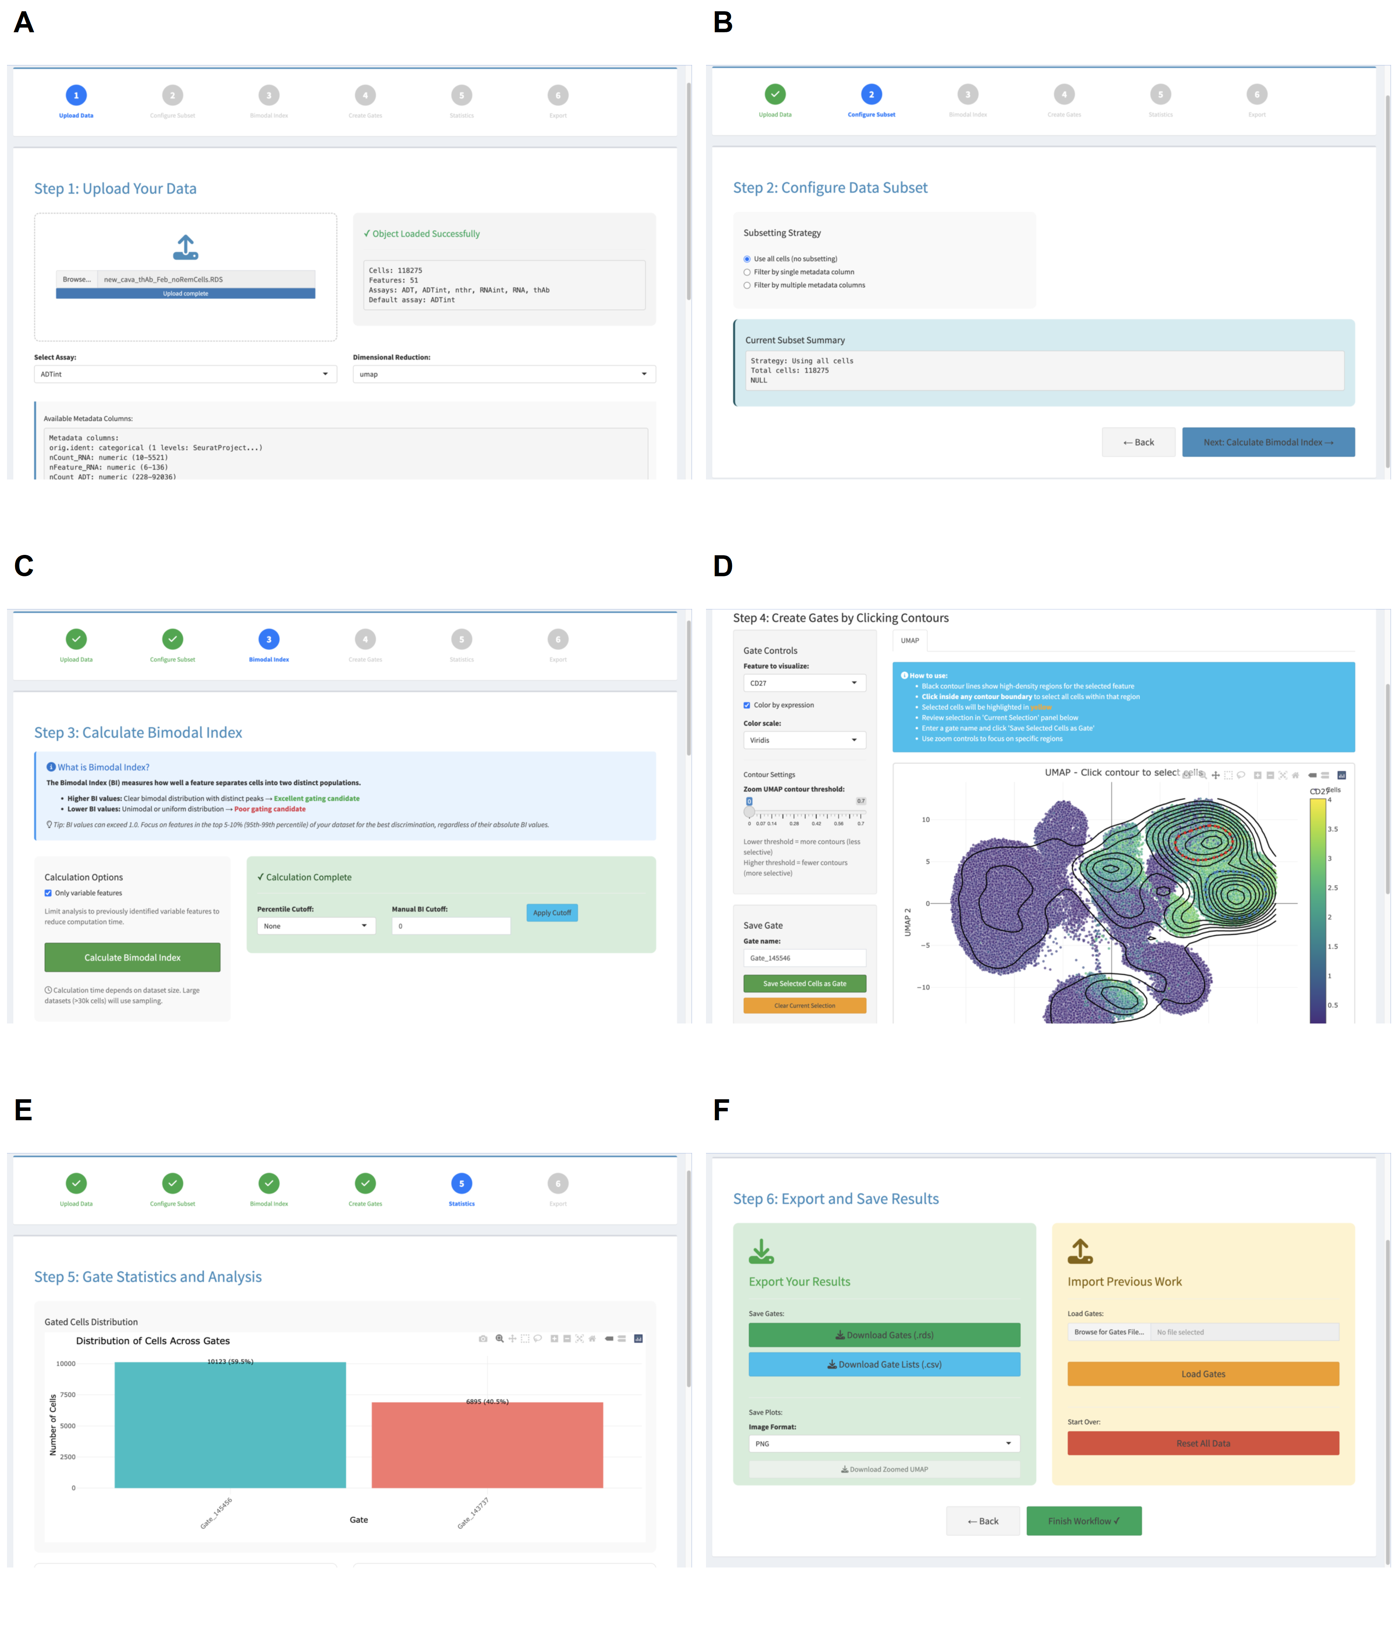
Figure S1: Screenshots of the scDIG application interface illustrating the six-step workflow. (A) Data upload and object validation. (B) Cell subsetting and filtering. (C) Bimodal Index calculation and feature selection. (D) KDE contour visualization and interactive gating. (E) Gate statistics and overlap analysis. (F) Gate export and import.

