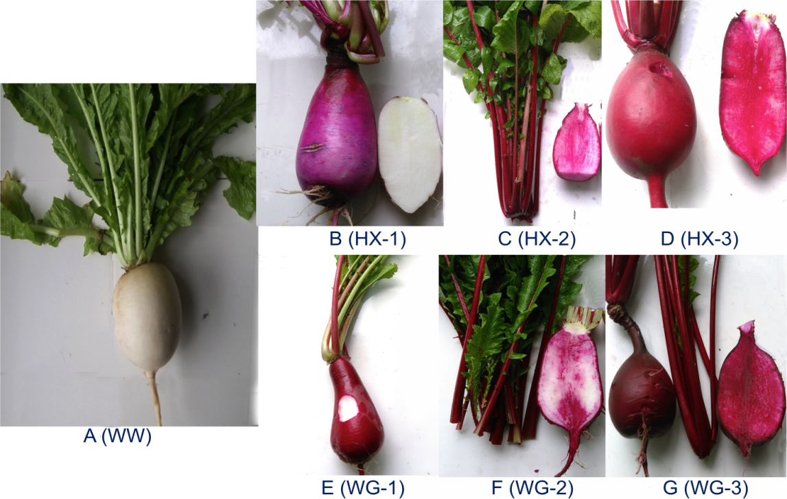
Fig. S1 Fleshy roots from seven types of radish are shown in A-G, including WW (white radish white skin and white fleshy root), HX-1 (Hongxin red skin and white fleshy root), HX-2 (Hongxin red skin and pink fleshy root), HX-3 (Hongxin red skin and red fleshy root), WG-1 (Waguan red skin and white fleshy root), WG-2 (Waguan red skin and pinkly fleshy root) and WG-3 (Waguan red skin and red fleshy root)

