Fig. S1 Structure-based multiple sequence alignment of selected proteins. The predicted compact region by ADM is indicated by a red bar. The brighter red denotes a higher compact density. The conserved hydrophobic residues in the predicted compact region are yellow, and a blue letter is a residue out of the predicted compact region. A black arrow represents beta-strand. A blue bar indicates the conserved predicted compact region when the conservation over than 70% of the aligned site.

Fig. S1 Continued

Fig. S1 Continued

Fig. S1 Continued
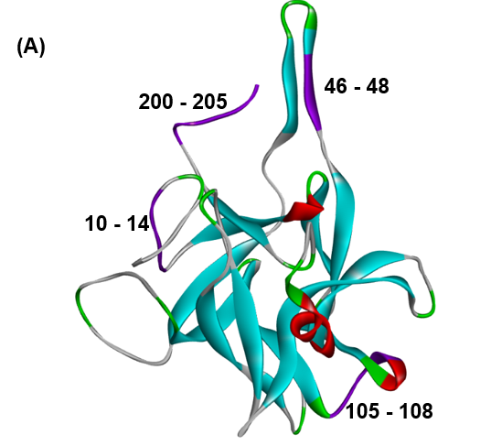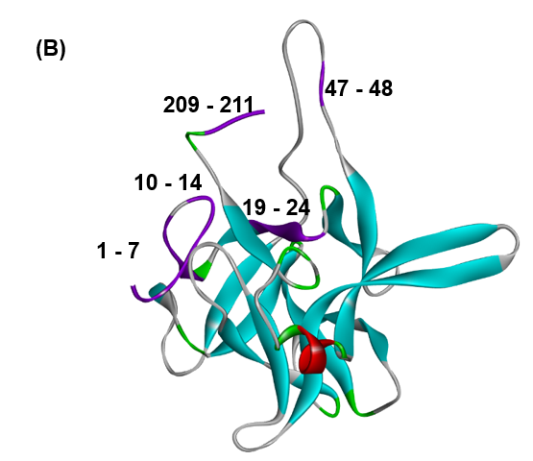
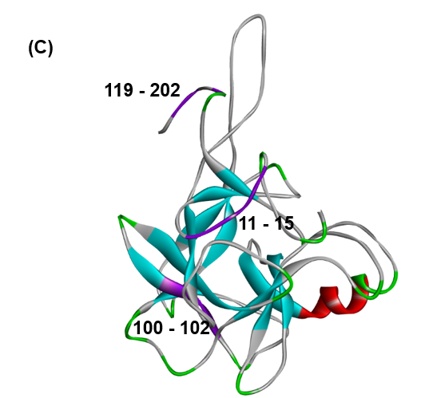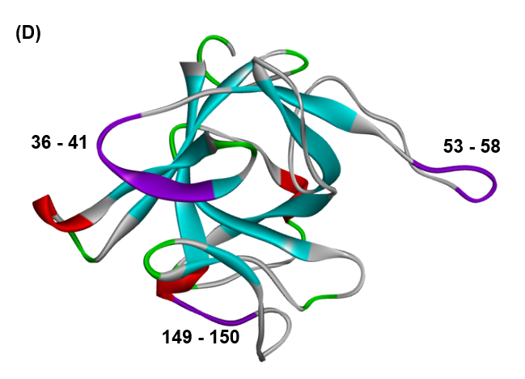
Fig. S2 Predicted disordered regions in 1A8D(A), 1EPW(B), 3BTA(C) and 1TTUY(D) based on the method proposed by Shimomura et al. A predicted disordered region is colored by purple. Similar regions are predicted as disorder in 1A8D, 1EPW and 3BTA because these are classified in the same superfamily.

