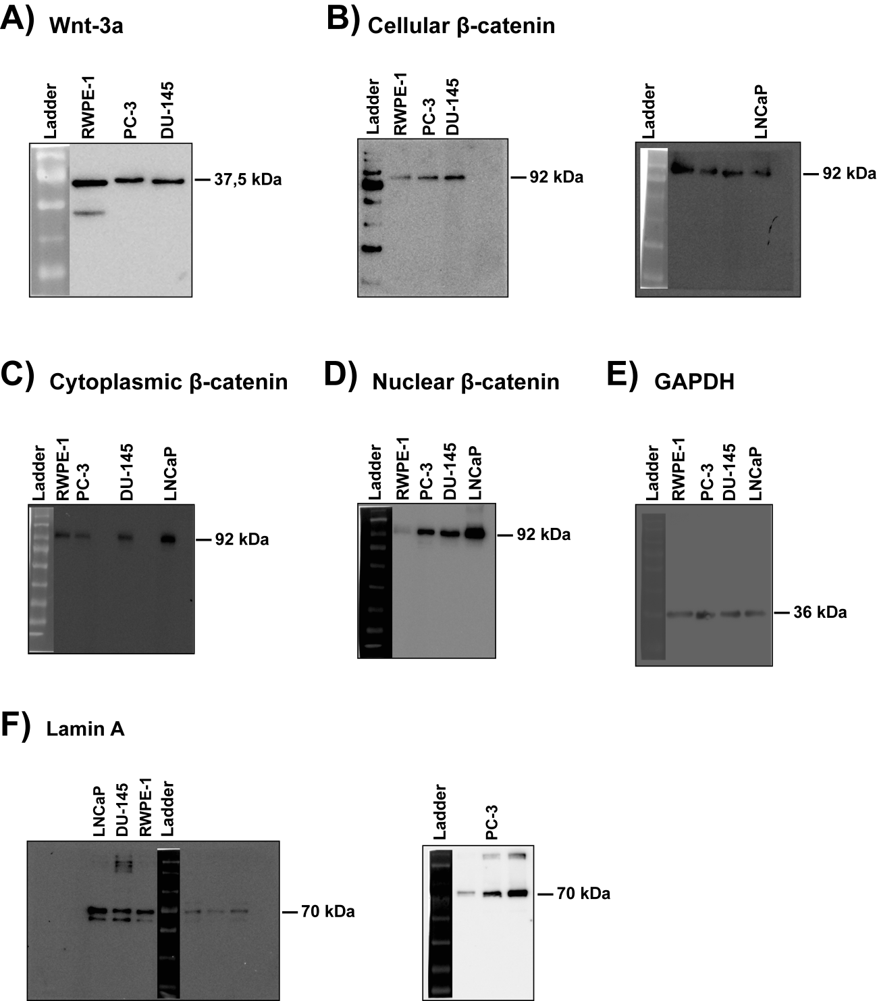

Figure S1. Uncropped immunoblot membranes concerning Figure 5A.

