(a) | 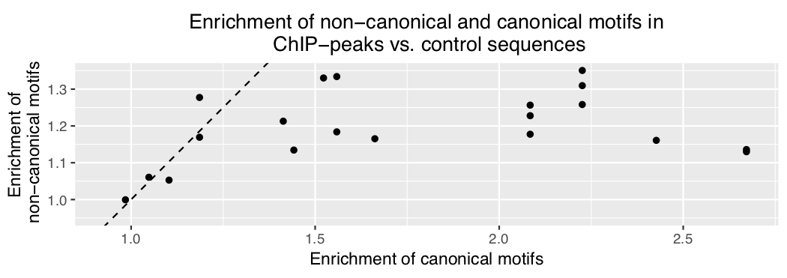
(b) | 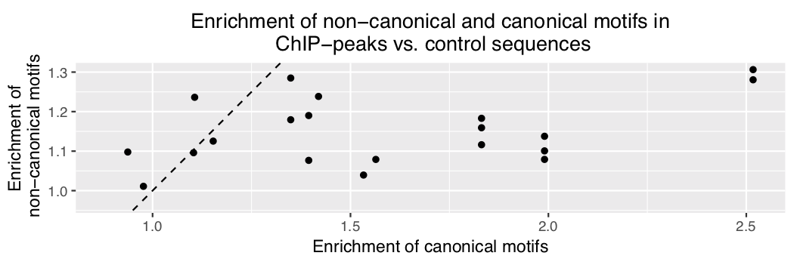
(c)
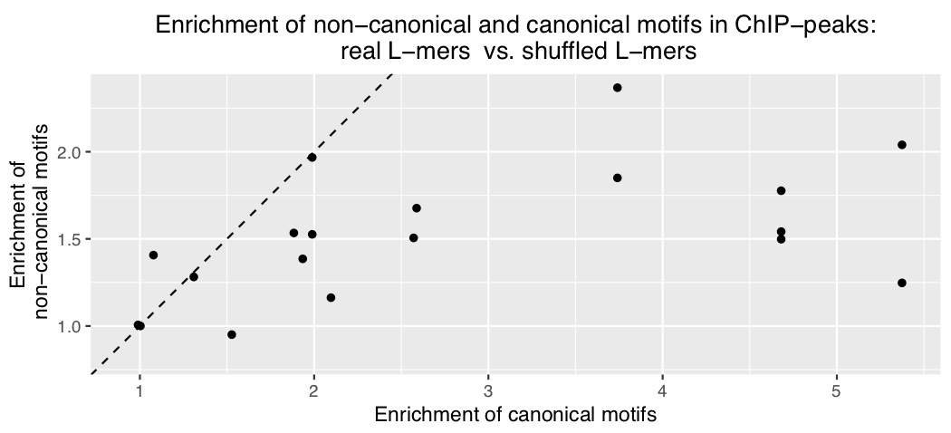
Supplementary Figure 1. Scatterplots showing the enrichments of non-canonical motifs against enrichments of canonical motifs in ChIP-seq data using three different control sequences: (a) dinucleotide shuffled versions of ChIP-peaks, (b) randomly selected genomic sequences matched for length, GC-content, and repeat-content, and (c) shuffled sequences of L-mers constituting the non-canonical and the canonical motifs.

