Figure S1
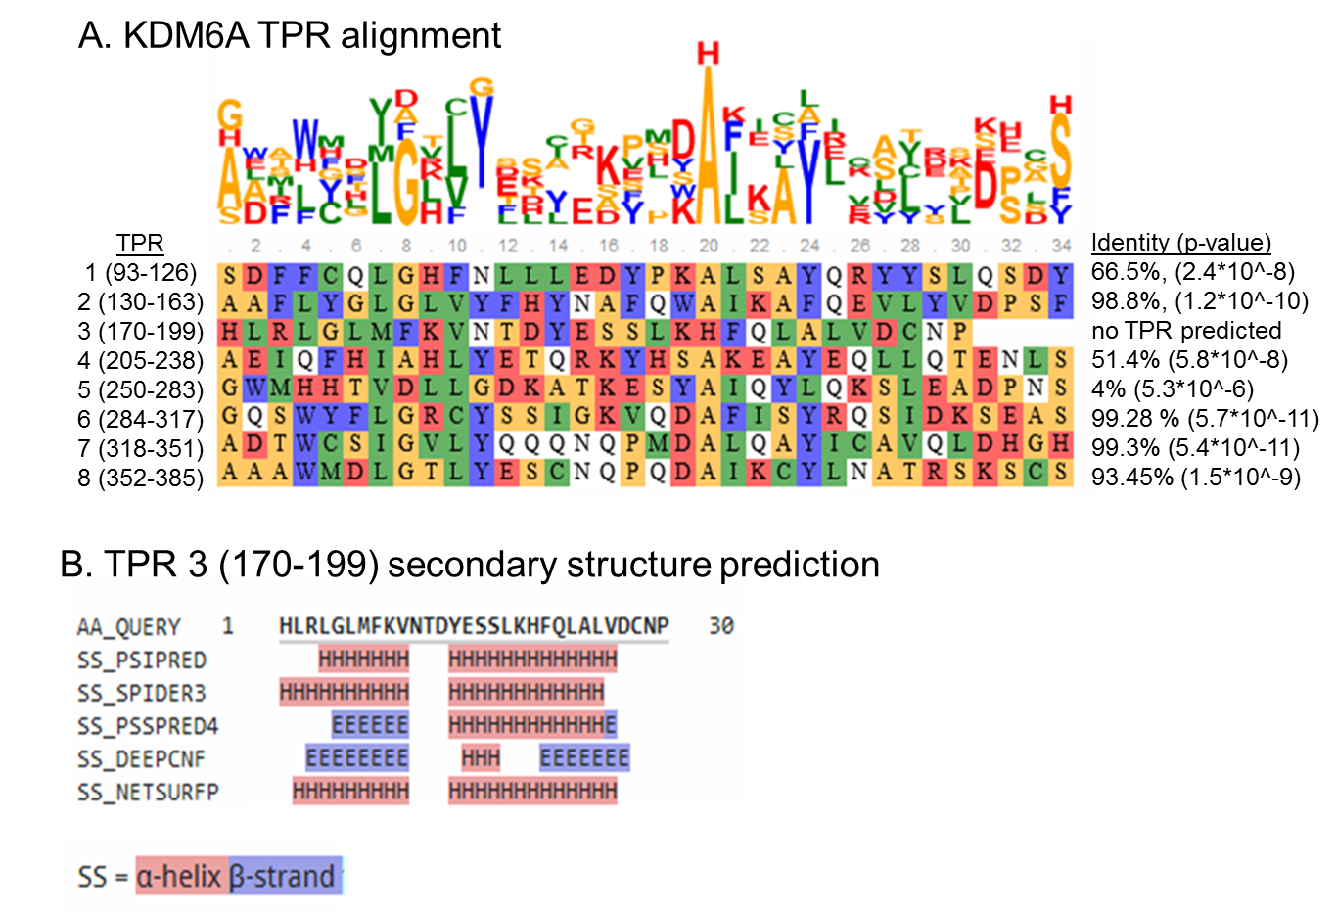
Bioinformatic analysis of KDM6A tetratricopeptide repeats. A. Alignment of annotated KDM6A TPRs using the TPRprediction and alignment tool published in [1]. All annotated KDM6A TPRs with the given amino acid range (see label) were compared for their TPR conservation to the consensus sequence as published in [4] with the most conserved amino acids W4, L7, G8, Y11, A20, Y24, A27 and P30. Identity and p-values are shown on the right hand. The 34 amino acid TPR motif could not be identified for TPR 3 (aa 170-199). Color coding according to CLUSTAL W alignment. B. secondary structure prediction of TPR3 using the Quick2D on the MPI Bioinformatics toolkit server [2, 3] indicated a high probability for aa 14-26 to form an α-helix, but aa 1-10 tend to form either an α-helix or a β-strand. Of note, the canonical 34 aa TPR repeating unit forms the crucial helix-turn-helix motif [4]. In general, the N-terminal TPRs 1-4 show less strict conservation towards the canonical TPR sequence compared to the C-terminal TPRs 6-8.

1. Karpenahalli, M.R., A.N. Lupas, and J. Soeding, TPRpred: a tool for prediction of TPR-, PPR- and SELI-like repeats from protein sequences. Bmc Bioinformatics, 2007. 8.
2. McGuffin, L.J., K. Bryson, and D.T. Jones, The PSIPRED protein structure prediction server. Bioinformatics, 2000. 16(4): p. 404-405.
3. Zimmermann, L., et al., A Completely Reimplemented MPI Bioinformatics Toolkit with a New HHpred Server at its Core. Journal of Molecular Biology, 2018. 430(15): p. 2237-2243.
4. Main, E.R.G., et al., Design of stable alpha-helical arrays from an idealized TPR motif. Structure, 2003. 11(5): p. 497-508.

