S1. Copy numbers of integrated lentiviral vectors were measured by the standard curve of real time PCR of puromycin resistant gene (Rotor-Gene 6000 Series Software 1.7). The titer of recombinant anti-MUC1 CAR lentiviral vector in transforming unit per mL was calculated 1.12 x 10⁸ TU/mL from real time PCR results. The image represents standard curve of quantification of virus copy numbers in 10-fold-dilutions (4.32 X 10⁶-4.32 X 10³ viral copies/ul). The results indicates CAR recombinant lentiviral titer was 1.12 X 105 viral particle/ul. DNA copy number of standards was calculated by this formula: number of copies = (amount (ng) * 6.022x1023) / (length (bp) * 1x10⁹ * 650)

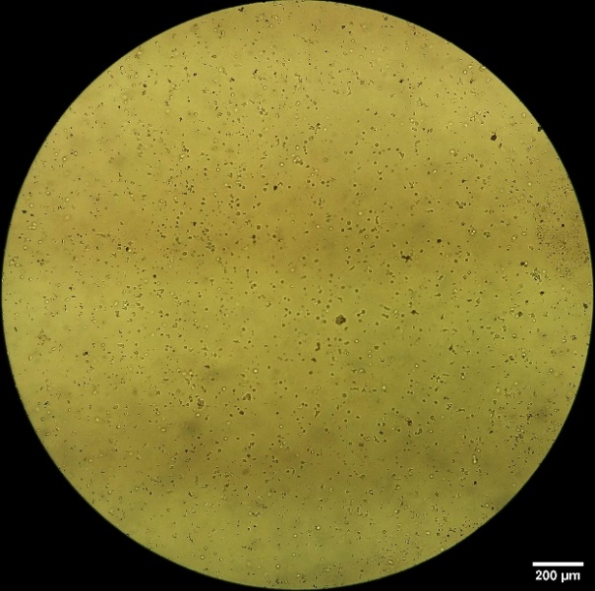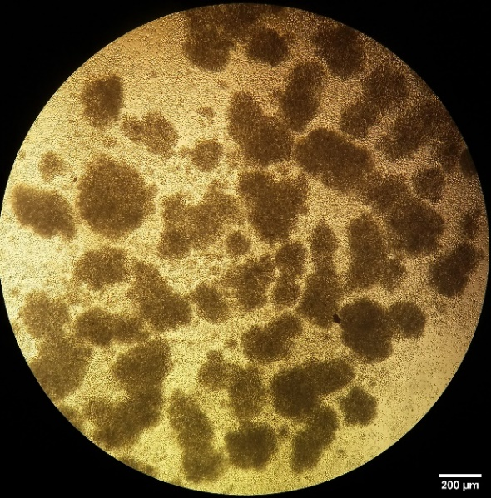
S2. Stimulation and enrichment of CD3⁺ T cells 48h after treatment by CD3/CD28 DynabeadsTM T-activator

