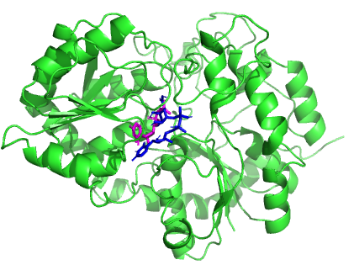

Additional file 8: Identification of cofactor location of UGT2B10 Model (by superposition with UGT76G from Stevia rebaudiana (PDB ID: 6INF) (Color codes: Blue: UDP orientation in UGT2B10 and Magenta: UGP orientation in crystal structure)

