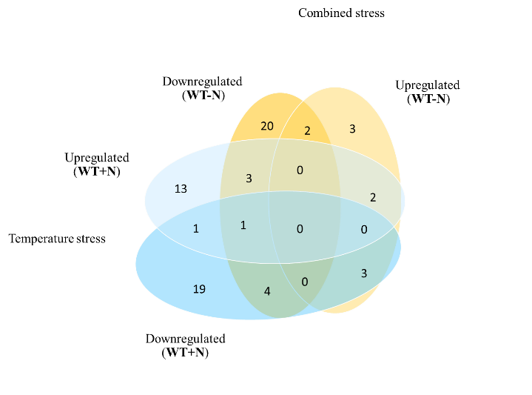
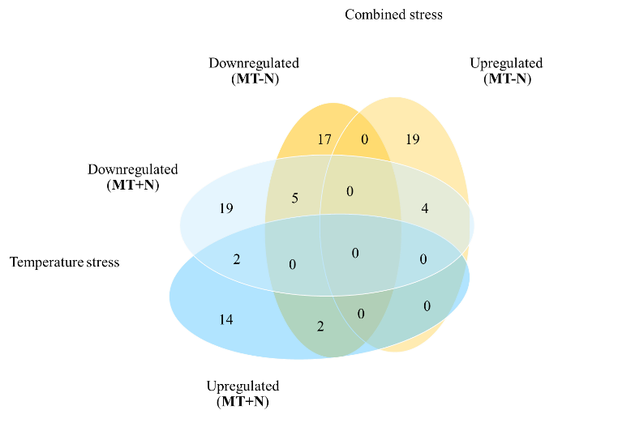
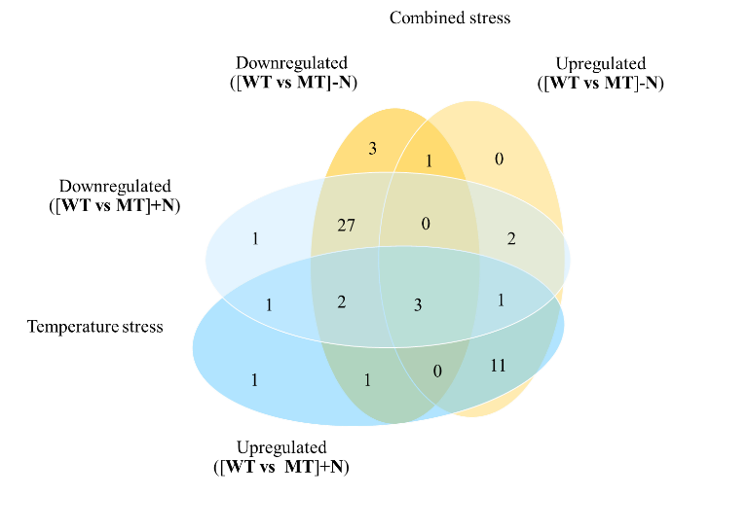
A
B
C

Supplementary Figure 4 Venn diagram showed the numbers of up- and downregulated proteins of (A) Synechocystis-WT, (B) MT and (C) both of WT and MT strains under temperature stress, combined stress and others.

