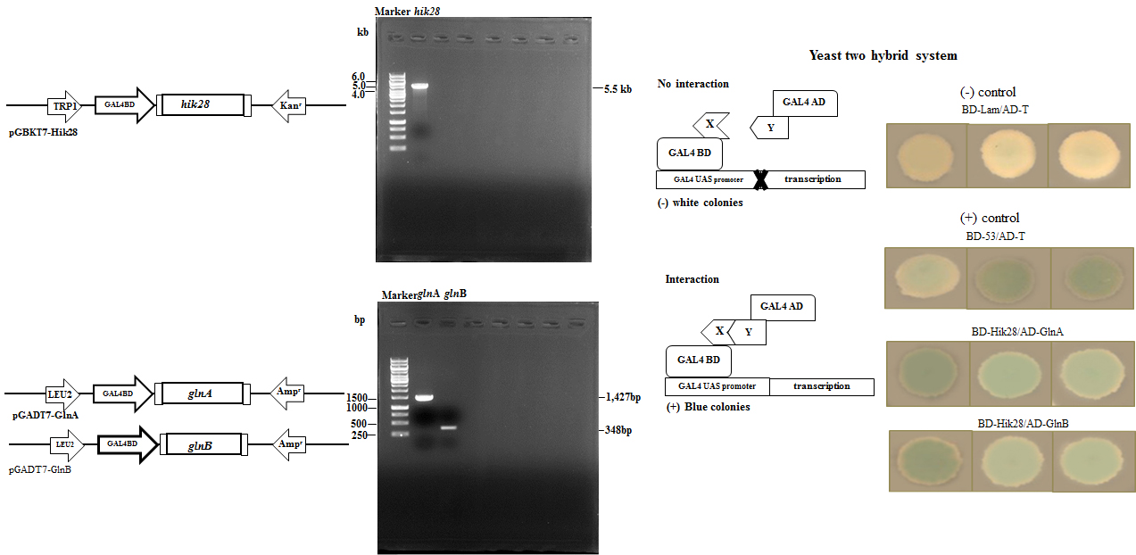
C
A
B

Supplementary Figure 2 Yeast two hybrid system; (A) the construction of hik28 gene in pGBKT7, (B) glnA and glnB genes in pGADT7 vector, (C) the negative result of AD-T and BD-Lam (white colonies) and the positive results (blue colonies) of AD-T and BD-53, Arthrospira-Hik28 and its client proteins, GlnA and GlnB, (modified from Kurdrid, 2020).

