Blue: helix Orange: sheet Grey: loop
TET1-PDB:6ASD TET2-PDB:4NM6 TET3-PDB:4Z3C
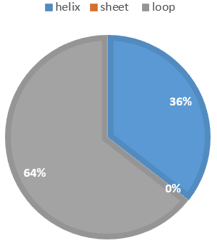
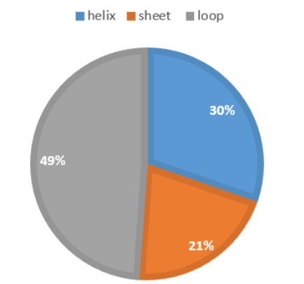
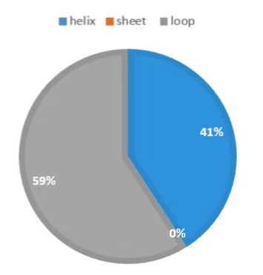

DNMT1-PDB:3PTA DNMT2-PDB:1G55 DNMT3A-PDB:5YX2
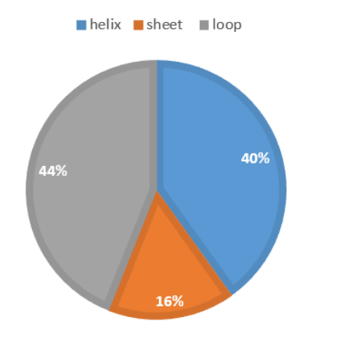
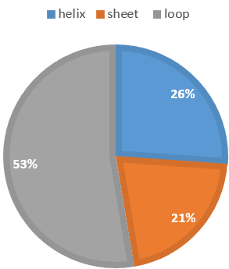
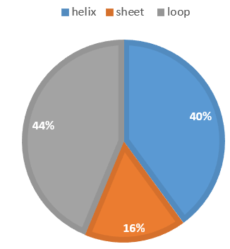

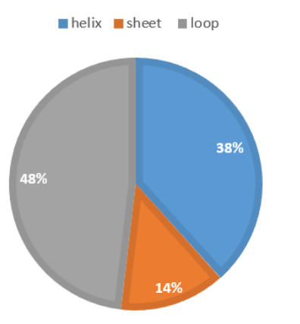
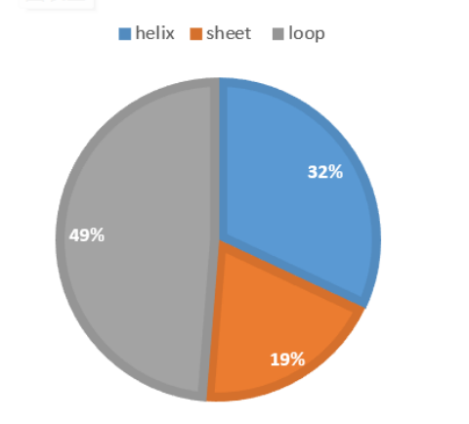
DNMT3B-PDB:6PA7 DNMT3L-PDB:2PV0

