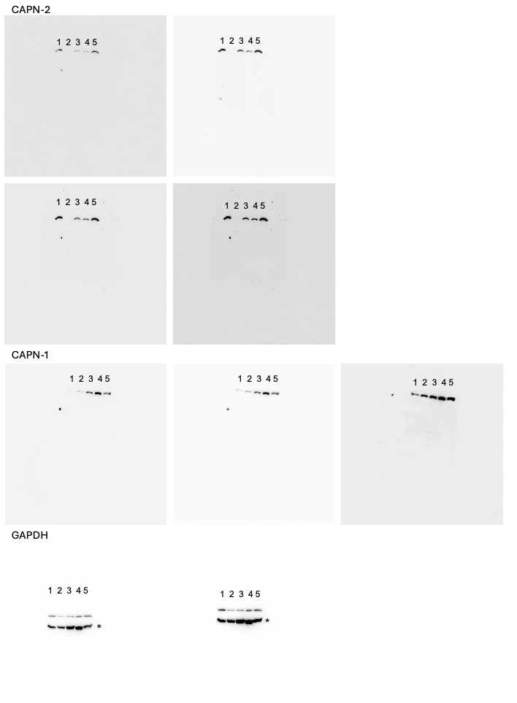
Original western blot images of Figure 1 with different exposures. Lanes: MDA-MB-231, MCF7, ZR-75-1, HCC1937, MCF10A * below bands on GAPDH images are residual signal from previous blot of an unrelated protein._
Original figure legend:___ Figure 1. Expression of CAPN-1 and CAPN-2 in different breast cell lines. CAPN-1 and CAPN-2 protein levels in the cell lines cultured, as described in the Materials and Methods section, were analyzed by Immunoblotting. GAPDH was used as the loading control. Corresponding uncropped/unprocessed full-length blots are included in Figure S3A.
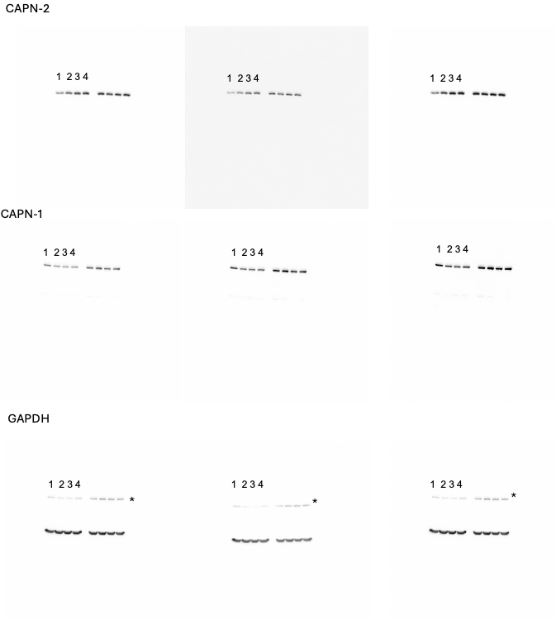
Original western blot images of left panel of Figure 2A with different exposures. First 4 lanes: Control siRNA and 3 different (siRNA1, siRNA2, siRNA3) CAPN-1 siRNA-transfected HCC1937 cells. Last 4 lanes: Control siRNA and siRNAs against another enzyme not related to the submitted manuscript. * upper bands on GAPDH images are residual signal from previous blot of CAPN-1.
___Original figure legend:___ Figure 2. CAPN-1 and CAPN-2 exert opposite functions in HCC1937 cell proliferation. (A) HCC1937 cells were transfected with three duplex siRNA for CAPN-1 (2 nM) and CAPN-2 (15 nM). Protein levels were then detected by immunoblotting. Corresponding uncropped/unprocessed full-length blots are included in Figure S3B and S3C.
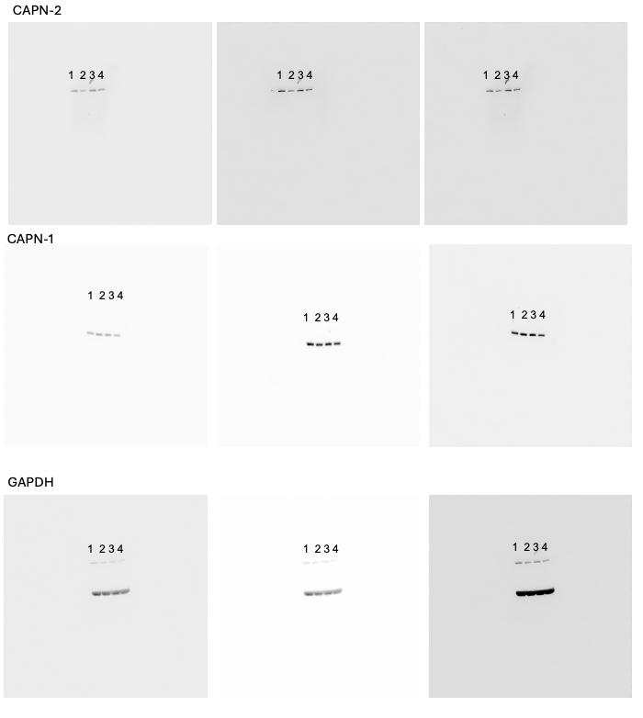
Original western blot images right panel of Figure 2A with different exposures. Lanes: Negative siRNA and 3 different (siRNA1, siRNA2, siRNA3) CAPN-2 siRNA-transfected HCC1937 cells.
___Original figure legend:___ Figure 2. CAPN-1 and CAPN-2 exert opposite functions in HCC1937 cell proliferation. (A) HCC1937 cells were transfected with three duplex siRNA for CAPN-1 (2 nM) and CAPN-2 (15 nM). Protein levels were then detected by immunoblotting. Corresponding uncropped/unprocessed full-length blots are included in Figure S3B and S3C.

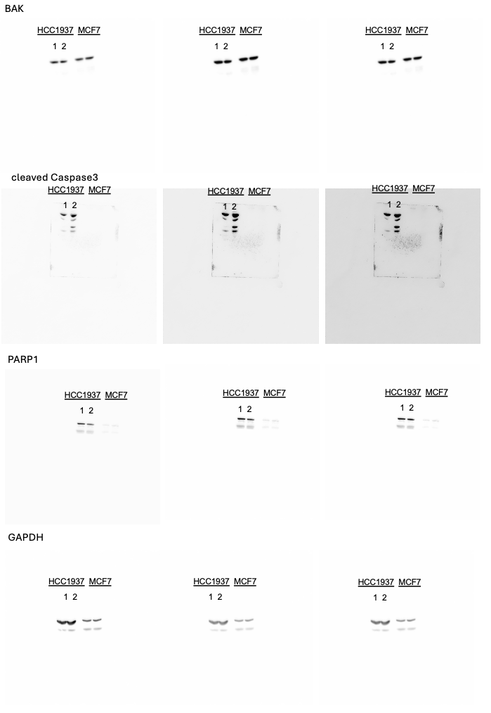
Original western blot images of right panel of Figure 2D with different exposures. exposures. First 2 lanes: Negative siRNA and CAPN-1 siRNA-transfected HCC1937 cells. Last 2 lanes: Result from MCF7 cells which are not related to the submitted manuscript. MCF7 cells do not express caspase 3.
___Original figure legend:___ Figure 2. CAPN-1 and CAPN-2 exert opposite functions in HCC1937 cell proliferation. (D) After HCC1937 cells were transfected with CAPN-1 siRNA, levels of CAPN-1, CAPN-2, Bcl-2, BAK, PARP-1, and cleaved caspase 3 were determined via immunoblotting. The experiments were repeated three times independently, with one representative result shown. Corresponding uncropped/unprocessed full-length blots are included in Figure S3D and S3E.
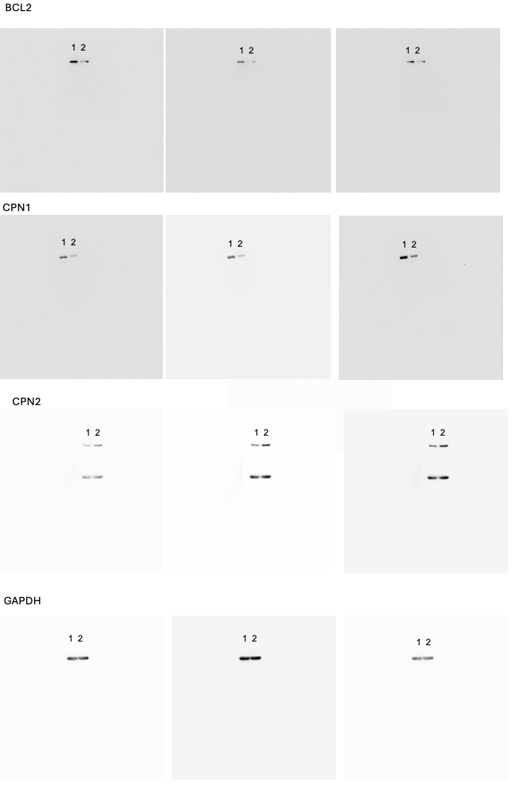
Original western blot images of left panel of Figure 2D with different exposures. exposures. Lanes:Control siRNA and CAPN-1 siRNA-transfected HCC1937 cells.
__Original figure legend:__ Figure 2. CAPN-1 and CAPN-2 exert opposite functions in HCC1937 cell proliferation. (D) After HCC1937 cells were transfected with CAPN-1 siRNA, levels of CAPN-1, CAPN-2, Bcl-2, BAK, PARP-1, and cleaved caspase 3 were determined via immunoblotting. The experiments were repeated three times independently, with one representative result shown. Corresponding uncropped/unprocessed full-length blots are included in Figure S3D and S3E.

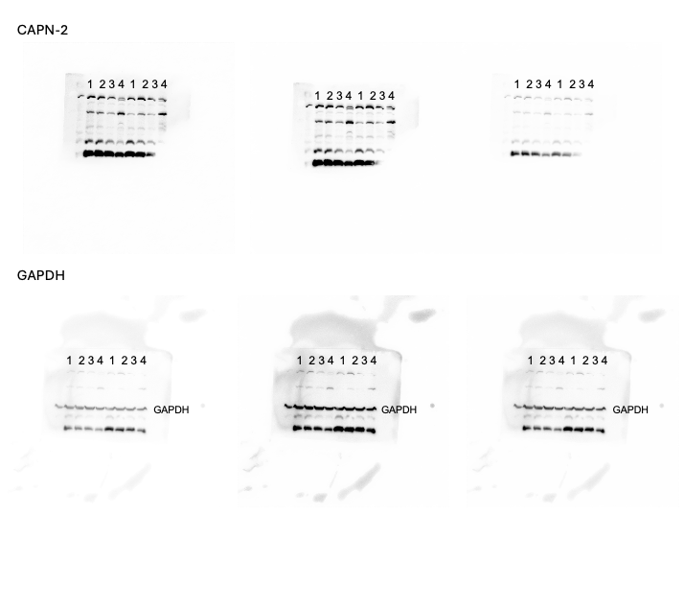
Original western blot images of upper panel of Figure 3A with different exposures. Lanes: DMSO and three different doses (4, 8, and 16 μM) of AG-08 treated HCC1937 cells. *The membrane includes two sets of experiment.
___Original figure legend:___ Figure 3. Effect of the calpain activator AG-08 on CAPN-1 and CAPN-2. HCC1937 cells were treated with AG-08 (4, 8, and 16 μM) for 16 hours. (A) The protein levels of CAPN-1 and CAPN-2 were analyzed via immunoblotting. Corresponding uncropped/unprocessed full-length blots are included in Figure S3F and S3G.

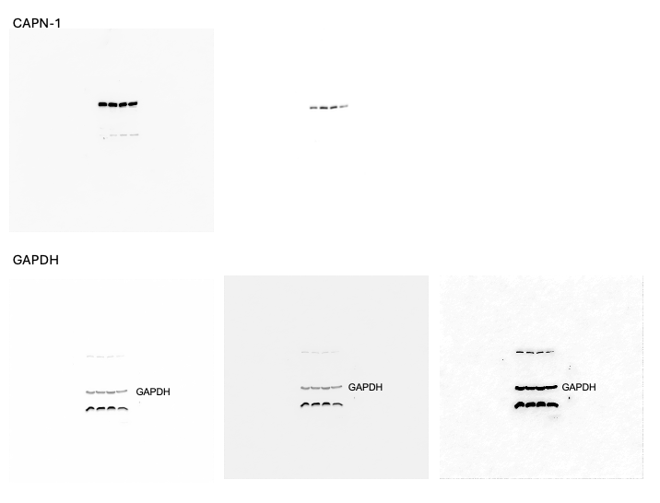
Original western blot images of lower panel of Figure 3A with different exposures. Lanes: DMSO and three different doses (4, 8, and 16 μM) of AG-08 treated HCC1937 cells.
___Original figure legend:___ Figure 3. Effect of the calpain activator AG-08 on CAPN-1 and CAPN-2. HCC1937 cells were treated with AG-08 (4, 8, and 16 μM) for 16 hours. (A) The protein levels of CAPN-1 and CAPN-2 were analyzed via immunoblotting. Corresponding uncropped/unprocessed full-length blots are included in Figure S3F and S3G.

