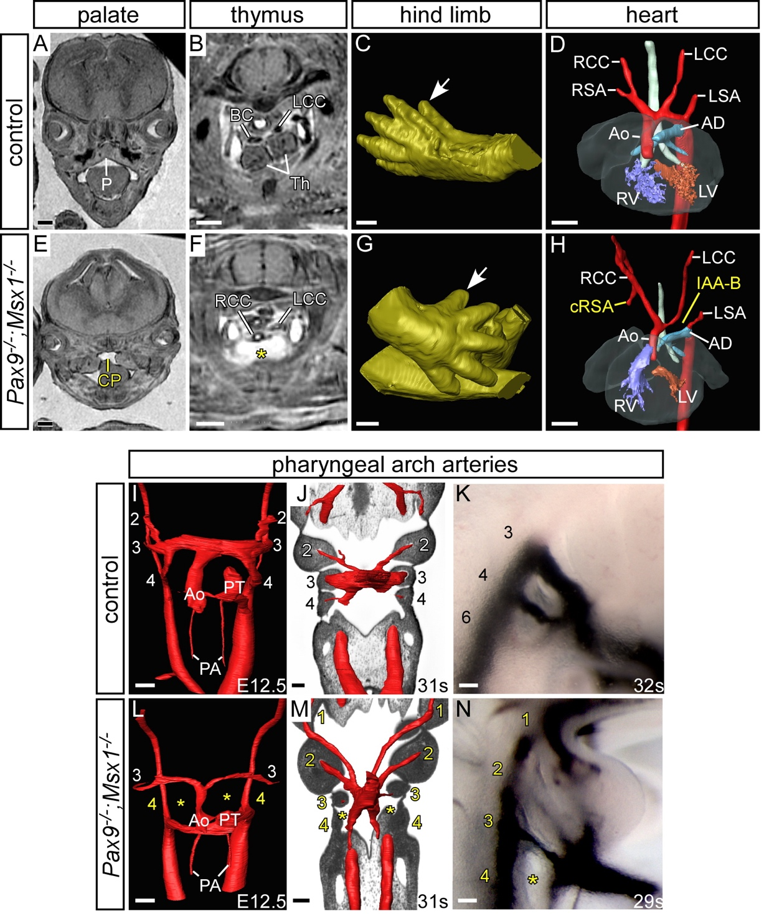

Additional file 2. Defects in Pax9–/–;Msx1–/– embryos on a congenic CD1 genetic background.
Embryos at E15.5 were imaged by MRI (A-H), at E12.5 (I, L) and E10.5 (J, M) by HREM, and at E10.5 following intracardiac ink injection (K, N). Panels A-D are taken from Figure 1 for comparison. (A-D) Control embryos have a normal palate (A), thymus (B), hind limb digit (white arrow; C), heart and arch arteries (D). (E-H) Pax9–/–;Msx1–/– embryos display cleft palate (CP; E), absent thymus (asterisk; F) but do not have pre-axial digit duplication (white arrow; G) as seen in Pax9–/– and Pax9–/–;Msx1^{+/–} embryos (see Figs 1H, 5D and 6B,C). (H) Some Pax9–/–;Msx1–/– embryos have cardiovascular defects such as cervical origin of the right subclavian artery (cRSA) and interrupted aortic arch type B (IAA-B). (I-K) Control embryos showing normal pharyngeal arch artery (PAA) development. (I) Embryo at E12.5 with a septated outflow tract and symmetric 3rd and 4th PAAs. (J) Embryo at E10.0 with symmetric 2nd and 3rd PAAs. The 4th PAA is forming. (K) Embryo at E10.0 with symmetrical 3rd, 4th and 6th PAAs patent to ink. (L-N) Pax9–/–;Msx1–/– embryos have aberrant PAA morphogenesis. (L) E12.5 embryo with hypoplastic 3rd and absent 4th PAAs. The outflow tract is not fully septated. (M, N) E10.0 embryos with aberrantly persisting 1st and 2nd, hypoplastic 3rd and absent 4th PAAs.
Abbreviations: AD, arterial duct; Ao, aorta: LCC/RCC, left/right common carotid artery; LSA/RSA, left/right subclavian artery; LV/RV, left/right ventricle; P, palate; PA, pulmonary artery; PT, pulmonary trunk; Th, thymus. Scale bars: 500µm in A-H, 100µm in I-N.

