Additional file 1
for
Pigmentary and photonic coloration mechanisms reveal taxonomic relationships of the Cattlehearts (Lepidoptera: Papilionidae: Parides)
by Bodo D. Wilts, N. IJbema and D.G. Stavenga

Supplementary Figures

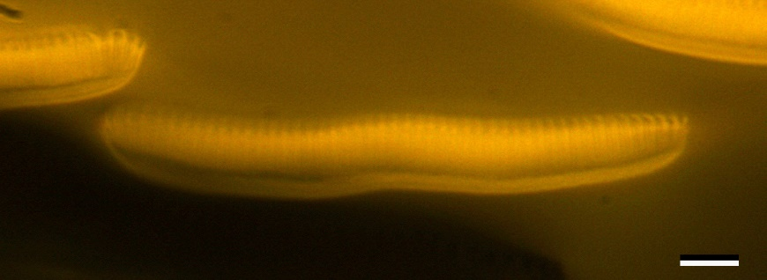
Figure S1. Fluorescence microscopy image of perpendicularly sectioned green wing scales of P. aeanas, using blue excitation light (450–490 nm) and a >520 nm barrier filter, showing that the scale’s pigment is mostly concentrated in the upper lamina. A SEM image of a cross-sectioned scale is shown in figure 1L; scale bar: 10 µm.

Figure S2. Reflectance spectra of the underside of green scales of Parides aeneas. The red curve is the average of five reflectance spectra measured with a microspectrophotometer; the dashed grey lines indicate the standard deviations. The blue curve is the reflectance spectrum modeled using classical multilayer theory.

Taxonomy
We used different phylogenies which are hereafter classified in more detail.

Classification 1: Condamine et al. (2012) (refined results from Silva-Brandao et al. 2005)
Technique: inferred from DNA barcoding with maximum parsimony, maximum likelihood (ML) and Bayesian inference (see also ref. Condamine et al., 2012; Silva-Brandao et al., 2005).
Number of included Parides species: 18
Silva-Brandao et al. (2005) divided Parides into four major lineages
- G1: P. ascanius, P. bunichus
- G2: P. agavus, P. proneus
- G3: P. chabrias, P. childrenae, P. photinus, P. sesostris, P. anchises, P. vertumnus
- G4: P. aeneas, P. tros, P. eurimedes, P. neophilus, P. zacynthus, P. lysander, P. panthonus
The species-level phylogenetic tree that was presented by Silva-Brandao et al. (2005) and was refined by Condamine et al. (2009) is shown in Figure 6A.

Classification 2: Möhn et al. (Möhn et al., 2007)
Technique: unknown
Number of included Parides species: 36.
Möhn et al. (2007) divided the Cattlehearts, Parides, into 6 species groups (Fig. 6B):
- Ascanius: P. agavus, P. alopius, P. ascanius, P. bunichus, P. gundlachianus, P. montezuma, P. phalaecus, P. photinus, P. proneus
- Klagesi: P. klagesi
- Chabrias: P. chabrias, P. hahneli, P. mithras, P. pizarro, P. quadratus, P. vercingetorix
- Aeneas: P. aeneas, P. aglaope, P. burchellanus, P. echemon, P. eurimedes, P. lysander, P. neophilus, P. orellana, P. panthonus, P. tros, P. zacynthus
- Sesostris: P. childrenae, P. sesostris
- Anchises: P. anchises, P. cutorina, P. erithalion, P. iphidamas, P. panares, P. phosphorus, P. vertumnus

