Figure S1 Patters of pairwise intronic substitution distances of 45 bird species
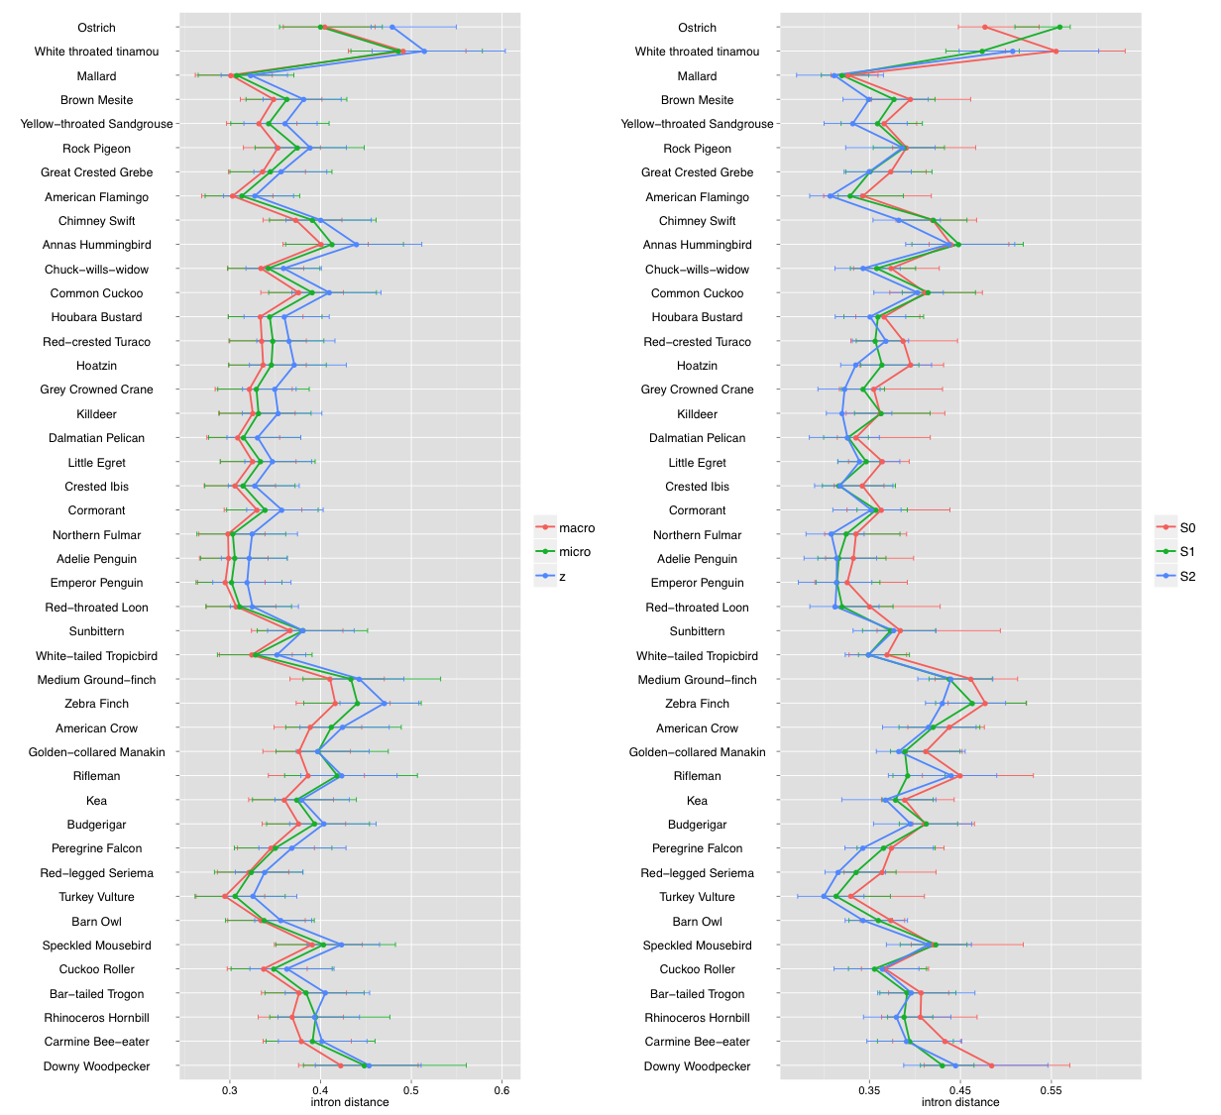

Figure S2. The correlation between life history traits and male-driven evolution
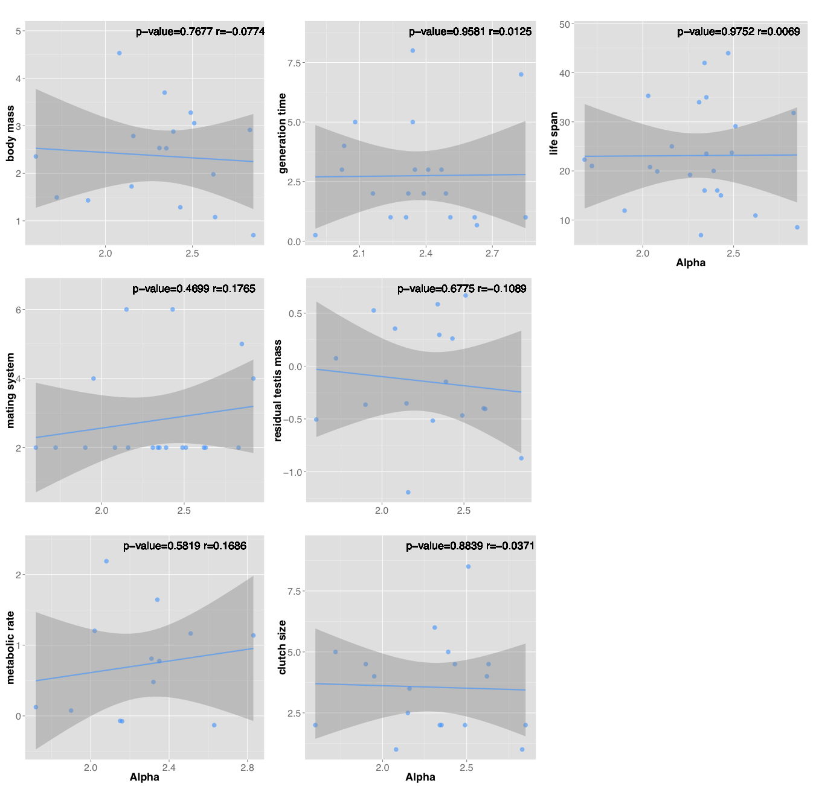

Figure S3. Patters of branch-specific synonymous substitution rates of 45 bird species
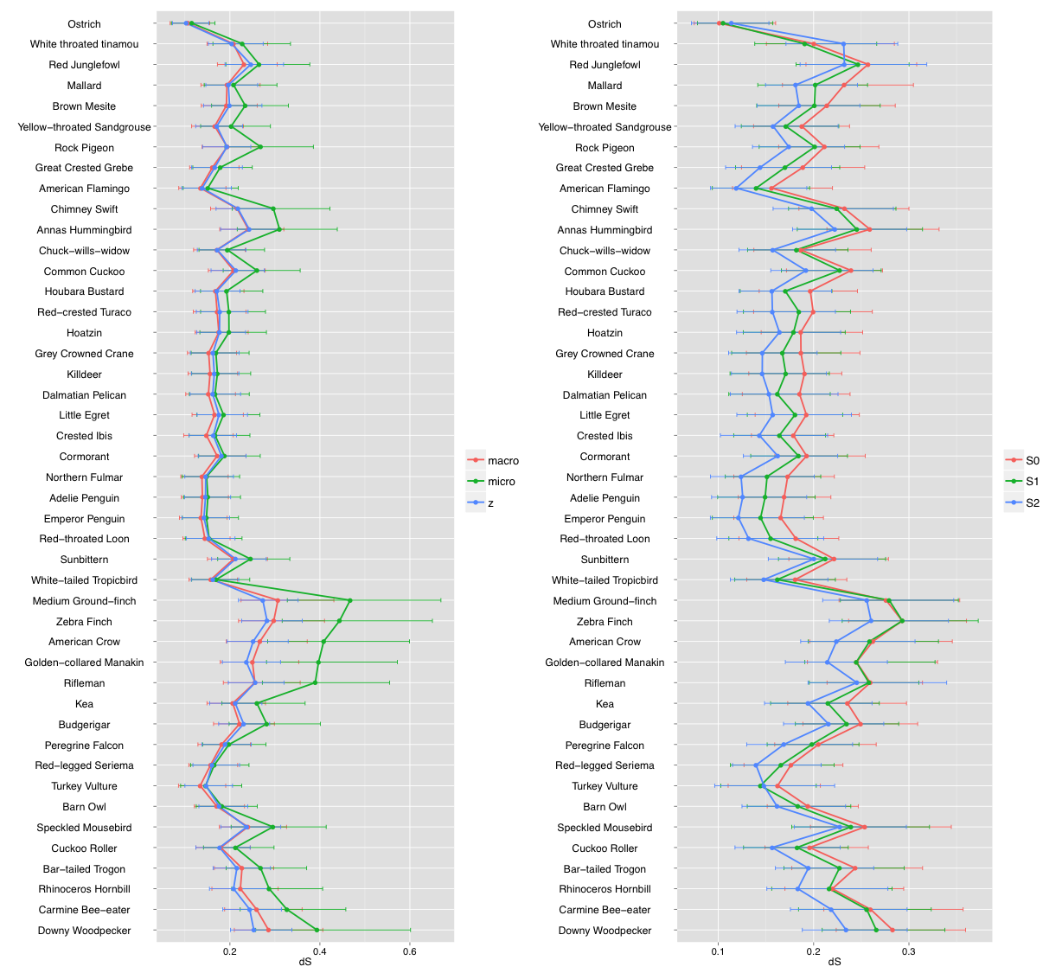

Figure S4. Patters of frequency of optimal codons of 45 bird species
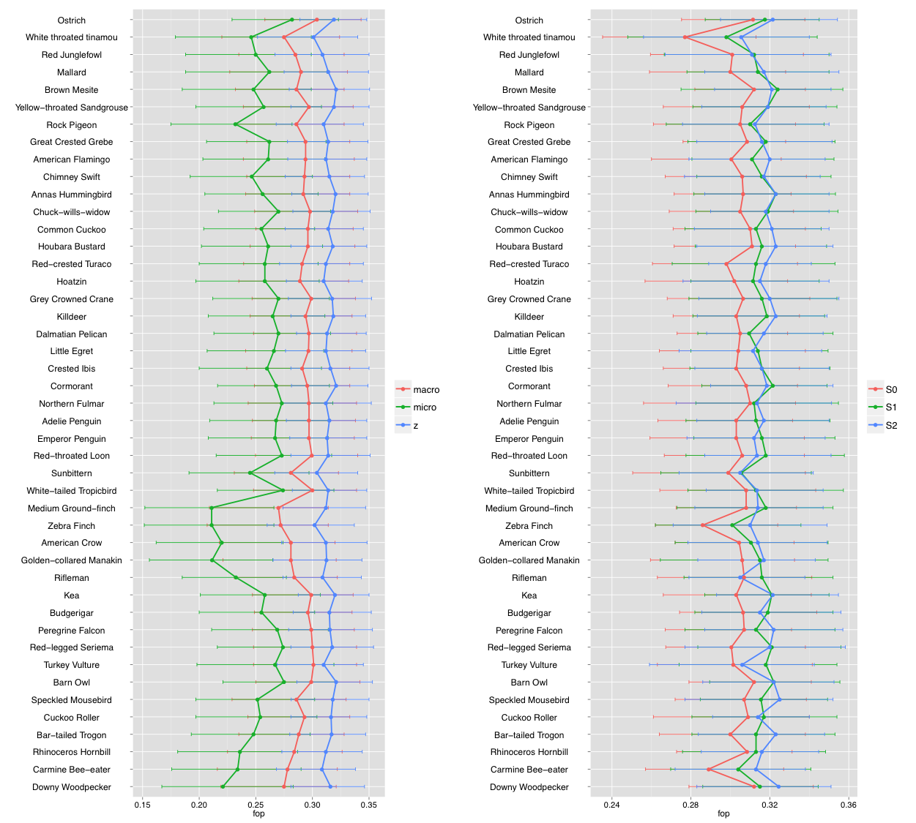

Figure S5. Patters of G+C content in the third codon positions of 45 bird species
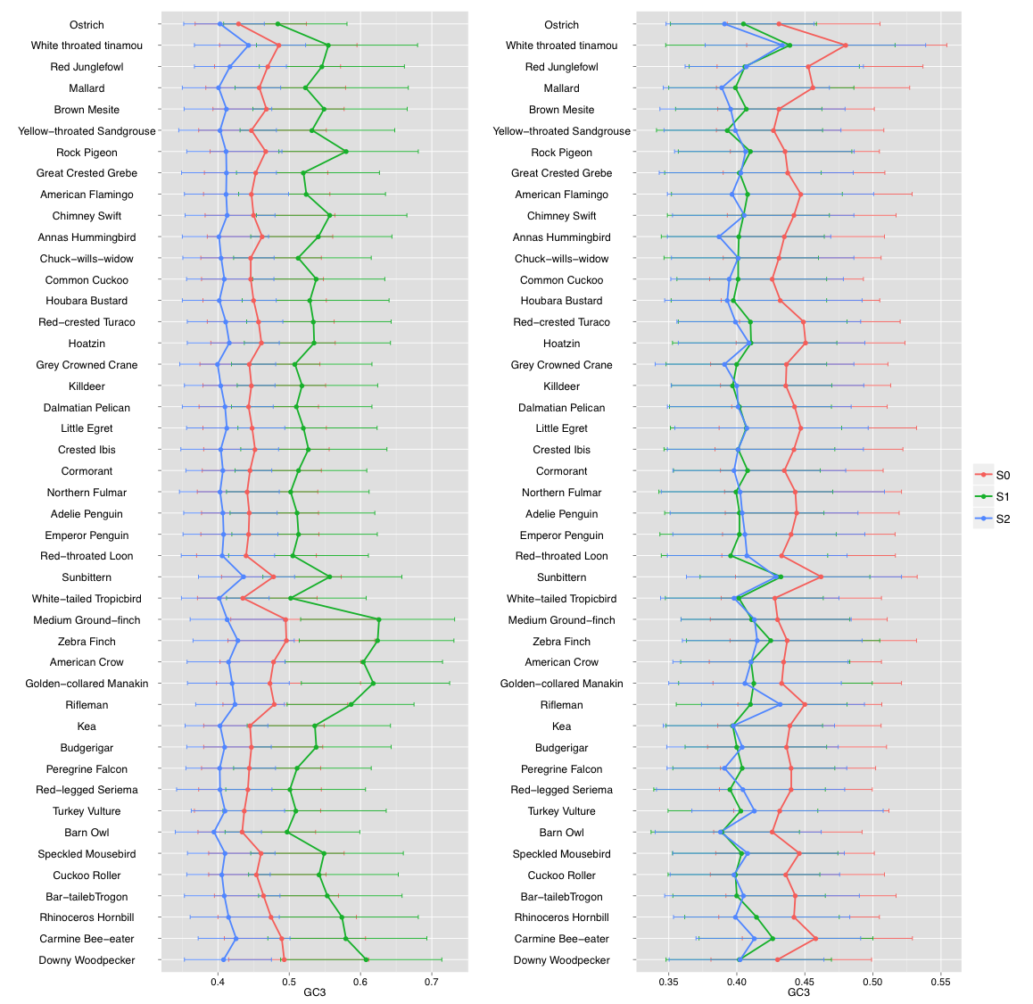

Figure S6. Patterns of G+C content in introns of 45 bird species
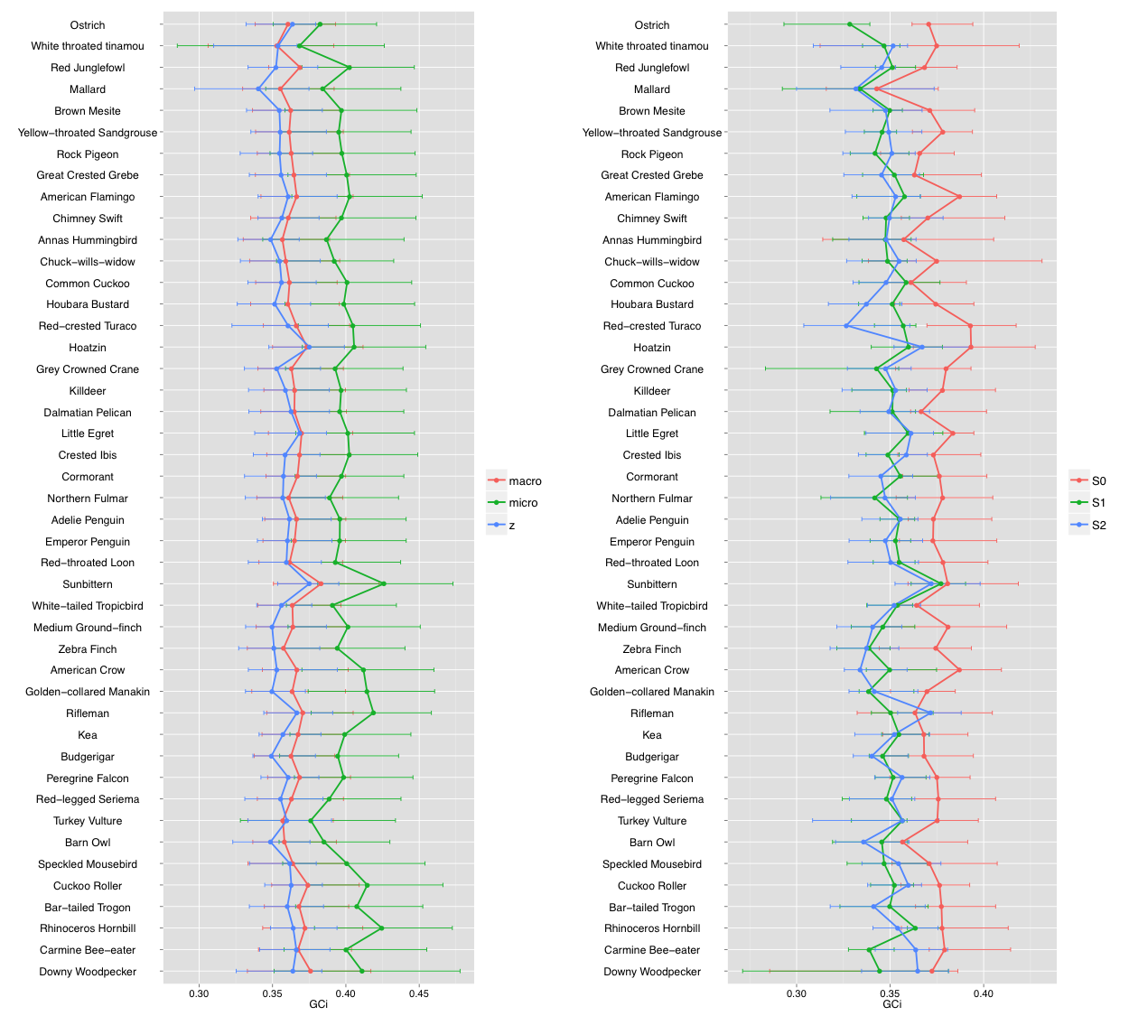

Figure S7. Patterns of lineage-specific evolutionary rate (dN/dS) of 45 bird species
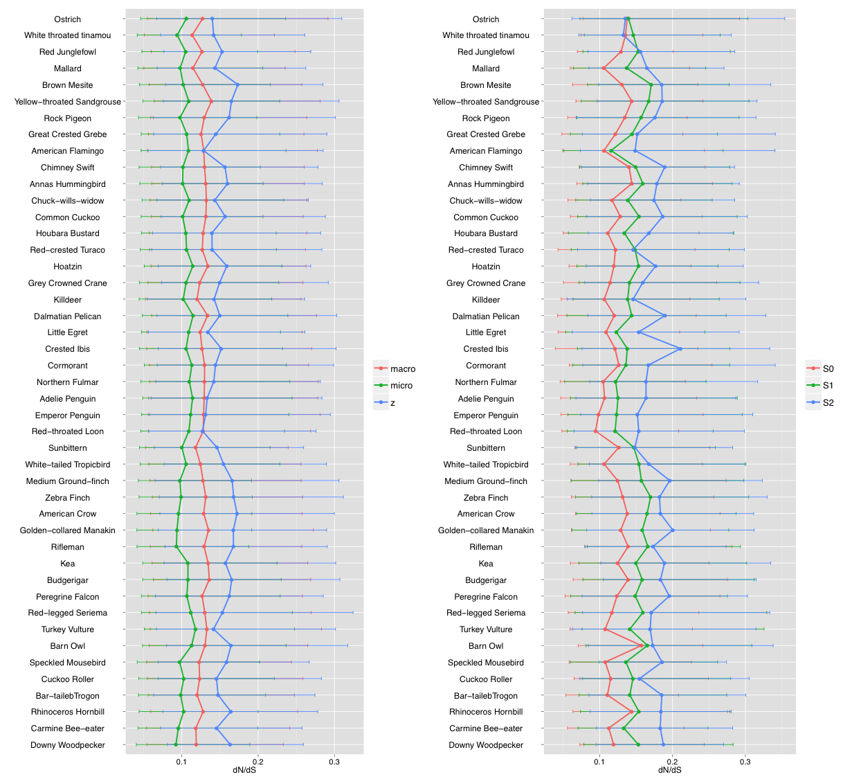

Figure S8. Patterns of nonsynonymous substitution rates of 45 bird species
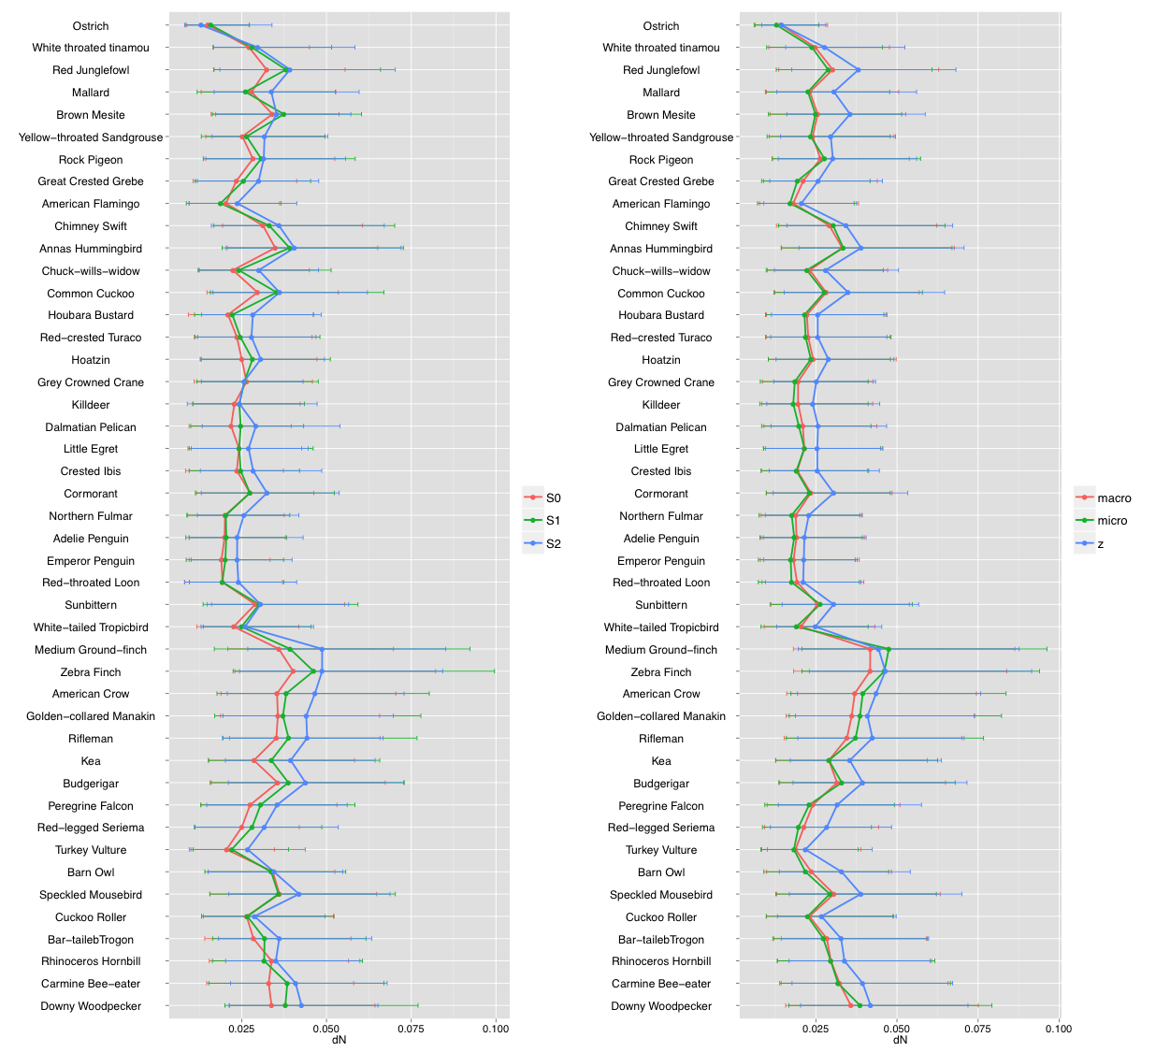

Figure S9 The association of sex-biased gene expression with gene evolutionary rate
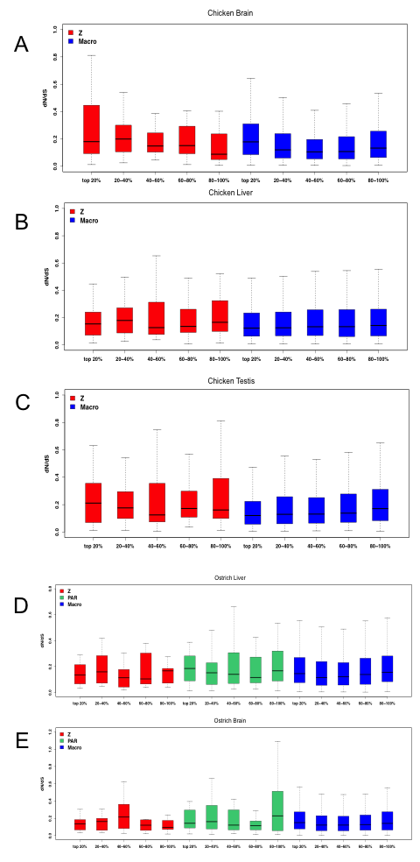
Figure S10 The correlation between life history traits vs. fast-Z evolution
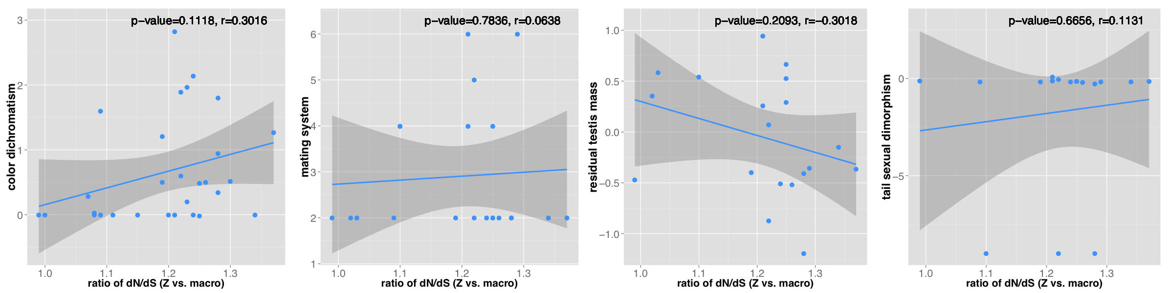

Figure S11. Extensive intra-chromosomal genomic rearrangements occurred surrounding the chicken MHM locus
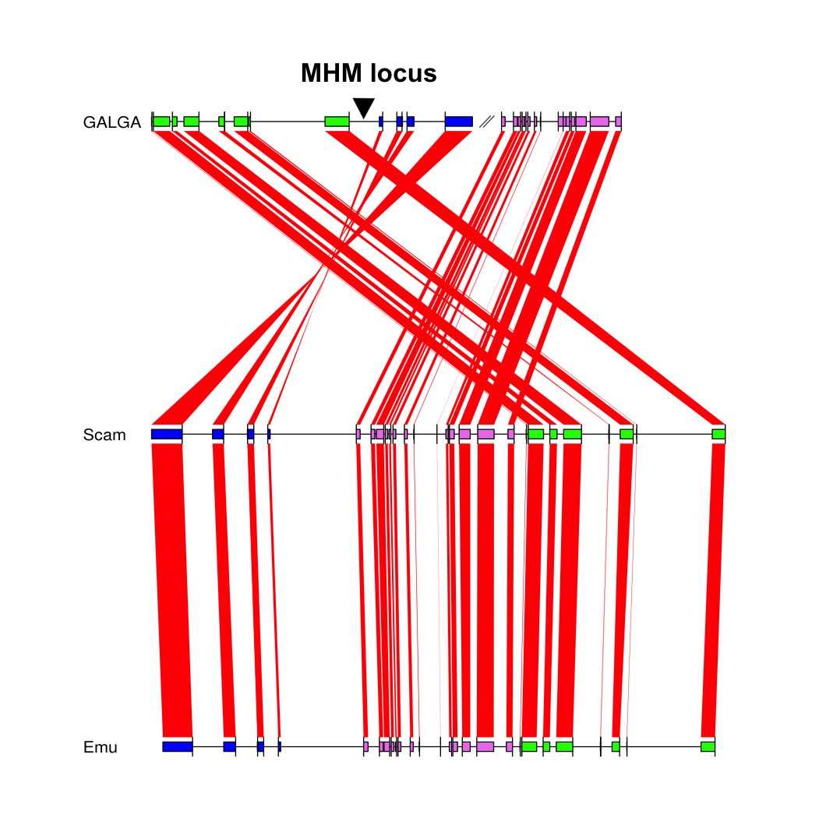

Figure S12. The distribution of gene expression level across different chromosome sets
