Table S1. Locality coordinates for each of the 29 Niveoscincus ocellatus populations used in this study. *localities where DNA samples were obtained from museum specimens.
Clade | Locality | Latitude °S | Longitude °E | mtDNA samples (n) | nDNA samples (n)
Northeast | Ben Lomond | -41.5085 | 147.6370 | 6 | 5
 | Bicheno | -41.8759 | 148.3108 | 18 | 17
 | Cataract Gorge | -41.4595 | 147.1116 | 20 | 15
 | Scottsdale | -41.1630 | 147.5622 | 1 | 1
 | Coles Bay | -42.1223 | 148.3419 | 20 | 18
 | Flinders Island* | -40.2375 | 148.1121 | 4 | 3
 | Goose Island* | -40.2992 | 147.7958 | 2 | -
 | The Gardens | -41.1623 | 148.2838 | 19 | 18
Southeast | Bushy Park | -42.6787 | 146.7549 | 5 | 5
 | Fortescue Bay | -43.1383 | 147.9567 | 6 | 5
 | Halfmoon Creek | -41.7499 | 146.7122 | 7 | 5
 | Lagoon of Islands | -42.1110 | 146.9355 | 4 | 4
 | Lake Echo | -42.2167 | 146.6387 | 3 | 3
 | Lake Mackenzie | -41.6801 | 146.3828 | 5 | 3
 | Lake St Clair | -42.1152 | 146.1794 | 6 | 5
 | Lost Falls | -42.0431 | 147.8915 | 12 | 8
 | Margate | -43.0210 | 147.2649 | 6 | 4
 | Miena | -41.9811 | 146.7301 | 6 | 9
 | Mt Field | -42.6761 | 146.6255 | 6 | 5
 | Mt Nelson | -42.9236 | 147.3439 | 7 | 4
 | Mt Wellington | -42.8897 | 147.2356 | 6 | 5
 | Orford | -42.5563 | 147.8321 | 7 | 6
 | Ridgeway | -42.9105 | 147.2964 | 3 | -
 | Ross* | -42.0278 | 147.3220 | 2 | 2
 | Russell River | -42.9414 | 146.7880 | 2 | 2
 | Strathgordon | -42.7366 | 145.9781 | 5 | 3
 | Tooms Lake | -42.2143 | 147.7529 | 8 | 5
Northwest | Dove Lake* | -41.6512 | 145.9615 | 3 | 3
 | Mt Oakleigh* | -41.8056 | 146.0374 | 5 | 5
 | Total samples |  |  | 204 | 168

Table S2. Details of museum samples used in genetic analyses. Samples are from the Australian National Wildlife Collection (ANWC), the South Australian Museum (SAM) and the Queen Victoria Museum and Art Gallery (QVMAG).
Population | Museum | Catalogue Number
Ross | ANWC | R05625
Ross | ANWC | R05628
Mt Oakleigh | SAM | TMHC874 (ABTC23118)
Mt Oakleigh | SAM | TMHC876 (ABTC23120)
Mt Oakleigh | SAM | TMHC877 (ABTC23121)
Mt Oakleigh | SAM | TMHC878 (ABTC23122)
Mt Oakleigh | SAM | TMHC879 (ABTC23123)
Flinders Island | SAM | NMVD62264 (ABTC23564)
Flinders Island | SAM | NMVD62263 (ABTC23563)
Flinders Island | SAM | NMVD62262 (ABTC23562)
Flinders Island | SAM | NMVD62261 (ABTC23561)
Dove Lake | SAM | TMHC485 (ABTC23227)
Dove Lake | SAM | TMHC486 (ABTC23228)
Dove Lake | SAM | TMHC460 (ABTC23201)
Goose Island | QVMAG | QVM:1986:3:0067
Goose Island | QVMAG | QVM:1986:3:0085

Table S3. Frequency and distribution of β-globin alleles in Niveoscincus ocellatus as indicated in Figure 4.
Allele# (Fig. 4) | Allele sampling locations (numbers in parentheses indicate frequencies when greater than one)
1 | Bicheno (33), Coles Bay (27), Cataract Gorge (9), Dove Lake (4), Fortescue Bay, Flinders Is. (6), Gardens (32), Lost Falls (5), Lake Mackenzie, Mt. Field, Margate, Miena (2), Mt. Nelson (2), Mt. Oakleigh (2), Orford (4), Halfmoon Creek (3), Tooms Lake (6), Mt Wellington (3)
2 | Bicheno (7)
3 | Scottsdale (2)
4 | Bicheno
5 | Cataract Gorge
6 | Cataract Gorge
7 | Bicheno
8 | Lake Echo
9 | Cataract Gorge (2)
10 | Bicheno, Ben Lomond (2), Bushy Park, Cataract Gorge (8), Lost Falls, Mt. Field (3), Orford (3)
11 | Orford (2)
12 | Halfmoon Creek
13 | Bushy Park (3), Lake St Clair (2), Dove Lake (2), Lake Echo, Lake Mackenzie (2), Mt. Field (2), Margate, Halfmoon Creek
14 | Lake St. Clair
15 | Orford, Mt. Wellington
16 | Mt. Wellington
17 | Cataract Gorge (2), Lake Echo, Lagoon of Islands, Lake Mackenzie, Miena(2), Russell River
18 | Lake Echo, Lagoon of Islands, Lake Mackenzie, Mt. Field
19 | Halfmoon Creek
20 | Mt. Wellington
21 | Lagoon of Islands (4), Miena, Strathgordon (4)
22 | Lake St. Clair
23 | Bushy Park, Lake St Clair (6), Miena
24 | Miena
25 | Lagoon of Islands
26 | Halfmoon Creek (2)
27 | Lake Mackenzie, Mt. Oakleigh (2)
28 | Lake Echo, Lagoon of Islands, Miena (3), Mt Oakleigh (5)
29 | Miena, Mt Oakleigh
30 | Mt. Wellington (2)
31 | Cataract Gorge (4), Lost Falls, Margate (2), Mt. Nelson (3), Russell River (3), Mt. Wellington
32 | Mt. Nelson (2), Mt. Wellington
33 | Cataract Gorge
34 | Cataract Gorge (2)
35 | Miena, Strathgordon (2)
36 | Tooms Lake
37 | Mt. Nelson
38 | Orford (2), Halfmoon Creek
39 | Bushy Park, Mt. Field (3)
40 | Lake Echo, Lost Falls
41 | Bushy Park, Ross, Lost Falls, Margate (4)
42 | Tooms Lake
43 | Lake Echo (2)
44 | Fortescue Bay (9)
45 | Lost Falls
46 | Halfmoon Creek
47 | Tooms Lake (2)
48 | Lake Echo
49 | Coles Bay (7), Lost Falls
50 | Coles Bay (2)
51 | Coles Bay (2)
52 | Lost Falls
53 | Bicheno
54 | Bicheno, Lost Falls (4)
55 | Gardens (4)

Table S4. Frequency and distribution of mitochondrial haplotypes in Niveoscincus ocellatus as indicated in Figure S2 (restricted to sequences with no missing data at known polymorphic sites).
Haplotype# (Fig. S1) | Haplotype sampling locations (numbers in parentheses indicate frequencies when greater than one)
1 | Gardens (3)
2 | Gardens (10)
3 | Gardens
4 | Gardens
5 | Gardens (2)
6 | Gardens (3)
7 | Scottsdale
8 | Bicheno (16)
9 | Ben Lomond
10 | Ben Lomond
11 | Ben Lomond (2)
12 | Ben Lomond (2)
13 | Cataract Gorge (4)
14 | Cataract Gorge (2)
15 | Cataract Gorge
16 | Cataract Gorge (3)
17 | Cataract Gorge
18 | Cataract Gorge (2)
19 | Cataract Gorge
20 | Lake St. Clair (2), Lake Echo
21 | Tooms Lake
22 | Tooms Lake
23 | Lake Echo
24 | Lake Echo
25 | Tooms Lake
26 | Lagoon of Islands
27 | Lagoon of Islands
28 | Lake Echo (2)
29 | Mt. Field
30 | Lake St. Clair
31 | Strathgordon (5)
32 | Mt. Field
33 | Mt. Field
34 | Mt. Field (3)
35 | Mt. Wellington (3)
36 | Lake Mackenzie
37 | Mt. Nelson (3)
38 | Mt. Wellington (2)
39 | Fortescue Bay (2)
40 | Fortescue Bay
41 | Fortescue Bay (3)
42 | Orford
43 | Mt. Nelson (4)
44 | Halfmoon Creek
45 | Halfmoon Creek
46 | Lost Falls (2)
47 | Lost Falls
48 | Orford (2)
49 | Coles Bay (5)
50 | Orford
51 | Lost Falls
52 | Lost Falls (2)
53 | Lost Falls
54 | Tooms Lake
55 | Halfmoon Creek
56 | Halfmoon Creek
57 | Lake Mackenzie
58 | Lake Mackenzie
59 | Halfmoon Creek
60 | Lagoon of Islands
61 | Lagoon of Islands
62 | Bushy Park (3)
63 | Margate
64 | Margate (2)
65 | Russell River (2)
66 | Margate
67 | Miena
68 | Miena
69 | Miena
70 | Halfmoon Creek
71 | Miena
72 | Mt. Oakleigh
73 | Coles Bay (10)
74 | Coles Bay
75 | Coles Bay
76 | Ridgeway
77 | Ridgeway
78 | Mt. Wellington

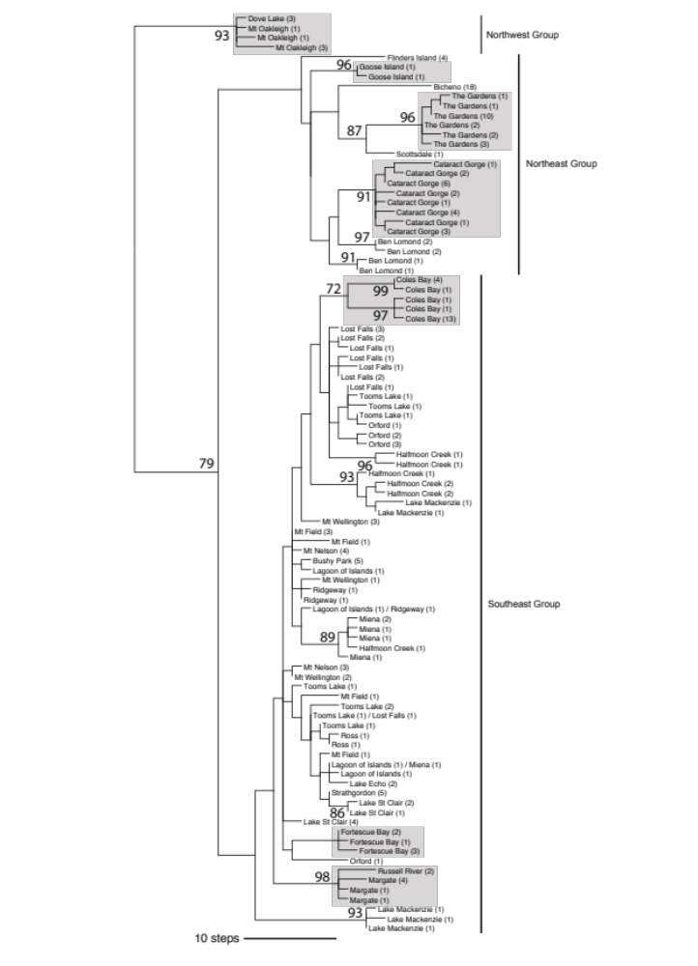
Figure S1. A minimum length tree (456 steps) from maximum parsimony analysis based on 1420 bp of ND2 and ND4 DNA sequence from Niveoscincus ocellatus. Branch lengths are scaled proportional to the number of steps. Numbers in parentheses indicate the number of individuals from a site exhibiting that haplotype. Grey boxes highlight regionally monophyletic areas within the major clades. The branch leading to the outgroups N. greeni and N. pretiosus were removed to aid presentation, but joined the tree at the branch leading to the Northwest group. Bootstrap values are labelled at each node where they exceeded 70%. The topology presented is one of 5000 recovered (max trees = 5000) minimum length topologies.

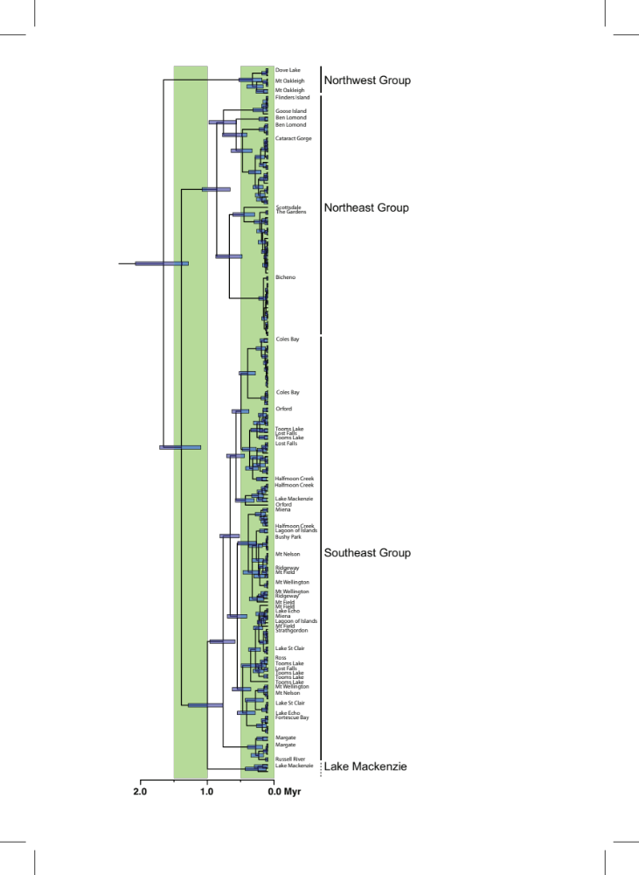
Figure S2. Maximum clade credibility tree from Bayesian analysis based on 1420 bp of ND2 and ND4 DNA sequence from Niveoscincus ocellatus analysed using BEAST under a coalescence tree prior with a strict clock (normal distribution of rate variation with mean 1.52% sequence divergence per million years, and standard deviation 0.5% sequence divergence). Branch lengths are scaled proportional to time, as indicated by the scale bar. Where the sampling locality of an individual is not listed, it is the same as the first label that appears above.

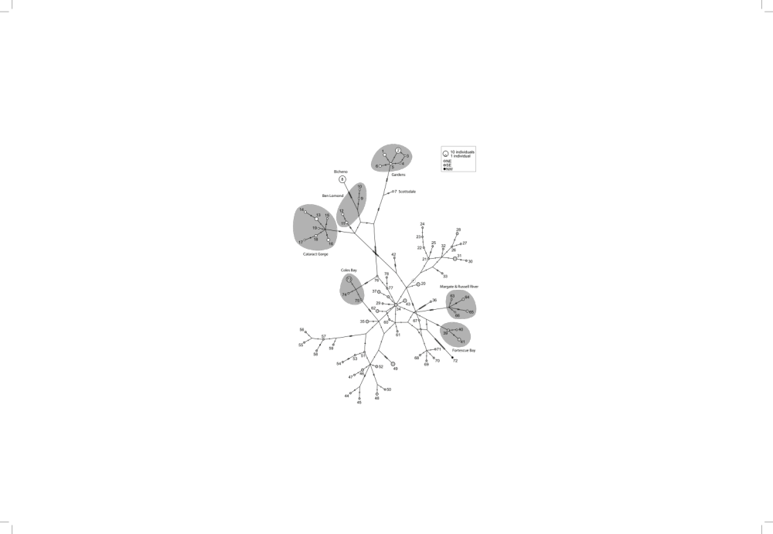
Figure S3. TCS network for mitochondrial haplotypes (ND2 and ND4) from individuals of Niveoscincus ocellatus. Inferred haplotypes are indicated as bars on the links between observed haplotypes (circles). Circle fill patterns indicate localities of haplotypes with respect to the three mitochondrially-defined regions. Numbers correspond to explicit sampling localities of alleles as defined in Table S4. Broader shading defines geographically clustered haplotypes. Note that not all individuals depicted in the Bayesian Inference tree (Figure 2) are represented in this network owing to the missing data thresholds employed during network construction.

