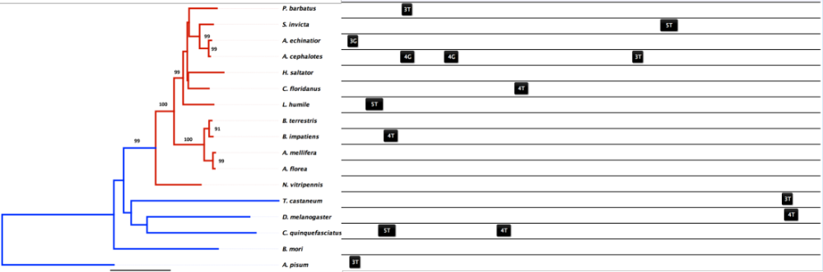

Figure S1. Maximum likelihood phylogeny of HSP60 (mitochondrial form) for 17 species of insects (rooted on A. pisum) using a JTT amino acid substitution model and 1000 bootstraps. Locally aligned cis-regulatory HSEs 700 base pairs upstream the predicted TSS are mapped back to the phylogeny and display little conservation in position.

