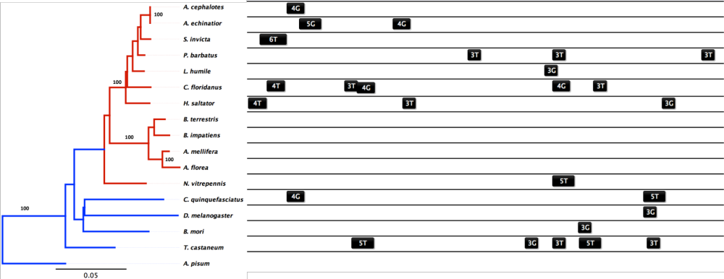
Figure S2. Maximum likelihood phylogeny of hsc70-3 (BIP) for 17 species of insects (rooted on A. pisum) using a JTT amino acid substitution model and 1000 bootstraps. Locally aligned cis-regulatory HSEs 500 base pairs upstream the predicted TSS were mapped back to the phylogeny and display little conservation in position.

