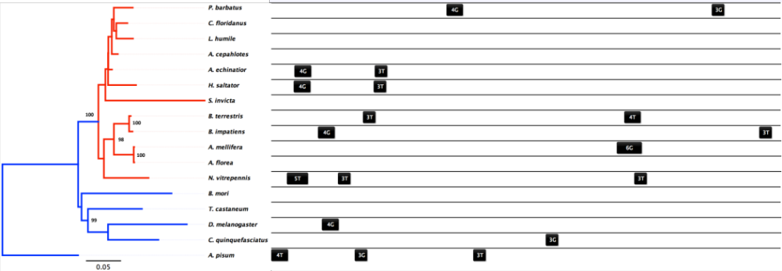
Figure S3. Maximum likelihood phylogeny of hsc70-5 for 17 species of insects (rooted on A. pisum) using a JTT amino acid substitution model and 600 bootstraps. Locally aligned cis-regulatory HSEs 700 base pairs upstream the predicted TSS were mapped back to the phylogeny and display little conservation in position.

