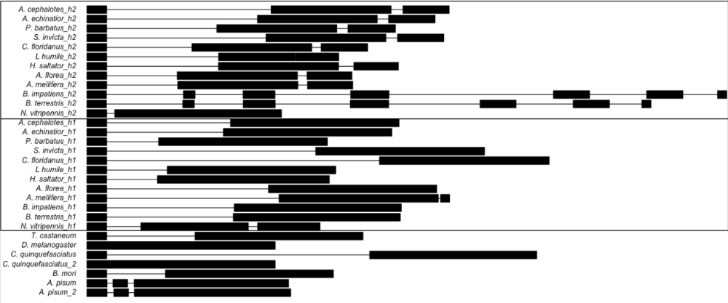
Figure S5. Local alignment of the genomic region of orthologous hsc70-4 from 17 insect species spanning 5 orders.Exons and introns are represented as boxes and lines, respectively.

