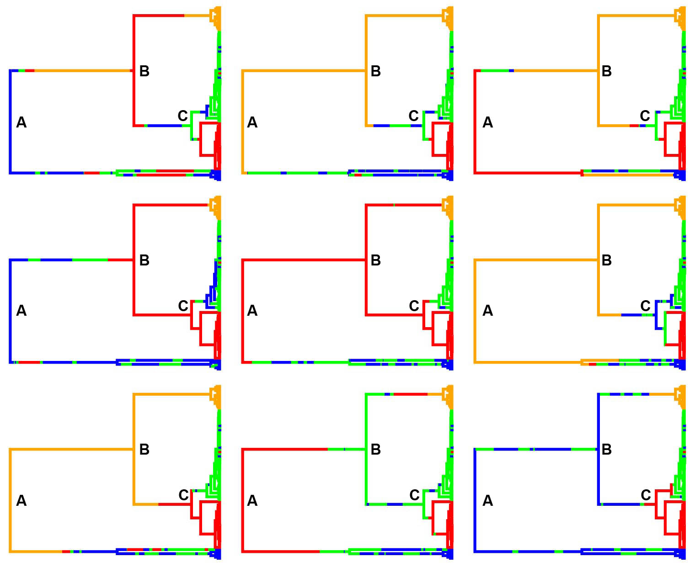

Additional File 4 Ancestral character state reconstruction for the locality of the bottlebrush octocorals through a stochastic mapping approach. This analysis was run under a symmetric rate model, an empirical Q matrix, and 1000 simulations using the packages 'phytools' [108] and 'geiger' [109] in R. The figure shows an example of nine reconstructions from a simulation of 1000 trees, where is evident the lack of resolution on the ancestral locality for node A, B, and C. The colours correspond to the localities: red for Tasmania, green for New Zealand, orange for Macquarie Ridge, and blue for Antarctica.

108. Revell LJ. Phytools: An R package for phylogenetic comparative biology (and other things). Methods in Ecology and Evolution. 2012;3:217-23.
109. Harmon LJ, Weir JT, Brock CD, Glor RE, Challenger W. GEIGER: investigating evolutionary radiations. Bioinformatics. 2008;24:129-31.

