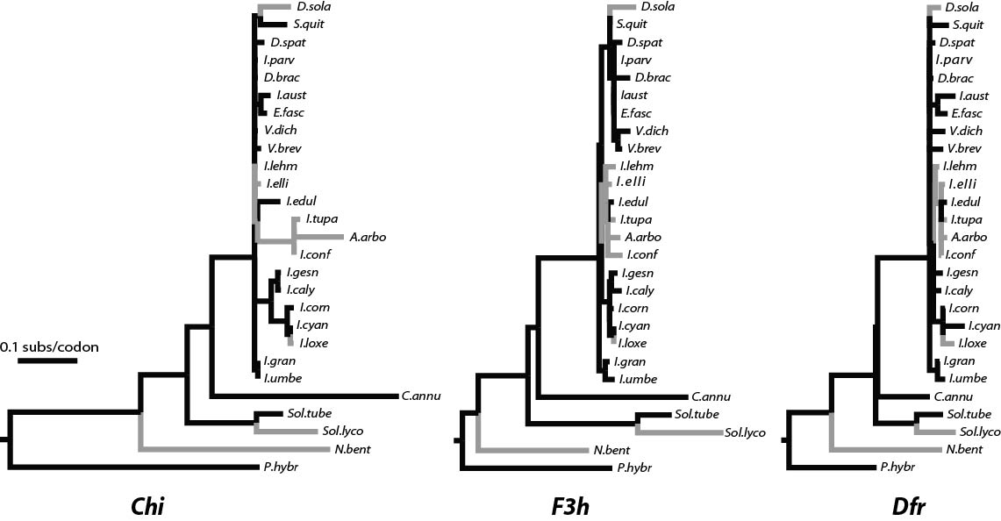
Fig. S1. Gene trees for Chi, F3h and Dfr. Branch lengths from PAML are in nucleotide substitutions per codon, estimated under the free ratio model. Taxon names are abbreviated to the first letter of the genus (except for Solanum abbreviated “Sol”) and the first four letters of the specific epithet. See Fig. 1 for full taxon names. Lineages with pigmentation are represented with black lines and those without with gray line.

