## read data
d <- read.table("FA.txt",header=T)
d$phylo <- as.factor(d$phylo)
contrasts(d$phylo) <- contr.sum

## scatter plot
panel.cor <- function(x, y, digits = 2, prefix = "", cex.cor, ...){
usr <- par("usr"); on.exit(par(usr))
par(usr = c(0, 1, 0, 1))
ra <- abs(cor(x, y, method="pearson"))
r <- cor(x, y, method="pearson")
txt <- format(c(r, 0.123456789), digits = digits)[1]
txt <- paste0(prefix, txt)
if(missing(cex.cor)) cex.cor <- 1.5/strwidth(txt)
text(0.5, 0.5, txt, cex = ra*1.2+0.5)
}
panel.smooth <- function (x, y, col = par("col"), bg = NA, pch = par("pch"),
cex = 1, col.smooth = "red", span = 4/5, iter = 10, ...)
{
points(x, y, pch = pch, col = col, bg = bg, cex = cex)
ok <- is.finite(x) & is.finite(y)
if (any(ok))
lines(stats::lowess(x[ok], y[ok], f = span, iter = iter),
col = col.smooth, ...)
}
pairs(
d[, -1],
lower.panel=panel.smooth,
upper.panel=panel.cor, pch=20, col="#000000", cex=0.2, gap=0.2
)

## Factor analysis
d.pred.group <- data.frame(phylo = d$phylo)

## Female somatic size
factorNumber <- 1
dat_FB <- d[c(2:5)]
fa.FB <- fa(dat_FB, factorNumber, rotate="oblimin") %>% fa.sort
fa.FB; KMO(scores(fa.FB)); cortest.bartlett(scores(fa.FB))
dev.new(); fa.diagram(fa.FB, simple=F, side=4, cex=9/12)
dev.new(); plot(fa.FB, xlim=c(0,5), ylim=c(0,5))
dev.new(); fa.parallel(dat_FB, n.iter=50, error.bars=T, fa="fa")
d.pred.group$FB <- fa.FB %>% scores %>% .[,1]

## Female external genital size
factorNumber <- 1
dat_FE <- d[c(6:8)]
fa.FE <- fa(dat_FE, factorNumber, rotate="oblimin") %>% fa.sort
fa.FE; KMO(scores(fa.FE)); cortest.bartlett(scores(fa.FE))
dev.new(); fa.diagram(fa.FE, simple=F, side=4, cex=9/12)
dev.new(); plot(fa.FE, xlim=c(0,5), ylim=c(0,5))
dev.new(); fa.parallel(dat_FE, n.iter=50, error.bars=T, fa="fa")
d.pred.group$FE <- fa.FE %>% scores %>% .[,1]
d.pred.group$open_W <- d$open_W

## Female internal genital size
factorNumber <- 1
dat_FI <- d[c(10:12)]
fa.FI <- fa(dat_FI, factorNumber, rotate="oblimin") %>% fa.sort
fa.FI; KMO(scores(fa.FI)); cortest.bartlett(scores(fa.FI))
dev.new(); fa.diagram(fa.FI, simple=F, side=4, cex=9/12)
dev.new(); plot(fa.FI, xlim=c(0,5), ylim=c(0,5))
dev.new(); fa.parallel(dat_FI, n.iter=50, error.bars=T, fa="fa")
d.pred.group$FI <- fa.FI %>% scores %>% .[,1]

## Male somatic size
factorNumber <- 1
dat_MB <- d[c(13:16)]
fa.MB <- fa(dat_MB, factorNumber, rotate="oblimin") %>% fa.sort
fa.MB; KMO(scores(fa.MB)); cortest.bartlett(scores(fa.MB))
dev.new(); fa.diagram(fa.MB, simple=F, side=4, cex=9/12)
dev.new(); plot(fa.MB, xlim=c(0,5), ylim=c(0,5))
dev.new(); fa.parallel(dat_MB, n.iter=50, error.bars=T, fa="fa")
d.pred.group$MB <- fa.MB %>% scores %>% .[,1]

## Male non-intromittent genital size
factorNumber <- 1
dat_MNI <- d[c(17:19)]
fa.MNI <- fa(dat_MNI, factorNumber, rotate="oblimin") %>% fa.sort
fa.MNI; KMO(scores(fa.MNI)); cortest.bartlett(scores(fa.MNI))
dev.new(); fa.diagram(fa.MNI, simple=F, side=4, cex=9/12)
dev.new(); plot(fa.MNI, xlim=c(0,5), ylim=c(0,5))
dev.new(); fa.parallel(dat_MNI, n.iter=50, error.bars=T, fa="fa")
d.pred.group$MNI <- fa.MNI %>% scores %>% .[,1]

## Male intromittent genital size
factorNumber <- 1
dat_MI <- d[c(20:21)]
fa.MI <- fa(dat_MI, factorNumber, rotate="oblimin") %>% fa.sort
fa.MI; KMO(scores(fa.MI)); cortest.bartlett(scores(fa.MI))
dev.new(); fa.diagram(fa.MI, simple=F, side=4, cex=9/12)
dev.new(); plot(fa.MI, xlim=c(0,5), ylim=c(0,5))
dev.new(); fa.parallel(dat_MI, n.iter=50, error.bars=T, fa="fa")
d.pred.group$MI <- fa.MI %>% scores %>% .[,1]

## SSD
factorNumber <- 1
dat_SSD <- d[c(22:25)]
fa.SSD <- fa(dat_SSD, factorNumber, rotate="oblimin") %>% fa.sort
fa.SSD; KMO(scores(fa.SSD)); cortest.bartlett(scores(fa.SSD))
dev.new(); fa.diagram(fa.SSD, simple=F, side=4, cex=9/12)
dev.new(); plot(fa.SSD, xlim=c(0,5), ylim=c(0,5))
dev.new(); fa.parallel(dat_SSD, n.iter=50, error.bars=T, fa="fa")
d.pred.group$SSD <- fa.SSD %>% scores %>% .[,1]

## SGD
factorNumber <- 1
dat_SGD <- d[c(26:31)]
fa.SGD <- fa(dat_SGD, factorNumber, rotate="oblimin") %>% fa.sort
fa.SGD; KMO(scores(fa.SGD)); cortest.bartlett(scores(fa.SGD))
dev.new(); fa.diagram(fa.SGD, simple=F, side=4, cex=9/12)
dev.new(); plot(fa.SGD, xlim=c(0,5), ylim=c(0,5))
dev.new(); fa.parallel(dat_SGD, n.iter=50, error.bars=T, fa="fa")
d.pred.group$SGD <- fa.SGD %>% scores %>% .[,1]

write.csv(d.pred.group, file="Nep_Gential_FA.csv", row.names = F)

pairs(data,
lower.panel=panel.smooth,
upper.panel=panel.cor, pch=20, col="#000000", cex=0.2, gap=0.2)

# FA_FB

Factor Analysis using method = minres
Call: fa(r = dat_FB, nfactors = factorNumber, rotate = "oblimin")
Standardized loadings (pattern matrix) based upon correlation matrix
MR1 h2 u2 com
FBL 0.98 0.97 0.032 1
FCW 0.98 0.97 0.033 1
FCL 0.98 0.97 0.035 1
FTPL 0.94 0.89 0.110 1

MR1
SS loadings 3.79
Proportion Var 0.95

Mean item complexity = 1
Test of the hypothesis that 1 factor is sufficient.

The degrees of freedom for the null model are 6 and the objective function was 8.97 with Chi Square of 97.16
The degrees of freedom for the model are 2 and the objective function was 1.37

The root mean square of the residuals (RMSR) is 0.03
The df corrected root mean square of the residuals is 0.05

The harmonic number of observations is 14 with the empirical chi square 0.12 with prob < 0.94
The total number of observations was 14 with MLE Chi Square = 13.89 with prob < 0.00097

Tucker Lewis Index of factoring reliability = 0.581
RMSEA index = 0.778 and the 90 % confidence intervals are 0.358 0.994
BIC = 8.61
Fit based upon off diagonal values = 1
Measures of factor score adequacy
MR1
Correlation of scores with factors 1.00
Multiple R square of scores with factors 0.99
Minimum correlation of possible factor scores 0.99
Kaiser-Meyer-Olkin factor adequacy
Call: KMO(r = scores(fa.FB))
Overall MSA = NaN
MSA for each item =
MR1
NaN
R was not square, finding R from data
$chisq
[1] 0

$p.value
[1] 1

$df
[1] 0
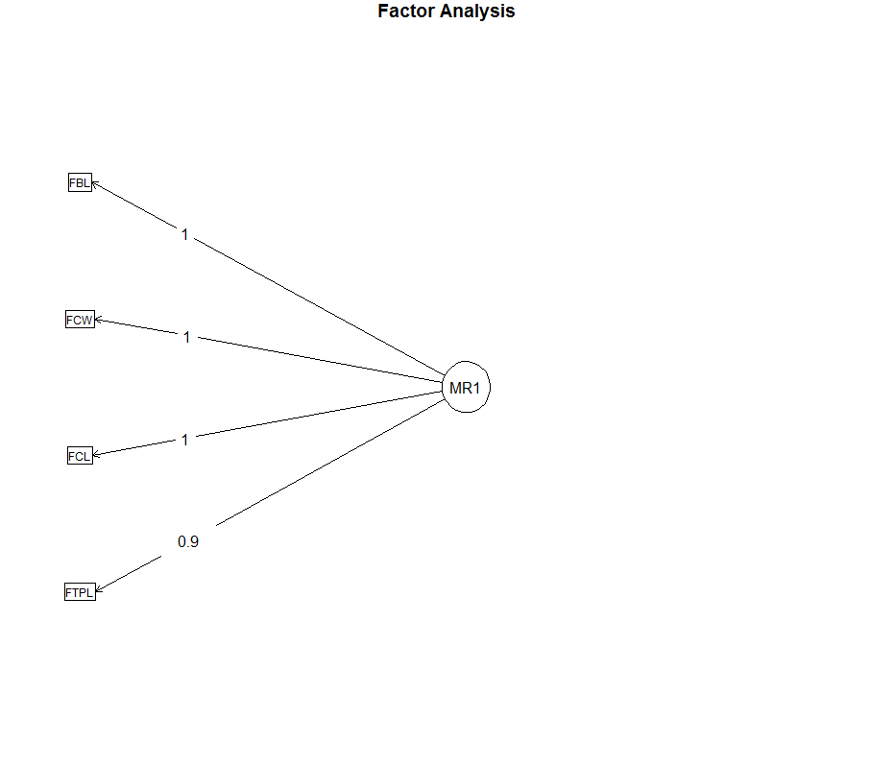
# FA_FE

Factor Analysis using method = minres
Call: fa(r = dat_FE, nfactors = factorNumber, rotate = "oblimin")
Standardized loadings (pattern matrix) based upon correlation matrix
MR1 h2 u2 com
sq_EA 0.97 0.94 0.060 1
sq_RA 0.97 0.94 0.064 1
DBO 0.89 0.79 0.210 1

MR1
SS loadings 2.67
Proportion Var 0.89

Mean item complexity = 1
Test of the hypothesis that 1 factor is sufficient.

The degrees of freedom for the null model are 3 and the objective function was 3.56 with Chi Square of 39.79
The degrees of freedom for the model are 0 and the objective function was 0

The root mean square of the residuals (RMSR) is 0
The df corrected root mean square of the residuals is NA

The harmonic number of observations is 14 with the empirical chi square 0 with prob < NA
The total number of observations was 14 with MLE Chi Square = 0 with prob < NA

Tucker Lewis Index of factoring reliability = -Inf
Fit based upon off diagonal values = 1
Measures of factor score adequacy
MR1
Correlation of scores with factors 0.99
Multiple R square of scores with factors 0.97
Minimum correlation of possible factor scores 0.94
Kaiser-Meyer-Olkin factor adequacy
Call: KMO(r = scores(fa.FE))
Overall MSA = NaN
MSA for each item =
MR1
NaN
R was not square, finding R from data
$chisq
[1] 0

$p.value
[1] 1

$df
[1] 0
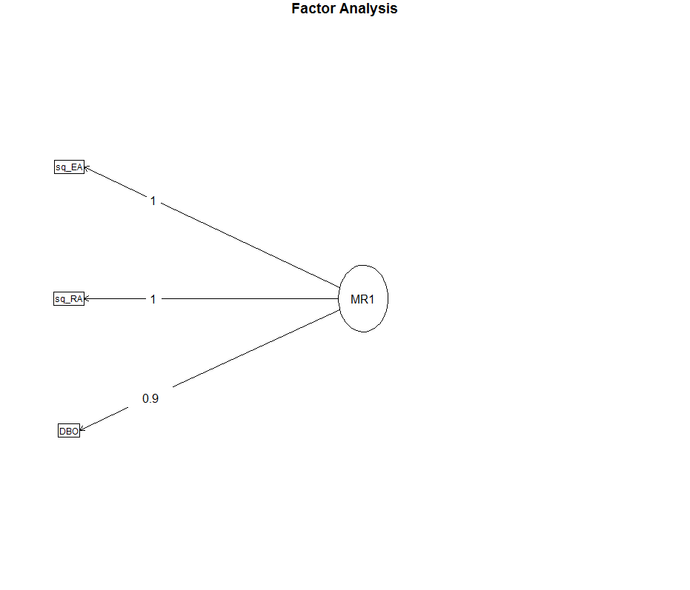

# FA_FI

Factor Analysis using method = minres
Call: fa(r = dat_FI, nfactors = factorNumber, rotate = "oblimin")
Standardized loadings (pattern matrix) based upon correlation matrix
MR1 h2 u2 com
duct_L 1.00 1.00 0.005 1
cube_SV 0.61 0.37 0.634 1
duct_W 0.52 0.27 0.725 1

MR1
SS loadings 1.64
Proportion Var 0.55

Mean item complexity = 1
Test of the hypothesis that 1 factor is sufficient.

The degrees of freedom for the null model are 3 and the objective function was 0.78 with Chi Square of 8.74
The degrees of freedom for the model are 0 and the objective function was 0.01

The root mean square of the residuals (RMSR) is 0.04
The df corrected root mean square of the residuals is NA

The harmonic number of observations is 14 with the empirical chi square 0.12 with prob < NA
The total number of observations was 14 with MLE Chi Square = 0.1 with prob < NA

Tucker Lewis Index of factoring reliability = -Inf
Fit based upon off diagonal values = 0.99
Measures of factor score adequacy
MR1
Correlation of scores with factors 1.00
Multiple R square of scores with factors 1.00
Minimum correlation of possible factor scores 0.99
Kaiser-Meyer-Olkin factor adequacy
Call: KMO(r = scores(fa.FI))
Overall MSA = NaN
MSA for each item =
MR1
NaN
R was not square, finding R from data
$chisq
[1] 0

$p.value
[1] 1

$df
[1] 0
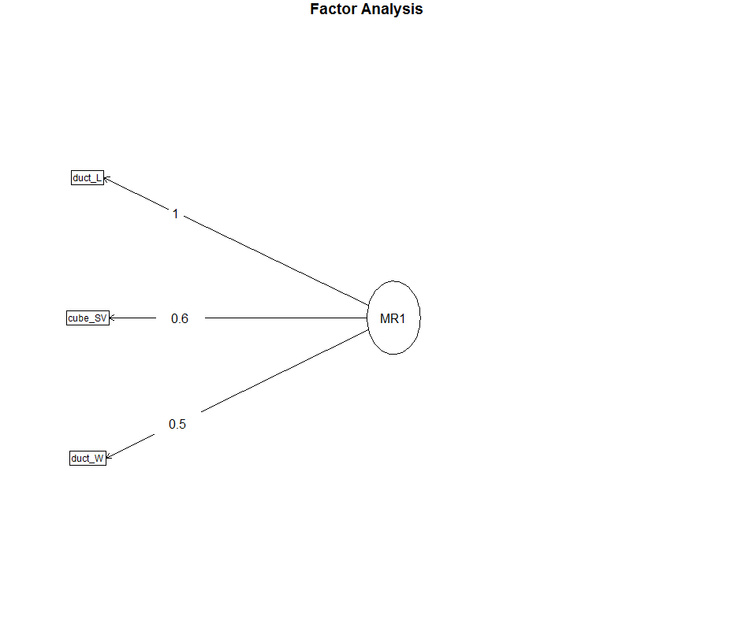

# FA_MB

Factor Analysis using method = minres
Call: fa(r = dat_MB, nfactors = factorNumber, rotate = "oblimin")
Standardized loadings (pattern matrix) based upon correlation matrix
MR1 h2 u2 com
MCL 0.96 0.93 0.073 1
MCW 0.94 0.89 0.113 1
MBL 0.85 0.72 0.278 1
MTPL 0.75 0.56 0.439 1

MR1
SS loadings 3.10
Proportion Var 0.77

Mean item complexity = 1
Test of the hypothesis that 1 factor is sufficient.

The degrees of freedom for the null model are 6 and the objective function was 5.15 with Chi Square of 55.8
The degrees of freedom for the model are 2 and the objective function was 1.47

The root mean square of the residuals (RMSR) is 0.12
The df corrected root mean square of the residuals is 0.21

The harmonic number of observations is 14 with the empirical chi square 2.48 with prob < 0.29
The total number of observations was 14 with MLE Chi Square = 14.93 with prob < 0.00057

Tucker Lewis Index of factoring reliability = 0.164
RMSEA index = 0.811 and the 90 % confidence intervals are 0.386 1.02
BIC = 9.65
Fit based upon off diagonal values = 0.98
Measures of factor score adequacy
MR1
Correlation of scores with factors 0.98
Multiple R square of scores with factors 0.96
Minimum correlation of possible factor scores 0.93
Kaiser-Meyer-Olkin factor adequacy
Call: KMO(r = scores(fa.MB))
Overall MSA = NaN
MSA for each item =
MR1
NaN
R was not square, finding R from data
$chisq
[1] 0

$p.value
[1] 1

$df
[1] 0
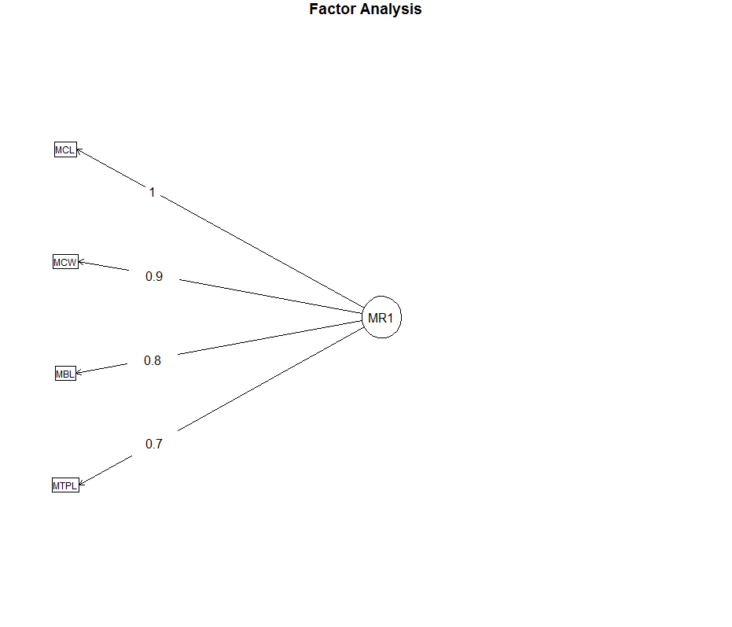

# FA_MNI

Factor Analysis using method = minres
Call: fa(r = dat_MNI, nfactors = factorNumber, rotate = "oblimin")
Standardized loadings (pattern matrix) based upon correlation matrix
MR1 h2 u2 com
cube_PV 1.00 1.00 0.0025 1
cube_BV 1.00 1.00 0.0026 1
ECL 0.69 0.48 0.5244 1

MR1
SS loadings 2.47
Proportion Var 0.82

Mean item complexity = 1
Test of the hypothesis that 1 factor is sufficient.

The degrees of freedom for the null model are 3 and the objective function was 10.24 with Chi Square of 114.36
The degrees of freedom for the model are 0 and the objective function was 3.36

The root mean square of the residuals (RMSR) is 0
The df corrected root mean square of the residuals is NA

The harmonic number of observations is 14 with the empirical chi square 0 with prob < NA
The total number of observations was 14 with MLE Chi Square = 35.29 with prob < NA

Tucker Lewis Index of factoring reliability = -Inf
Fit based upon off diagonal values = 1
Measures of factor score adequacy
MR1
Correlation of scores with factors 1
Multiple R square of scores with factors 1
Minimum correlation of possible factor scores 1
Kaiser-Meyer-Olkin factor adequacy
Call: KMO(r = scores(fa.MNI))
Overall MSA = NaN
MSA for each item =
MR1
NaN
R was not square, finding R from data
$chisq
[1] 0

$p.value
[1] 1

$df
[1] 0
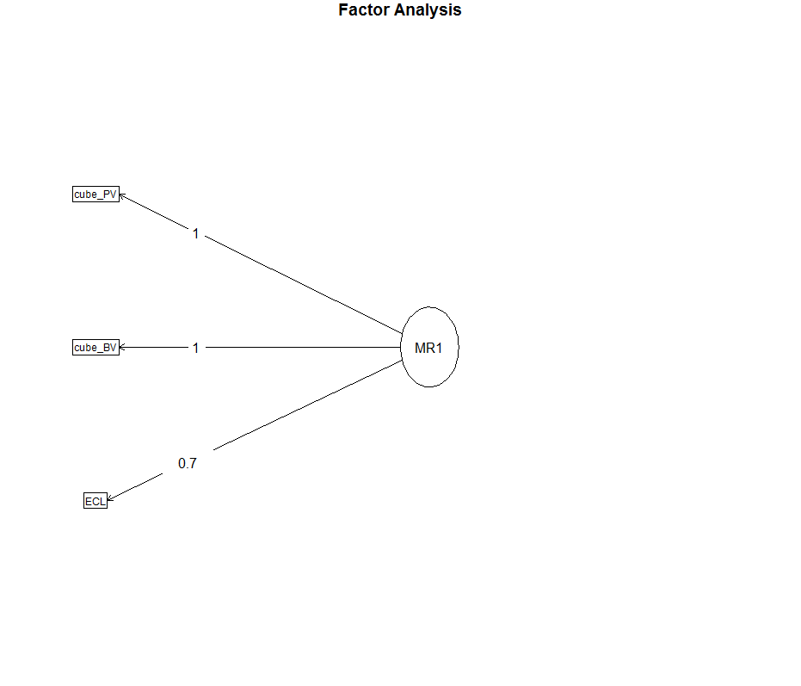

# FA_MI

Factor Analysis using method = minres
Call: fa(r = dat_MI, nfactors = factorNumber, rotate = "oblimin")
Standardized loadings (pattern matrix) based upon correlation matrix
MR1 h2 u2 com
EW 0.94 0.88 0.12 1
cube_EV 0.94 0.88 0.12 1

MR1
SS loadings 1.76
Proportion Var 0.88

Mean item complexity = 1
Test of the hypothesis that 1 factor is sufficient.

The degrees of freedom for the null model are 1 and the objective function was 1.51 with Chi Square of 17.34
The degrees of freedom for the model are -1 and the objective function was 0

The root mean square of the residuals (RMSR) is 0
The df corrected root mean square of the residuals is NA

The harmonic number of observations is 14 with the empirical chi square 0 with prob < NA
The total number of observations was 14 with MLE Chi Square = 0 with prob < NA

Tucker Lewis Index of factoring reliability = 1.065
Fit based upon off diagonal values = 1
Measures of factor score adequacy
MR1
Correlation of scores with factors 0.97
Multiple R square of scores with factors 0.94
Minimum correlation of possible factor scores 0.88
Kaiser-Meyer-Olkin factor adequacy
Call: KMO(r = scores(fa.MI))
Overall MSA = NaN
MSA for each item =
MR1
NaN
R was not square, finding R from data
$chisq
[1] 0

$p.value
[1] 1

$df
[1] 0
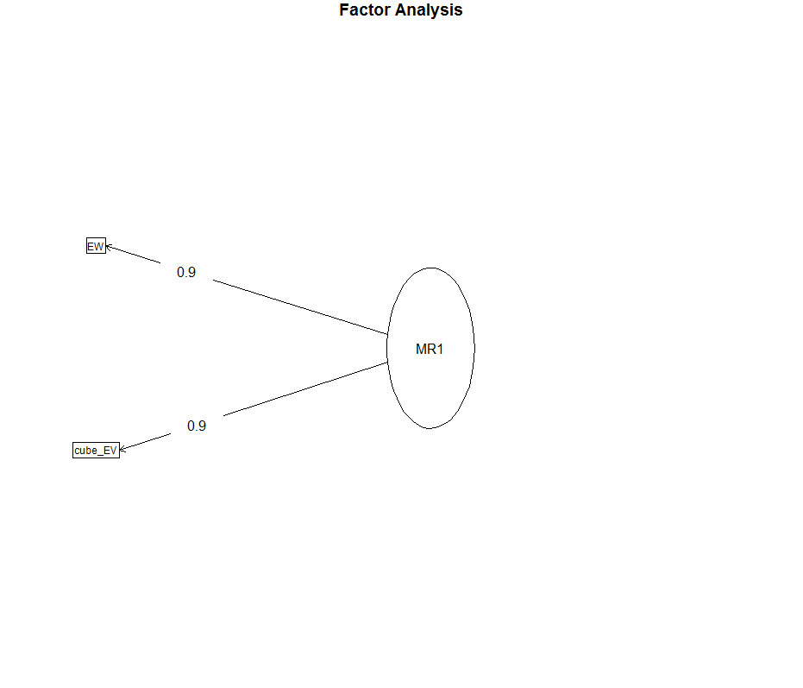

# FA_SSD

Factor Analysis using method = minres
Call: fa(r = dat_SSD, nfactors = factorNumber, rotate = "oblimin")
Standardized loadings (pattern matrix) based upon correlation matrix
MR1 h2 u2 com
SSD_CL 0.99 0.99 0.012 1
SSD_BL 0.99 0.98 0.018 1
SSD_CW 0.99 0.98 0.021 1
SSD_TPL 0.99 0.98 0.023 1

MR1
SS loadings 3.92
Proportion Var 0.98

Mean item complexity = 1
Test of the hypothesis that 1 factor is sufficient.

The degrees of freedom for the null model are 6 and the objective function was 10.95 with Chi Square of 118.59
The degrees of freedom for the model are 2 and the objective function was 0.26

The root mean square of the residuals (RMSR) is 0
The df corrected root mean square of the residuals is 0.01

The harmonic number of observations is 14 with the empirical chi square 0 with prob < 1
The total number of observations was 14 with MLE Chi Square = 2.65 with prob < 0.27

Tucker Lewis Index of factoring reliability = 0.981
RMSEA index = 0.231 and the 90 % confidence intervals are NA 0.575
BIC = -2.63
Fit based upon off diagonal values = 1
Measures of factor score adequacy
MR1
Correlation of scores with factors 1.00
Multiple R square of scores with factors 1.00
Minimum correlation of possible factor scores 0.99
Kaiser-Meyer-Olkin factor adequacy
Call: KMO(r = scores(fa.SSD))
Overall MSA = NaN
MSA for each item =
MR1
NaN
R was not square, finding R from data
$chisq
[1] 0

$p.value
[1] 1

$df
[1] 0
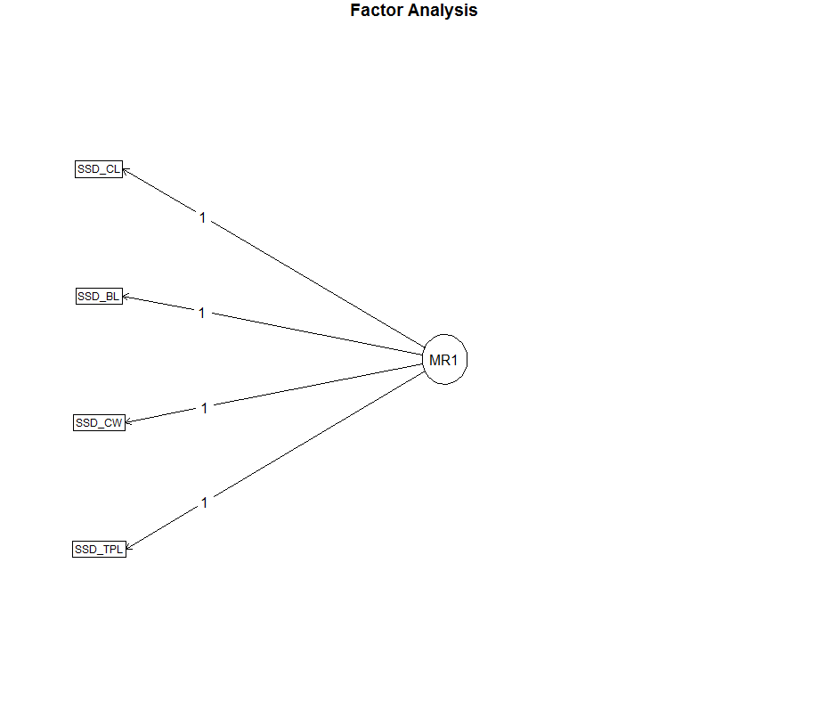
# FA_SGD

Factor Analysis using method = minres
Call: fa(r = dat_SGD, nfactors = factorNumber, rotate = "oblimin")
Standardized loadings (pattern matrix) based upon correlation matrix
MR1 h2 u2 com
SGD_RP 0.96 0.92 0.084 1
SGD_RB 0.96 0.92 0.084 1
SGD_EB 0.94 0.89 0.110 1
SGD_EP 0.94 0.89 0.110 1
SGD_SB 0.84 0.70 0.302 1
SGD_SP 0.83 0.70 0.303 1

MR1
SS loadings 5.01
Proportion Var 0.83

Mean item complexity = 1
Test of the hypothesis that 1 factor is sufficient.

The degrees of freedom for the null model are 15 and the objective function was 39.29 with Chi Square of 399.5
The degrees of freedom for the model are 9 and the objective function was 31.25

The root mean square of the residuals (RMSR) is 0.13
The df corrected root mean square of the residuals is 0.17

The harmonic number of observations is 14 with the empirical chi square 7.09 with prob < 0.63
The total number of observations was 14 with MLE Chi Square = 296.92 with prob < 1.2e-58

Tucker Lewis Index of factoring reliability = -0.339
RMSEA index = 1.843 and the 90 % confidence intervals are NA NA
BIC = 273.16
Fit based upon off diagonal values = 0.97
Measures of factor score adequacy
MR1
Correlation of scores with factors 1
Multiple R square of scores with factors 1
Minimum correlation of possible factor scores 1
Kaiser-Meyer-Olkin factor adequacy
Call: KMO(r = scores(fa.SGD))
Overall MSA = NaN
MSA for each item =
MR1
NaN
R was not square, finding R from data
$chisq
[1] 0

$p.value
[1] 1

$df
[1] 0

