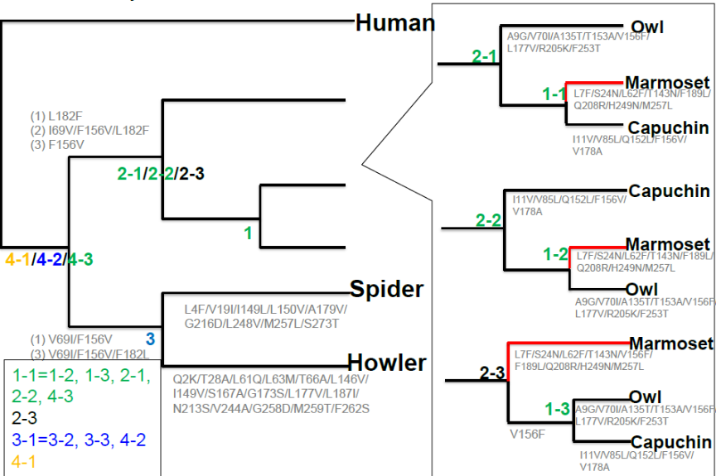

(B)
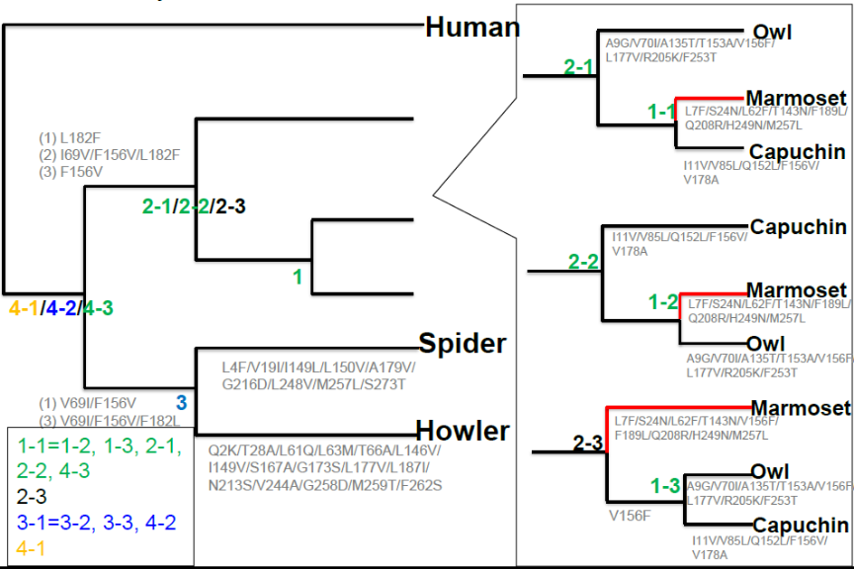

Figure S2. Reconstruction of ancestral TAS2R1s (A) and TAS2R4s (B).
Ancestral amino acid sequences of New World Monkey TAS2R1 and TAS2R4 were inferred using the maximum likelihood method implemented in MEGA5 with the Dayhoff and JTT amino acid substitution models (Tamura K, Peterson D, Peterson N, Stecher G, Nei M, Kumar S. Mol Biol Evol 2011; 28(10):2731-2739).

