Additional file 8. Mantel test results as implemented in GENALEX [62] on matrix correlation (r_{m}) between genetic distance and water depth (a and b), and genetic distance and geographic distance (c). The relationship shown in graph ‘a’ was significant after interpolation of the data point highlighted. The original non-significant relationship and outlier data point are shown in graph ‘b’.
a) b)
Genetic distance (Fst/(1 – Fst)
Genetic distance (Fst/(1 – Fst)
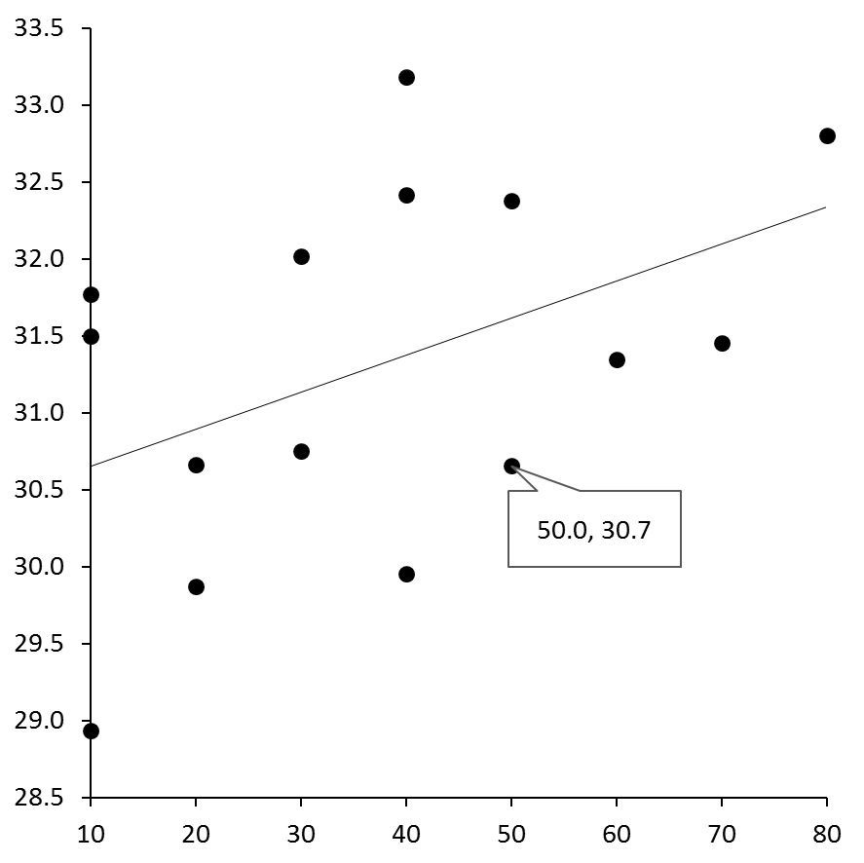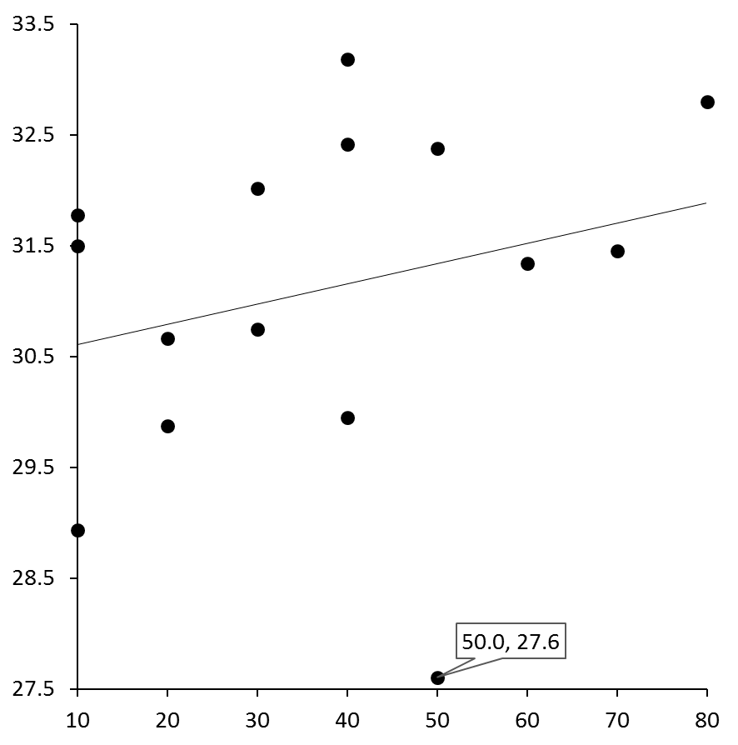
r_{m} = 0.26, P = 0.217
r_{m} = 0.45, P = 0.047
Water depth (in metres)
Water depth (in metres)

c)
Genetic distance (Fst/(1 – Fst)
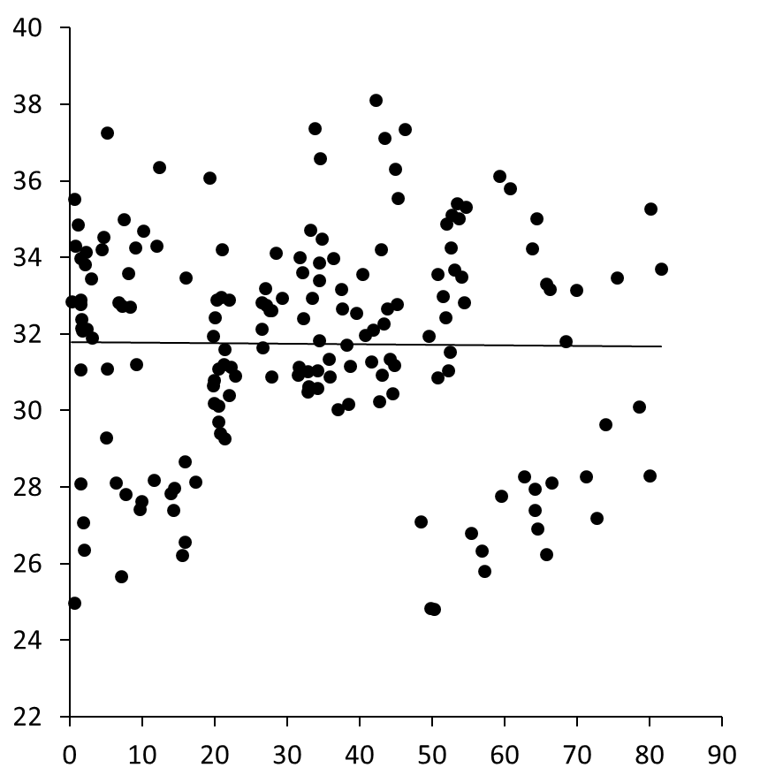
r_{m} = -0.05, P = 0.7
Geographic distance (in thousands of metres)

