Supplementary figure

FIG. S1. eggNOG classification of G. przewalskii transcriptome.

FIG. S2. GO classification of G. przewalskii transcriptome.
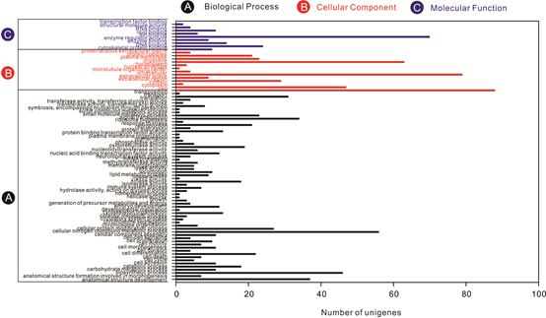

FIG. S3. Phylogenetic tree of G. przewalskii and eight fish species.

