Supplementary Materials
for
Longwing (Heliconius) butterflies combine a restricted set of pigmentary and structural coloration mechanisms
by
Bodo D. Wilts*, Aidan J.M. Vey, Adriana D. Briscoe and Doekele G. Stavenga

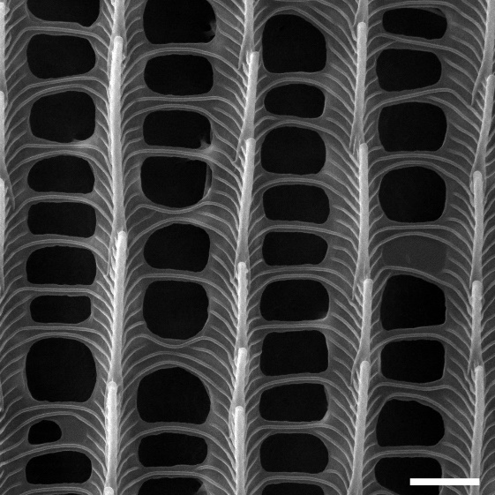
Figure S1. SEM of a yellow-pigmented pigmented wing scale of H. sara showing the same ultrastructure as the red-pigmented wing scale of H. telesiphe shown in Figure 2A.

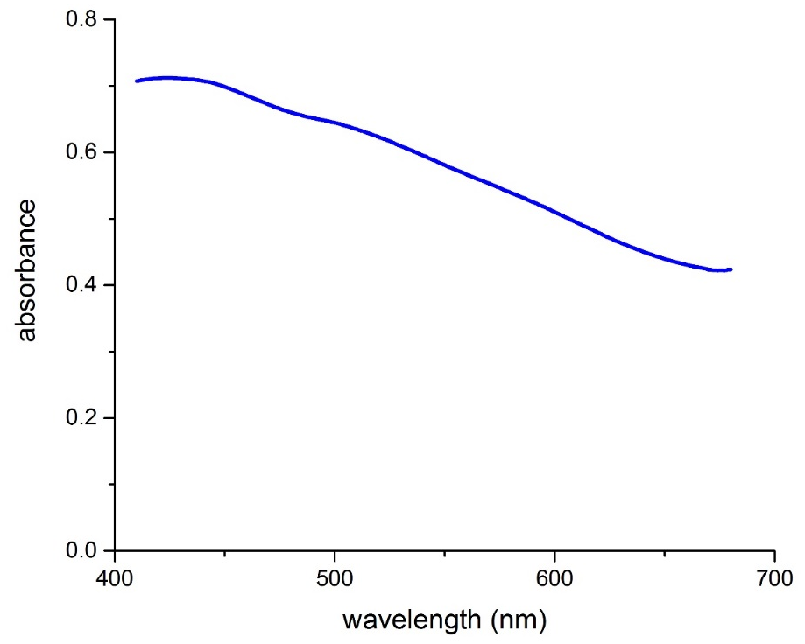
Figure S2. Absorbance spectrum of a single blue wing scale of H. sara immersed in refractive index-matching fluid.

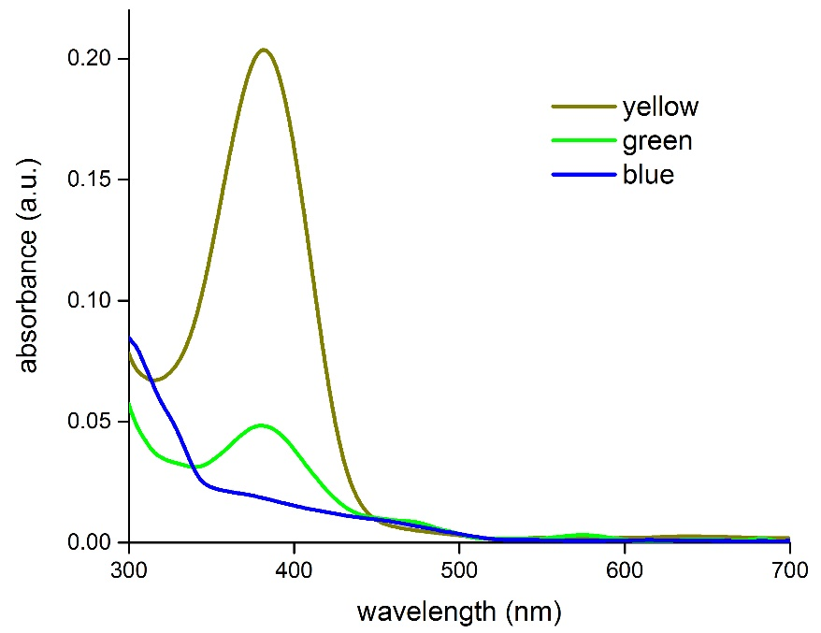
Figure S3. UV-Vis absorbance spectra of acidified methanol extracts from the different colored wing patches of the H. doris morphs (Fig. 5), confirming the presence of 3-OHK pigment in the green and yellow wing patches (c.f. Fig. 2F).
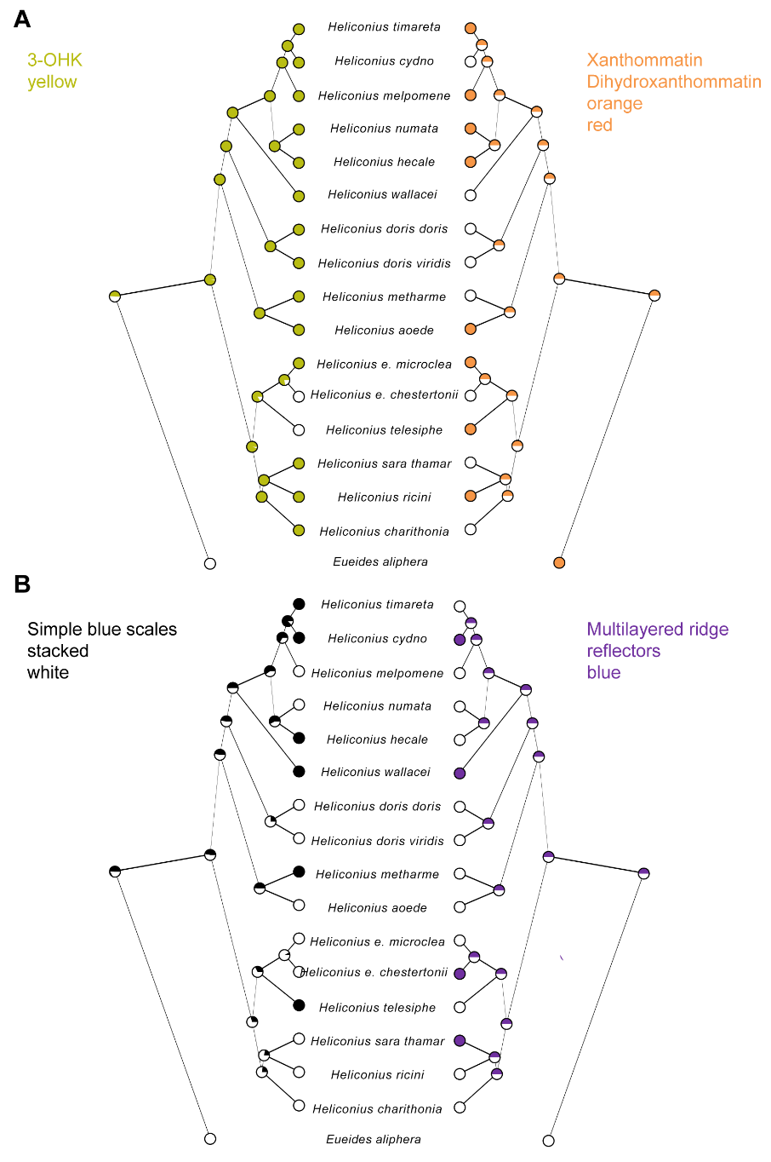
Figure S4. Maximum likelihood reconstruction of yellow and orange pigmentary and white and blue structural scale coloration on the Heliconius phylogeny. Character mapping of four colored scale types found in Heliconius species and an outgroup in the genus Eueides on the topology of Kozak et al. [24] with branch lengths indicated. Filled circles indicate the presence of reflectance spectra of scales characteristic of: 3-OHK (yellow), xanthommatin/dihydroxanthommatin (orange), simple blue scales stacked (black) and multi-ridge reflectors coloration (blue). White indicates an absence of that scale type on the wings. Simple blue scales stacked produce scales that are white in color. Due to its universal presence, the presence of melanin has not been included. Circle graphs represent the likelihood that a particular trait was present in an ancestral node as estimated using Mesquite [28].

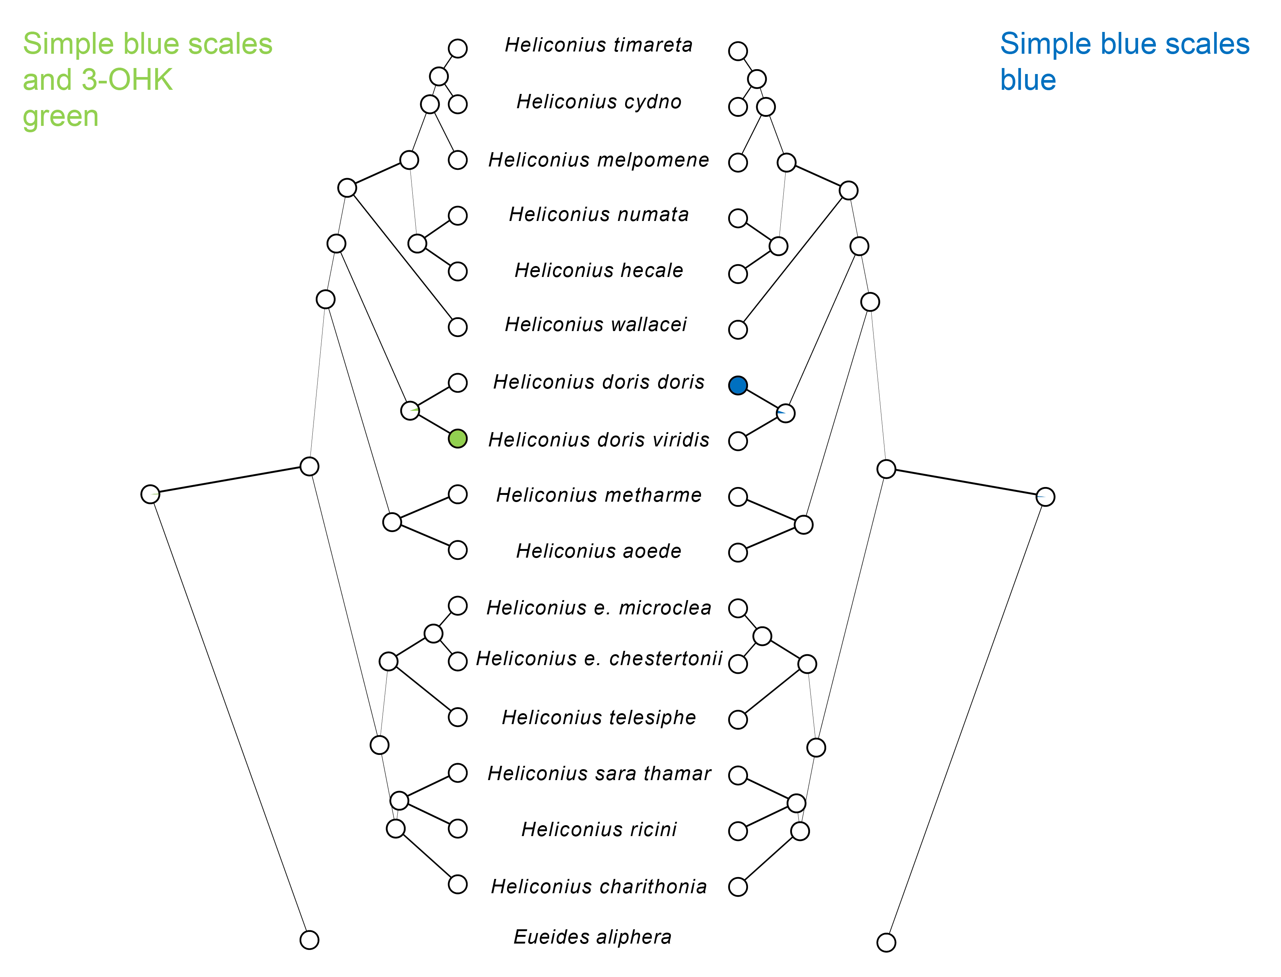

Figure S5. Maximum likelihood reconstruction of red and green pigmentary and simple blue structural scale coloration on the Heliconius phylogeny. Character mapping of three colored scale types found in Heliconius species and an outgroup in the genus Eueides on the topology of Kozak et al. [24] with branch lengths indicated. Filled circles indicates the presence of scales with reflectance spectra characteristic of: simple blue scales filled with 3-OHK (green) or simple blue scales (blue). White indicates an absence of that scale type on the wings. Circle graphs represent the likelihood that a particular trait was present in an ancestral node as estimated using Mesquite [28].

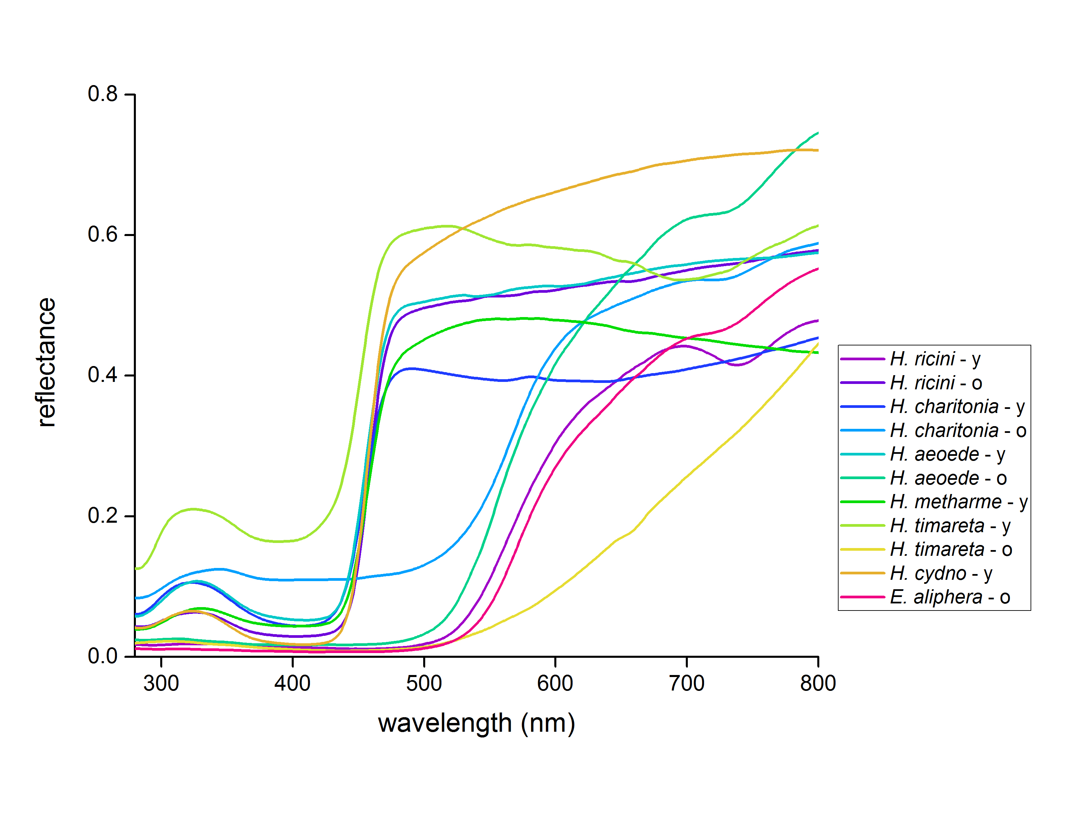
Figure S6. Reflectance spectra of the various colored dorsal wing areas measured with a bifurcated probe. This data was additionally used to assemble the dataset presented in Table S1 (c.f. Figs. 1 & 2).
Table S1. Overview of the pigmentary and structural coloration mechanisms encountered in the butterfly genus Heliconius as measured using reflectance spectroscopy.
 | Pigment |  | Structural |  |  | Both
Species | Y | R/O | B | W | M | G

erato clade
Heliconius telesiphe telesiphe⁺ |  | o |  | o
Heliconius erato microclea⁺ |  | o
Heliconius erato chestertonii⁺ | o |  |  |  | o

sara/sapho clade
Heliconius charitonia# | o | o
Heliconius ricini# | o | o
Heliconius sara thamar⁺ | o |  |  |  | o

aoede clade
Heliconius aeoede# | o | o
Heliconius metharme# | o |  |  | o

doris clade
Heliconius doris viridis (green morph) * | o |  |  |  |  | o
Heliconius doris doris (blue morph)* | o |  | o

wallacei clade
Heliconius wallacei flavescens⁺ | o |  |  | o | o

melpomene clade
Heliconius melpomene⁺ | o | o
Heliconius cydno# | o |  |  | o | o
Heliconius timareta# | o | o |  | o
silvaniform clade
Heliconius numata⁺ | o | o
Heliconius hecale⁺ | o | o |  | o
OUTGROUP SPECIES
Eueides aliphera# |  | o

Pigment data shown in: ⁺Fig. 2 *Fig. 5 #Fig. S6

Abbreviations: Y: yellow, 3-OH-kynurenine
R/O: orange/red, xanthommatin and/or dihydroxanthommatin
B: simple blue scales
W: simple blue scales stacked
G: green, yellow-filtered simple blue scales
M: multilayered ridge-reflector scales

