Supporting Information for

Rates of morphological evolution, asymmetry and morphological integration of shell shape in scallops (Bivalvia: Pectinidae)

Authors:

E. Sherratt, J.M. Serb and D.C. Adams

(1 supplementary figure and 2 supplementary tables)

Figure S1 Variation in matching asymmetry in scallop shells across the 86 species, colored by life habit (green = cementing, red = nestling, blue = byssal-attaching, purple = recessing, black = free-living, orange = gliding).

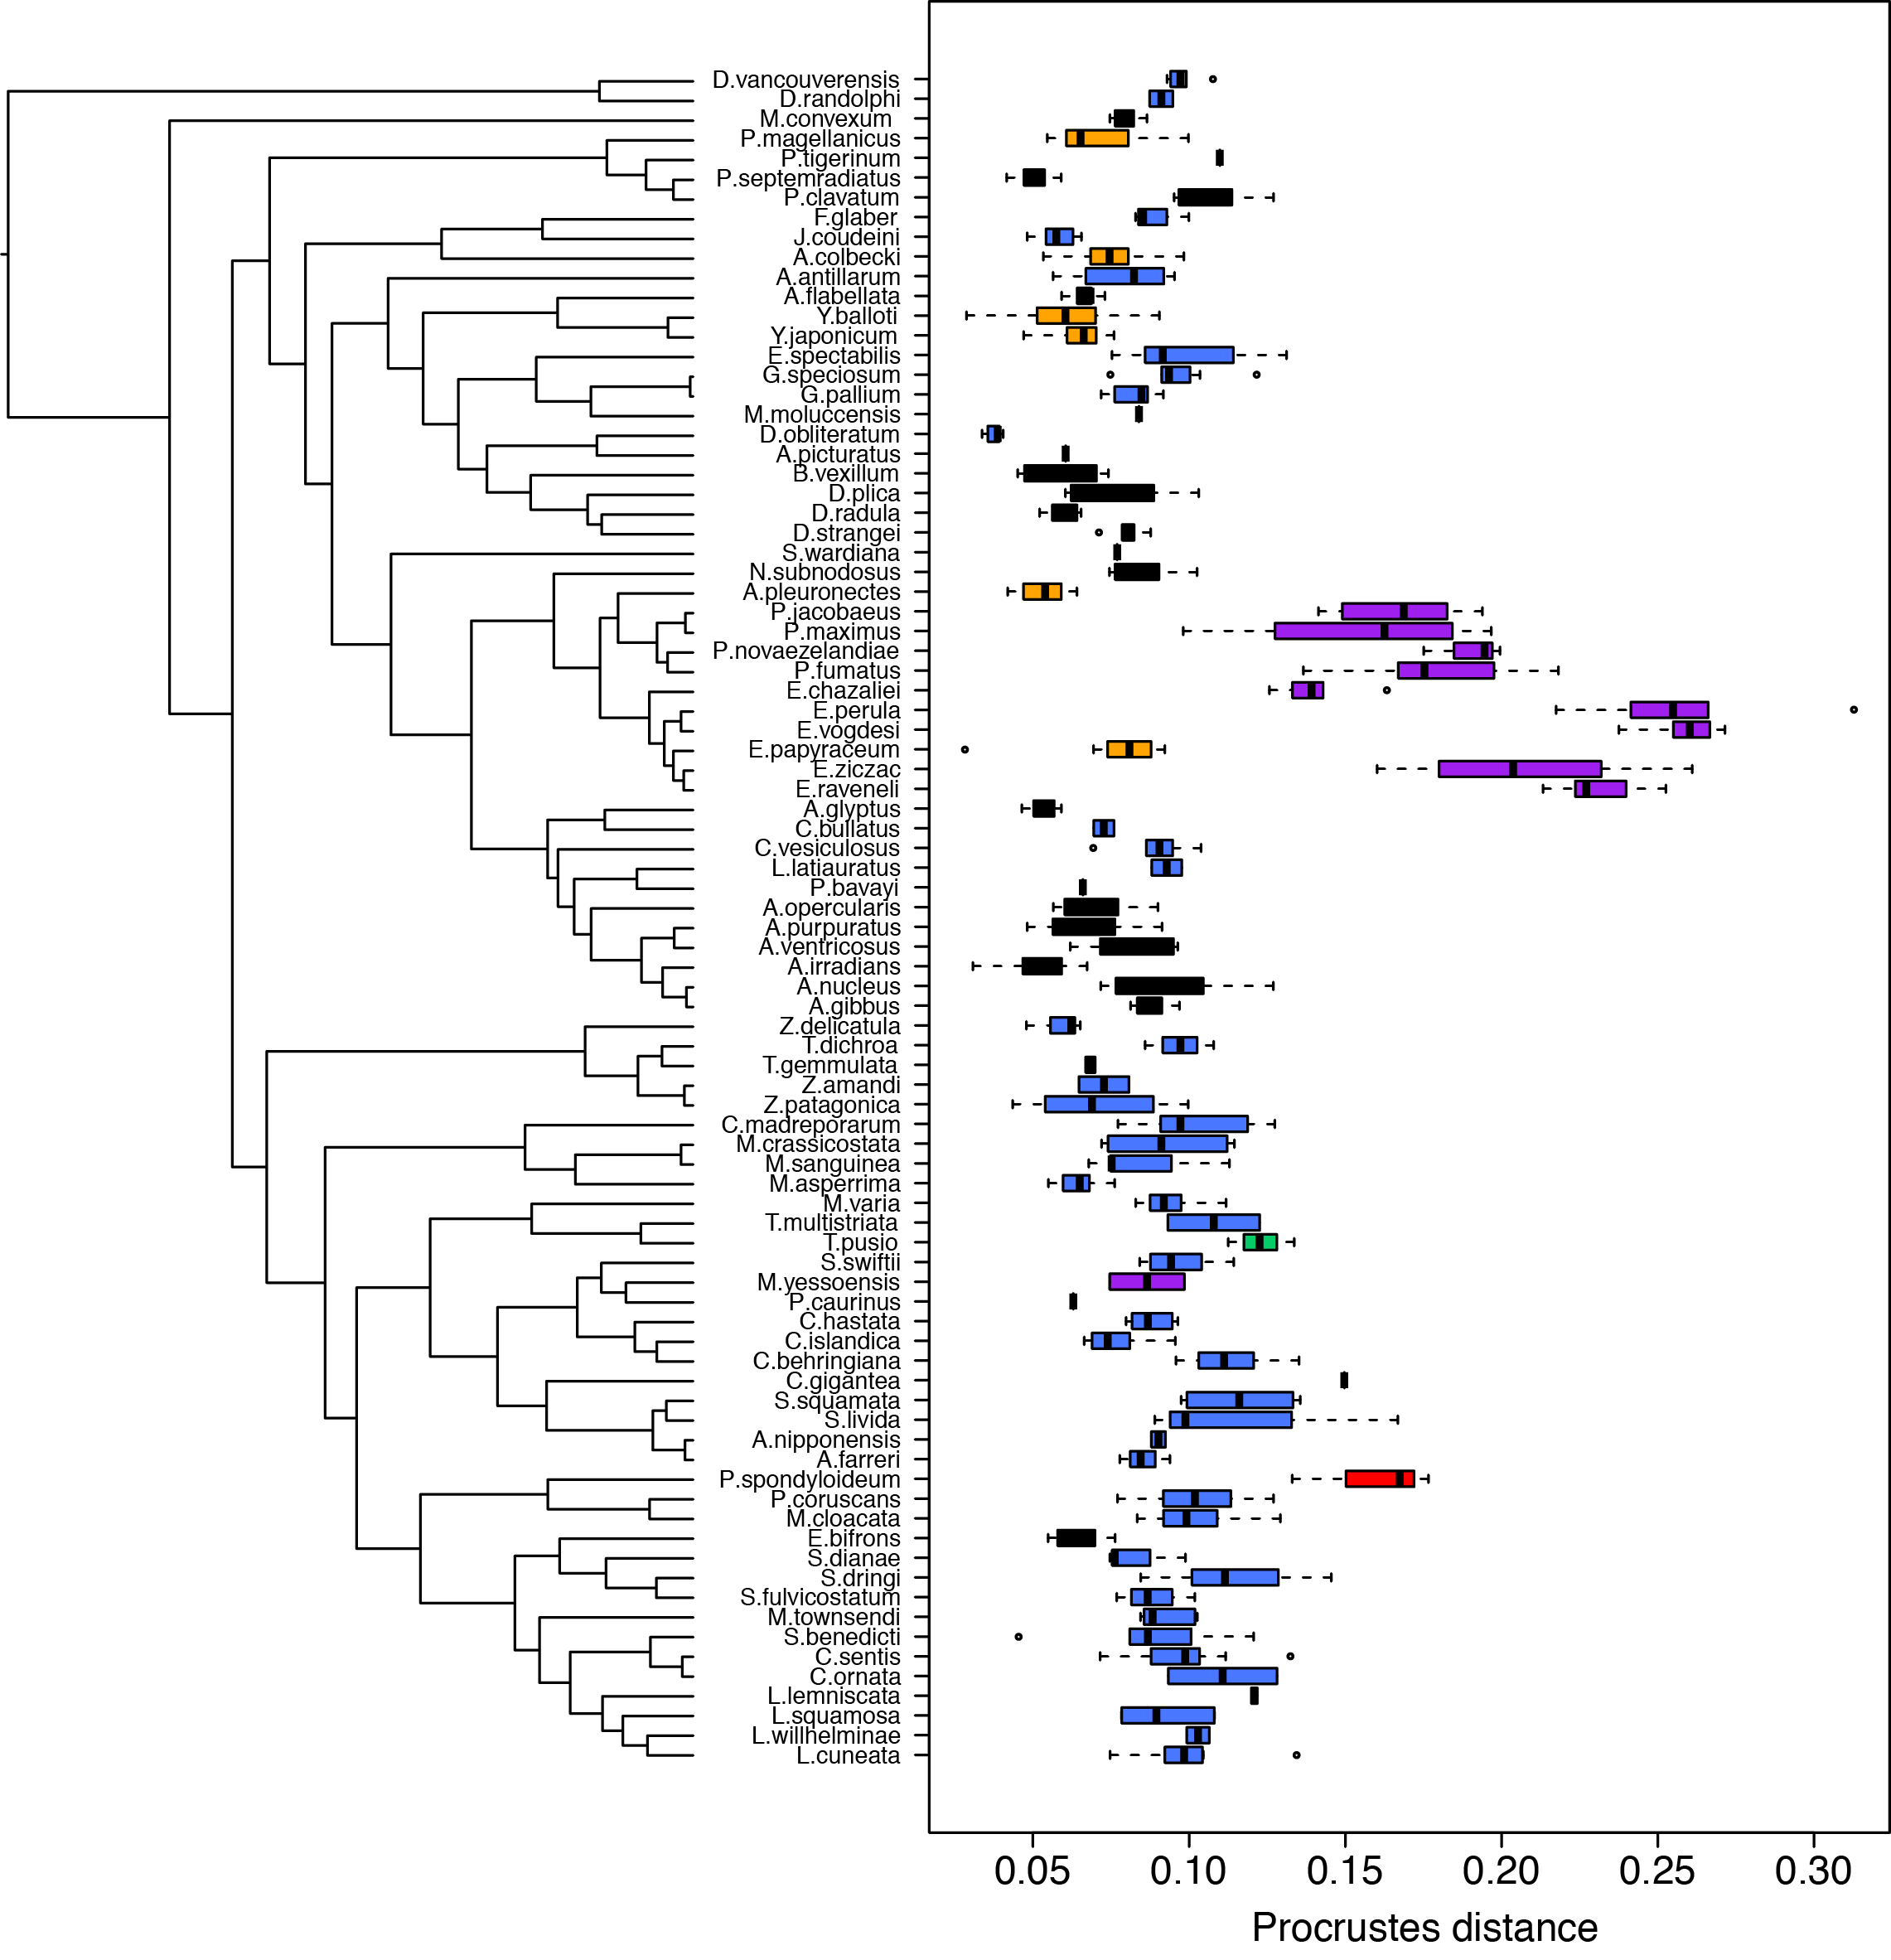

Table S1 Morphometric data of left and right valves were available for 86 species comprising six life habits. The ID corresponds to the label of Figure S1. Number of specimens used (No. spec.) to calculate the average for each species were taken from museum collections, summarized here using the official museum acronyms. Free, free-living. Byssal, byssal-attaching.
Species | ID | Habit | No. spec. | Museum
Adamussium colbecki | A.colbecki | gliding | 39 | USNM
Aequipecten glyptus | A.glyptus | free | 5 | FMNH
Aequipecten opercularis | A.opercularis | free | 7 | FMNH
Amusium pleuronectes | A.pleuronectes | gliding | 30 | USNM
Anguipecten picturatus | A.picturatus | free | 3 | MNHN
Annachlamys flabellata | A.flabellata | free | 5 | UF
Antillipecten antillarum | A.antillarum | byssal | 7 | UF; LACM; USNM; LACM
Argopecten gibbus | A.gibbus | free | 5 | LACM
Argopecten irradians | A.irradians | free | 28 | DMNH
Argopecten nucleus | A.nucleus | free | 10 | LACM
Argopecten purpuratus | A.purpuratus | free | 25 | UF
Argopecten ventricosus | A.ventricosus | free | 6 | LACM; CAS
Azumapecten farreri | A.farreri | byssal | 5 | LACM; BPBM
Azumapecten nipponensis | A.nipponensis | byssal | 2 | AMNH
Bractechlamys vexillum | B.vexillum | free | 10 | LACM
Caribachlamys ornata | C.ornata | byssal | 2 | BPBM
Caribachlamys sentis | C.sentis | byssal | 30 | UF
Chlamys behringiana | C.behringiana | byssal | 19
Chlamys hastata | C.hastata | byssal | 13 | MCZ; BPBM
Chlamys islandica | C.islandica | byssal | 8 | YPM; LACM
Coralichlamys madreporarum | C.madreporarum | byssal | 9 | LACM; MNHN
Crassadoma gigantea | C.gigantea | cementing | 1 | NCSM
Cryptopecten bullatus | C.bullatus | byssal | 2 | MCZ; UF
Cryptopecten vesiculosus | C.vesiculosus | byssal | 5 | LACM
Decatopecten plica | D.plica | free | 10 | LACM
Decatopecten radula | D.radula | free | 10 | LACM; BPBM
Decatopecten strangei | D.strangei | free | 6 | LACM
Delectopecten randolphi | D.randolphi | byssal | 3 | MCZ
Delectopecten vancouverensis | D.vancouverensis | byssal | 7 | LACM
Dentamussium obliteratum | D.obliteratum | byssal | 5 | LACM; DMNH
Equichlamys bifrons | E.bifrons | free | 9 | LACM; DMNH; BPBM
Euvola chazaliei | E.chazaliei | recessing | 5 | NCSM; AMNH
Euvola papyraceum | E.papyraceum | gliding | 14 | FMNH
Euvola perula | E.perula | recessinging | 7 | UF
Euvola raveneli | E.raveneli | recessinging | 7 | LACM; YPM
Euvola vogdesi | E.vogdesi | recessing | 12 | LACM; USNM
Euvola ziczac | E.ziczac | recessing | 28 | FMNH; LACM
Excellichlamys spectabilis | E.spectabilis | byssal | 16 | LACM
Flexopecten glaber | F.glaber | byssal | 2 | MNHN; YPM
Gloripallium pallium | G.pallium | byssal | 9 | FMNH
Gloripallium speciosum | G.speciosum | byssal | 8 | LACM
Juxtamusium coudeini | J.coudeini | byssal | 6 | MNHN
Laevichlamys cuneata | L.cuneata | byssal | 8 | LACM; MNHN
Laevichlamys lemniscata | L.lemniscata | byssal | 5 | LCSM; MCZ; DMNH
Laevichlamys squamosa | L.squamosa | byssal | 8 | MNHN; CAS
Laevichlamys willhelminae | L.willhelminae | byssal | 4 | USNM
Leptopecten latiauratus | L.latiauratus | byssal | 5 | BPBM; NCSM; CAS
Mesopeplum convexum | M.convexum | free | 5 | MCZ; DMNH
Mimachlamys asperrima | M.asperrima | byssal | 7 | LACM
Mimachlamys cloacata | M.cloacata | byssal | 7 | MNHN; USNM
Mimachlamys crassicostata | M.crassicostata | byssal | 10 | FMNH
Mimachlamys sanguinea | M.sanguinea | byssal | 5 | MCZ; USNM; CAS
Mimachlamys townsendi | M.townsendi | byssal | 5 | USNM; AMNH
Mimachlamys varia | M.varia | byssal | 8 | FLMNH
Mirapecten moluccensis | M.moluccensis | byssal | 1 | MNHN
Mizuhopecten yessoensis | M.yessoensis | recessing | 5 | CAS; UF; AMNH
Nodipecten subnodosus | N.subnodosus | free | 4 | LACM; YPM
Palliolum tigerinum | P.tigerinum | byssal | 2 | CAS
Paraleptopecten bavayi | P.bavayi | byssal | 5 | DAMNH; UF
Pascahinnites coruscans | P.coruscans | byssal | 8 | FMNH USNM
Patinopecten caurinus | P.caurinus | recessing | 4 | CAS, MCZ; DMNH
Pecten fumatus | P.fumatus | recessing | 17 | LACM
Pecten jacobaeus | P.jacobaeus | recessing | 5 | NCSM; YPM
Pecten maximus | P.maximus | recessing | 6 | LACM
Pecten novaezelandiae | P.novaezelandiae | recessing | 5 | NCSM
Pedum spondyloideum | P.spondyloideum | nestling | 4 | MNHN; USNM;YPM
Placopecten magellanicus | P.magellanicus | gliding | 24
Pseudamussium clavatum | P.clavatum | free | 5 | MCZ; AMNH
Pseudamussium septemradiatus | P.septemradiatus | free | 28 | USNM
Scaeochlamys livida | S.livida | byssal | 5 | FMNH; YPM; BPBM
Scaeochlamys squamata | S.squamata | byssal | 5 | MNHN; USNM
Semipallium dianae | S.dianae | byssal | 3 | MCZ; DMNH
Semipallium dringi | S.dringi | byssal | 24 | MCZ; MNHN
Semipallium fulvicostatum | S.fulvicostatum | byssal | 5 | MNHN; YPM; BPBM
Semipallium wardiana | S.wardiana | byssal | 1 | AMNH
Spathochlamys benedicti | S.benedicti | byssal | 5 | FMNH; DMNH
Swiftopecten swiftii | S.swiftii | byssal | 8 | DMNH; CAS
Talochlamys dichroa | T.dichroa | byssal | 3 | MNHN; DMNH
Talochlamys gemmulata | T.gemmulata | byssal | 5 | AMNH; BPBM; UF; MCZ
Talochlamys multistriata | T.multistriata | byssal | 4 | MNHN
Talochlamys pusio | T.pusio | cementing | 5 | BPBM; YPM; DMNH?
Ylistrum balloti | Y.balloti | gliding | 39 | WAMS; BALD ISL
Ylistrum japonicum | Y.japonicum | gliding | 36 | LACM; USNM
Zygochlamys amandi | Z.amandi | byssal | 3 | USNM
Zygochlamys delicatula | Z.delicatula | byssal | 5 | AMNH; MCZ
Zygochlamys patagonica | Z.patagonica | byssal | 14 | BPBM; YPM; LACM; UF

Table S2 Significance (P-values) for pairwise comparisons of effect sizes, Z scores, from partial least squares analysis.
 | byssal | recess | free | glide
byssal | -
recess | 0.1953 | -
free | 0.4041 | 0.1767 | -
glide | 0.0585 | 0.2578 | 0.0597 | -

