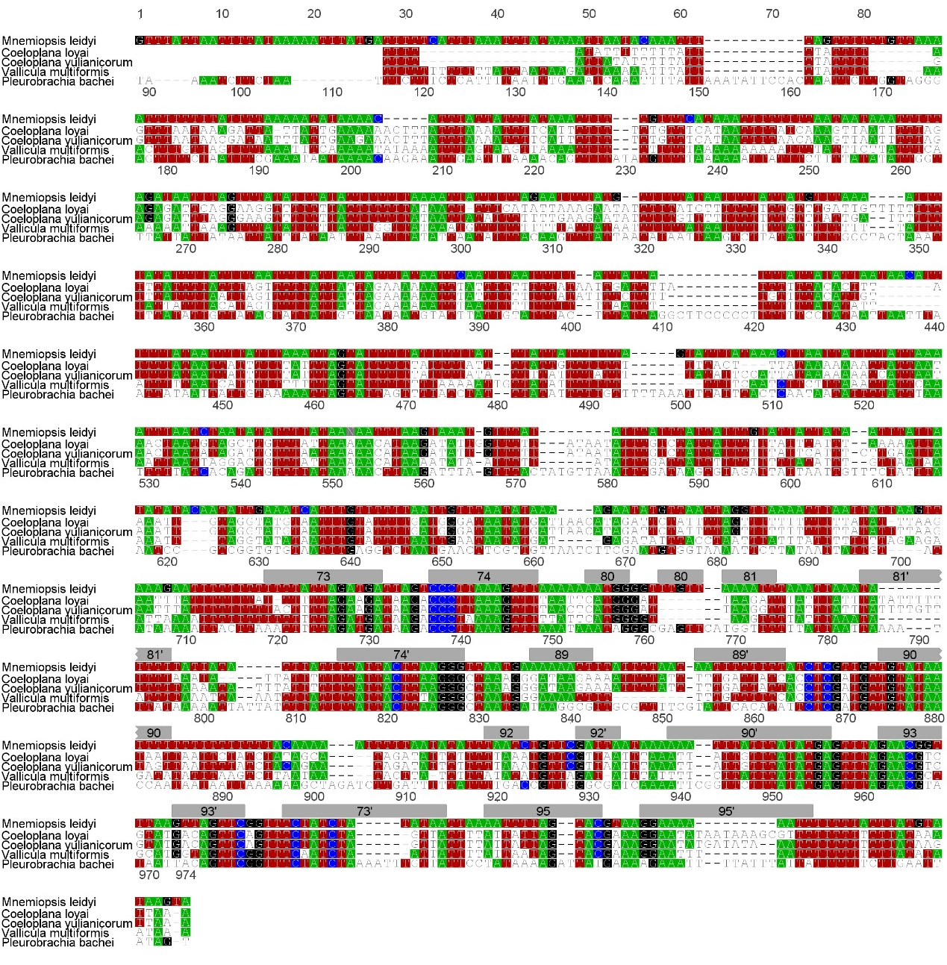

Additional file 5 – Alignment of the rnl sequences of ctenophores.
The gray boxes indicate the helix identified by Pett et al [10] for Mnemiopsis leidyi.

