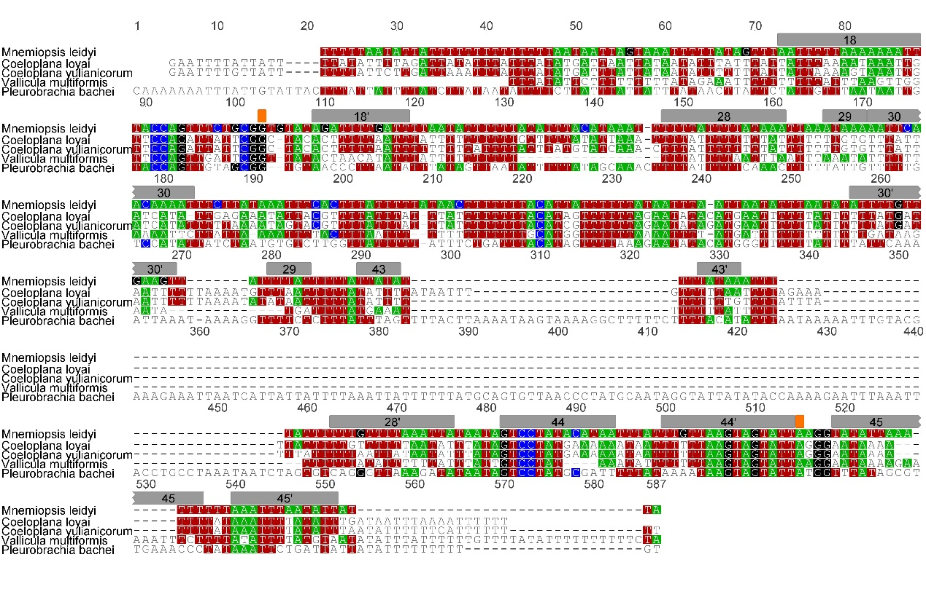

Additional file 6 – Alignment of the rns sequences of ctenophores.
The gray boxes indicate the helix identified by Pett et al [10] for Mnemiopsis leidyi. The orange boxes indicate positions that are critical for the rns function.

