SUPPLEMENTARY INFORMATION
Böhmer et al. “Homeotic transformations reflect departure from the mammalian ‘rule of seven’ cervical vertebrae in sloths: Inferences on the Hox code and morphological modularity of the mammalian neck”

Content:
Figure S1: Results of cluster analysis for each specimen.
Figure S2: 3D renderings of all analyzed vertebrae.
Figure S3: Landmark set used in the 3D geometric morphometric analysis.

Table S1: Percentage of total variance explained and cumulative variance per relative warp (RW).

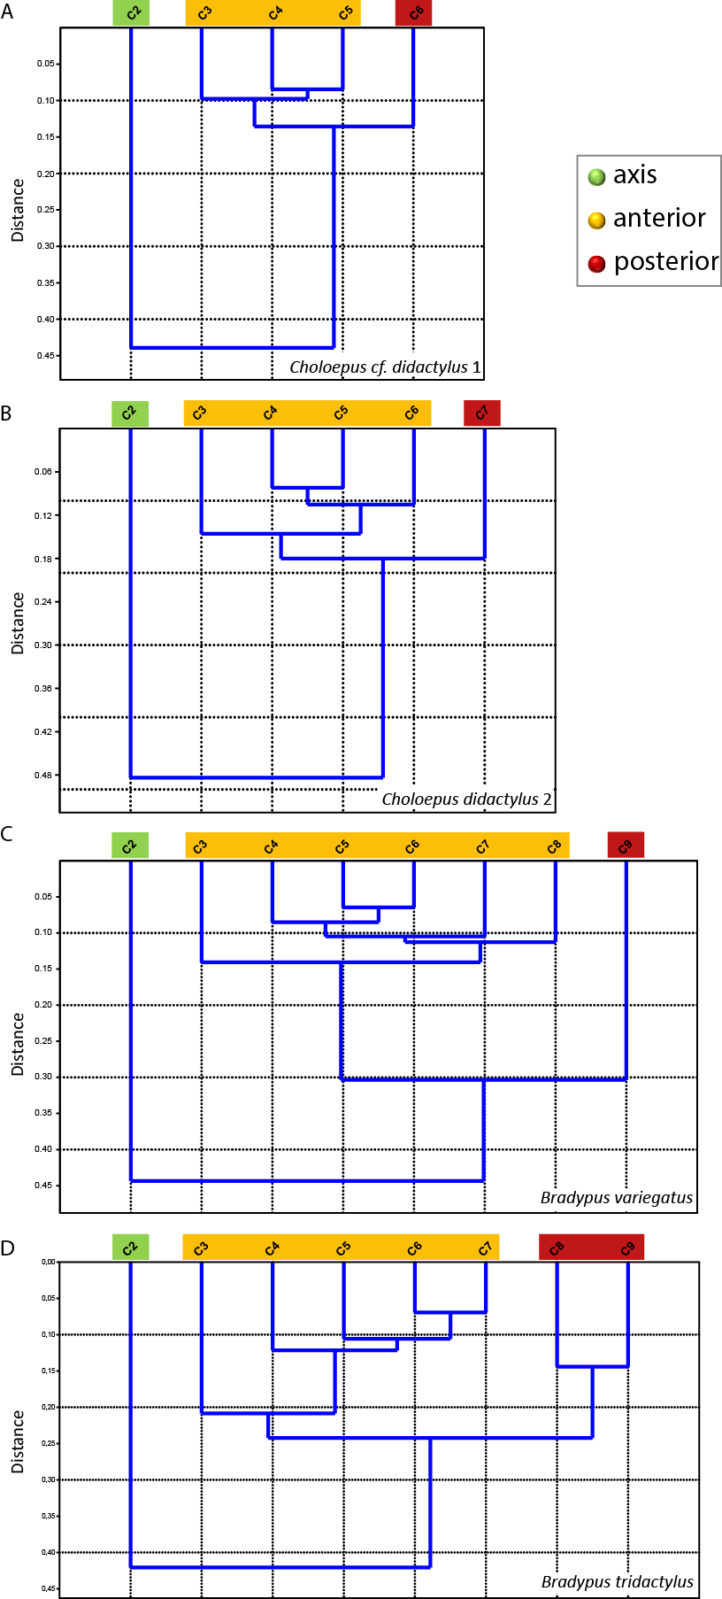
Fig. S1: Results of cluster analysis for each specimen. A three subunit pattern was revealed in all specimens analyzed. Green, axis; yellow, anterior subunit; red, posterior subunit. A, C. cf. didactylus 1; B, C. didactylus 2; C, B. variegatus; D, B. tridactylus.
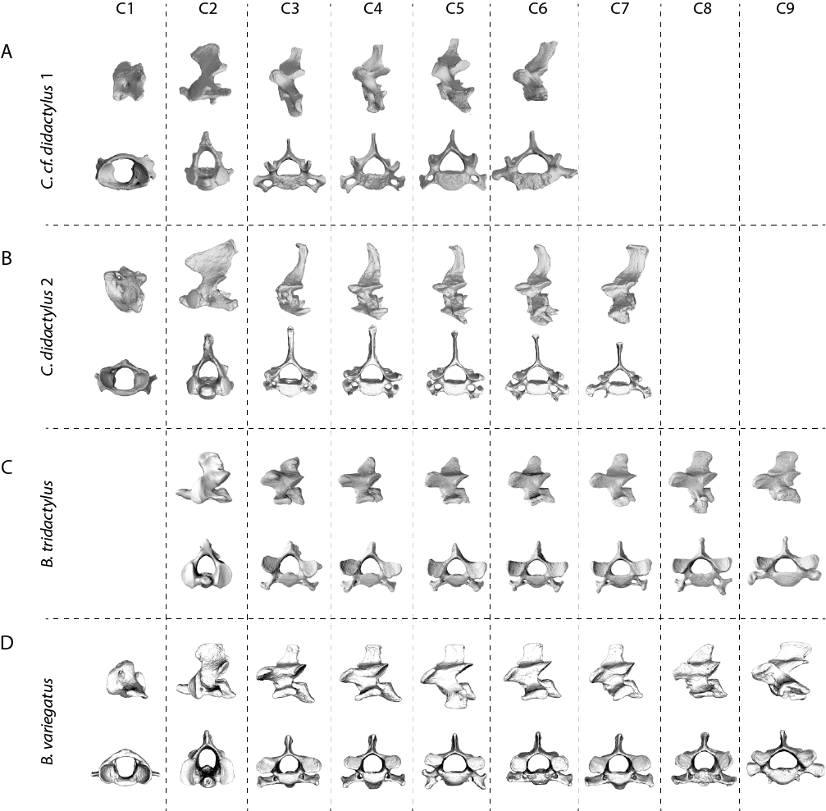
Fig. S2: 3D renderings of all analyzed vertebrae. For each specimen left lateral view above and anterior view below. A, C. cf. didactylus 1; B, C. didactylus 2; C, B. variegatus; D, B. tridactylus. C1 (atlas) of B. tridactylus was not available with the museum specimen. Note that the present analysis involved only postatlantal CV.

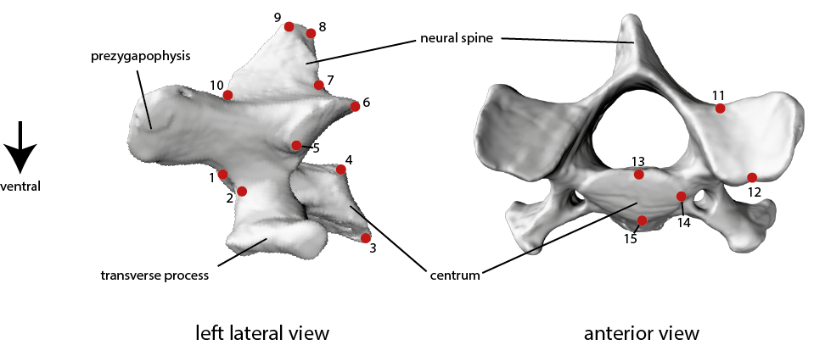
Fig. S3: Landmark set used in the 3D geometric morphometric analysis. The numbered 3D landmarks (red points) are shown on a mid-cervical vertebra of Bradypus tridactylus (3D model). LM1=dorsal-anterior edge of vertebral centrum, LM2=ventral-anterior edge of vertebral centrum, LM3=ventral-posterior edge of vertebral centrum, LM4=dorsal-posterior edge of vertebral centrum, LM5=anteriormost edge of articular facet of postzygapophysis, LM6=dorsal-posterior edge of articular facet of postzygapophysis, LM7=point of maximum curvature between postzygapophysis and neural spine, LM8=posterior edge of neural spine, LM9=anterior edge of neural spine, LM10=point of maximum curvature between neural spine and prezygapophysis, LM11=posteriormost point of articular facet of prezygapophysis, LM12=dorsal-anterior edge of articular facet of prezygapophysis, LM13=dorsalmost point of vertebral centrum in anterior view, LM14=lateralmost point of vertebral centrum in anterior view, LM15=ventralmost point of vertebral centrum in anterior view.

Table S1: Percentage of total variance explained and cumulative variance per relative warp (RW). Only the first four RWs are indicated since they explain more than 95% of the total variance.
 | Variance [%] | Cumulative variance [%]
Choloepus cf. didactylus 1
RW1 | 85.47 | 85.47
RW2 | 9.93 | 95.40
RW3 | 2.81 | 98.21
RW4 | 1.79 | 100.00
Choloepus didactylus 2
RW1 | 82.66 | 82.66
RW2 | 9.09 | 91.75
RW3 | 4.85 | 96.60
RW4 | 2.09 | 98.69
Bradypus variegatus
RW1 | 59.44 | 59.44
RW2 | 28.98 | 88.42
RW3 | 6.07 | 94.49
RW4 | 2.49 | 96.98
Bradypus tridactylus
RW1 | 55.33 | 55.33
RW2 | 25.73 | 81.06
RW3 | 10.71 | 91.77
RW4 | 4.24 | 96.01

