Host symbiotic growth non-linear regression analysis – CT39 Removed due to high variance in parameter estimates

Call:
Model: slope ~ (rmax * (light.n - pbar)/(k + (light.n - pbar))) | strain
Data: slopedata[symbionts == "g" & strain != "CT39", ]

Coefficients:
rmax
Estimate Std. Error t value Pr(>|t|)
Dd1 0.2684359 0.07340272 3.657029 1.783458e-04
HA1 0.5160393 0.10411673 4.956353 4.278129e-04
HK1 0.1766509 0.04737774 3.728564 2.325513e-06
s186 0.5753377 0.12187399 4.720759 3.452707e-03
pbar
Estimate Std. Error t value Pr(>|t|)
Dd1 3.78329557 1.1286342 3.35210070 0.0004594226
HA1 -0.09186747 1.0640457 -0.08633789 0.9410697836
HK1 1.15014406 0.9003295 1.27747016 0.0474300915
s186 0.05472349 1.0585332 0.05169747 0.9710145146
k
Estimate Std. Error t value Pr(>|t|)
Dd1 17.015452 9.326754 1.824370 0.03782889
HA1 16.700718 8.884221 1.879818 0.12001068
HK1 8.260467 6.234620 1.324935 0.04034145
s186 19.892866 10.365828 1.919081 0.18823500

Residual standard error: 0.06940574 on 86 degrees of freedom

Note that strain ID s186 is 186b
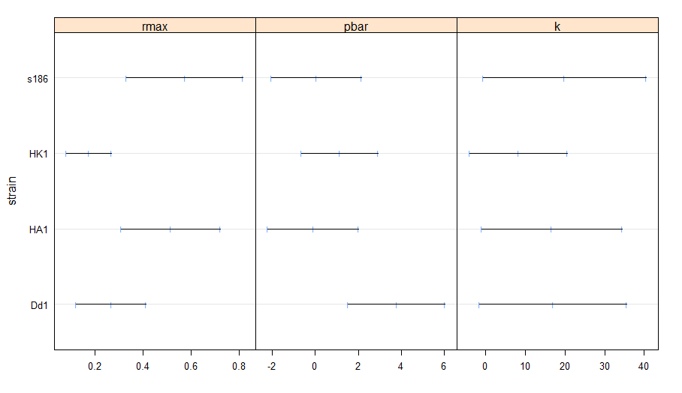

Host symbiont load non-linear regression analysis
Call:
Model: host.FL.mn ~ (a * (light.n - l)/(b + ((light.n - l)^c))) | strain
Data: host.FL

Coefficients:
a
Estimate Std. Error t value Pr(>|t|)
CT39 13985847 2584753 5.410903 4.007584e-04
Dd1 21130112 6512990 3.244303 1.051916e-03
HA1 18147382 3985035 4.553883 1.344770e-04
HK1 11308172 2346631 4.818896 4.375117e-06
s186 22705976 3852382 5.894009 1.109982e-06
b
Estimate Std. Error t value Pr(>|t|)
CT39 3.042376 1.1417840 2.664581 0.054343765
Dd1 6.255133 3.5022226 1.786047 0.051360060
HA1 3.554785 1.5239586 2.332599 0.028887430
HK1 2.003719 0.9590379 2.089301 0.017286899
s186 3.425407 1.2591026 2.720514 0.006475345
c
Estimate Std. Error t value Pr(>|t|)
CT39 1.291467 0.05681229 22.73218 4.932328e-15
Dd1 1.590884 0.09991338 15.92263 1.359433e-15
HA1 1.551124 0.07697162 20.15190 1.633347e-16
HK1 1.380785 0.07032434 19.63452 2.668239e-18
s186 1.405294 0.05264168 26.69547 2.754025e-20
l
Estimate Std. Error t value Pr(>|t|)
CT39 -0.2842604 0.1019374 -2.788578 4.479926e-02
Dd1 -0.8925523 0.2754005 -3.240925 1.062175e-03
HA1 -0.4196455 0.1215738 -3.451776 2.138142e-03
HK1 -0.2265049 0.0919472 -2.463423 5.983514e-03
s186 -0.7962617 0.1770086 -4.498435 4.952296e-05

Residual standard error: 588806.4 on 120 degrees of freedom
Note that strain ID s186 is 186b
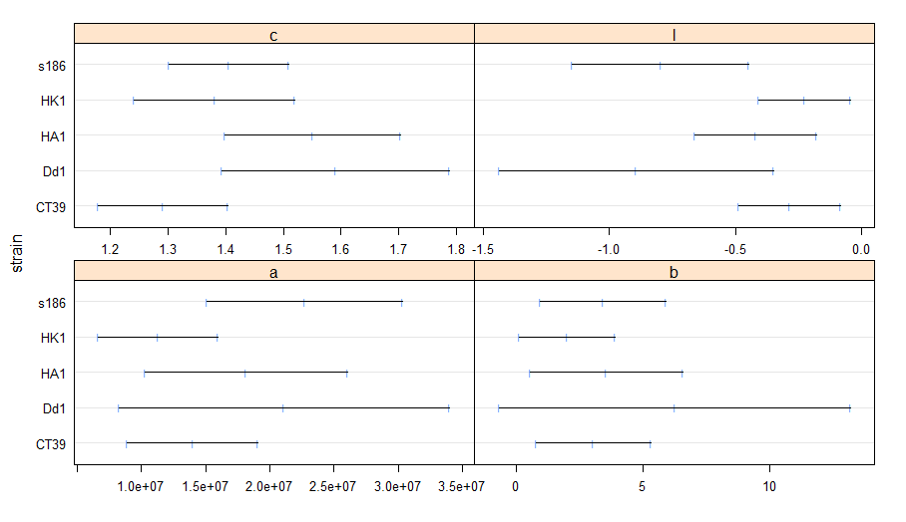
Host symbiont load non-linear mixed effects model
Nonlinear mixed-effects model fit by maximum likelihood
Model: host.FL.mn ~ symresp(a, b, c, l, L = light.n)
Data: host.FL
AIC BIC logLik
-373.306 -308.5899 208.653

Random effects:
Formula: a ~ 1 | strain
a.(Intercept) Residual
StdDev: 1.437245e-06 0.05451294

Fixed effects: list(a + b + c + l ~ 1 + strain)
Value Std.Error DF t-value p-value
a.(Intercept) 1.391270 0.256402 116 5.426120 0.0000
a.strainDd1 0.716827 0.697755 116 1.027335 0.3064
a.strainHA1 0.423445 0.473858 116 0.893611 0.3734
a.strainHK1 -0.260401 0.347587 116 -0.749170 0.4553
a.strains186 0.878914 0.462665 116 1.899677 0.0600
b.(Intercept) 3.006673 1.128940 116 2.663271 0.0088
b.strainDd1 3.220454 3.663333 116 0.879105 0.3812
b.strainHA1 0.548015 1.896533 116 0.288956 0.7731
b.strainHK1 -1.002718 1.481365 116 -0.676888 0.4998
b.strains186 0.417267 1.690693 116 0.246802 0.8055
c.(Intercept) 1.290003 0.056674 116 22.761845 0.0000
c.strainDd1 0.300188 0.114771 116 2.615529 0.0101
c.strainHA1 0.261117 0.095585 116 2.731780 0.0073
c.strainHK1 0.090795 0.090320 116 1.005263 0.3169
c.strains186 0.115240 0.077347 116 1.489913 0.1390
l.(Intercept) -0.281630 0.101229 116 -2.782098 0.0063
l.strainDd1 -0.608863 0.292904 116 -2.078713 0.0398
l.strainHA1 -0.138009 0.158200 116 -0.872369 0.3848
l.strainHK1 0.055104 0.136758 116 0.402933 0.6877
l.strains186 -0.514424 0.203878 116 -2.523190 0.0130

Standardized Within-Group Residuals:
Min Q1 Med Q3 Max
-2.94168498 -0.63533970 -0.01036713 0.48430929 2.95636643

Number of Observations: 140
Number of Groups: 5

