Additional files (Figs S1–S5 and Tabs S1–S7)

Oldest ctenodactyloid tarsals from the Eocene of China and evolution of locomotor adaptations in early rodents

Łucja Fostowicz-Frelik^{*1,2}, Qian Li¹, Xijun Ni¹

¹Key Laboratory of Vertebrate Evolution and Human Origins, Institute of Vertebrate Paleontology and Paleoanthropology, Chinese Academy of Sciences, 100044 Beijing, People’s Republic of China (liqian@ivpp.ac.cn; nixijun@ivpp.ac.cn)
²Institute of Paleobiology, Polish Academy of Sciences, PL 00-818 Warszawa, Poland; (lfost@twarda.pan.pl) [*to whom correspondence should be addressed]

Table S1 Specimens examined in morphological analyses
Taxon | Collection number | Status: (E) extant, (F) fossil
Arvicola terrestris | ISEZ M/13423 | (E)
Cricetus cricetus | ISEZ M/13323 | (E)
Cynomys ludovicianus | IVPP-coll. 81-33A-2-18 | (E)
Glis glis | ISEZ M/8510/88  ISEZ M/12110 | (E)  (E)
Gomphos elkema | uncataloged IVPP coll. | (F), Nuhetingboerhe, Erlian Basin, Nei Mongol, China
Marmota marmota | NX-coll.¹ | (E)
Mus musculus | ISEZ M/13329 | (E)
Ochotona pallasi | ISEZ M/2984/66 | (E)
Ondatra zibethicus | NX-coll | (E)
Paramyinae indet. | Calcaneus R; uncataloged IVPP coll. | (F) Irdin Manha Fm. Erlian Basin, Nei Mongol, China
Paramys sp. | USNM 491851 astragalus R; literature data² | (F)
Purgatorius sp. | UCMP 197509, L astragalus  UCMP 197517, R calcaneus  Literature data³ | (F) Paleocene (late Puercan) Garbani Channel fauna; localities in NE Montana, USA
Rattus norvegicus | IVPP coll. 417-4-7-4 | (E)
Sciurotamias davidianus | IVPP-coll. 780-33A-1-16 | (E)
Sciurus vulgaris | ISEZ M/12119  ISEZ M/13322  ISEZ M/13337 | (E)  (E)  (E)
Tamquammys robustus | IVPP coll. V24136.1-3 R calcanei  IVPP coll. V24136.4-6 R astragalus and two L astragali, respectively | (F) Nuhetingboerhe, Erlian Basin, Nei Mongol, China; Arshanto Fm. (late early to early middle Eocene)
Tamquammys wilsoni | IVPP coll. V24137.1-3 R calcaneus and L calcanei  IVPP coll. V24137.4-6 L astragali  IVPP coll. V24138 R calcaneus  IVPP coll. V24139 L astragalus  IVPP coll. V24140 L calcaneus  IVPP coll. V24141 L astragalus  IVPP coll. V24142 L astragalus | Nuhetingboerhe, Erlian Basin, Nei Mongol, China; Arshanto Fm. (late early to early middle Eocene)  Huheboerhe (H-2), Nei Mongol, China; Irdin Manha Fm. middle Eocene  Huheboerhe (H-2A), Nei Mongol, China, Irdin Manha Fm. middle Eocene
Tribosphenomys minutus | uncataloged IVPP coll. | (F) Subeng, Erlian Basin, China, Late Paleocene
Tupaia glis | NX-coll. | (E)

¹ Ni Xijun comparative collection at IVPP (NX-coll.), ² Data from Rose and Chinnery (2004), ³ Data from Chester et al. (2015); ISEZ, Institute of Systematics and Evolution of Animals, Polish Academy of Sciences, Kraków, Poland; IVPP, Institute of Vertebrate Paleontology and Paleoanthropology, Chinese Academy of Sciences, Beijing, People’s Republic of China
Table S2 Guide to the bone measurements – calcaneus

Measurement No. | Description | Abbreviation | Figure
1 | Total bone length | CL | FigS1A
2 | Maximum bone width, measured from the medial tip of the sustentaculum tali to the lateral tip of the peroneal process | CW | FigS1A
3 | Length of the calcaneal body | CBL | FigS1A
4 | Width of the calcaneal tuber, measured at its caudal extremity | TCW | FigS1A
5 | Dorsoplantar dimension of the calcaneal tuber, measured at its caudal extremity | TCdp | FigS1B
6 | Length of the calcaneal eminence | EML | FigS1B
7 | Length of the ectal facet | CEL | Fig1A
8 | Width of the ectal facet at its cranial margin | EWCr | Fig1A
9 | Width of the ectal facet in its mid-length | EWm-l | Fig1B
10 | Maximum width of the calcaneal eminence | EW | Fig1A
11 | Maximum dorsoplantar dimension of the bone, measured from the dorsalmost point of the calcaneal eminence to the plantarmost point of the anterior plantar tubercle | DP | Fig1B
12 | Width of the calcaneal body, measured from the medialmost point of the calcaneal body (anteriorly to the sustentaculum tali) to the lateralmost point of the peroneal tubercle | CBW | Fig1A
13 | Width of the calcaneocuboid facet, the maximum mediolateral dimension of the articular facet | CaCuW | Fig1A
14 | Dorsoplantar length of the calcaneocuboid facet | CaCuL | Fig1B
15 | Width of the calcaneal tuber in mid-length | TCWm-l | Fig1A

Table S3 Guide to the bone measurements – astragalus

Measurement No. | Description | Abbreviation | Figure
1 | Total bone length | AL | Fig1C
2 | Total width of the astragalar body | AW | Fig1C
3 | Total trochlea width | TW | Fig1C
4 | Length of the astragalar neck | NL | Fig1C
5 | Mediolateral length of the astragalar head | HL | Fig1C
6 | Dorsoplantar width of the astragalar head | HW | Fig1C
7 | Length of the lateral crest | LCL | Fig1C
8 | Length of the medial crest | MCL | Fig1C
9 | Width of the astragalar ectal facet | AEW | Fig1D
10 | Length of the astragalar ectal facet | AEL | Fig1D
11 | Length of the sustentacular facet | SL | Fig1D
12 | Width of the sustentacular facet | SW | Fig1D

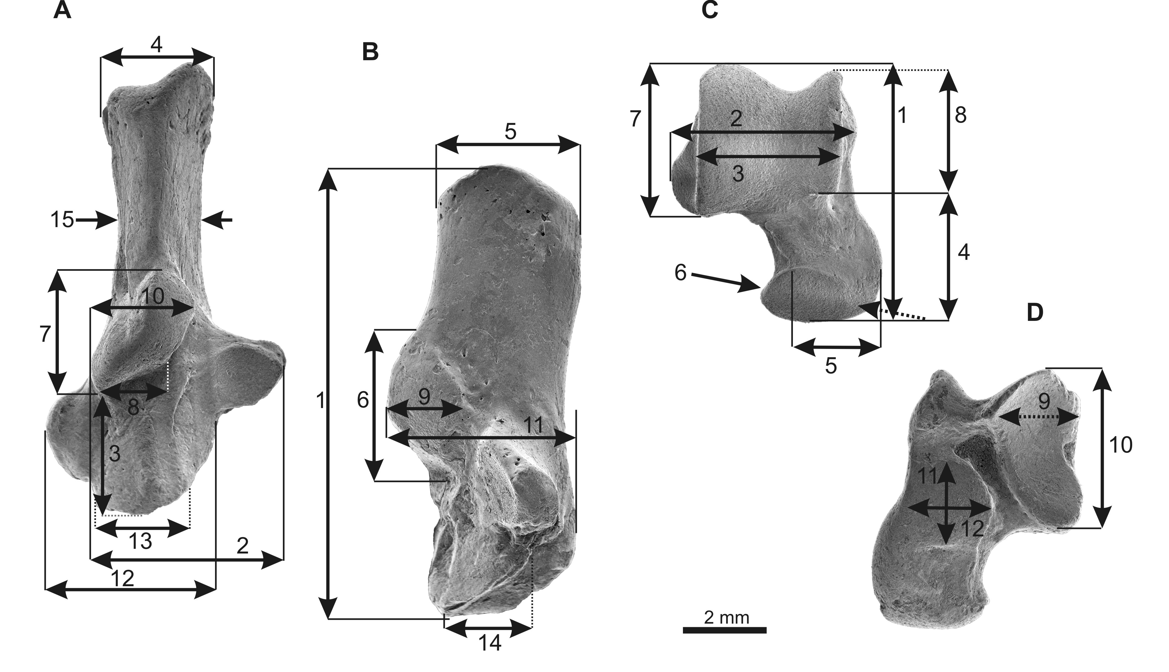

Fig. S1 Measurements of the tarsal elements shown at the right calcaneus (A, B) and right astragalus (C, D) of Tamquammys robustus (IVPP coll. V24136.1 and IVPP coll. V24136.4, respectively) from the Arshanto Formation (early Eocene) of Nuhetingboerhe section, Erlian Basin, Nei Mongol, China.
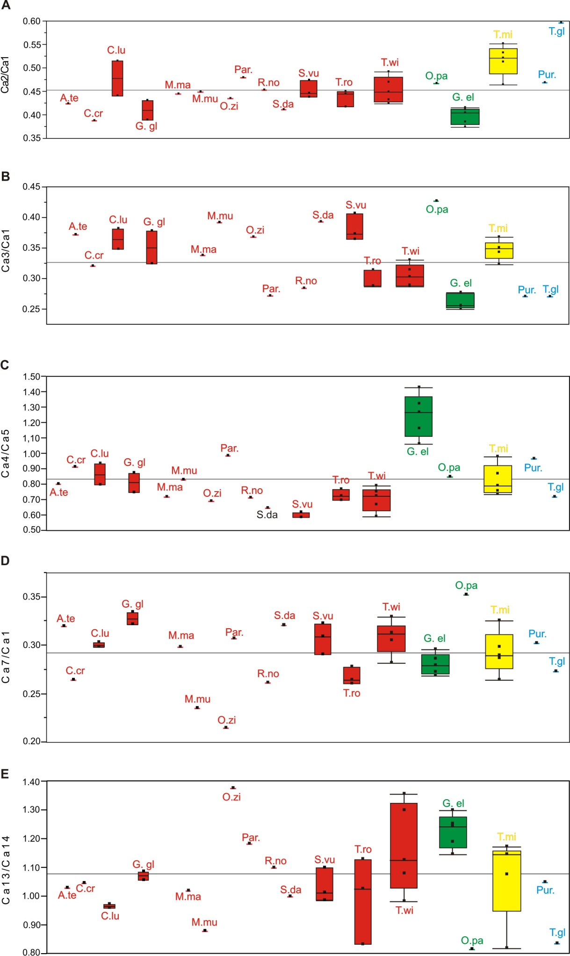
Fig. S2 Ratios for calcaneal measurements. A, slenderness ratio (CW/CL); B, calcaneal load arm (CBL/CL); C tuber proportions (TCW/TCdp); D, relative length of the ectal facet (CEL/CL); E, proportions of the calcaneocuboid facet (CaCuW/CaCuL). Abbreviations: A.te, Arvicola terrestris; C.cr, Cricetus cricetus; C.lud, Cynomys ludovicianus; G.gl, Glis glis; G.el, Gomphos elkema; M.ma, Marmota marmota; M.mu, Mus musculus; O.pa, Ochotona pallasi; O.zi, Ondatra zibethicus; Par., paramyine rodent; Pur, Purgatorius; R.no, Rattus norvegicus; S.vu, Sciurus vulgaris; T.gl, Tupaia glis; T.mi, Tribosphenomys minutus; T.ro, Tamquammys robustus; T.wi, Tamquammys wilsoni. Colors: red for rodents; yellow for Rodentiaformes; green for stem duplicidentate and lagomorph; blue for Euarchonta (basal primate and Scandentia).

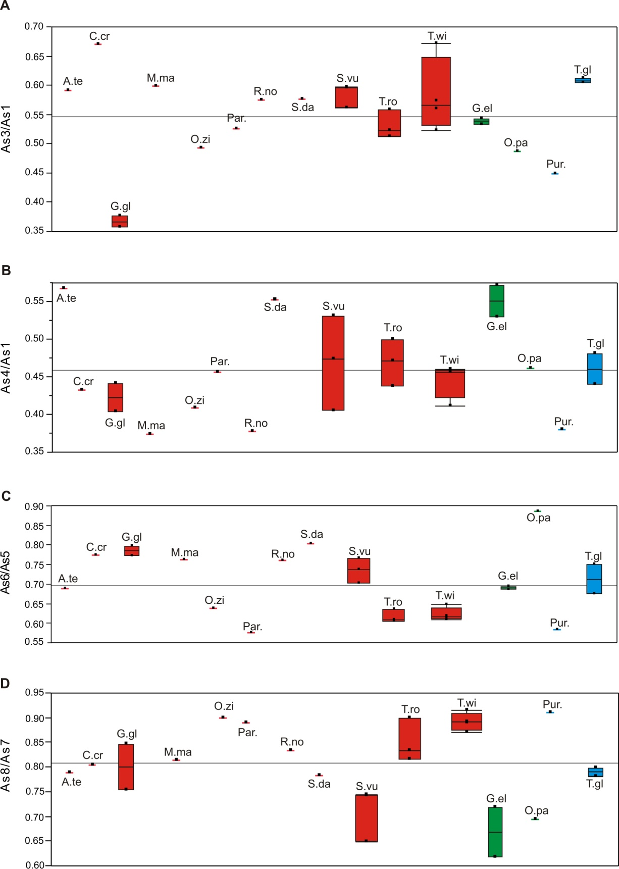

Fig. S3 Ratios for astragalar measurements. A, trochlear ratio (TW/AL); B, neck ratio (NL/AL); C head proportions (HW/NL); D, trochlear crests ratio (MCL/LCL); abbreviations as in Fig.S2.

Table S4
Measurements of calcaneus of Tamquammys robustus, T. wilsoni, and comparative taxa (in mm)

Measurement | 1 | 2 | 3 | 4 | 5 | 6 | 7 | 8 | 9 | 10 | 11 | 12 | 13 | 14 | 15
Tamquammys robustus
V24136.1  V24136.2  V24136.3 | 10.62  9.83  10.62 | 4.77  4.09  4.72 | 3.05  3.08  3.04 | 2.47  2.46  2.45 | 3.43  3.20  3.53 | 3.0  2.75  2.98 | 2.76  2.60  2.95 | 1.67  1.63  1.82 | 1.56  1.43  1.36 | 2.19  2.0  2.11 | 4.04  4.50  4.38 | 4.38  3.73  4.14 | 2.57  2.30  2.20 | 2.51  2.04  2.65 | 1.89  1.85  1.90
Tamquammys wilsoni
V24137.1  V24137.2  V24137.3  V24138.1  V24140 | 5.67  5.57  5.86  5.92  5.51 | 2.54  2.36  2.53  2.78  2.71 | 1.62  1.75  1.69  1.79  1.82 | 1.45  1.29  1.17  1.73  1.19 | 1.94  1.79  1.99  2.19  1.78 | 1.79  1.77  1.95  2.07  1.59 | 1.77  1.70  1.93  1.85  1.55 | 0.99  1.09  0.95  1.20  0.80 | 0.74  0.88  1.0  0.95  0.80 | 1.15  1.06  1.0  1.20  1.05 | 2.60  2.36  2.52  2.60  2.25 | 3.27  2.14  2.43  3.32  2.24 | 1.43  1.64  1.96  1.68  1.84 | 1.46  1.46  1.45  1.56  1.42 | 1.01  1.01  1.0  1.23  1.03
Tribosphenomys minutus
IVPP uncat. 1  IVPP uncat. 2  IVPP uncat. 3  IVPP uncat. 4  IVPP uncat. 5 | 2.52  2.95  2.91  2.83  2.48 | 1.34  1.51  1.35  1.56  1.29 | 0.88  1.01  0.94  0.99  0.91 | 0.78  0.86  0.77  0.86  0.812 | 0.90  1.17  1.02  1.09  0.83 | 0.77  0.96  0.81  0.84  0.78 | 0.73  0.96  0.77  0.81  0.74 | 0.37  0.45  0.49  0.40  0.41 | 0.62  0.69  0.55  0.60  0.45 | 0.76  0.78  0.69  0.71  0.69 | 1.34  1.70  1.52  1.61  1.40 | 1.26  1.34  1.25  1.30  1.25 | 0.41  0.99  0.87  0.80  0.69 | 0.35  1.21  0.81  0.70  0.69 | 0.56  0.61  0.57  0.62  0.58
Gomphos elkema
IVPP uncat. 1  IVPP uncat. 2  IVPP uncat. 3  IVPP uncat. 4  IVPP uncat. 5 | 21.0  22.05  22.34  23.07  24.16 | 8.62  8.90  8.36  9.57  9.30 | 5.34  6.09  5.57  6.33  6.17 | 6.90  6.35  7.32  7.73  7.88 | 5.42  5.96  6.26  5.83  5.50 | 7.29  7.47  7.33  7.11  7.40 | 6.0  5.92  6.22  6.81  6.57 | 3.93  3.56  3.45  3.48  4.30 | 3.43  3.33  3.41  2.76  3.50 | 4.17  4.74  4.48  4.41  4.88 | 9.16  9.02  9.64  9.66  10.51 | 6.57  7.11  7.53  6.90  7.42 | 6.07  6.41  6.38  5.52  6.61 | 5.11  5.13  4.92  4.83  5.33 | 4.71  4.45  5.13  4.65  4.90
Ochotona pallasi
ISEZ M/2984/66 | 8.19 | 3.82 | 3.49 | 2.12 | 2.51 | 3.21 | 2.88 | 0.50 | 1.29 | 2.07 | 2.95 | 3.01 | 2.34 | 2.88 | 2.07
Arvicola terrestris
ISEZ M/13423 | 5.54 | 2.35 | 2.06 | 1.67 | 2.09 | 1.76 | 1.77 | 1.09 | 0.99 | 1.30 | 2.08 | 2.32 | 1.88 | 1.83 | 1.52
Cricetus cricetus
ISEZ M/13323 | 10.48 | 4.06 | 3.35 | 2.88 | 3.16 | 2.84 | 2.77 | 1.97 | 1.98 | 2.06 | 3.13 | 4.09 | 2.88 | 2.76 | 2.14
Cynomys ludovicianus
IVPP-coll. 81-33A-2-18 | 11.61  12.04 | 5.98  5.30 | 4.03  4.59 | 3.63  4.40 | 4.57  4.72 | 3.46  3.71 | 3.46  3.65 | 2.11  1.92 | 2.10  2.01 | 2.81  2.78 | 4.78  5.29 | 6.12  4.93 | 3.60  3.45 | 3.71  3.60 | 2.28  2.29
Glis glis
ISEZ M/8510/88  ISEZ M/12110 | 5.99  6.65 | 2.58  2.59 | 2.26  2.15 | 1.44  1.63 | 1.93  1.17 | 2.07  2.44 | 2.0  2.14 | 1.02  1.09 | 1.16  1.21 | 1.09  1.16 | 2.22  2.21 | 2.17  2.79 | 1.70  1.75 | 1.57  1.66 | 1.06  1.02
Marmota marmota
IVPP NX-coll. | 20.18 | 8.98 | 6.82 | 5.63 | 7.84 | 6.50 | 6.01 | 3.85 | 3.67 | 4.28 | 8.40 | 8.37 | 5.04 | 4.96 | 3.95
Mus musculus
ISEZ M/13329 | 2.94 | 1.32 | 1.15 | 0.68 | 0.82 | 0.73 | 0.69 | 0.44 | 0.44 | 0.63 | 1.04 | 1.24 | 0.85 | 0.97 | 0.51
Ondatra zibethicus
IVPP NX-coll. | 17.26 | 7.50 | 6.35 | 4.35 | 6.31 | 3.87 | 3.71 | 2.61 | 2.99 | 4.52 | 6.36 | 6.47 | 4.81 | 3.50 | 3.44
Paramyinae indet.
IVPP ucat. | 26.0 | 12.45 | 7.05 | 7.57 | 7.68 | 8.12 | 7.97 | 4.81 | 3.74 | 7.20 | 11.49 | 10.89 | 7.67 | 6.50 | 4.80
Rattus norvegicus
IVPP coll. 417-4-7-4 | 7.97 | 3.61 | 2.26 | 1.94 | 2.72 | 2.73 | 2.08 | 1.19 | 1.32 | 1.61 | 3.02 | 3.27 | 2.04 | 1.86 | 1.64
Sciurotamias davidianus
IVPP-coll. 780-33A-1-16 | 9.75 | 4.01 | 3.83 | 2.18 | 3.37 | 3.22 | 3.13 | 1.69 | 1.49 | 2.10 | 3.47 | 4.42 | 2.49 | 2.50 | 1.91
Sciurus vulgaris
ISEZ M/13322  ISEZ M/13337  ISEZ M/12119 | 10.74  10.53  11.10 | 4.79  4.99  4.86 | 4.36  3.92  4.04 | 2.39  2.45  2.42 | 3.86  3.98  4.13 | 3.80  3.29  3.21 | 3.32  3.40  3.22 | 1.82  2.18  1.93 | 1.71  1.99  1.80 | 1.88  2.15  1.98 | 4.38  4.59  4.46 | 4.22  4.18  3.67 | 2.67  2.57  2.88 | 2.64  2.61  2.63 | 1.54  1.55  1.48
Tupaia glis
IVPP NX-coll. | 6.96 | 4.15 | 1.88 | 1.73 | 2.41 | 1.97 | 1.90 | 1.19 | 1.25 | 1.44 | 2.69 | 2.85 | 1.46 | 1.75 | 1.50

Table S5 Measurements of astragalus of Tamquammys robustus and T. wilsoni and comparative taxa (in mm)

Measurement | 1 | 2 | 3 | 4 | 5 | 6 | 7 | 8 | 9 | 10 | 11 | 12
Tamquammys robustus
V24136.4  V24136.5  V24136.6 | 6.91  6.30  5.82 | 4.55  4.36  4.34 | 3.54  3.29  3.25 | 3.02  3.15  2.74 | 3.33  3.02  2.86 | 2.01  1.92  1.74 | 3.97  3.50  3.46 | 3.31  3.15  2.82 | 2.67  2.08  2.34 | 3.13  3.26  3.20 | 2.14  2.24  2.02 | 1.81  1.64  1.71
Tamquammys wilsoni
V24137.4  V24137.5  V24141  V24142  V24139 | 3.77  4.17  3.12  3.23  3.21 | 2.52  2.64  2.26  2.06  1.98 | 2.11  2.18  1.60  1.66  1.84 | 1.72  1.90  1.31  1.40  1.32 | 1.89  1.97  1.66  1.60  1.61 | 1.21  1.20  1.0  0.98  0.99 | 2.15  2.27  1.94  1.97  2.01 | 1.87  2.02  1.80  1.84  1.84 | 1.49  1.29  1.02  1.20  1.18 | 2.45  2.33  1.73  1.53  1.76 | 1.60  1.49  0.81  0.82  1.18 | 1.27  1.07  1.32  1.17  0.81
Gomphos elkema
IVPP uncat (12170-1)  IVPP uncat (12099-1) | 12.23  12.92 | 8.13  8.70 | 6.52  7.03 | 6.49  7.41 | 6.08  6.81 | 4.22  4.67 | 7.3  7.59 | 4.51  5.45 | 4.42  4.71 | 6.79  7.53 | 5.48  5.04 | 3.72  3.95
Ochotona pallasi
ISEZ M/2984/66 | 4.88 | 2.76 | 2.38 | 2.25 | 2.03 | 1.80 | 2.97 | 2.06 | 1.29 | 2.72 | 1.82 | 1.28
Arvicola terrestris
ISEZ M/13423 | 3.38 | 2.48 | 2.00 | 1.92 | 1.89 | 1.30 | 2.36 | 1.86 | 1.42 | 1.98 | 1.30 | 0.99
Cricetus cricetus
ISEZ M/12119 | 5.37 | 3.93 | 3.60 | 2.32 | 2.52 | 1.95 | 3.21 | 2.58 | 2.01 | 2.91 | 1.99 | 1.26
Glis glis
ISEZ M/8510/88  ISEZ N/12110 | 4.64  4.60 | 2.46  2.38 | 1.66  1.73 | 2.05  1.86 | 1.67  1.68 | 1.29  1.34 | 2.39  2.43 | 1.80  2.06 | 1.52  1.41 | 2.48  2.38 | 1.72  2.04 | 1.26  1.07
Marmota marmota
IVPP NX coll. | 12.11 | 8.82 | 7.25 | 4.53 | 6.20 | 4.72 | 8.28 | 6.74 | 5.0 | 7.32 | 5.45 | 3.75
Ondatra zibethicus
IVPP NX coll. | 10.70 | 7.11 | 5.27 | 4.37 | 5.21 | 3.32 | 6.0 | 5.40 | 4.83 | 5.30 | 4.86 | 2.53
Paramys sp.
USNM 491851 | 11.5 | 8.11 | 6.04 | 5.25 | 6.45 | 3.71 | 7.11 | 6.32 | 5.68 | 8.00 | 5.27 | 4.71
Rattus norvegicus
IVPP coll. 417-4-7-4 | 5.11 | 3.50 | 2.94 | 1.93 | 2.12 | 1.61 | 2.89 | 2.41 | 2.04 | 2.68 | 2.12 | 1.40
Sciurotamias davidianus
IVPP-coll. 780-33A-1-16 | 5.92 | 4.08 | 3.41 | 3.27 | 2.94 | 2.36 | 3.68 | 2.88 | 2.20 | 3.46 | 2.78 | 1.88
Sciurus vulgaris
ISEZ M/13322  ISEZ M/13337  ISEZ M/12119 | 7.23  7.13  6.84 | 4.78  4.59  4.32 | 4.06  4.25  4.09 | 2.93  3.38  3.63 | 3.79  3.66  3.79 | 2.79  2.80  2.66 | 4.56  4.72  4.41 | 3.38  3.06  3.28 | 2.60  2.82  2.78 | 3.76  4.04  3.61 | 2.68  3.14  3.30 | 2.05  1.82  1.97
Tupaia glis
IVPP NX coll. | 4.05  4.07 | 2.88  2.83 | 2.45  2.49 | 1.78  1.96 | 2.04  2.09 | 1.53  1.41 | 2.53  2.51 | 2.02  1.96 | 1.59  1.71 | 2.46  2.12 | 2.24  2.0 | 1.09  0.87

Table S6 Results of Kaiser-Meyer-Olkin (KMO) Test for sampling adequacy
Calcaneus | 0.8979 (good)
Astragalus | 0.90136 (very good)

Table S7 Eigenvalues for calcaneus (A) and astragalus (B) PCA analysis
A
PC | Eigenvalue | % variance
1 | 9.65722 | 96.6
2 | 0.13154 | 1.3158
3 | 0.0480915 | 0.48105
4 | 0.0444457 | 0.44458
5 | 0.0334508 | 0.3346
6 | 0.0221309 | 0.22137
7 | 0.0167797 | 0.16785
8 | 0.016072 | 0.13611
9 | 0.0083259 | 0.083283
10 | 0.0072261 | 0.072282
11 | 0.0053616 | 0.053632
12 | 0.0038230 | 0.038242
13 | 0.0022059 | 0.022066
14 | 0.0017349 | 0.017355
15 | 0.0011764 | 0.011768

B
PC | Eigenvalue | % variance
1 | 7.23773 | 96.366
2 | 0.103047 | 1.372
3 | 0.0649602 | 0.8649
4 | 0.0320865 | 0.42721
5 | 0.0301298 | 0.40116
6 | 0.0120705 | 0.16071
7 | 0.010684 | 0.14225
8 | 0.0086644 | 0.11536
9 | 0.0063013 | 0.83899
10 | 0.0023774 | 0.031654
11 | 0.0014124 | 0.018805
12 | 0.0012294 | 0.01637

Fig. S4 PCA loadings for the calcaneus. Loadings are for variables described in Table S2 (Ca1–15)
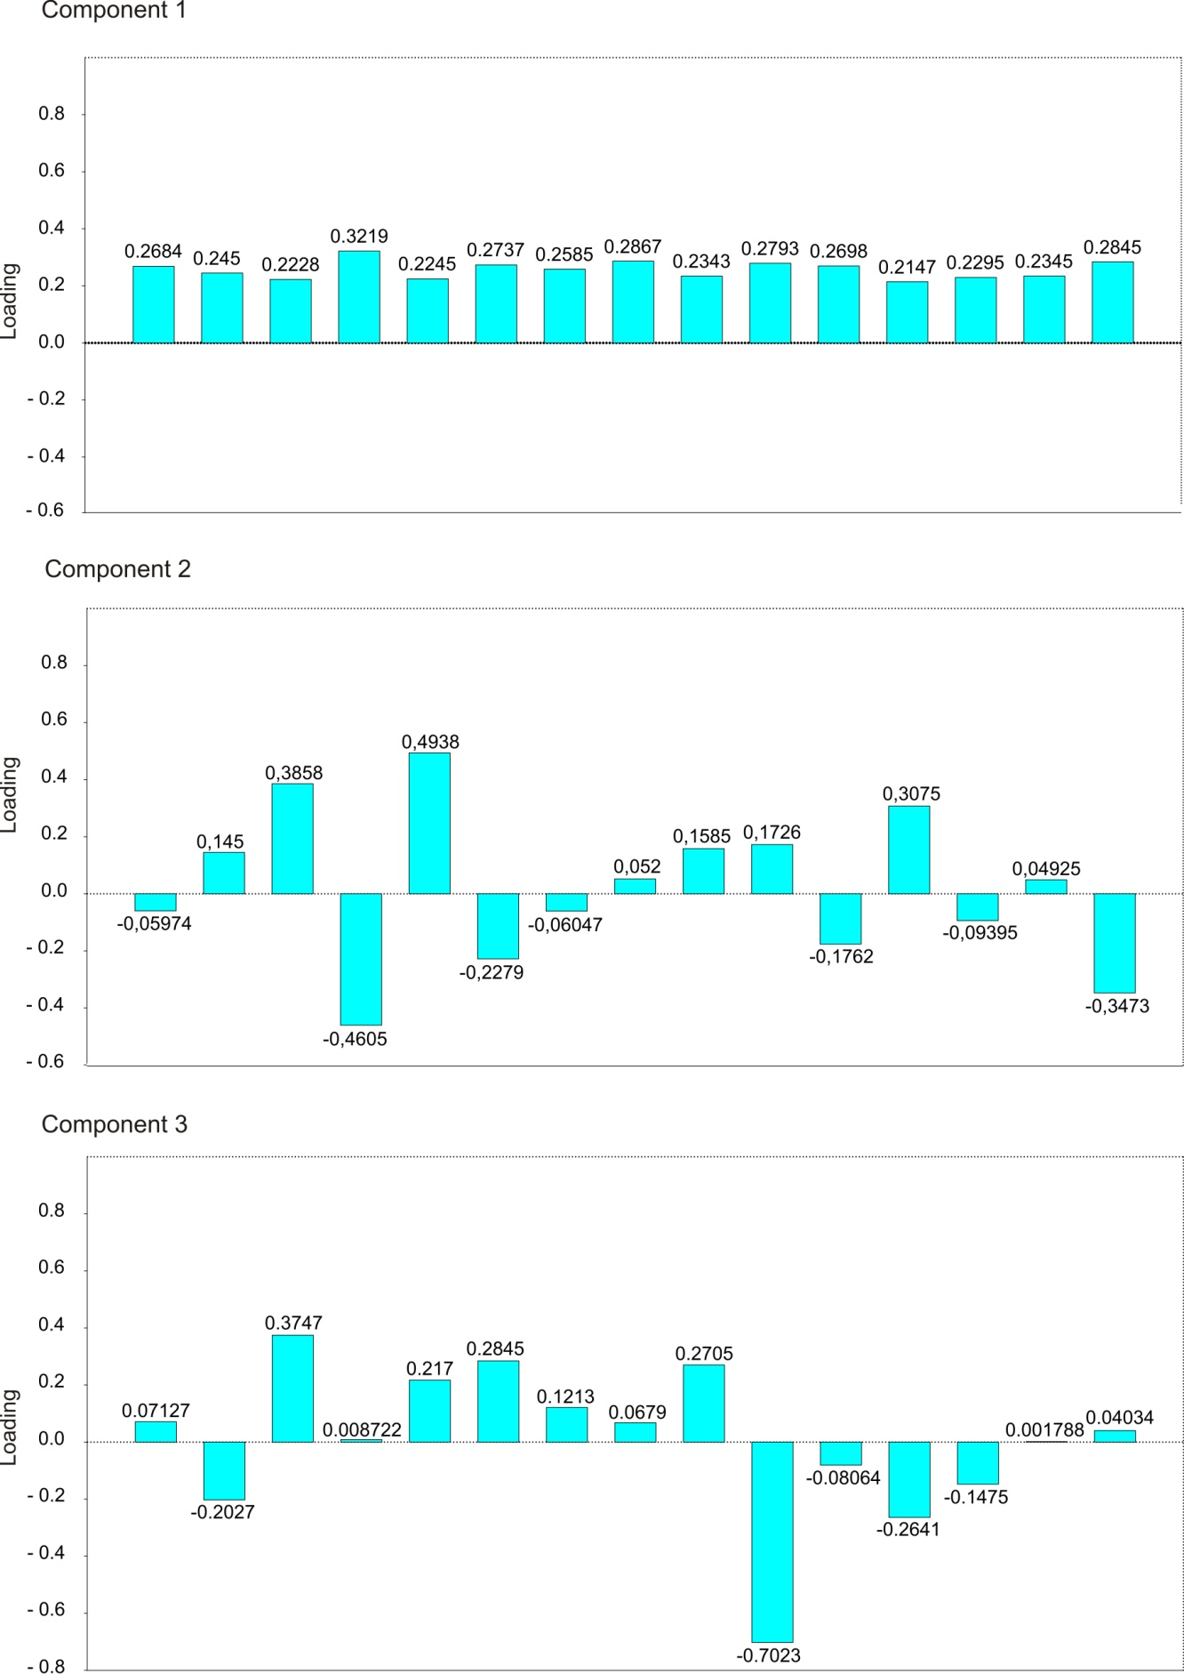

Fig S5 PCA loadings for the astragalus. Loadings are for variables described in Table S3 (As1–12)
