Additional File 8: Additional results

Outlier annotation
From the 1,119 unique outliers identified with either PCADAPT or from the empirical F_{ST} distribution approach, we obtained a blast hit for 126 outlier RAD-tags (12%) in both pool data sets (population pools and leg pools; see Table 1 below). Among these 126 outliers we also identified candidate loci for FLL regulation such as the Hox gene Sex combs reduced (Scr), 12 other transcription factors and five genes involved in the regulation of transcription or cell division/DNA replication (see Additional file 10).

In most insect taxa the expression of Scr is needed to suppress wing development and to establish the identity of legs in the first thoracic segment [73–76]. But so far no role in leg length regulation has been suggested for Scr. The Scr gene is a promising starting point for understanding the genetic architecture of FLL variation. However, the Scr outlier was only detected in the lower tail of the F_{ST} distribution in leg pools; we could not confirm it using PCADAPT or the population pool data. Future studies empolying individual SNP genotyping of the Scr locus and functional studies of bees in earlier developmental stages (e.g. pupal stages) would be required to support the role of the Scr locus in FLL regulation. Moreover, as our pooled RAD-seq design sampled only a small proportion of the R. longimanus genome, our approach might have missed other important regulators of FLL variation, which can only be tackled with whole genome sequencing.

Table 1. Number of outliers identified in PCADAPAT or the tails of the F_{ST} distribution in the population and leg pool dataset that yielded a BLAST hit. Note that we identified 1,133 outliers overall with 14 shared between approaches or datasets, i.e. 1,119 unique outliers overall.
Method | Dataset | F_{ST} | Outlier RAD-tags identified | Outliers blasted
PCADAPT | population pools | - | 309 | 34
F_{ST} (upper) | population pools | 0.547 - 0.833 | 86 | 7
F_{ST} (lower) | population pools | 0.001 - 0.014 | 86 | 24
PCADAPT | leg pools | - | - | -
F_{ST} (upper) | leg pools | 1 | 592 | 53
F_{ST} (lower) | leg pools | 0 - 0.002 | 60 | 7
Total |  |  | 1,133 (14 shared) | 126

From all the outliers identified that we were able to annotate (126 overall), 62 could be associated with GO terms, which tested for GO term enrichment. GO annotation revealed several loci that might be promising candidates for controlling processes such as limb growth. For example, the “molecular function” of many outliers related to either catalytic activity (31.3 %) or binding processes (43.8%), in particular to nucleic acids or nucleotides (Fig. 1). The GO ‘ion binding’ was also found to be significantly overrepresented in GO enrichment analyses (Fig. 2). Some outliers also have regulatory activity and control protein translation (2.1%) or act as molecular transducer (4.2%, Fig. 1).
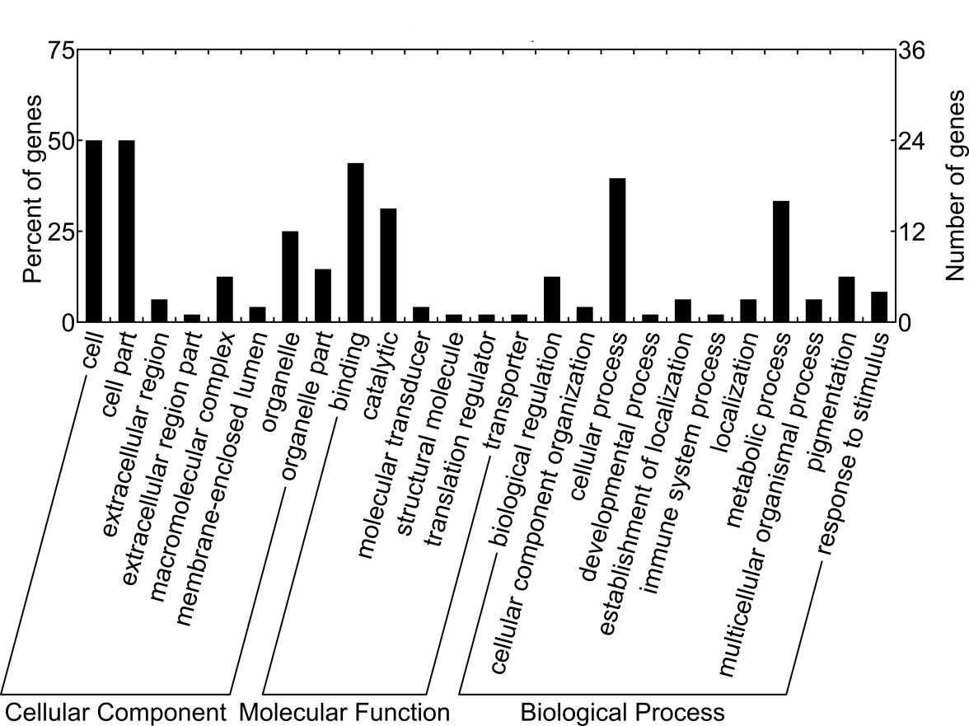
Fig. 1 Gene ontology (GO) classification of the 62 outlier loci we successfully blasted and annotated with BLAST2GO. Plotted are the number and percentage of outliers falling into the three main ontologies (cellular component, molecular function and biological process)

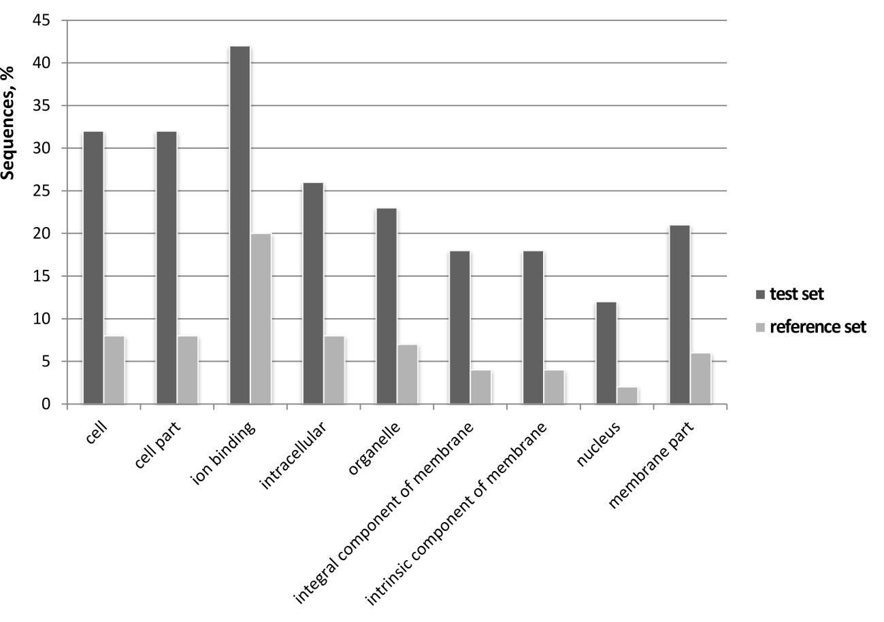
Fig. 2 GO categories that were found to be significantly overrepresented in our outlier (test) set compared to the reference during GO term enrichment analyses

