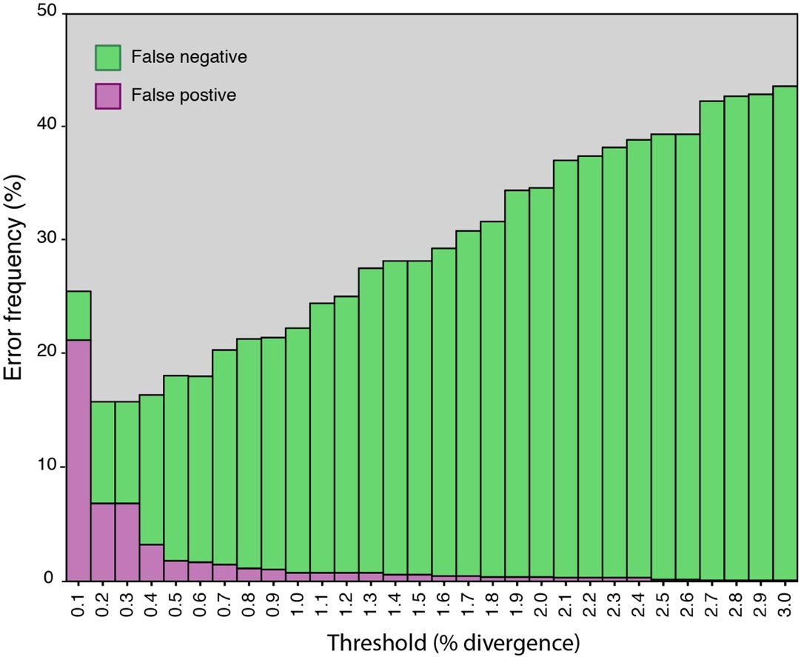

Additional file 2: Figure S2. Cumulative error plot of type I (false positive) and type II (false negative) errors for different divergence thresholds of maximum intraspecific and minimum interspecific genetic distances measured using a standardised 648bp region of the cytochrome c oxidase gene for all New Zealand bird species with >1 specimen obtained during the study. The optimal threshold occurs at 0.25%.

