Figure S1. The discription of RNA-seq in Adelphocoris suturalis. (a) The distribution of sequences length. (b) The E-value distribution of the top matches in the nr database. (c) The species distribution of the matches in the nr database. (d) The sequence similarity distribution.

Figure S2. The discription of RNA-seq in Adelphocoris fasciaticollis. (a) The distribution of sequences length. (b) The E-value distribution of the top matches in the nr database. (c) The species distribution of the matches in the nr database. (d) The sequence similarity distribution.

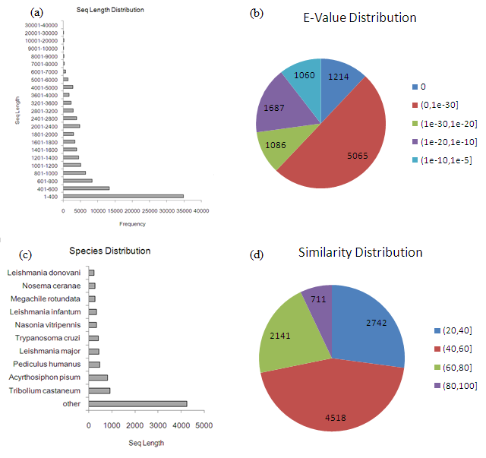
Figure S3. The discription of RNA-seq in Adelphocoris lineolatus. (a) The distribution of sequences length. (b) The E-value distribution of the top matches in the nr database. (c) The species distribution of the matches in the nr database. (d) The sequence similarity distribution.

lineolatus 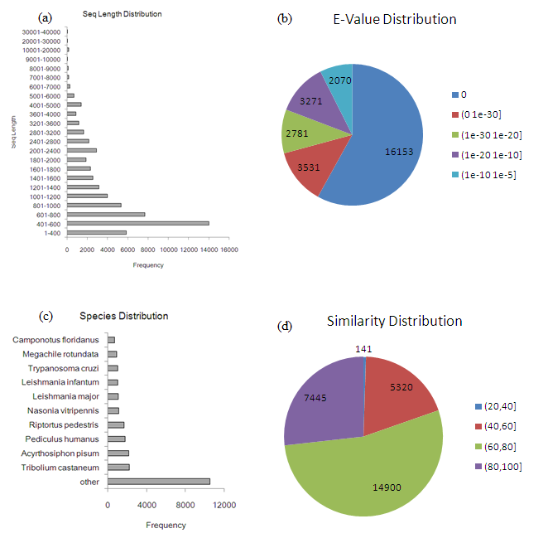
Figure S4. The discription of RNA-seq in Nesidiocoris tenuis. (a) The distribution of sequences length. (b) The E-value distribution of the top matches in the nr database. (c) The species distribution of the matches in the nr database. (d) The sequence similarity distribution.

Figure S5. The genome structure of polygalacturonase gene (m_50643) in Nesidiocoris tenuis. The intron was showed using shade.
Figure S6. The expression levels of PGs in Adelphocoris fasciaticollis.

Figure S7. The expression levels of PGs in Nesidiocoris tenuis.

