Additional file 3: Figures S1-S3
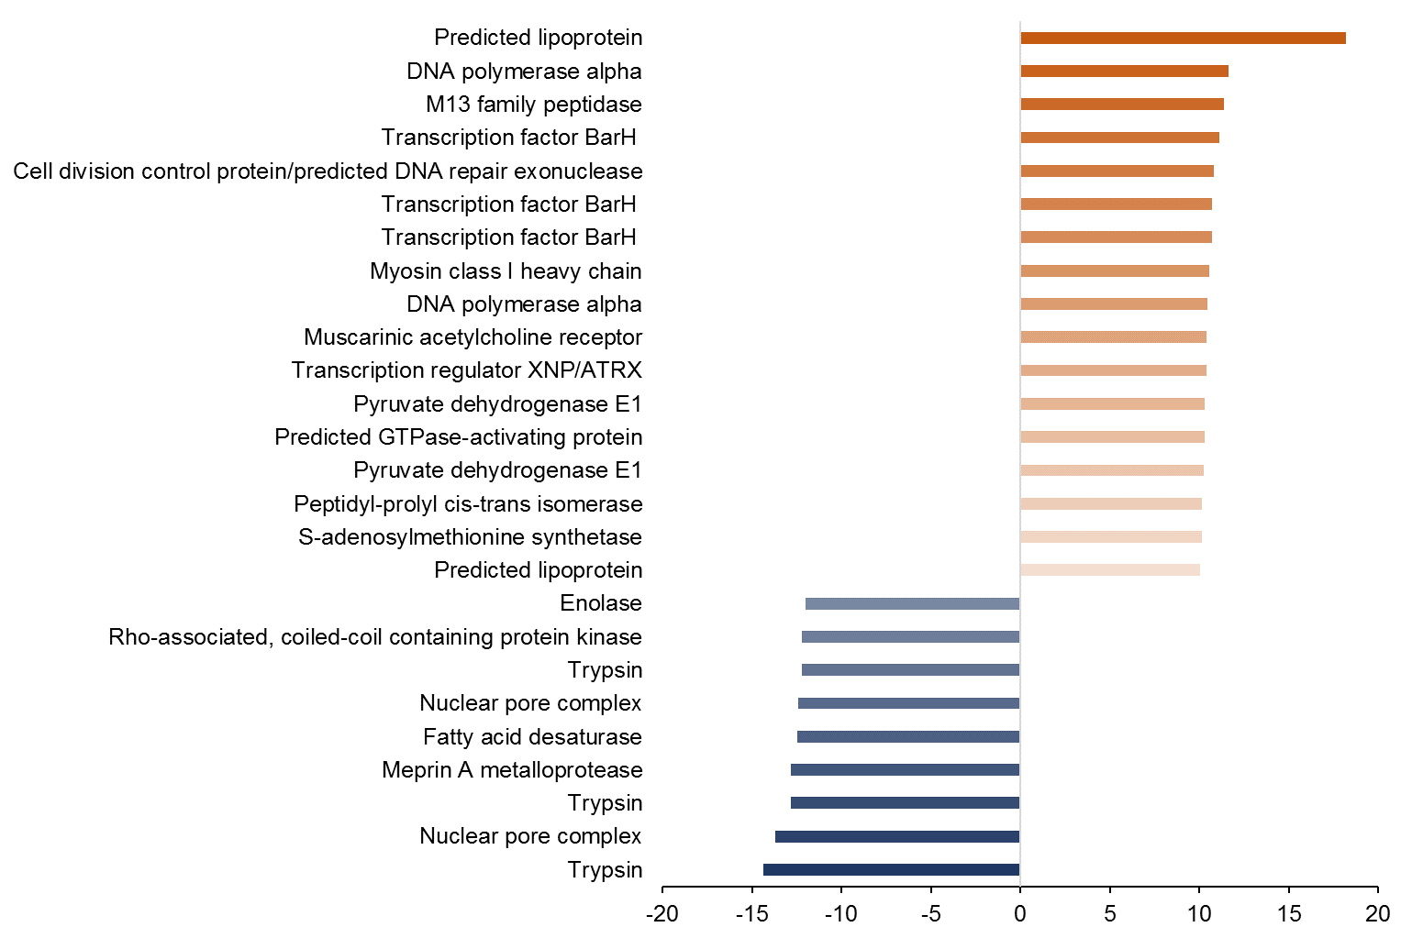
Figure S1a

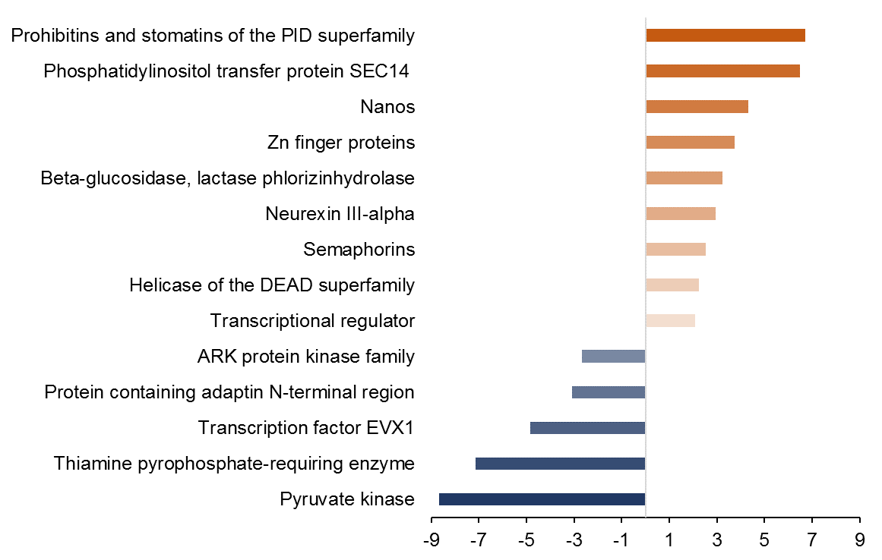
Figure S1b

Figure S1: Overview of genes in which expression was most strongly affected by the factors sex (a) and feeding regime (b). In (a) genes with logFC values > 10 and < -12 and in (b) > 6 and < -8 were included. Blue: down-regulation in females, and under food ad libitum; red: up-regulation in females, and under food ad libitum. The darker the colour the stronger the up- or down-regulation.

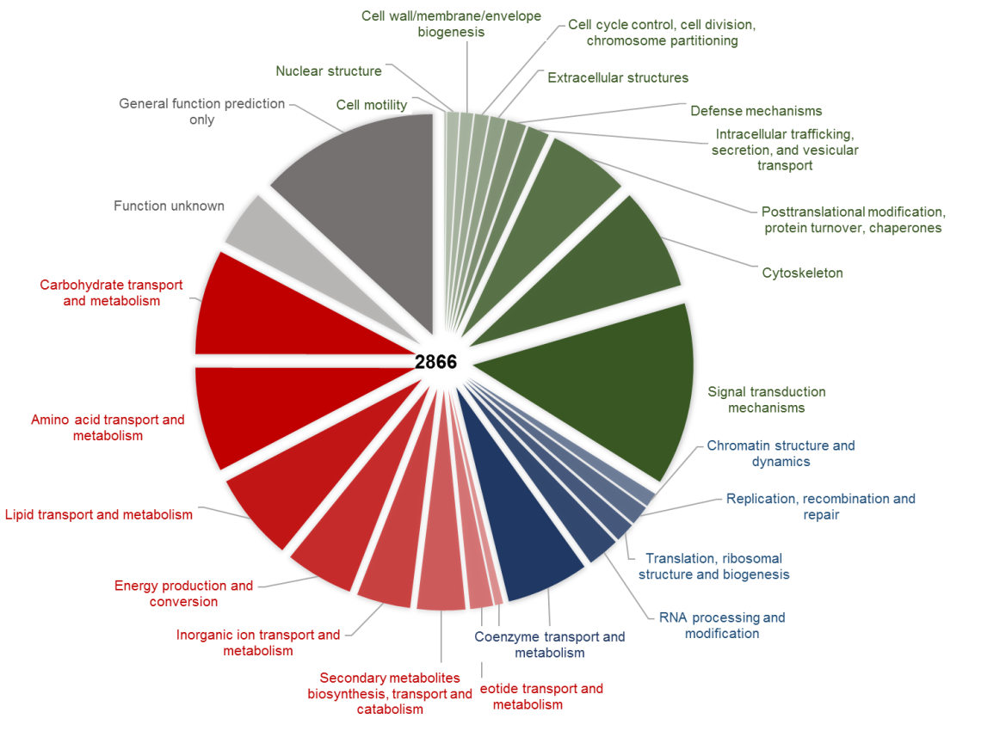
Figure S2a

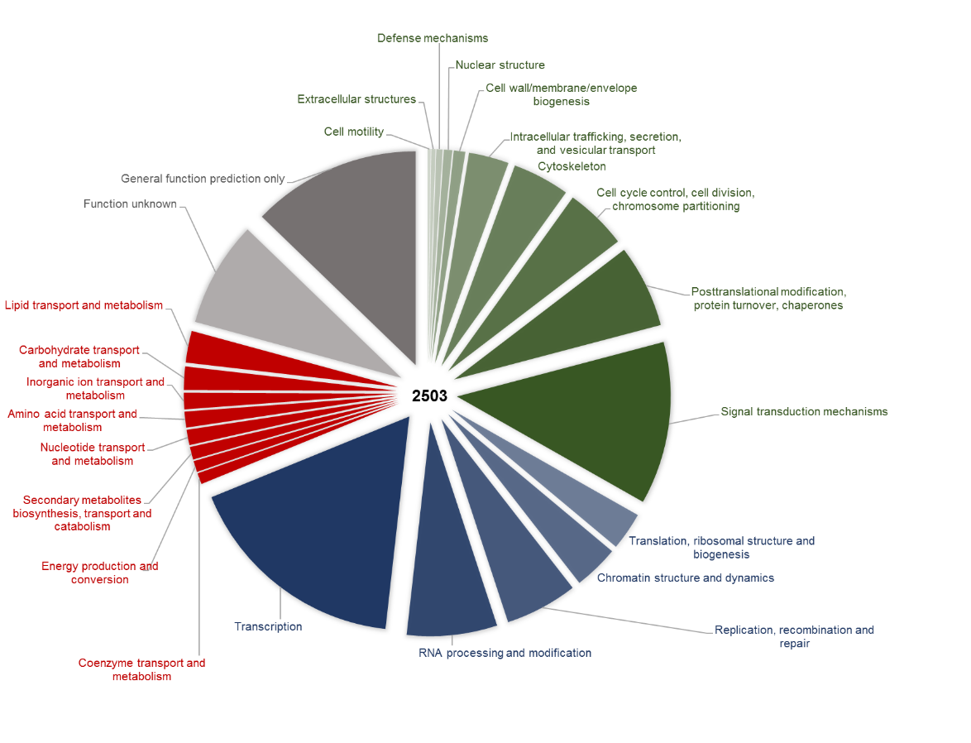
Figure S2b

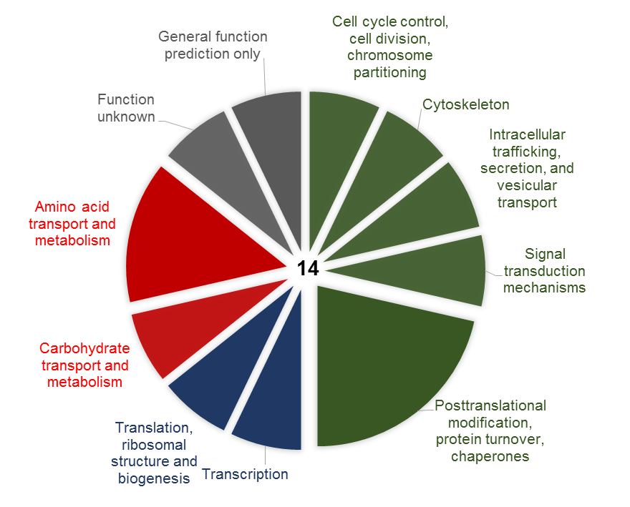
Figure S2c

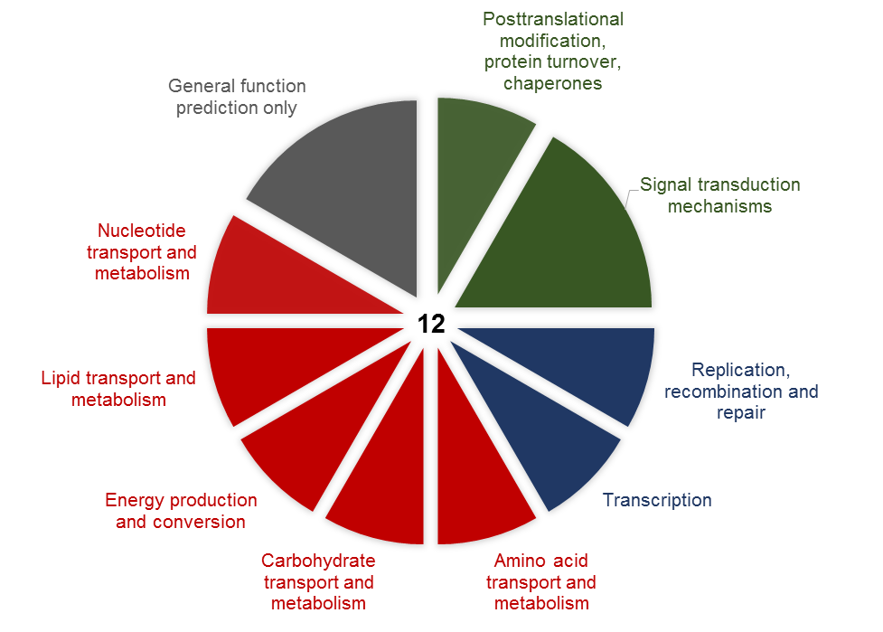
Figure S2d

Figure S2: Functional annotation of transcripts (COG / KOG after Prophane, www.prophane.de) being down- (a) or up-regulated (b) in females relative to males, and being down- (c) or up-regulated (d) under food ad libitum relative to food restriction. Green: cellular processes and signalling; blue: information storage and processing; red: metabolism; grey: poorly characterized. Numbers represent the numbers of down- and up-regulated transcripts.

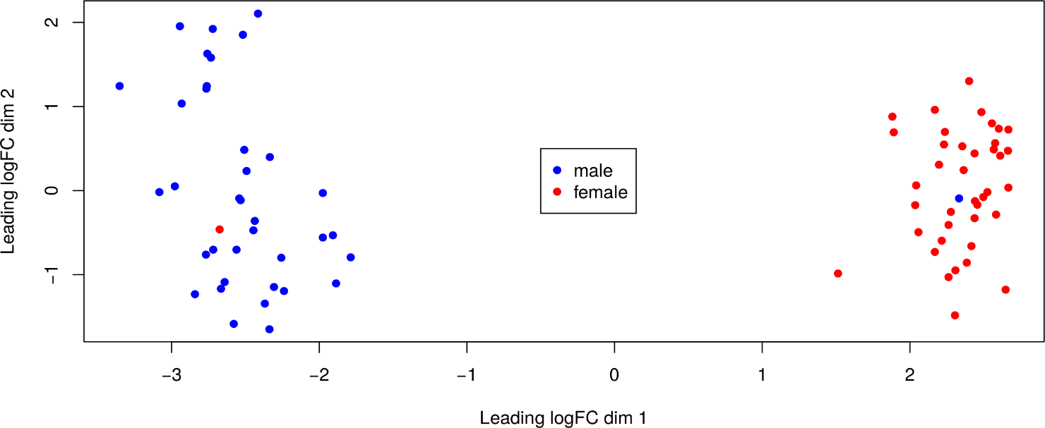

Figure S3: Multidimensional Scaling (MDS) plot of all 77 samples for detecting outliers. Points are placed proximal if their expression profiles are similar. The clear clustering of samples according to sex suggests that sex has a major influence on gene expression. Additionally, the two outlier samples (red dot at left and blue dot at right) were assumed to have a mislabelled sex and were therefore excluded from further analyses.

