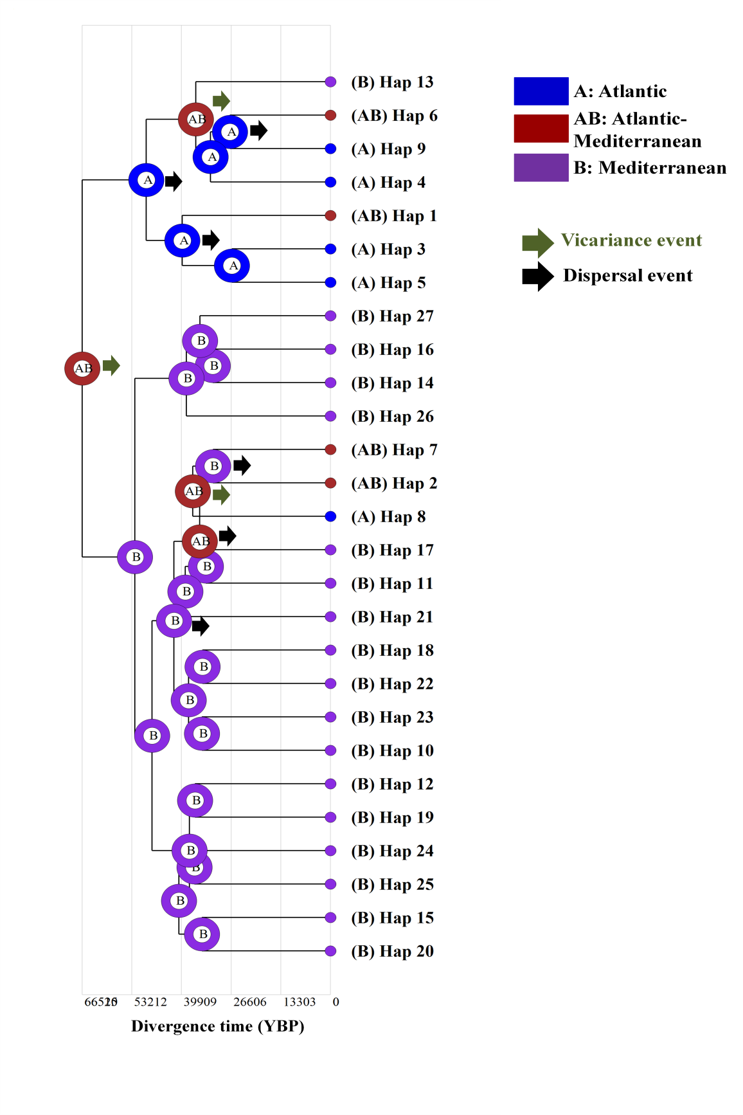
Fig. S1 Analysis of the historical biogeography of E. verrucosa based on a total dataset of 143 sequences (excluding the GenBank sequences). Couloured pie charts on each node show the likelihood of occurrence of each ancestral haplotype at an inferred ancestral biogeographic region. Graphical results of ancestral distributions at each node of the phylogeny were obtained by S-DIVA method, as implemented in RASP version 3.2. Biogeographic regions are shown in different colors and denoted with alphabetic letters (A, B, and AB). Green arrows indicate vicariance events at the corresponding nodes; while black arrows highlight possible dispersal events

