Additional File 5 - Base pairing potential in the S. salmonicida Rpl30 intron.
(A) MFOLD secondary structural prediction for the Rpl30 intron from S. salmonicida (Xu et al. 2014) is shown as described in Figure 2, with the predicted single stranded length indicated. (B) ClustalW2 alignment of S. salmonicida introns (modified from Xu et al. 2014), with stem loop forming nucleotides from the Rpl30 intron in red and total intron lengths indicated in nucleotides (nt).

(A)
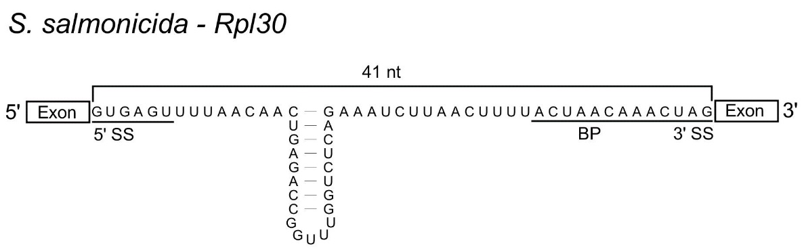

(B)
SS5-377_16979(Rpl30) GUGAGUUUUAACAACUGAGACCGGUUUGGUCUCAGAAAUCUUAACUUUUACUAACAAACUAG 67 nt
SS5-377_16134 GUAUGUUUUAA-------------------CAAUUAAAAAAUAACUUAUACUAACAAACUAG 43 nt
SS5-377_18398 GUAUGUUUUAA-------------------CUCAAUAAAUACAACUUUUACUAACAAACUAG 43 nt
SS5-377_17358 GUAUGUCUAAA-------------------CUUUUUUAAUGUAACUUAUACUAACAAACUAG 43 nt
** ** * ** * * ***** **************

