Additional file 3. Model of mutation elimination under constant recombination rate and selection on female gametophytes.
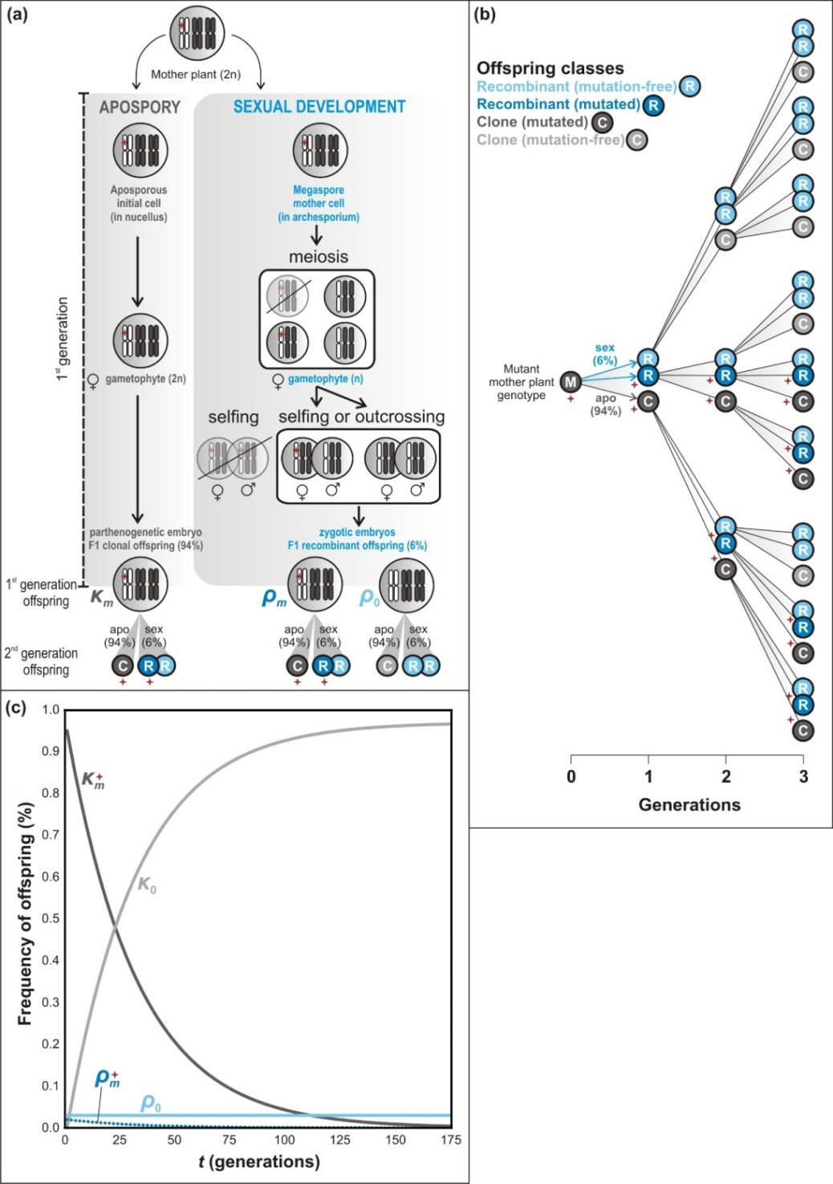
Additional file 3 Figure. Model of mutation elimination under constant recombination rate and selection on female gametophytes. (a) Aposporous and sexual development results in clonal and recombinant offspring, respectively. Grey circles with white “C” letter indicate clonal offspring; blue letters with white “R” letter indicate recombinant offspring; red asterisk stands for a mutation. The frequency of each offspring is given by κ_{m} (mutant clone), κ₀ (non-mutant clone), ρ_{m} (mutant recombinant) and ρ₀ (non-mutant recombinant). (b) The shift in frequencies of mutant and non-mutant offspring over the first three generations. (c) The shift in frequencies of mutant and non-mutant offspring modeled over multiple generations until mutants are eliminated.

