Supplementary material
Table S1: Bioclimatic variables used in analysis of environmental variation within and between species, including source, resolution, and loadings for the first 3 principal component axes.
 | Variable | Source | Resolution | PC1 loading | PC2 loading | PC3 loading
BIO1 | Annual Mean Temp | Worldclim | 30” | -0.163 | 0.218 | -0.046
BIO2 | Mean Diurnal Range | Worldclim | 30” | 0.115 | 0.159 | 0.106
BIO3 | Isothermality | Worldclim | 30” | -0.121 | 0.215 | -0.065
BIO4 | Temperature Seasonality | Worldclim | 30” | 0.188 | -0.171 | 0.085
BIO5 | Max Temperature of Warmest Month | Worldclim | 30” | -0.017 | 0.268 | 0.065
BIO6 | Min Temperature of Coldest Month | Worldclim | 30” | -0.188 | 0.189 | -0.058
BIO7 | Temperature Annual Range | Worldclim | 30” | 0.219 | -0.106 | 0.099
BIO8 | Mean Temperature of Wettest Quarter | Worldclim | 30” | 0.002 | 0.116 | -0.401
BIO9 | Mean Temperature of Driest Quarter | Worldclim | 30” | -0.174 | 0.162 | 0.216
BIO10 | Mean Temperature of Warmest Quarter | Worldclim | 30” | -0.111 | 0.227 | 0.004
BIO11 | Mean Temperature of Coldest Quarter | Worldclim | 30” | -0.174 | 0.213 | -0.057
BIO12 | Annual Precipitation | Worldclim | 30” | -0.237 | -0.069 | 0.059
BIO13 | Precipitation of Wettest month | Worldclim | 30” | -0.221 | 0.020 | -0.107
BIO14 | Precipitation of Driest month | Worldclim | 30” | -0.211 | -0.104 | 0.170
BIO15 | Precipitation Seasonality | Worldclim | 30” | 0.130 | 0.155 | -0.250
BIO16 | Precipitation of Wettest Quarter | Worldclim | 30” | -0.224 | -0.002 | -0.124
BIO17 | Precipitation of Driest Quarter | Worldclim | 30” | -0.215 | -0.098 | 0.175
BIO18 | Precipitation of Warmest Quarter | Worldclim | 30” | -0.199 | -0.035 | -0.276
BIO19 | Precipitation of Coldest Quarter | Worldclim | 30” | -0.217 | -0.047 | 0.222
BIO20 | Annual mean radiation | Climond | 10’ | -0.052 | 0.290 | 0.062
BIO21 | Highest weekly radiation | Climond | 10’ | 0.146 | 0.196 | 0.150
BIO22 | Lowest weekly radiation | Climond | 10’ | -0.121 | 0.263 | -0.028
BIO23 | Radiation seasonality | Climond | 10’ | 0.173 | -0.208 | 0.050
BIO24 | Radiation of wettest quarter | Climond | 10’ | 0.114 | 0.035 | -0.348
BIO25 | Radiation of driest quarter | Climond | 10’ | -0.103 | 0.165 | 0.320
BIO26 | Radiation of warmest quarter | Climond | 10’ | 0.156 | 0.172 | 0.180
BIO27 | Radiation of coldest quarter | Climond | 10’ | -0.130 | 0.254 | -0.047
BIO28 | Annual mean moisture index | Climond | 10’ | -0.204 | -0.165 | 0.028
BIO29 | Highest weekly moisture index | Climond | 10’ | -0.208 | -0.139 | 0.064
BIO30 | Lowest weekly moisture index | Climond | 10’ | -0.171 | -0.196 | -0.073
BIO31 | Moisture index seasonality | Climond | 10’ | 0.035 | 0.137 | 0.263
BIO32 | Mean moisture index of wettest quarter | Climond | 10’ | -0.208 | -0.142 | 0.074
BIO33 | Mean moisture index of driests quarter | Climond | 10’ | -0.191 | -0.171 | -0.102
BIO34 | Mean moisture indeox of warmest quarter | Climond | 10’ | -0.200 | -0.092 | -0.241
BIO35 | Mean moisture index of coldest quarter | Climond | 10’ | -0.188 | -0.154 | 0.169

Table S2: Associations between environmental PC1 or PC2 and UV survival, separated by treatment level. Reported statistics are from Pearson’s correlation between each PC and median UV resistance. Bonferroni-corrected significance level is P < 0.0004.
Energy | PC1 |  | PC2
 | r | P | r | P
0J | 0.48 | 0.20 | 0.37 | 0.42
100J | 0.64 | 0.061 | -0.037 | 0.92
500J | 0.10 | 0.79 | -0.0011 | 0.99
1000J | 0.53 | 0.14 | 0.12 | 0.76
5000J | 0.092 | 0.81 | -0.0003 | 0.99

Table S3: Correlations between UV resistance (survival in days, post-exposure) at each energy exposure level and each of the other two physiological traits measured. Reported statistics are Pearson’s correlation coefficients between each trait and UV survival at one energy level, separated by sex. Bonferroni-corrected significance level is P < 0.0004.
Energy | Pigmentation |  |  |  | Desiccation Resistance
 | Males |  | Females |  | Males |  | Females
 | r | P | r | P | r | P | r | P
0J | -0.063 | 0.872 | -0.652 | 0.057 | -0.079 | 0.84 | -0.226 | 0.558
100J | -0.029 | 0.941 | -0.439 | 0.238 | 0.161 | 0.700 | -0.398 | 0.289
500J | -0.494 | 0.177 | -0.526 | 0.146 | -0.298 | 0.437 | -0.528 | 0.144
1000J | -0.220 | 0.571 | -0.068 | 0.862 | 0.370 | 0.327 | -0.271 | 0.481
5000J | -0.394 | 0.295 | 0.704 | 0.034 | -0.555 | 0.121 | 0.563 | 0.115

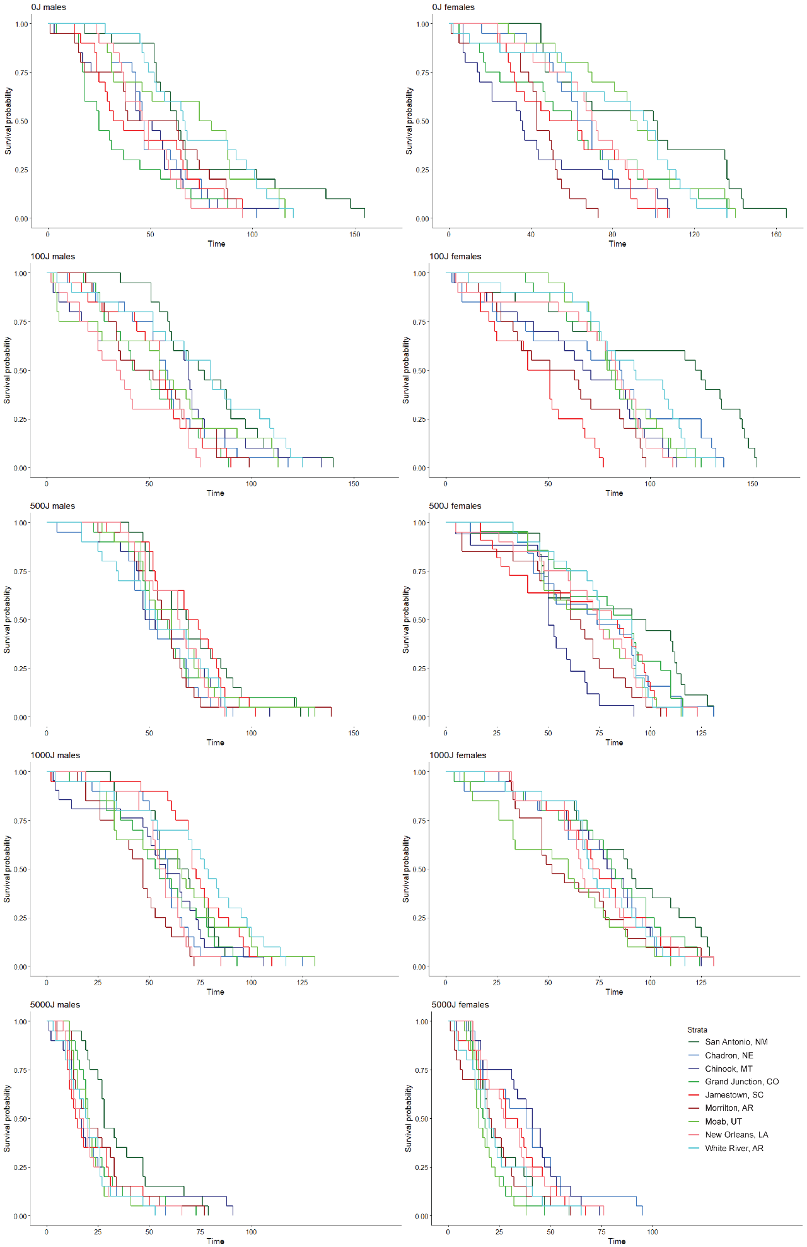
Figure S1: Meier-Kaplan survival curves after UV treatment for each population. X-axis is time (in days); Y-axis is survival probability (for each 20 fly trial). Panels are organized by UV-B energy exposure (from top to bottom: 0J, 100J, 500J, 1000J, and 5000J) and by sex (with males on the left and females on the right). Population legend is in bottom right for reference throughout.

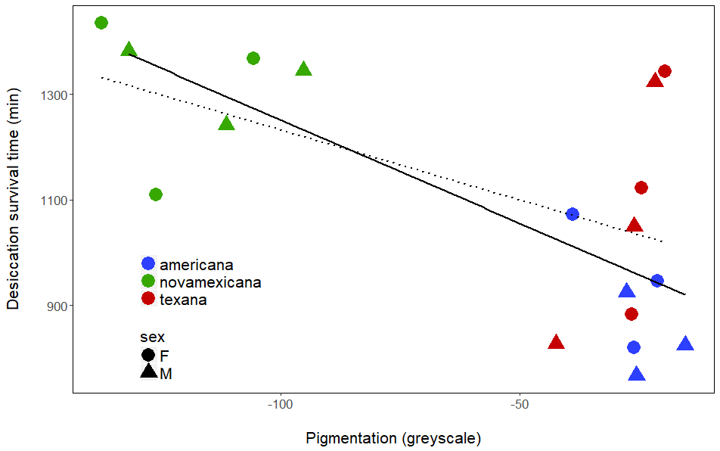
Figure S2: Associations between desiccation resistance and pigmentation for males (triangles, solid line) and females (circles, dotted line). Mean population desiccation resistance and pigmentation are correlated in males (r(7) = 0.701, P = 0.0355), but only marginally in females (r(7) = 0.594, P = 0.0914).

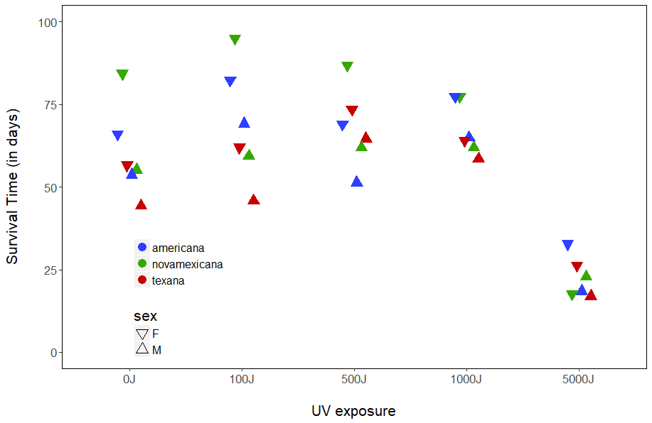
Figure S3: Survival time in days for UV resistance trials across treatments for each species – split by sex. Survival time was significantly influenced by sex (F(1, 4.22), P < 0.001) with females living longer in general. With sexes combined, only the 5000J exposure group (F(3, 12.36), P < 0.001) significantly differed in relative survival from the reference treatment level (100J, see methods), while 500J (F(3, -0.23), P = 0.82) and 1000J (F(3, -0.31), P = 0.76) did not.

