Ancient DNA of Northern China Hystricidae Sub-Fossils Reveals the Evolutionary History of Old World Porcupines in the Late Pleistocene
Guilian Sheng^{1,2*}, Jiaming Hu¹, Haowen Tong³, Bastien Llamas⁴, Junxia Yuan⁵, Xindong Hou¹, Shungang Chen⁵, Bo Xiao¹, Xulong Lai^{2,6*}

Supplementary Materials 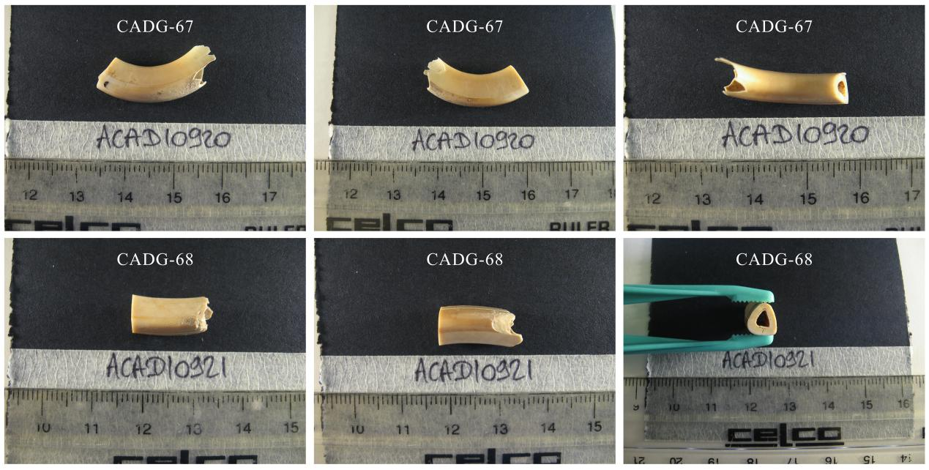
Fig. S1 Photos of two Tianyuan Cave samples.

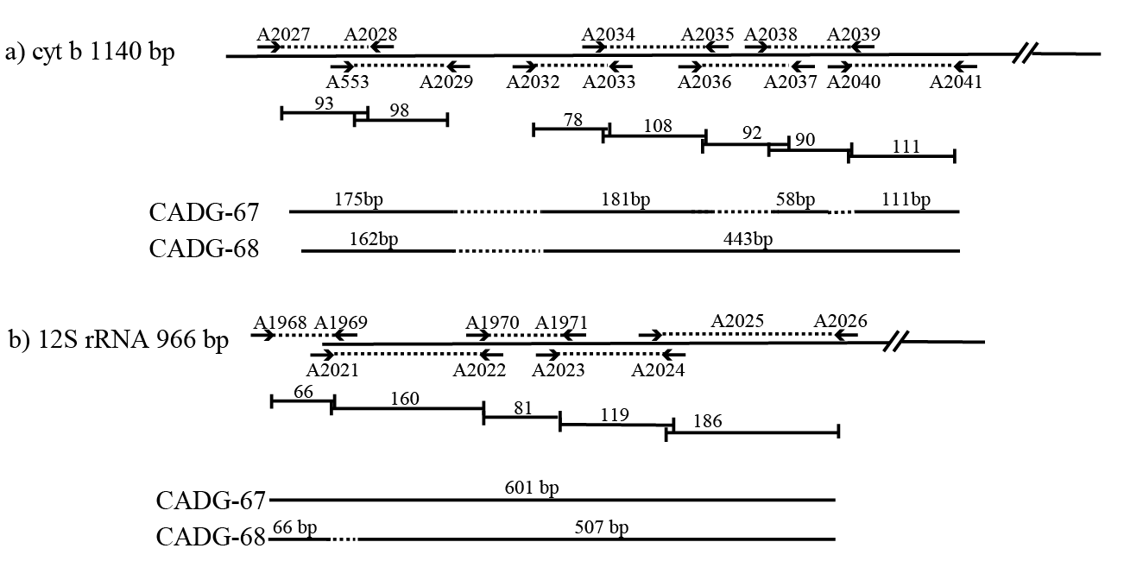
Fig. S2 Schematic view of the primers designed for porcupines (arrows flanking dotted lines), amplicon sizes in base pairs (on top of plain lines) and structure of valid sequences (CADG labels) obtained from Tianyuan Cave samples. (a) Seven overlapping fragments designed for the cyt b gene. (b) Five overlapping fragments designed for the 12S rRNA gene.

Table S1. PCR primers of 1140-bp cyt b gene for the Pleistocene porcupines. The characters ‘F’ and ‘R’ in the ‘site’ column refer to ‘forward primer’ and ‘reverse primer’, respectively.
Primer Name | Primers (5’ position to 3’ position) | Site | Amplicon Size (excluding primers) | Annealing Temperature（℃）
A2027 | GAACTAATGACAAACATCCGAAAA | 24F | 114 bp | 50
A2028 | GGATGTGGATGAGTAAGCAGGCTCC | 137R | 114 bp | 50
A553 | CCCCCTCCAACATCTCCTCATGATGAAA | 88F | 127 bp | 50
A2029 | CTCGGCAGATATGGGYTACTG | 214R | 127 bp | 50
A2032 | CTGYCTATACCTCCACGTAGG | 276F | 120 bp | 50
A2033 | GGACGTATCCTATGAARGCAGTAGC | 396R | 120 bp | 50
A2034 | CGGACTTCTCTTACTGTTTACAG | 345F | 154 bp | 50
A2035 | CCCTCAAATTCATGCAACTARTG | 498R | 154 bp | 50
A2036 | CAGCAATCCCCTATCTTGGAAC | 452F | 135 bp | 50
A2037 | TGGACTAGTACAAGGGCTGTGA | 586R | 135 bp | 50
A2038 | AACACGATTCTTTGCTTTCCA | 525F | 132 bp | 50
A2039 | GGAATTGTGTCTGAGTTTGRG | 656R | 132 bp | 50
A2040 | GAAACAGGGTCAAACAACCCATC | 604F | 157 bp | 50
A2041 | CTGAGTCTCCTACAAGGTCTAGG | 760R | 157 bp | 50

Table S2. PCR primers of 966-bp 12S rRNA gene for the Pleistocene porcupines. The characters ‘F’ and ‘R’ in the ‘site’ column refer to ‘forward primer’ and ‘reverse primer’, respectively.
Primer Name | Primers (5’ position to 3’ position) | Site | Amplicon Size (excluding primers) | Annealing Temperature（℃）
A1968 | GTCCATGTAGCTTAACACACA | 8F | 103 bp | 54
A1969 | GTAACTAATGGAAAGGCTAGG | 110R | 103 bp | 54
A1970 | TAGCCACATCCCCACGGAAATA | 244F | 136 bp | 54
A1971 | GAGTTAATCGTATGACCGCGG | 379R | 136 bp | 54
A2021 | CTCCATAGACATAAAGGTTTGG | 67F | 203 bp | 50
A2022 | GCTGAATGGTGATCACTGCTG | 269R | 203 bp | 50
A2023 | GGTAAATTTCGTGCCAGCC | 328F | 141 bp | 50
A2024 | GAGAYTGCTTTCGCGTACTGG | 468R | 141 bp | 50
A2025 | CGTACACCACTTCAGATTGATAC | 421F | 197 bp | 50
A2026 | TATCGATTATAGAACAGGCTCC | 617R | 197 bp | 50

Table S3. Datasets used in this study (excluding ancient samples).
No. | Species | Isolate | Location | GenBank Acc. No. | Dataset | Type
1 | Atherurus africanus | AafrT886_Niga | Nigeria | HQ450774 | 2 | cyt b
2 | Atherurus africanus | AafrT966_Niga | Nigeria | HQ450775 | 2 | cyt b
3 | Atherurus africanus | AafrBAY001 | Cameroon | KJ193296 | 2 | cyt b
4 | Atherurus africanus | AafrCAM015 | Cameroon | KJ193297 | 2 | cyt b
5 | Atherurus africanus | AafrCAM016 | Cameroon | KJ193298 | 2 | cyt b
6 | Atherurus africanus | AafrCAM033 | Cameroon | KJ193299 | 2 | cyt b
7 | Atherurus africanus | AafrCAMP001 | Cameroon | KJ193300 | 2 | cyt b
8 | Atherurus africanus | AafrT1327 | Ghana | KJ193301 | 2 | cyt b
9 | Atherurus africanus | AafrT1328 | Ghana | KJ193302 | 2 | cyt b
10 | Atherurus africanus | AafrYAO002 | Cameroon | KJ193304 | 2 | cyt b
11 | Atherurus macrourus | AM01 | Malaysia | KX580782 | 2 | cyt b
12 | Atherurus macrourus | AM03 | Malaysia | KX580783 | 2 | cyt b
13 | Atherurus macrourus | AM04 | Malaysia | KX580784 | 2 | cyt b
14 | Atherurus macrourus | AM05 | Malaysia | KX580785 | 2 | cyt b
15 | Atherurus macrourus | AM06 | Malaysia | KX580786 | 2 | cyt b
16 | Atherurus macrourus | AM07 | Malaysia | KX580787 | 2 | cyt b
17 | Atherurus macrourus | AM08 | Malaysia | KX580788 | 2 | cyt b
18 | Atherurus macrourus | AM09 | Malaysia | KX580789 | 2 | cyt b
19 | Atherurus macrourus | AM10 | Malaysia | KX580790 | 2 | cyt b
20 | Atherurus macrourus | / | / | FJ931121 | 1&2 | cyt b
21 | Hystrix africaeaustralis | / | / | X70674 | 1&2 | cyt b
22 | Hystrix brachyura | HB03 | Malaysia | KX580791 | 2 | cyt b
23 | Hystrix brachyura | HB05 | Malaysia | KX580792 | 2 | cyt b
24 | Hystrix brachyura | HB06 | Malaysia | KX580793 | 2 | cyt b
25 | Hystrix brachyura | HB07 | Malaysia | KX580794 | 2 | cyt b
26 | Hystrix brachyura | HB109 | Malaysia | KX580795 | 2 | cyt b
27 | Hystrix brachyura | Hbra01 | Thailand | JQ991599 | 2 | cyt b
28 | Hystrix cristata | ITAA | Italy | FJ472565 | 1&2 | cyt b
29 | Hystrix cristata | ITAA1 | Italy | FJ472566 | 2 | cyt b
30 | Hystrix cristata | Tun02 | Tunisia | FJ472567 | 1&2 | cyt b
31 | Hystrix cristata | Lib01 | Libya | FJ472568 | 1&2 | cyt b
32 | Hystrix cristata | Mar01 | Morocco | FJ472569 | 2 | cyt b
33 | Hystrix cristata | Mar02 | Morocco | FJ472570 | 1&2 | cyt b
34 | Hystrix cristata | Eri01 | Eritrea | FJ472571 | 2 | cyt b
35 | Hystrix cristata | Eri02 | Eritrea | FJ472572 | 1&2 | cyt b
36 | Hystrix cristata | Eth01 | Ethiopia | FJ472573 | 1&2 | cyt b
37 | Hystrix cristata | Tan01 | Tanzania | FJ472574 | 1&2 | cyt b
38 | Hystrix cristata | BuF01 | Bukina Faso | FJ472575 | 1&2 | cyt b
39 | Hystrix africaeaustralis | Nam02 | Namibia | FJ472576 | 1&2 | cyt b
40 | Hystrix africaeaustralis | Nam03 | Namibia | FJ472577 | 2 | cyt b
41 | Hystrix africaeaustralis | Nam05 | Namibia | FJ472578 | 1&2 | cyt b
42 | Hystrix indica | In02 | Israel | FJ472579 | 1 | cyt b
43 | Hystrix indica | KAU7810 | India | JN794531 | 2 | cyt b
44 | Hystrix crassispinis | HBR01 | Malaysia | KX580796 | 2 | cyt b
45 | Trichys fasciculata | TF01 | Malaysia | KX580797 | 2 | cyt b
46 | Trichys fasciculata | TF02 | Malaysia | KX580798 | 2 | cyt b
47 | Trichys fasciculata | TF03 | Malaysia | KX580799 | 2 | cyt b
48 | Ctenodactylus vali | / | / | AJ389532 | 2 | cyt b
49 | Fukomys damarensis | / | / | KT321364 | 1, 2 &3 | mitochondrion
50 | Massoutiera mzabi | / | N/A | AJ389533 | 2 | cyt b
51 | Petromus typicus | / | N/A | DQ139935 | 2 | cyt b
52 | Thryonomys swinderianus | / | South Africa | AJ301644 | 2 | mitochondrion
53 | Hystrix brachyura | / | / | AY012117 | 3 | 12S rRNA
54 | Hystrix cristata | ITAA | Italy | FJ472530 | 3 | 12S rRNA
55 | Hystrix cristata | Tun01 | Tunisia | FJ472531 | 3 | 12S rRNA
56 | Hystrix cristata | Tun02 | Tunisia | FJ472532 | 3 | 12S rRNA
57 | Hystrix cristata | Tun06 | Tunisia | FJ472533 | 3 | 12S rRNA
58 | Hystrix cristata | Lib01 | Libya | FJ472534 | 3 | 12S rRNA
59 | Hystrix cristata | Mar01 | Morocco | FJ472535 | 3 | 12S rRNA
60 | Hystrix cristata | Mar03 | Morocco | FJ472536 | 3 | 12S rRNA
61 | Hystrix cristata | Eri02 | Eritrea | FJ472537 | 3 | 12S rRNA
62 | Hystrix cristata | Tan01 | Tanzania | FJ472538 | 3 | 12S rRNA
63 | Hystrix cristata | BuF01 | Burkina Faso | FJ472539 | 3 | 12S rRNA
64 | Hystrix africaeaustralis | Nam02 | Namibia | FJ472540 | 3 | 12S rRNA
65 | Hystrix africaeaustralis | Nam05 | Namibia | FJ472541 | 3 | 12S rRNA
66 | Hystrix africaeaustralis | Zam01 | Zambia | FJ472542 | 3 | 12S rRNA
67 | Hystrix africaeaustralis | Zam02 | Zambia | FJ472543 | 3 | 12S rRNA
68 | Hystrix africaeaustralis | SAf01 | South Africa | FJ472544 | 3 | 12S rRNA
69 | Hystrix africaeaustralis | SAf04 | South Africa | FJ472545 | 3 | 12S rRNA
70 | Hystrix indica | In02 | Israel | FJ472546 | 3 | 12S rRNA
71 | Hystrix cristata | / | / | AY093659 | 3 | 12S rRNA
72 | Hystrix africaeaustralis | / | / | U12448 | 3 | 12S rRNA

