Figure S1

Figure S2
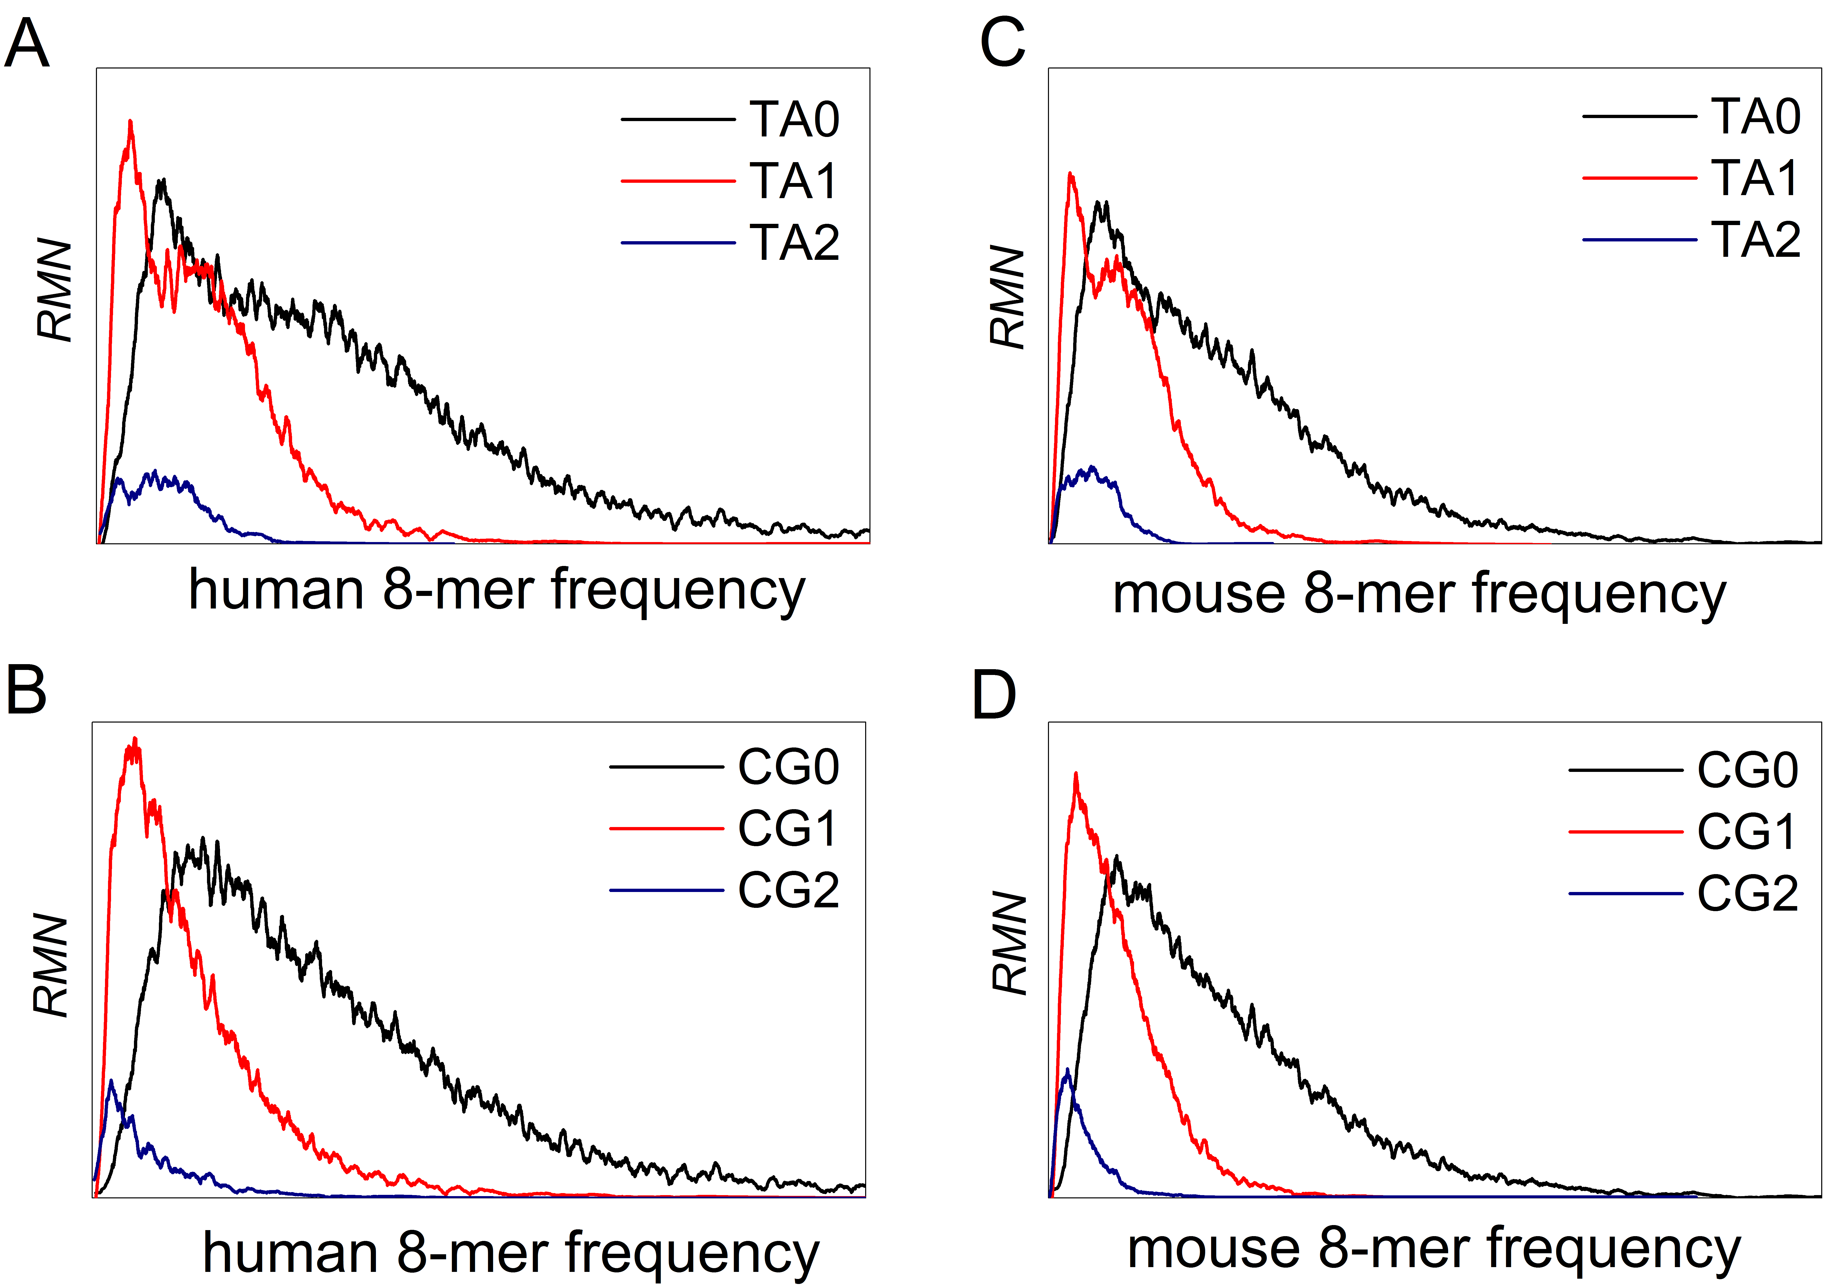

Additional Figure Legends
Figure S1 The spectrum distributions of CG1 and TA1 6-mer subsets. The vertical broken line (middle) represents the average 6-mer frequency of the corresponding genome sequence. (A) Methanocaldococcus infernus genome (archaea) that has remarkable CG independent selection and strong TA inhibition. (B) Borrelia recurrentis A1 genome (eubacteria) that has remarkable CG independent selection and strong TA inhibition. (C) Halosimplex genome (archaea) that has remarkable TA independent selection and strong CG inhibition. (D) Agrococcus sp. SGAir0287 genome (eubacteria) that has remarkable TA independent selection and strong CG inhibition.

Figure S2 The 8-mer spectrum distributions. (A) TA2, TA1 and TA0 8-mer spectra of protein coding sequences in human genome. (B) CG2, CG1 and CG0 8-mer spectra of protein coding sequences in human genome. (C) TA2, TA1 and TA0 8-mer spectra of protein coding sequences in mouse genome. (D) CG2, CG1 and CG0 8-mer spectra of protein coding sequences in mouse genome.

