Supplementary Section
Supplementary Table 1. Diet of Australian elapids taken mainly from Shine.
 | Invertebrates | Fish | Frogs | Lizards | Snakes | Mammals | Birds | Eggs | REF
Denisonia devisi | 0.025 | 0 | 0.88 | 0.095 | 0 | 0 | 0 | 0 | (30)
Denisonia maculata | 0.05 | 0 | 0.95 | 0 | 0 | 0 | 0 | 0 | (30)
Elapognathus coronatus | 0.03 | 0 | 0.53 | 0.44 | 0 | 0 | 0 | 0 | (55)
Parasuta flagellum | 0 | 0 | 0 | 1 | 0 | 0 | 0 | 0 | (29)
Parasuta monachus | 0 | 0 | 0 | 0.98 | 0.02 | 0 | 0 | 0 | (29)
Suta fasciata | 0 | 0 | 0 | 1 | 0 | 0 | 0 | 0 | (30)
Suta punctata | 0 | 0 | 0 | 0.83 | 0.17 | 0 | 0 | 0 | (30)
Suta suta | 0 | 0 | 0.03 | 0.67 | 0.02 | 0.19 | 0 | 0.09 | (29)
Cryptophis nigrescens | 0 | 0 | 0.01 | 0.915 | 0.055 | 0 | 0 | 0.02 | (31)
Cryptophis pallidiceps | 0 | 0 | 0.055 | 0.89 | 0.055 | 0 | 0 | 0 | (31)
Echiopsis curta | 0.015 | 0 | 0.32 | 0.52 | 0 | 0.13 | 0.015 | 0 | (39)
Austrelaps labialis | 0.04 | 0 | 0.17 | 0.754 | 0 | 0.018 | 0 | 0.018 | (51)
Austrelaps ramsayi | 0.016 | 0 | 0.17 | 0.78 | 0.034 | 0 | 0 | 0 | (51)
Austrelaps superbus | 0 | 0 | 0.503 | 0.464 | 0.013 | 0.02 | 0 | 0 | (51, 56)
Hoplocephalus bitorquatus | 0 | 0 | 0.77 | 0.153 | 0 | 0.077 | 0 | 0 | (49)
Hoplocephalus bungaroides | 0 | 0 | 0 | 1 | 0 | 0 | 0 | 0 | (49)
Hoplocephalus stephensi | 0 | 0 | 0.11 | 0.445 | 0 | 0.445 | 0 | 0 | (49)
Notechis scutatus | 0 | 0.04 | 0.48 | 0.01 | 0 | 0.4 | 0.11 | 0 | (41, 56)
Tropidechis carinatus | 0 | 0 | 0.4 | 0.0378 | 0 | 0.487 | 0.074 | 0 | (52)
Hemiaspis damelii | 0 | 0 | 1 | 0 | 0 | 0 | 0 | 0 | (35)
Demansia psammophis | 0 | 0 | 0.067 | 0.9 | 0 | 0 | 0 | 0.027 | (32)
Demansia torquata | 0 | 0 | 0 | 1 | 0 | 0 | 0 | 0 | (32)
Demansia vestigiata | 0 | 0 | 0.28 | 0.71 | 0 | 0 | 0 | 0 | (57)
Acanthophis antarcticus | 0 | 0 | 0 | 0.71 | 0 | 0.2 | 0.09 | 0 | (53)
Acanthophis pyrrhus | 0 | 0 | 0.083 | 0.75 | 0 | 0.166 | 0 | 0 | (53)
Pseudechis porphyriacus | 0 | 0 | 0.6 | 0.27 | 0.036 | 0.08 | 0 | 0 | (40, 41)
Pseudechis australis | 0.006 | 0 | 0.195 | 0.36 | 0.118 | 0.24 | 0.047 | 0.023 | (40)
Pseudechis butleri | 0 | 0 | 0 | 0.75 | 0.17 | 0.08 | 0 | 0 | (40)
Pseudechis papuanus | 0 | 0 | 0 | 0 | 0 | 1 | 0 | 0 | (40)
Pseudechis colletti | 0 | 0 | 0.25 | 0 | 0 | 0.75 | 0 | 0 | (40)
Pseudechis guttatus | 0.12 | 0 | 0.4 | 0.12 | 0.08 | 0.28 | 0 | 0 | (40)
Pseudonaja guttata | 0 | 0 | 0.41 | 0.35 | 0 | 0.24 | 0 | 0 | (50)
Pseudonaja modesta | 0 | 0 | 0 | 0.97 | 0 | 0.03 | 0 | 0 | (50)
Pseudonaja textilis | 0 | 0 | 0.08 | 0.51 | 0 | 0.41 | 0 | 0 | (50)
Vermicella annulata | 0 | 0 | 0 | 0 | 1 | 0 | 0 | 0 | (38)
Oxyuranus microlepidota | 0 | 0 | 0 | 0 | 0 | 1 | 0 | 0 | (36)
Oxyuranus scutellatus | 0 | 0 | 0 | 0 | 0 | 0.95 | 0.05 | 0 | (36)
Oxyuranus temporalis | 0 | 0 | 0 | 0 | 0 | 1 | 0 | 0 | (58)

Supplementary Table 2. Location sites and collectors for all snakes used in the study.
Species | Specimen I.D. | Location | Collector/Keeper
Acanthophis antarcticus | 78 | Smokey Bay S.A. | Nathan Dunstan
 | 241 | Smokey Bay S.A. | Nathan Dunstan
 | 80 | Middleback Range S.A. | Nathan Dunstan
Acanthophis pyrrhus |  | Alice Springs N.T. | Nathan Dunstan
Austrelaps labialis | 29 | Kangaroo Island S.A. | Nathan Dunstan
 | 30 | Kangaroo Island S.A. | Nathan Dunstan
 | 31 | Lobethal S.A. | Nathan Dunstan
Austrelaps ramsayi |  | Barrington Tops N.S.W. | Theo Tasoulis
Austrelaps superbus | 89 | Melbourne VIC | Nathan Dunstan
 | 90 | Melbourne VIC | Nathan Dunstan
Demansia psammophis |  | Newcastle N.S.W | Daniel Stace
 |  | Brisbane QLD | Richie Gilbert
Demansia torquata |  | Airlie Beach QLD | Kylee Gray
Demansia vestigiata |  | Bowen QLD | Nathan Dunstan
 |  | Rockhampton QLD | Callan Crigan
Denisonia devisi | DD5 | Glenmorgan QLD | Richie Gilbert
 | DD6 | Glenmorgan QLD | Richie Gilbert
 | DD7 | Glenmorgan QLD | Richie Gilbert
 | DD8 | Glenmorgan QLD | Richie Gilbert
 | DD9 | Glenmorgan QLD | Richie Gilbert
Denisonia maculata | DM1 | Eaglefield QLD | Brendan Schembri
 | DM2 | Eaglefield QLD | Brendan Schembri
 | DM3 | Eaglefield QLD | Brendan Schembri
 | DM4 | Eaglefield QLD | Brendan Schembri
Echiopsis curta | EC1 | s.e. of Perth W.A | Nathan Dunstan
 | EC2 | West coast S.A. | Nathan Dunstan
 | EC3 | West coast S.A. | Nathan Dunstan
Elapognathus coronatus |  | Jerramungup W.A. | Ross McGibbon
Hemiaspis dameli |  | Kogan QLD | Nathan Dunstan
Hoplocephalus bitorquatus | HB5 | 15km west of Dalby QLD | Nathan Dunstan
 | HB8 | 15km west of Dalby QLD | Nathan Dunstan
 | HB9 | Emerald QLD | Nathan Dunstan
Hoplocephalus bungaroides | 1 | Captive bred | Simon Tresseder
 | 2 | Captive bred | Simon Tresseder
 | BH3 | Captive bred | Captive bred
Hoplocephalus stephensi | W | Cooranbong N.S.W. | Stephan Mahony
 | B | Bunghwal N.S.W. | Theo Tasoulis
Notechis scutatus | 305 | Lake Alexandrina S.A. | Nathan Dunstan
 | 308 | Lake Alexandrina S.A. | Nathan Dunstan
 | 404 | Lake Alexandrina S.A. | Nathan Dunstan
 | 350 | Melbourne VIC | Nathan Dunstan
 | 353 | Melbourne VIC | Nathan Dunstan
 | 354 | Melbourne VIC | Nathan Dunstan
 | 444 | Heardsman Lake W.A. | Nathan Dunstan
 | 446 | Carnac Island W.A. | Nathan Dunstan
Oxyuranus microlepidotus | Pooled | Goyder’s Lagoon S.A. | Nathan Dunstan
Oxyuranus scutellatus | GL 258 | Gladstone QLD | Nathan Dunstan
 | C 419 | Cooktown QLD | Nathan Dunstan
 | SI 1 | Saibai Island QLD | Nathan Dunstan
Oxyuranus temporalis | Pooled | Ilkurlka Roadhouse W.A. | Nathan Dunstan
Parasuta flagellum |  | Cooma N.S.W. | Stephen Mahony
Parasuta monachus |  | Pilbara W.A. | Brian Bush
Pseudechis australis | 108 | Renmark S.A. | Nathan Dunstan
 | 128 | Renmark S.A. | Nathan Dunstan
 |  | Windorah QLD | Theo Tasoulis
Pseudechis butleri | PB3 | Cue W.A. | Nathan Dunstan
 | PB4 | Cue W.A. | Nathan Dunstan
Psudechis colletti | PC 45 | Captive bred | Nathan Dunstan
 | PC 46 | Captive bred | Nathan Dunstan
Pseudechis guttatus | 13 | Lake Broadwater QLD | Nathan Dunstan
 | 16 | Unknown | Nathan Dunstan
Pseudechis papuanus | PAP 1 | Saibai Island QLD | Nathan Dunstan
 | PAP 2 | Saibai Island QLD | Nathan Dunstan
 | PAP 3 | Saibai Island QLD | Nathan Dunstan
Pseudechis porphyriacus | 87 | Tanunda S.A. | Nathan Dunstan
Pseudonaja guttata | SB 20 | Ilfracombe QLD | Theo Tasoulis
 | SB 22 | Ilfracombe QLD | Theo Tasoulis
Pseudonaja modesta | PM 11 | Stonehenge QLD | Nathan Dunstan
 | PM 2 | Stonehenge QLD | Nathan Dunstan
 | PM 12 | 115km n of Meekatharra W.A. | Brian Bush
 | PM 13 | Carnarvon W.A. | Brian Bush
 | PM 14 | Carnarvon W.A. | Brian Bush
Pseudonaja textilis | S.A. 474 | Rowland Flat S.A. | Nathan Dunstan
 | A.S. 3 | Alice Springs N.T. | Nathan Dunstan
 | N.S.W. 1 | Singleton N.S.W. | Theo Tasoulis
Rhinoplocephalus boschmai |  | Charters Towers | Nathan Dunstan
Rhinoplocephalus nigrescens |  | Calliope QLD | Nathan Dunstan
 |  | Newcastle N.S.W | Theo Tasoulis
Rhinoplocephalus pallidiceps |  | Darwin N.T. | Nathan Dunstan
Suta fasciata | SF1 | 75km s of Karratha W.A. | Brian Bush
 | SF2 | Cue W.A. | Brian Bush
 | SF3 | Carnarvon W.A. | Brian Bush
Suta punctata | SP3 | 100km sse of Fitzroy Crossing W.A. | Brian Bush
 | SP4 | 150km s of Halls Creek W.A | Brian Bush
Suta suta | SS1 | QLD | Nathan Dunstan
 | SS2 | Mary Kathleen Dam QLD | Nathan Dunstan
 | SS3 | Dajarra QLD | Nathan Dunstan
 | SS4 | Mt Isa QLD | Nathan Dunstan
 | SS6 | Glenmorgan QLD | Nathan Dunstan
Vermicella annulata |  | Brisbane QLD | Richie Gilbert

Supplementary Fig 1. PLA2 activity reconstructed using square-change parsimony, analytically equivalent to a special case of likelihood (42), on a phylogeny (1) of 16 of the 17 genera tested (27 of the 37 species; Hemiaspis has no PLA2 data). The Y-axis represents millions of years before present. Values had 1 added before log transformation (to avoid attempting to log 0 values, as any species with activity below the threshold of detection of 0.5 - unlogged value - was allocated a score of 0). Dotted vertical lines separate clades. Warmer colours (red) show higher activity; black is no activity; white is extreme uncertainty due to missing data in Hemiaspis.
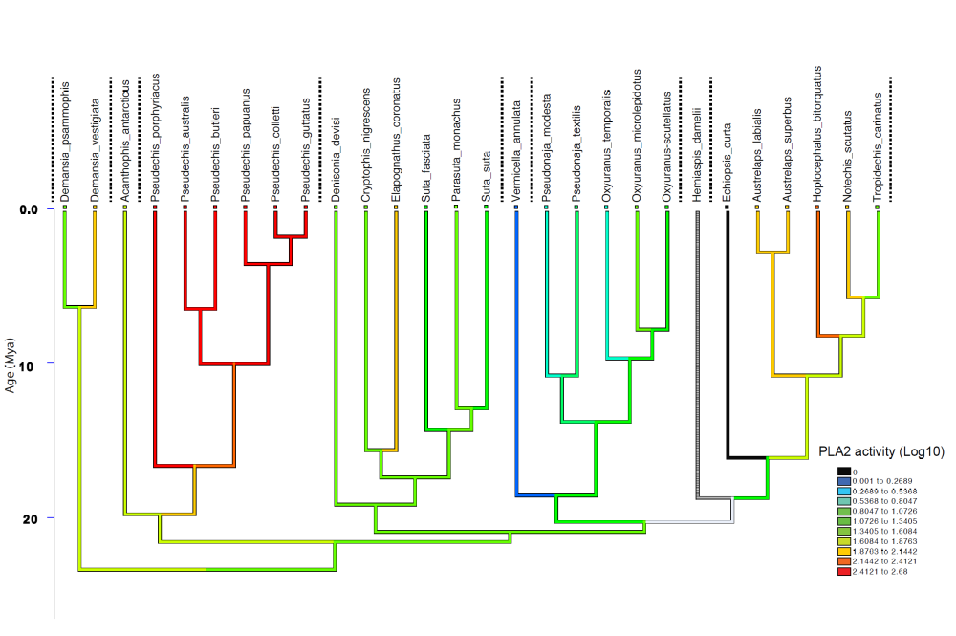

Supplementary Fig 2. LAAO activity reconstructed using linear parsimony on a phylogeny (1) for all 17 genera tested (28 of the 39 species for which activity was measured). Y-axis represents millions of years before present. Values had 1 added before log transformation (to avoid attempting to log 0 values, as any species with activity below the threshold of detection of 0.5 - unlogged value - was allocated a score of 0). Dotted vertical lines separate clades. Warmer colours (red) show higher activity, black is no activity
