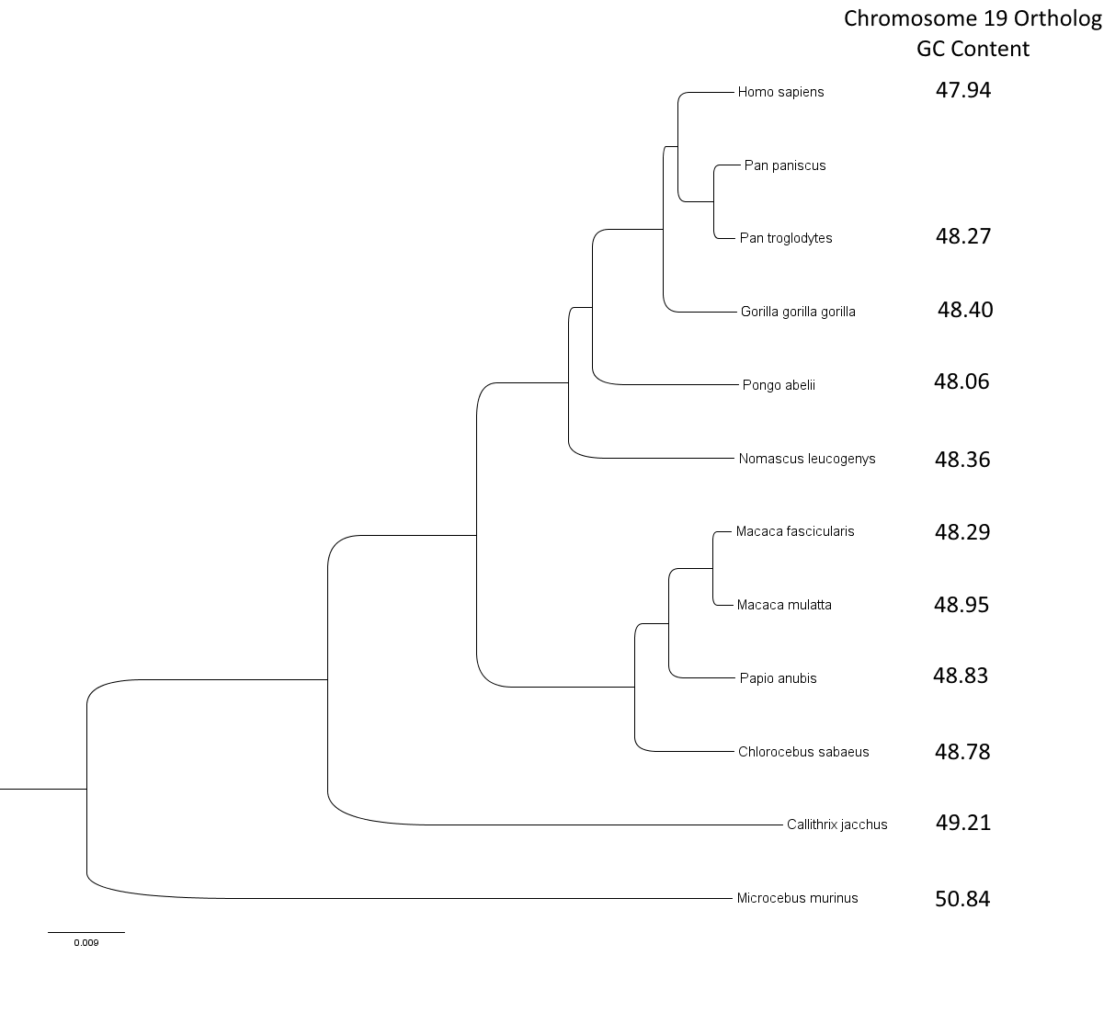
Fig S1.
Nonhuman primate phylogenetic tree showing the chromosome 19 ortholog GC content for species in the tree. The tree topology is based on the species tree used in the Ensembl Compara pipelines (https://ensembl.org/info/genome/compara/species_trees.html).

A.
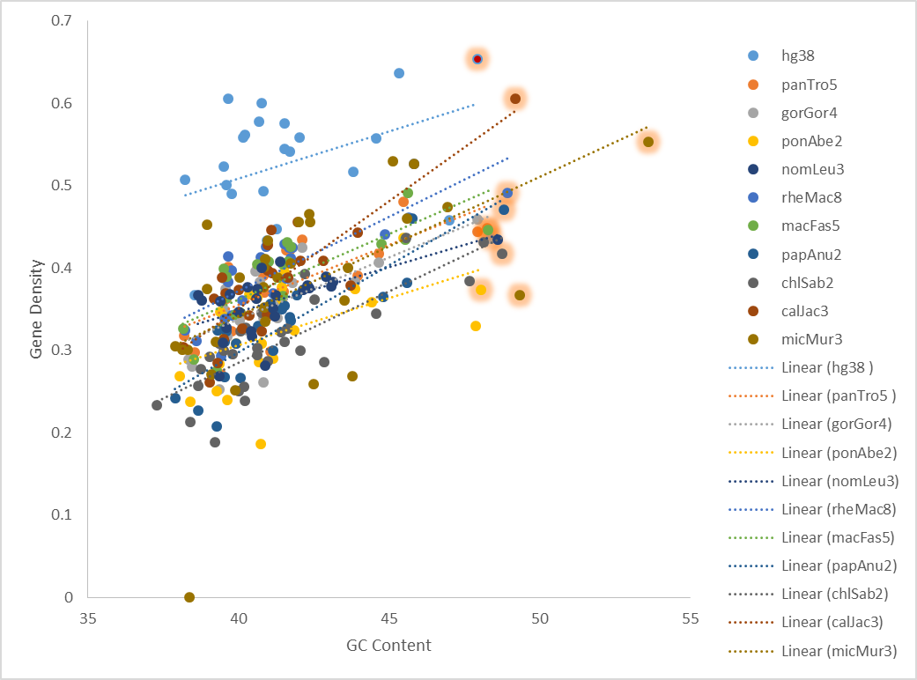
B.
Assembly | r_{s} | two-tailed p value
hg38 | 0.3494 | 0.102002
panTro5 | 0.7913 | 0.000004
gorGor4 | 0.713 | 0.000092
ponAbe2 | 0.6327 | 0.000912
nomLeu3 | 0.641 | 0.00042
rheMac8 | 0.8636 | < 0.000001
macFas5 | 0.887 | < 0.000001
papAnu2 | 0.8918 | < 0.000001
chlSab2 | 0.7673 | 0.000001
calJac3 | 0.8034 | 0.000004
micMur3 | 0.5878 | 0.000318
Fig S2.
GC content compared to gene density in 100kbp windows of human and non-human primate chromosomes. A) Scatterplot of GC content compared to gene density by chromosome. Chromosome 19 orthologs are highlighted in red. B) Spearman's correlation coefficients and p values for GC content compared to gene density.

